Recommendation System to help New Expats to start Restaurant Business in New York
Capstone Project for IBM Data Science Course
Preeti Sarin

- Introduction
  - Background
The City of New York, usually known as New York City (NYC), is the most populous city in the United States. New York is also the most densely populated major city in the United States. New York City has been described as the cultural, financial, and media capital of the world, significantly influencing commerce, entertainment, research, technology, education, politics, tourism, art, fashion, and sports.
When deciding where to open a new business in New York City, it helps to accept one truth early on in your search: No single neighbourhood will have everything you want—you can get a good deal, or a decent-sized place, or a good location, but rarely all three together. And while it might be easy to prioritize what’s most important to you, even the most seasoned New Yorker can have a hard time choosing a neighbourhood that checks enough of their boxes. Add to that the fact that the idea of affordability has all but disappeared in many parts of the city, displacement continues to tear apart longstanding communities, and myriad subway issues make even the most accessible locales hard to reach, and the decision becomes downright daunting.
  - Problem
Shifting demographics and changing lifestyles are driving the surge in food-service businesses. Busy consumers don't have the time or inclination to cook. They want the flavour of fresh bread without the hassle of baking. They want tasty, nutritious meals without dishes to wash. In fact, the rise in popularity of to-go operations underscores some clear trends in the food-service industry. More and more singles, working parents and elderly people are demanding greater convenience when it comes to buying their meals. The cuisine of New York City comprises many cuisines belonging to various ethnic groups that have entered the United States through the city. Almost all ethnic cuisines are well represented in New York City, both within and outside the various ethnic neighbourhoods. Its food culture includes an array of international cuisines influenced by the city’s immigrant history. So, it is evident that to survive in such competitive market to open a restaurant is very important to strategically plan. Various factors need to be studied in order to decide on location such as:
- Are there any Farmers Markets, Wholesale markets etc. nearby so that the ingredients can be purchased fresh to maintain quality and cost?
- Are there any venues like Tourist attractions, Entertainment zones, Parks etc., nearby where floating population is high and so on..
Even though well-funded XYZ Company Ltd. needs to choose the correct location to start its first venture. If this is successful, they can replicate the same in other locations. First move is very important; thereby choice of location is very important. To build a recommendation model, following datasets and information are considered for analysis:
- Scrapped https://geo.nyu.edu/catalog/nyu_2451_34572, to extract information about 5 New York boroughs. Also, considered local areas or neighbourhoods for each borough for detailed analysis.
- I used Foursquare API to get information about available venues for a given neighbourhood and borough in NYC. The API also provided information about shopping area, transportation, nightlife, leisure places etc in each neighbourhood.
- A recommendation system is constructed suggesting suitable neighbourhoods for opening new restaurant based on the customer preferences.
  - Interest
A recommendation system suggesting suitable neighbourhoods for new expats, could be a value added feature to the user offering services in different fields like real estate etc. Recommendation system can guide users on a suitable Neighbourhood and suggest related venues of interest.
- Data sources
To examine the above said, following data sources will be used:
  - New York City Dataset
This New York City Neighbourhood Names point file was created as a guide to New York City’s neighbourhoods that appear on the web resource, “New York: A City of Neighbourhoods.” Best estimates of label centroids were established at a 1:1,000 scale, but are ideally viewed at a 1:50,000 scale. This dataset will provide the addresses of neighbourhood of NYC in json format. Link to the file is: https://geo.nyu.edu/catalog/nyu_2451_34572. An extract of the json is as follows:
{'type': 'Feature',
'id': 'nyu_2451_34572.306',
'geometry': {'type': 'Point',
'coordinates': [-74.08173992211962, 40.61731079252983]},
'geometry_name': 'geom',
'properties': {'name': 'Fox Hills',
'stacked': 2,
'annoline1': 'Fox',
'annoline2': 'Hills',
'annoline3': None,
'annoangle': 0.0,
'borough': 'Staten Island',
'bbox': [-74.08173992211962, 40.61731079252983, -74.08173992211962, 0.61731079252983]}}
  - Foursquare API:
Foursquare API, a location data provider, will be used to make RESTful API calls to retrieve data about venues in different neighbourhoods. This is the link to Foursquare Venue Category Hierarchy. Venues retrieved from all the neighbourhoods are categorized broadly into "Arts & Entertainment", "College & University", "Event", "Food", "Nightlife Spot", "Outdoors & Recreation", etc. Link: https://developer.foursquare.com/docs. An extract of an API call is as follows:
'categories': [{'id': '4bf58dd8d48988d110941735',
'name': 'Italian Restaurant',
'pluralName': 'Italian Restaurants',
'shortName': 'Italian',
'icon': {'prefix': 'https://ss3.4sqi.net/img/categories_v2/food/italian_',
'suffix': '.png'},
'primary': True}],
'verified': False,
'stats': {'tipCount': 17},
'url': 'http://eccorestaurantny.com',
'price': {'tier': 4, 'message': 'Very Expensive', 'currency'

- Methodology
  - Download and Explore New York Dataset
In order to segment the neighbourhoods of New York City, a dataset is required that contains the 5 boroughs and the neighbourhoods, that exist in each borough, with respective latitude and longitude coordinates. Using downloadable json format file :
https://cocl.us/new_york_dataset/newyork_data.json, we created our data-frame.
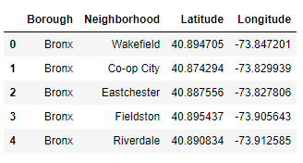
Next we used GeoPy library to establish the coordinates of our centre i.e. New York and create a map of New York with neighbourhoods superimposed on top.
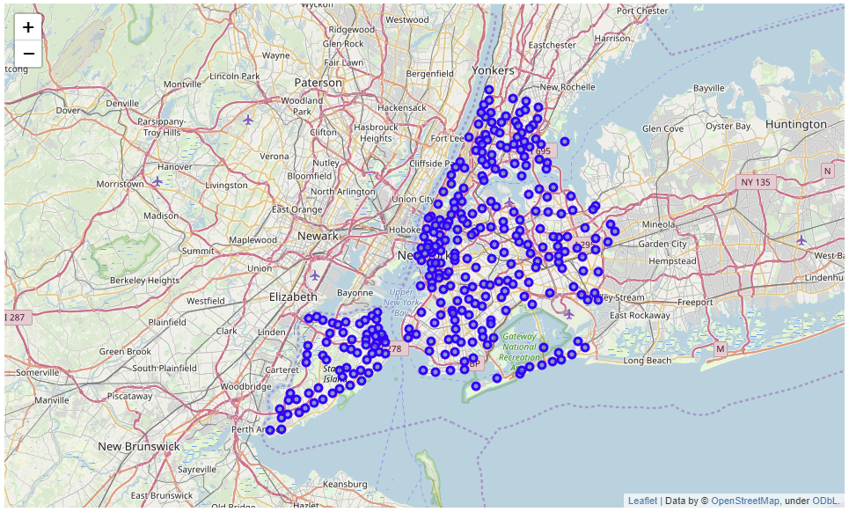

  - Exploring New York Venues by using Foursquare
Foursquare has numerous ‘Venue Categories’ that are used to identify each type of venue. So the next step was to collect the data on the venues and create a new data-frame with the venue categories for each neighbourhood.
Our aim is to segment the neighbourhoods of New York and venues in its vicinity. To proceed further, we create a getNearbyVenues() function to repeat the following process to all the neighbourhoods in New York:
- Loop through neighbourhoods
- Create the API request URL with radius=500, LIMIT=100
- Make the GET request to the ‘api.foursquare.com/v2/venues/explore?’
- For each neighbourhood, return only relevant information for each nearby venue
- Append all nearby venues to a list
- Unfold the list & append it to data-frame being returned
The function returns the below snippet of data-frame with 300 Neighbourhoods and 431 unique venue categories.
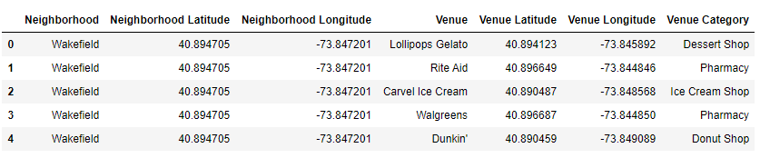

One hot encoding
One hot encoding is a process by which categorical variables are converted into a form that could be provided to machine learning algorithms to do a better job in prediction. To help us with organizing the venues we used Onehot encoding in our dataset to create a data-frame with occurrence of each venue present (1) or not (0) under each Neighbourhood and then we grouped the rows by neighbourhood and the mean of the frequency of occurrence of each category was calculated and included in a new data-frame.
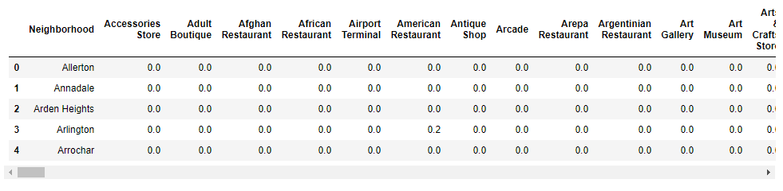

  - Feature selection
Feature Selection is the process where you automatically or manually select those features which contribute most to your prediction variable or output in which you are interested in. There are 431 unique venue categories in the dataset with a lot of them belonging to the same general "group" for example there is “Yoga”, “Gym”, “Health”, “Fitness” all belonging to the same logical group “Fitness”.

The 431 venues will be filtered through a key words search so to create a number of higher level categories which will be used for both clustering as well as recommendation. For this purpose the categories created with corresponding filters are:
- Restaurants - keywords (Restaurant|Steak|Bistro)
- Fast_Food - keywords (Fast|Burger|Food Truck|Sandwich|Pizza Place|Place|Joint)
- Health_Fitness - keywords (Yoga|Gym|Martial|Health|Fitness|Pool|Healthy|Field|Sports|
Trail|Stadium|Tennis|Climbing)
- Kids_Friendly - keywords (Kid|Play|Park|Nursery|Playground|School|College|Nursery|
- Medical Center| Clinic|Basketball|Football)
- Nightlife' - keywords (Night|Bar|Pub|Wine|Dance|Strip Club|Adult|Club|Speakeasy|
Liquor| Brewery)
- Culture - keywords (Gallery|Museum|Paintings|Monument|Church|Theater|Cinema|
Sculpture|Aquarium|Concert|Art)
- Shopping - keywords (Mall|Shopping|Shop|Retail|Store|Boutique)
- Short_stay - keywords (Motel|Hotel|Airport|Stay)
- Personal_care - keywords (Salon|Barber|Spa|Massage|Hair|Nail|Tanning)
- Food_markets - keywords (Supermarket|Market|Grocery|Bakery|Butcher)
- Transportation - keywords (Train|Metro|Bus|Tram|Boat)
- Leisure - keywords (Beach|Plaza|Skating)
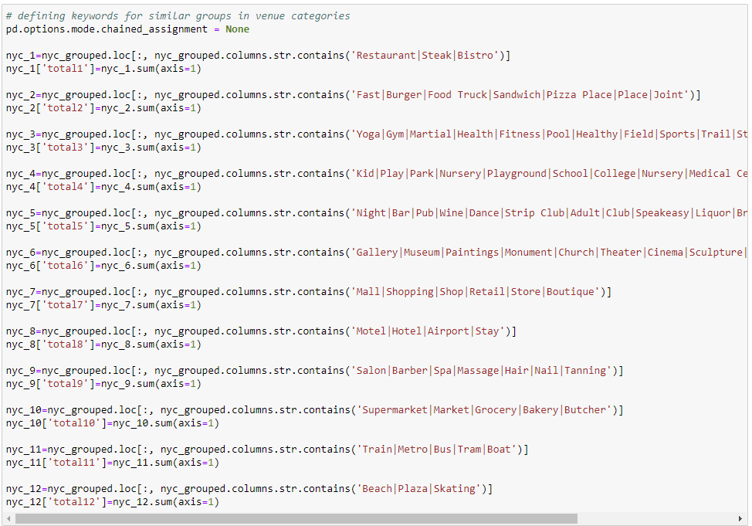
After keywords are defined, we filter venue categories as below.
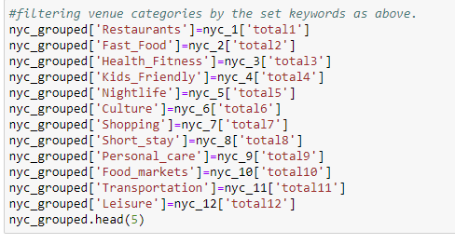
The result was a new data-frame with 12 key categories as columns and the corresponding mean frequencies per Neighbourhood as sums of the values we calculated earlier with one hot encoding grouped data-frame.
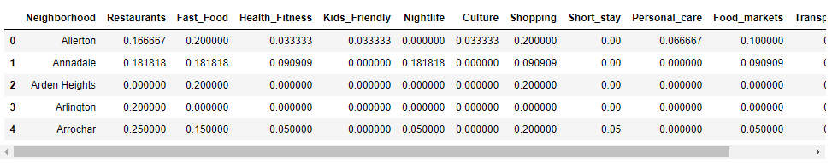

Next we created and applied a function that sorted our data-frame basis top 5 most common categories for each Neighbourhood which would help us in the evaluation of our recommendation system results.

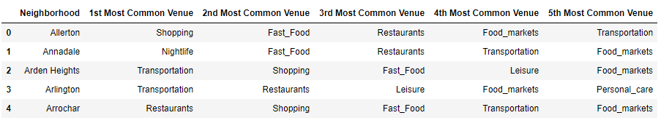

- Modelling:
We need to identify similarity of neighbourhoods based on venue occurrences. We utilize K-mean clustering.
K-mean Clustering
K-means clustering is one of the simplest and popular unsupervised machine learning algorithms. A cluster refers to a collection of data points aggregated together because of certain similarities. We define a target number k, which refers to the number of centroids you need in the dataset. Every data point is allocated to each of the clusters through reducing the in-cluster sum of squares. In other words, the K-means algorithm identifies k number of centroids, and then allocates every data point to the nearest cluster, while keeping the centroids as small as possible. The ‘means’ in the K-means refers to averaging of the data; that is, finding the centroid.

Before running the algorithm we normalized our data using StandardScaler() from sklearn library.

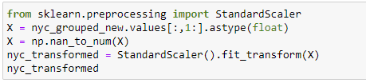

To evaluate the optimum K we used the “Elbow method” and “Silhouette Method”.

Elbow Method: This is probably the most well-known method for determining the optimal number of clusters. Calculate the Within-Cluster-Sum of Squared Errors (WSS) for different values of k, and choose the k for which WSS becomes first starts to diminish. In the plot of WSS-versus-k, this is visible as an elbow. Unfortunately, we do not always have clearly clustered data. This means that the elbow may not be clear and sharp.

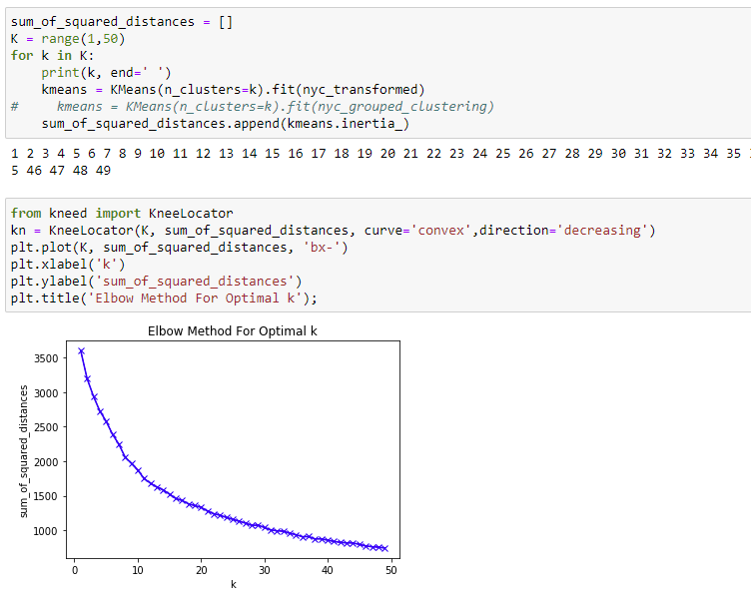
Elbow method did not give a clear cluster data, so we used Silhouette Method.

Silhouette Method: The silhouette value measures how similar a point is to its own cluster (cohesion) compared to other clusters (separation).
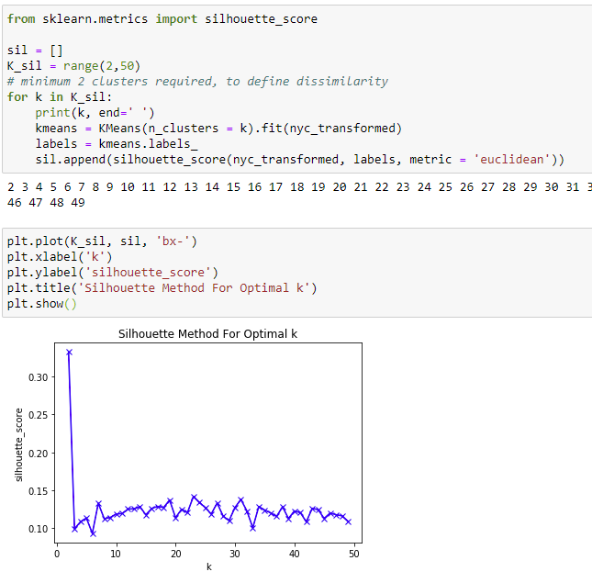
We find peaks at 2, 5 and 7. 2 and 5 clusters will not give us more generalized clusters, so we opt for 7. Using the k-clusters defined by the above methods, we segment the neighbourhoods into 7 clusters. We assign the labels to the rows of our data-frame and mapped the Neighbourhoods accordingly
Recommendation System:
Content-based recommenders system is used in our project. It treats recommendation as a user-specific classification problem and learns a classifier for the user's likes and dislikes based on product features. For instance, Netflix, the similarity between the movies is calculated on the basis of genres, the actors in the movie, the director of the movie, etc and based on what we like; the algorithm will simply pick movies with similar content to recommend us.
So in our case, we assume there are no pre recorded data with respect to the neighbourhood. We assume customer is new to the city and has no knowledge about the neighbourhoods.

The first step was to feed the system with user ratings for each of the 12 categories we created depending on how important each was for the user in a scale of 1–10. For the testing purpose we used a “persona” of a user who wants to open restaurant at a place where it has less competition moreover to attract more customers he want a location which has shopping areas, transportation facilities, nightlife / leisure activities/ college & university etc. Rating is recorded as
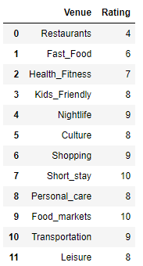

Next we create user preferences matrix by calculating the weighted average of the user ratings against the frequency of each category and for all New York neighbourhoods in our data-frame. The result was sorted to a top 5 list of recommended Neighbourhoods basis user profile which was then plotted on the map of New York.

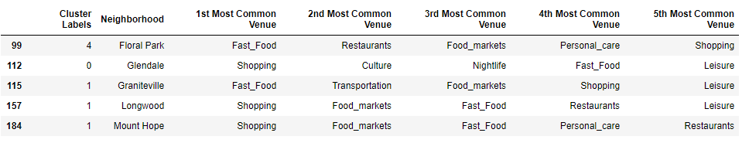

- Results
A qualitative analysis of the recommended results is a more challenging task since to properly evaluate the suitability of the neighbourhood’s basis the user preferences. K-Means Clustering algorithm gave us 7 clusters according to the 12 categories created. The cluster 0, 1, 3 and 4 depicted restaurant as the most common venue in these neighbourhoods, though these clusters meet other requirements as Shopping, Nightlife, health- fitness etc as stated by the user. But customer has to face a great competition as there are many restaurants around. Whereas in cluster 2, 5, and 6 neighbourhoods do not have restaurant as the most common venue. These neighbourhood cluster seems to be quite promising as competition would be less or negligible.

But we wanted to narrow down the results by using recommendation system, so that we could clearly identify the neighbourhoods that meet the customer preference. K-means did help identify area clusters based on the venue concentration and give us a first distinction on the areas as i.e. where is the busiest locations and which ones are more suitable for opening restaurant.

Recommendation systems help us short list 5 neighbourhoods in different cluster which meet the customer preferences. And then plot the short listed neighbourhoods superimposed on the New York map.
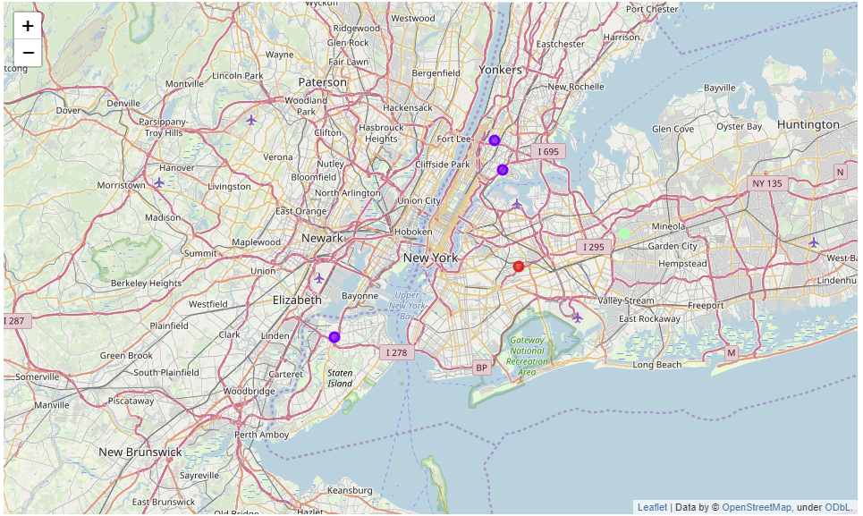

- Future Scope
This analysis is performed on limited data. If good amount of data is available there is scope to come up with better results. This problem can be further enhanced by considering population and demographics of New York, cuisine served.

