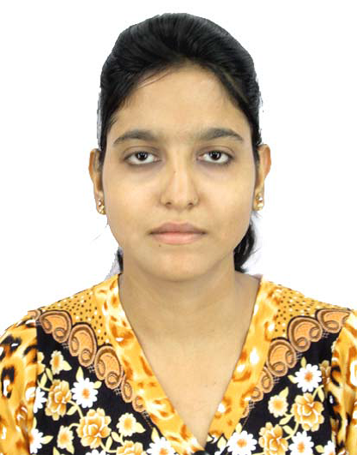

**MANJUSA DUTTA**

*Mobile: 9163770002*

*Email: [manjusadutta93@gmail.com](mailto:manjusadutta93@gmail.com)*

Academic Qualification :

|  |  |  |  |  |  |  |
| --- | --- | --- | --- | --- | --- | --- |
| Degree/Certificate | Degree | Discipline | Institute | Board/  University | Year of passing | Aggregate%/CGPA |
| *Graduation* | *B.Tech* | *Information Technology* | *BCET* | *WBUT* | *2015* | *8.52* |
| 12th | XII | Science | Laban Hard Vidya Pith For Girls | WBCHSE | 2011 | 62.42 |
| 10th | X | General | Laban Hard Vidya Pith For Girls | WBBSE | 2009 | 72.37 |

*Aggregate Marks means Summation of the marks obtained in all the subjects (including optional subjects ) divided by the total marks in all subjects .

|  |  |
| --- | --- |
| Please mention any pending Backlogs in your Academic Career | None |

Trainings/Projects Undertaken :

|  |  |  |
| --- | --- | --- |
| Name of Institute/Organigation | Project Title | Duration |
| Ardent | Asp .Net with C# | 1 months |
| IBM | IBM CE –Fundamental course on Mobile Application Design ,Development & Testing for Android based devices | 1 months |

Academic Project :

**B.Tech Final Year Project : *“Online University Management System ”.***

*We have design this project by using Asp .Net with C# that helps to replace current paper records of a university .College stuffs are able to access all aspects of students academic progress and student also downloads syllabus or find college related notification through online interface embedded in the college’s  website.*

**Duration : *1 year***

Subjects Of Interest :

1. **Programming Languages:** Basic C programming, Core Java, C++
2. **Others:** Data Structure And Algorithms , Database Management System

Extra - Curriculum Activities :

* Participated in games & sports/co-cocurricular activities in Independence day in College .

Achievements :

* Certificate of completed the computer literacy program for the academic year 2006-2007.
* Certificate of merits,sksgi(3rd rank in college in 6th semester).

Hobbies :

* Internet Surfing .
* Collecting news.

Family Details :

|  |  |  |
| --- | --- | --- |
| Details | Name | Occupation |
| Father | Manotosh Dutta | Govt. Service |
| Mother | Kajal Dutta | House Wife |
| Siblings | Subhajit Dutta | Student |

Personal Details :

**Name :** Manjusa Dutta

**Address(permanent) :** 6E, Girish Vidya Ratna Lane Kolkata-700011

**Date Of Birth :** 13-07-1993

**Sex :** Female

**Nationality :** Indian

**Language known :** English,Bengali,Hindi

Declaration :

I hereby delare that above informations are true and its best of my knowledge .

**Place :** Kolkata Manjusa Dutta

**Date:**