Game Design Document

Fill up the Following document

1. Write the title of your project.

Magic cards

1. What is the goal of the game?

To find the exact number the player thinks of.

1. Write a brief story of your game?

The player thinks of a number. In the shown flash cards the player

Should pick if their number is in there or not depending on the yes

Cards we tell the number.

1. Which are the playing characters of this game?

* Playing characters are the ones which respond to the user based on the input from the user
* Cars, monkeys, dinos, wizards etc, are the playing characters in the game.

|  |  |  |
| --- | --- | --- |
| Number | Character Name | What can this character do? |
| 1 | illusiono | It shows the flash cards |
| 2 | Braino | It guess the number |
| 3 | distingo | Separates the yes and the no cards |
| 4 |  |  |
| 5 |  |  |
| 6 |  |  |
| 7 |  |  |
| 8 |  |  |

1. Which are the Non Playing Characters of this game?

* Non Playing characters are the ones which don't have an action or a behaviour when the user interacts with the game.
* Hurdles, stones, bananas, coins, etc are non playing characters in the game.

|  |  |  |
| --- | --- | --- |
| Number | Character Name | What can this character do? |
| 1 |  |  |
| 2 |  |  |
| 3 |  |  |
| 4 |  |  |
| 5 |  |  |
| 6 |  |  |
| 7 |  |  |
| 8 |  |  |

Draw your imagination of this game. What does this game look like?

* Draw the game either on your computer or on paper,
* Add images of scenes of the game to show each of the playing and non-playing characters at least once.

The flash cards:- 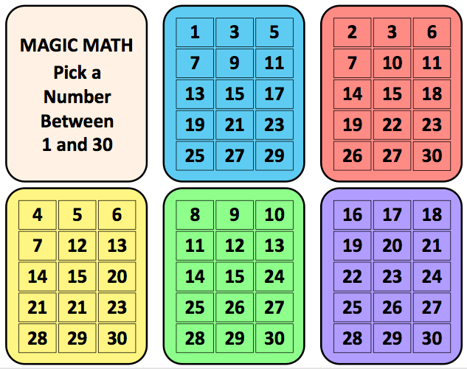

Braino:- 

Illusiono:- 

Distingo:- 

How do you plan to make your game engaging?

By making the player curious to find how we know the correct number.