Project-2

Sandalpreet kaur, Taranjot kaur

Continental Institute For International Studies

IMDW-18008,18010

Amandeep Singh

September 26, 2018

**Introduction**

The website named as -MEETINGSPOT is a kind of a website which can be accessible by Students, customers and professionals for their own particular task .It will help to organize the large annual conferences for clients and interested parties free of cost. This website will enhance the business and will give more profit by indulging international costumers or those who are living at faraway places without travelling at for the long distances. Virtual conferences will have a number of business topics, such as logistics, supply-chain management, software development, IT infrastructure, human resources, etc. we should include students to famous our website throughout the globe. As students will be our next clients or future professionals.

**Description**

Meeting spot is a website which is used for interaction among users, students and professionals which includes specific features such as webinars, live chats, mixers, blogs Forums etc. It is very useful website for students to study the specific subjects or topics. It provides questionnaire which helps in asking and getting the queries. It has many more features which make it a unique website as given below:-

A preliminary list of desirable features for the website.

* Organize webinars
* Support forums
* Support live chats
* Host blogs
* Occasionally schedule live talks, mixers and other events
* Grow a network of clients, interested professionals and students

Organize webinars- A webinar is a live gathering that happens over the web. It tends to be an introduction, a talk, an exhibition or an instructional "how-to" session. The individuals who partake see a live video feed, an application or reports by means of computer.

Support forums- It will provide you Internet forum, or message board, which is an online exchange website where individuals can hold discussions as posted messages. They contrast from visit rooms in that messages are regularly longer than one line of content, and are in any event briefly filed.

Support live chats- Live support is a Web benefit that enables organizations to convey, or talk, progressively with guests to their Web webpage. Live support applications are normally used to give quick client support and data to customers and clients.

Host blogs- Web and Search. On the off chance that you've chosen you need to create and distribute a blog on the web, you'll require a facilitating supplier. A blog have is the organization that gives the space on its servers and gear to store your blog.

Occasionally schedule live talks, mixers and other events- A mixer facilitated by a substantial firm, an expert affiliation or a business locale is a chance to increase social capital, which has come to be viewed as a basic factor in progress. Numerous individuals give huge cash and time to these occasions with the straightforward objective of making new contacts.

Grow a network of clients, interested professionals and students - Things being what they are, a seven-advance methodology works best to pull in new clients.

Its various purposes, including its business purposes

Various types of websites have distinctive purposes relying upon who the target group is. A few websites are outfitted towards offering items and different websites are adapted towards giving useful data, while others are simply for stimulation. We should investigate a portion of the distinctive sorts of websites that are out there.

The purposes of e-commerce websites are to sell items to users. The best websites are carefully optimized to achieve a high percentage of purchases. To achieve success e-commerce websites need to integrate the majority of the latest online shutting and upsell techniques available which have been proven to increase the chances that a guest will purchase. There are numerous imperative elements that go into building a successful e-commerce website, for example, removing grinding amid the buying process, making the checkout smooth and easy, making the website quick and attractive, up selling users on related items, incentivizing buyers, reducing truck abandonment, supporting past buyers to purchase once more, remarketing to past guests who haven't yet purchased, utilizing the proper payment alternatives, having a mobile ready design, etc., etc.

Future goals for the website are marketing is drive traffic, engage prospects, generate leads and re-engage existing customers. Sales help close sales by validating and supporting sales team communications. Customer support improves customer satisfaction through better service. Webmasters simplify and optimize content updates and website management. IT is integrate with other systems; meet security, performance and scalability requirements. Operations are reducing costs by streamlining and automating workflows and tasks. HR attract and recruit new employees and support current employees. C-Suite grows the company’s bottom line and increase profitability.

**Research**

I have conducted a survey related to the website in which many people has contributed . An E-mail has also been used to send the survey to the old customers for their views . It is shown in the below given figures:-

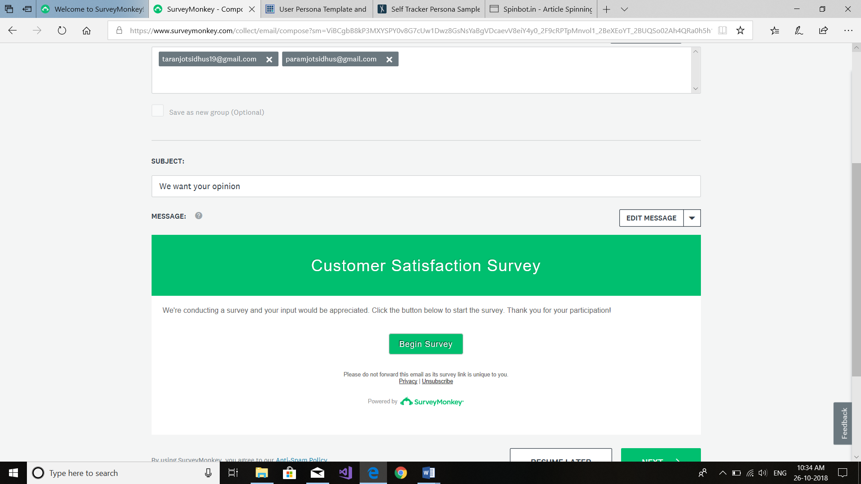

Figure 1: *E-mail.*

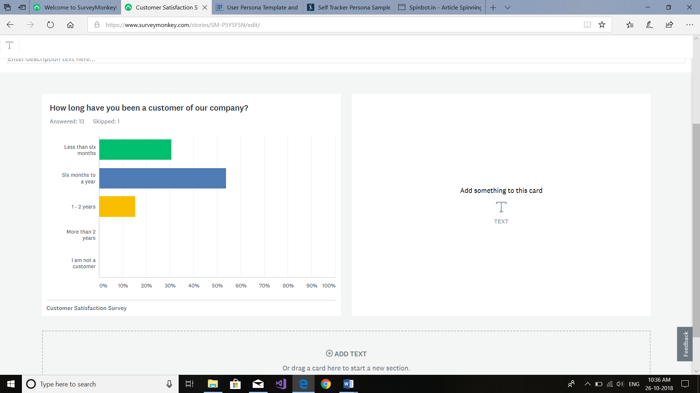

Figure 2: *Results of the survey.*

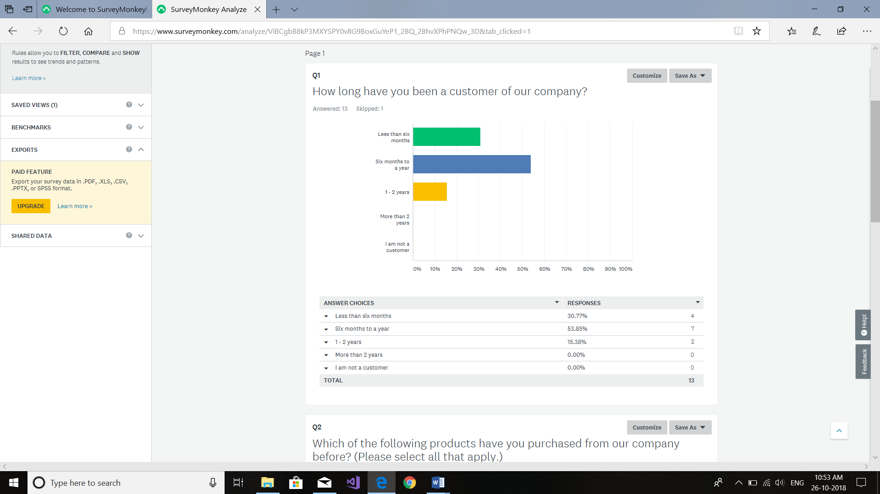

Figure 3: *Result of question 1.*

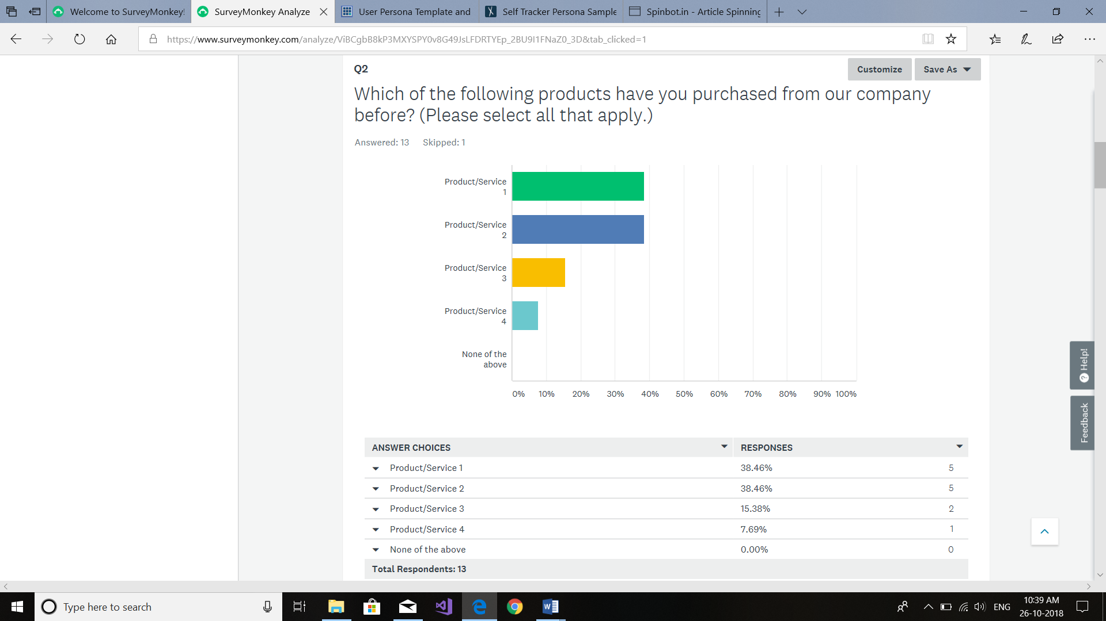

Figure 4: *Result of question 2.*

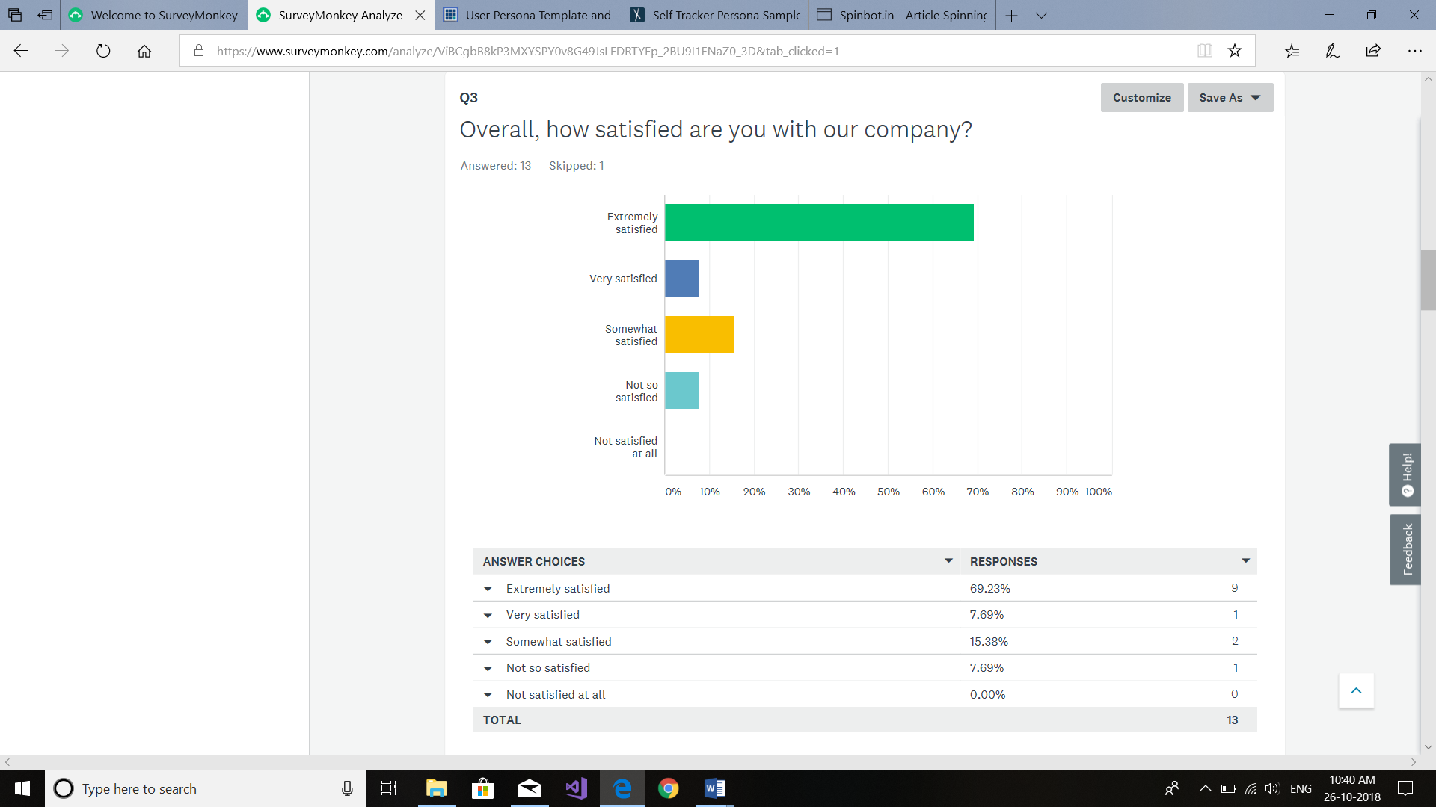

Figure 5: *Result of question 3.*

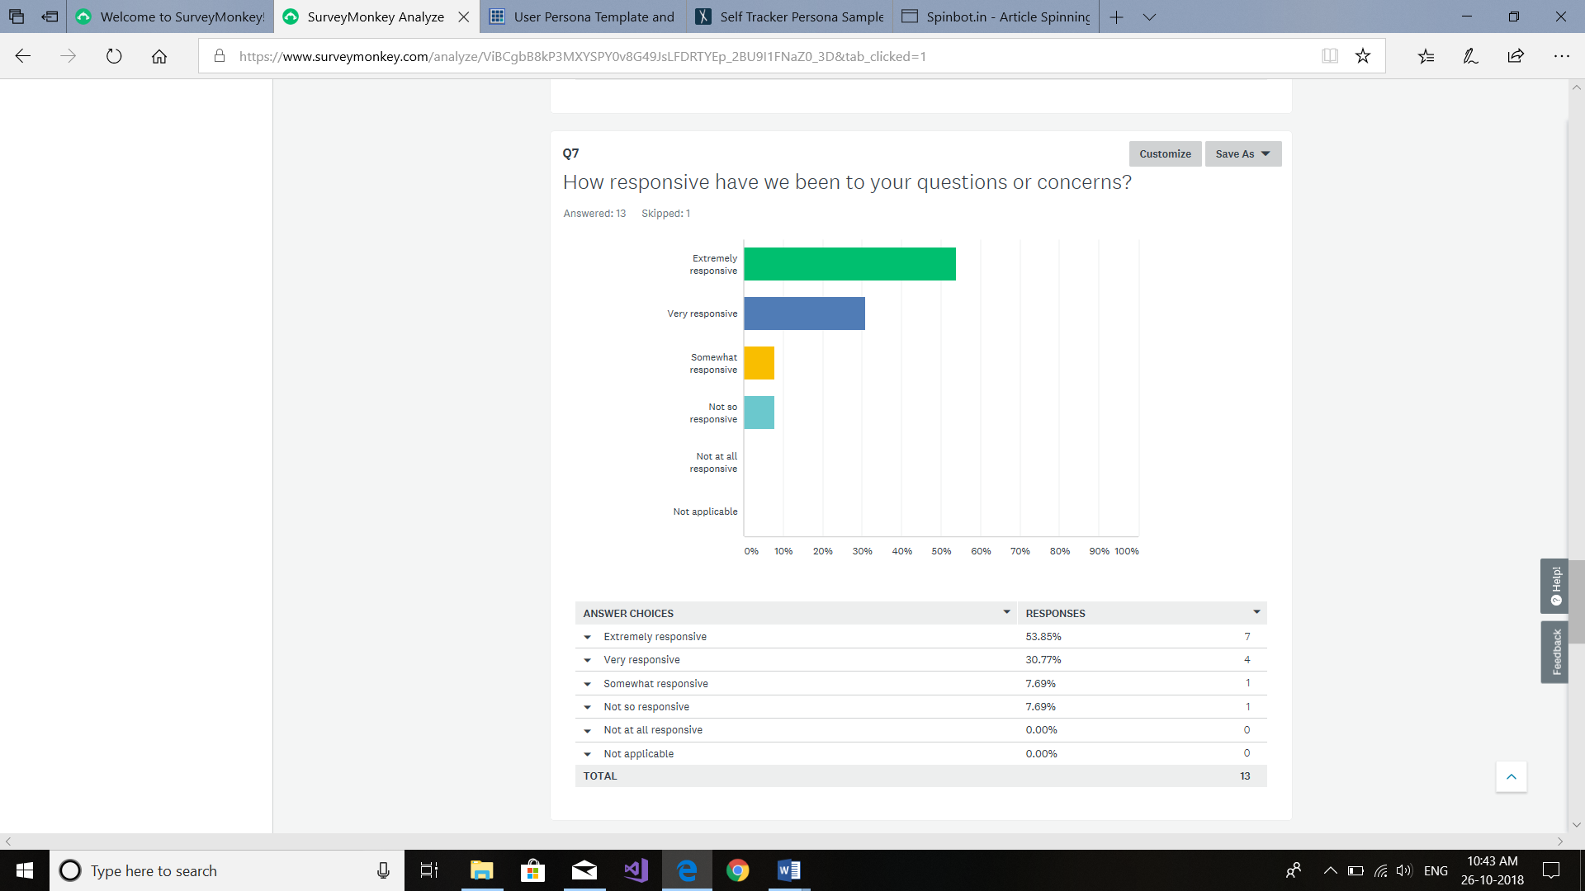

Figure 6: *Result of question 7.*

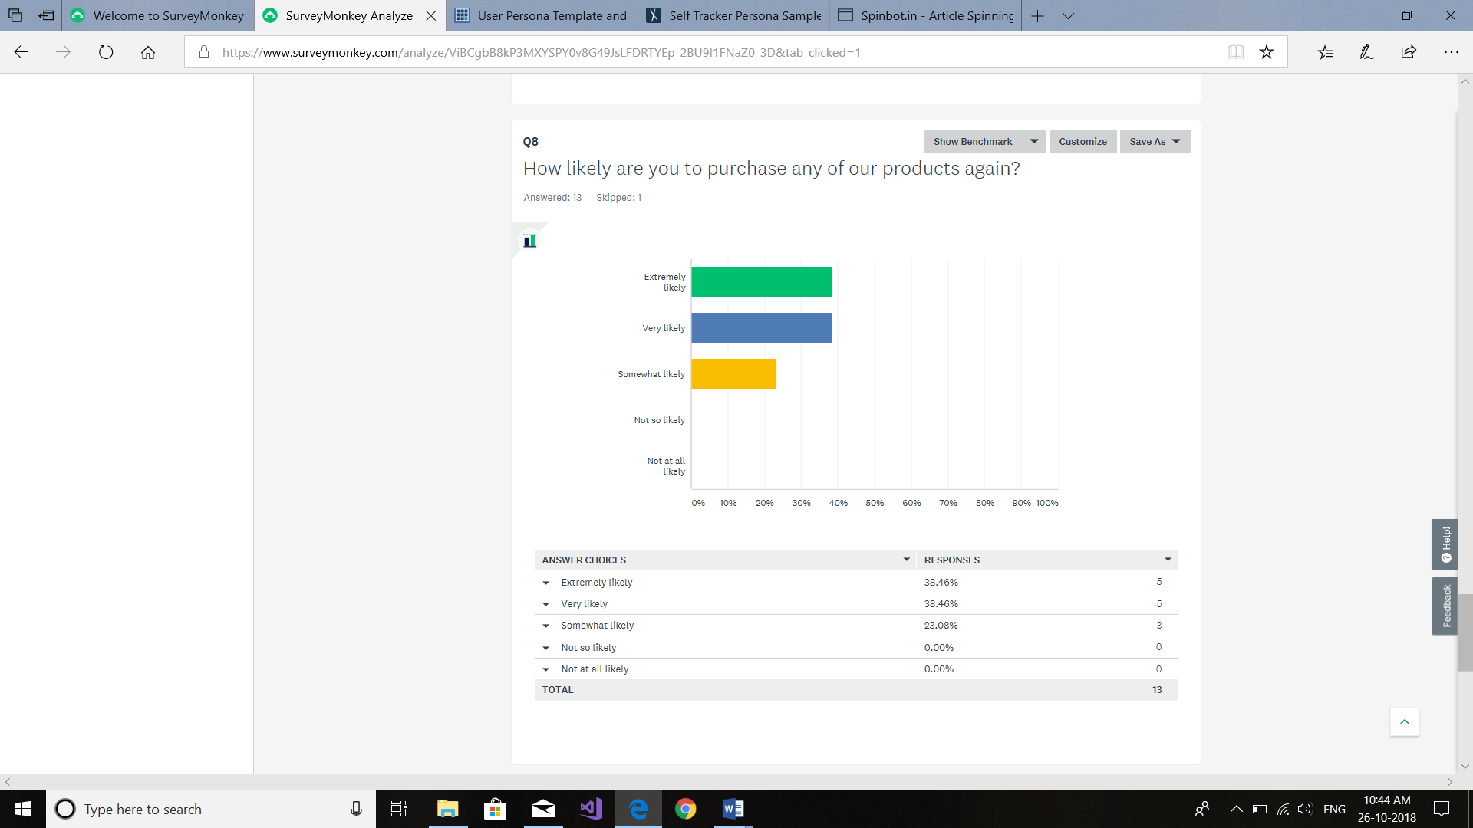

Figure 7: *Result of question 8.*

**Technical Issues**

This website incorporates the computer case, screen, console, and mouse. It additionally incorporates every one of the parts inside the computer case, for example, the hard circle drive, motherboard, video card, and numerous others. Computer hardware and its types. Computer hardware is a physical piece of a computer that executes inside the hardware. It is not normal for computer programming or information that can be much of the time changed, altered or deleted on a computer. The following are the distinctive sorts of hardware's found in a computer. Processor should be 8th Gen. Operating System should have Windows 10. Display should be 14 - inch Full HD (1920 x 1080) IPS Anti-Glare display. Memory and Storage should be 4GB+16GB DDR4 RAM with Integrated Graphics Storage: 1TB HDD. Battery backup should be up to 6 hours. A motherboard is an electronic circuit board in a computer which interconnects hardware gadgets connected to it. At the very least it incorporates at least one Central preparing unit, and the primary handling movement of the computer happens on it. Notwithstanding, other associated printed circuit sheets may contain their very own pre-handling or post-preparing CPUs, to take a portion of the heap off of the motherboard; these, together with other module sheets without CPUs, might be classified "girl sheets." It was known as a "mother" board in connection to these. A PC motherboard may have a progression of attachments, permitting girl sheets to be connected to straightforwardly. Different connectors on the motherboard permit correspondence through links with different fringe gadgets, both inside and outside the computer case. Ports are utilized by a motherboard to interface with hardware both inside and outside of the computer.

A lot of web substance can be ensured the right HTML components are utilized for the right reason consistently. This article looks in detail at how HTML can be utilized to guarantee most extreme openness. Out there on the web, in all actuality individuals do some extremely bizarre things with HTML mark-up. A few maltreatment of HTML are because of heritage hones that have not been totally overlooked, and some are out and out obliviousness. Whatever the case, you should supplant such awful code wherever you see it, at whatever point you can. Once in a while you are not generally in the situation to dispose of terrible mark up your pages may be produced by some sort of server-side structure that you don't have full power over, or you may have outsider substance on your page, (for example, advertisement pennants) that you don't have command over. The objective isn't "win or bust", anyway each change you can make will help the reason for availability.

A requirement, in undertaking administration, is any confinement that characterizes a task's restrictions; the extension, for instance, is the farthest point of what the venture is relied upon to achieve. The three most critical task imperatives - calendar, cost and degree - are once in a while known as the triple requirement or the venture administration triangle. A venture's extension includes the particular objectives, expectations and errands that characterize the limits of the undertaking. The timetable (once in a while expressed all the more comprehensively as time) determines the course of events as per which those parts will be conveyed, including the last due date for fulfilment. Cost (some of the time expressed all the more comprehensively as assets) includes the money related restriction of assets contribution to the task and furthermore as far as possible for the aggregate sum that can be spent. Task limitations are likewise viewed as to some degree fundamentally unrelated. In the undertaking administration triangle, it is expected that creation a change to one requirement will influence either of the others. For instance, expanding the extent of the venture is probably going to require additional time and cash. That the truth is additionally communicated as the pick two guideline, which keeps up that for some random arrangement of three wanted characteristics or desires -, for example, "great, quick and modest" - it is likely that no one but two can exist together: A given item may be conveyed rapidly and cheaply, for instance, however the quality will endure.

**Content Plan**

1.

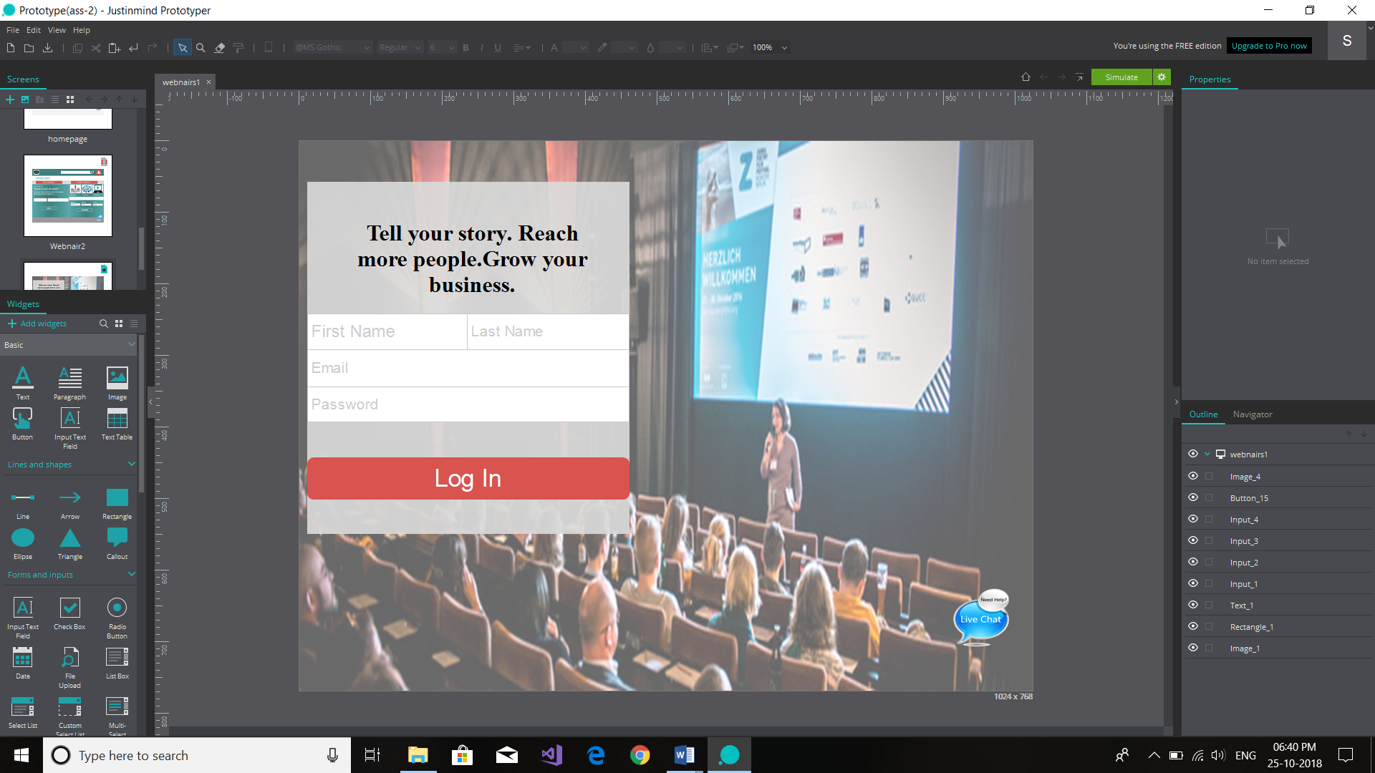

Figure 1:*First Page*

This is the first page of the website-Meetingspot, which includes the login process with First name, last name,E-mail and a password set to login in the website. All the spaces are mandatory to be filled with in the accurate way.Moreover every page has an onlne chatting system.

2.

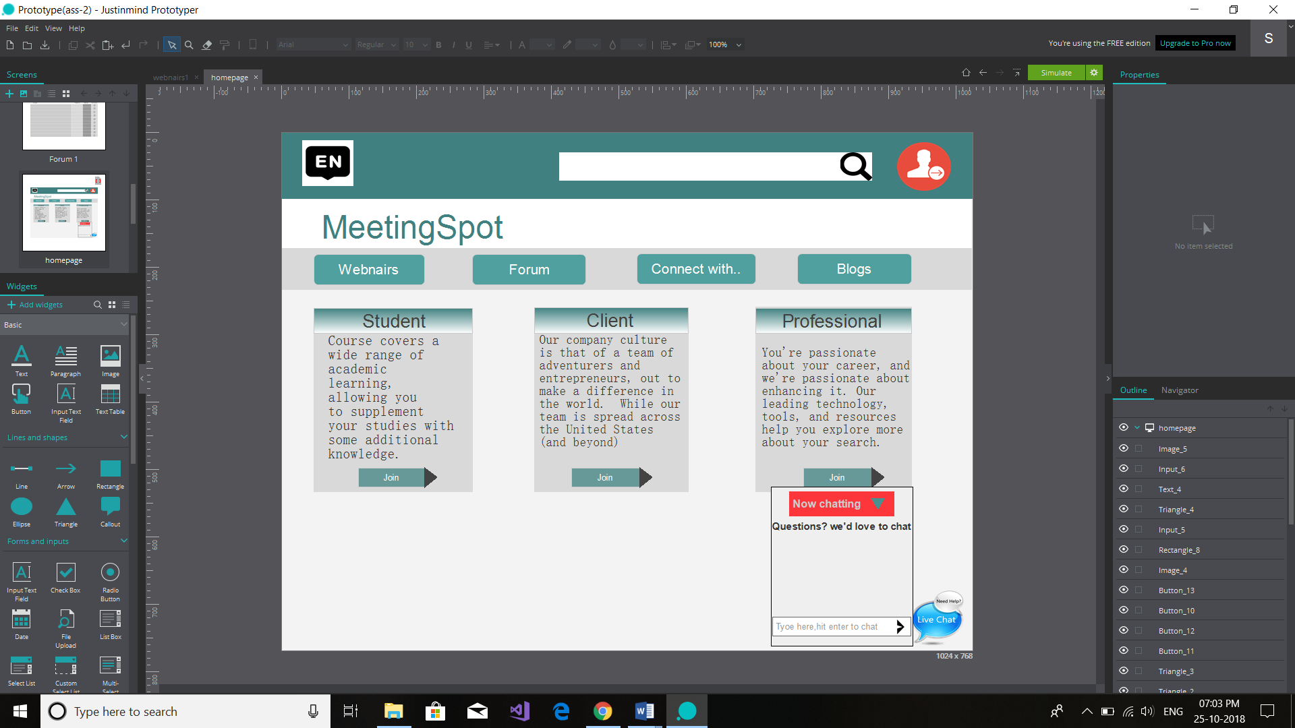

Figure 2:*Home Page*

The second webpage holds the Homepage which has all the links to other webpages.It has Webnair,Forum,chatting system,Blogs,student section,client section, Professional section. Every page will have an online chatting help .It has a search,language and account buttons to further enhance the working of website.

3.

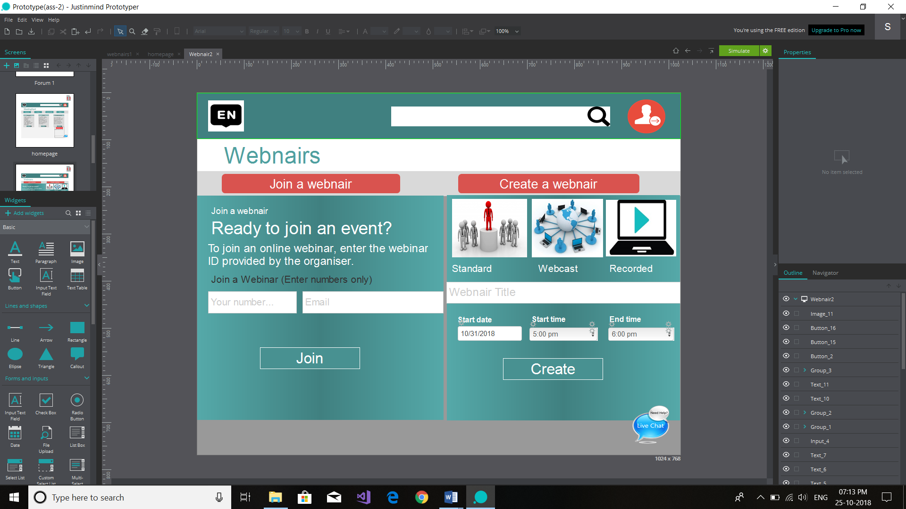

Figure 3:*Webnair’s Page*

Webnair button will take you to another webpage which has create and join features. Joining to the website will need a number given by host party to join the webnair alongwith business E-mail. Another one is to create. For the creation of the webnair all the given detail has to be filled-Webnair titile, Start date, start time, End time and then press the create button.

4.

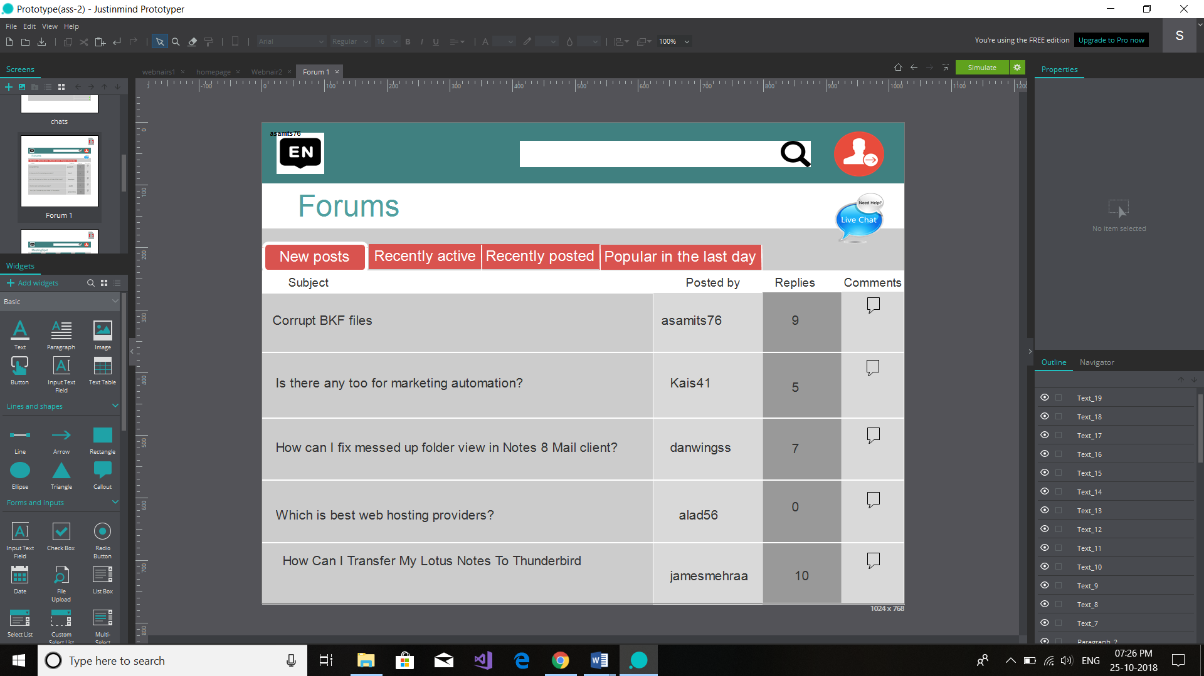

Figure 4:*Forum’s Page*

When you will click on the Forum button given on Homepage , this page will appear which contains the subject of the questions or Forums along with the name of its writer and the comments on the particular subject. Another features of this webpage is, that it will provide Recently active, Recently posted and most popular subjects in different sections along with the live chat option.

5.

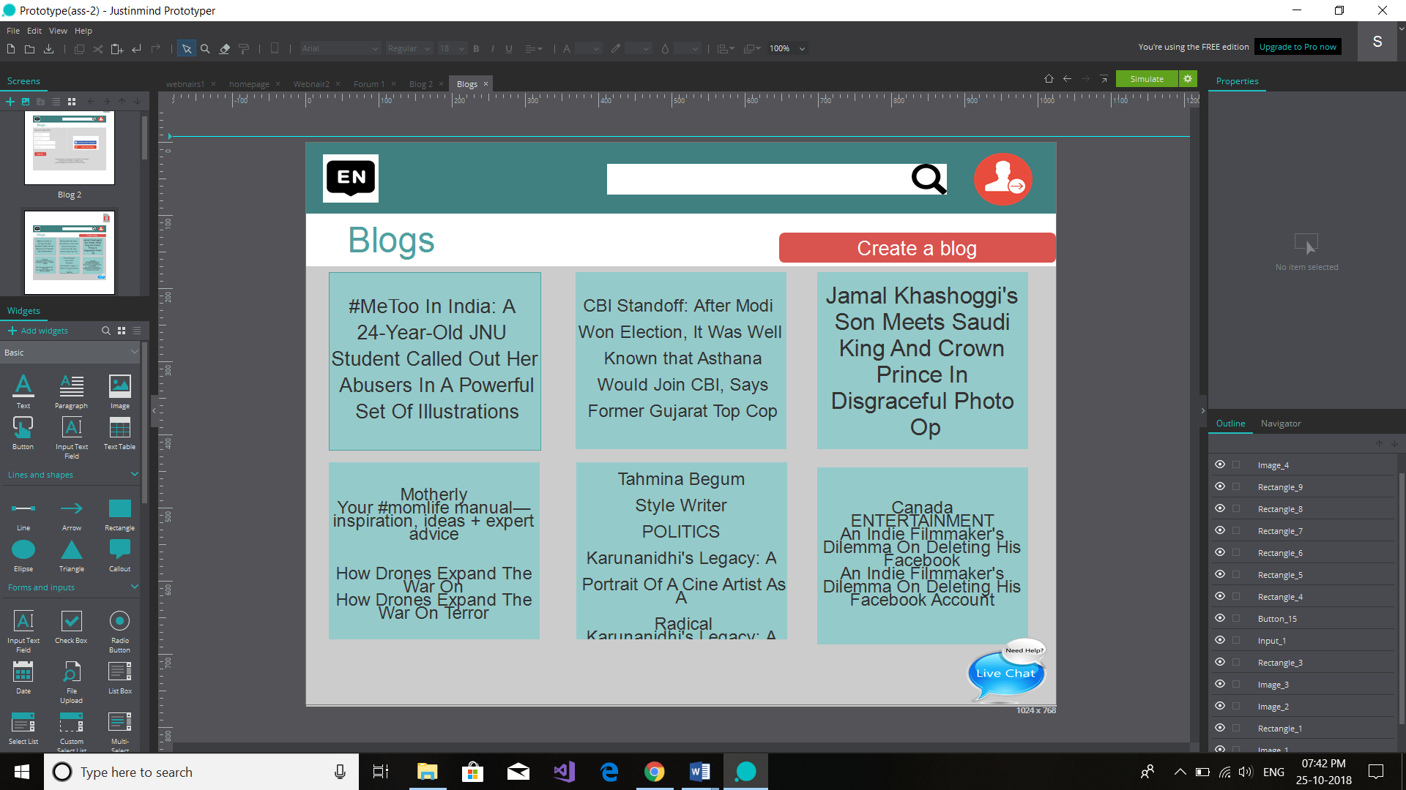

Figure 5:*Blog’s Page*

This is the second page of blog where you can create your blog and read other’s blog . It will help to collect knowledge from different sources. It has a button on the flush left of the webpage where you can create a blog .

6.

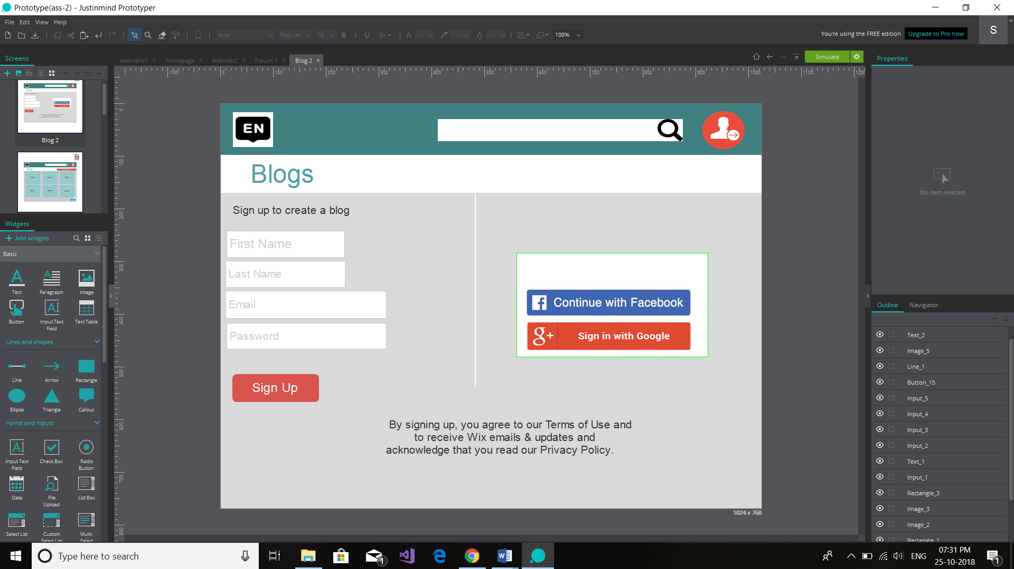

Clicking on the create a blog button given on blog’s webpage will bring you to this page which contains Sign up form to create a blog . On this page you can create your own new account which signing up with, continue with Facebook or google also.

7.

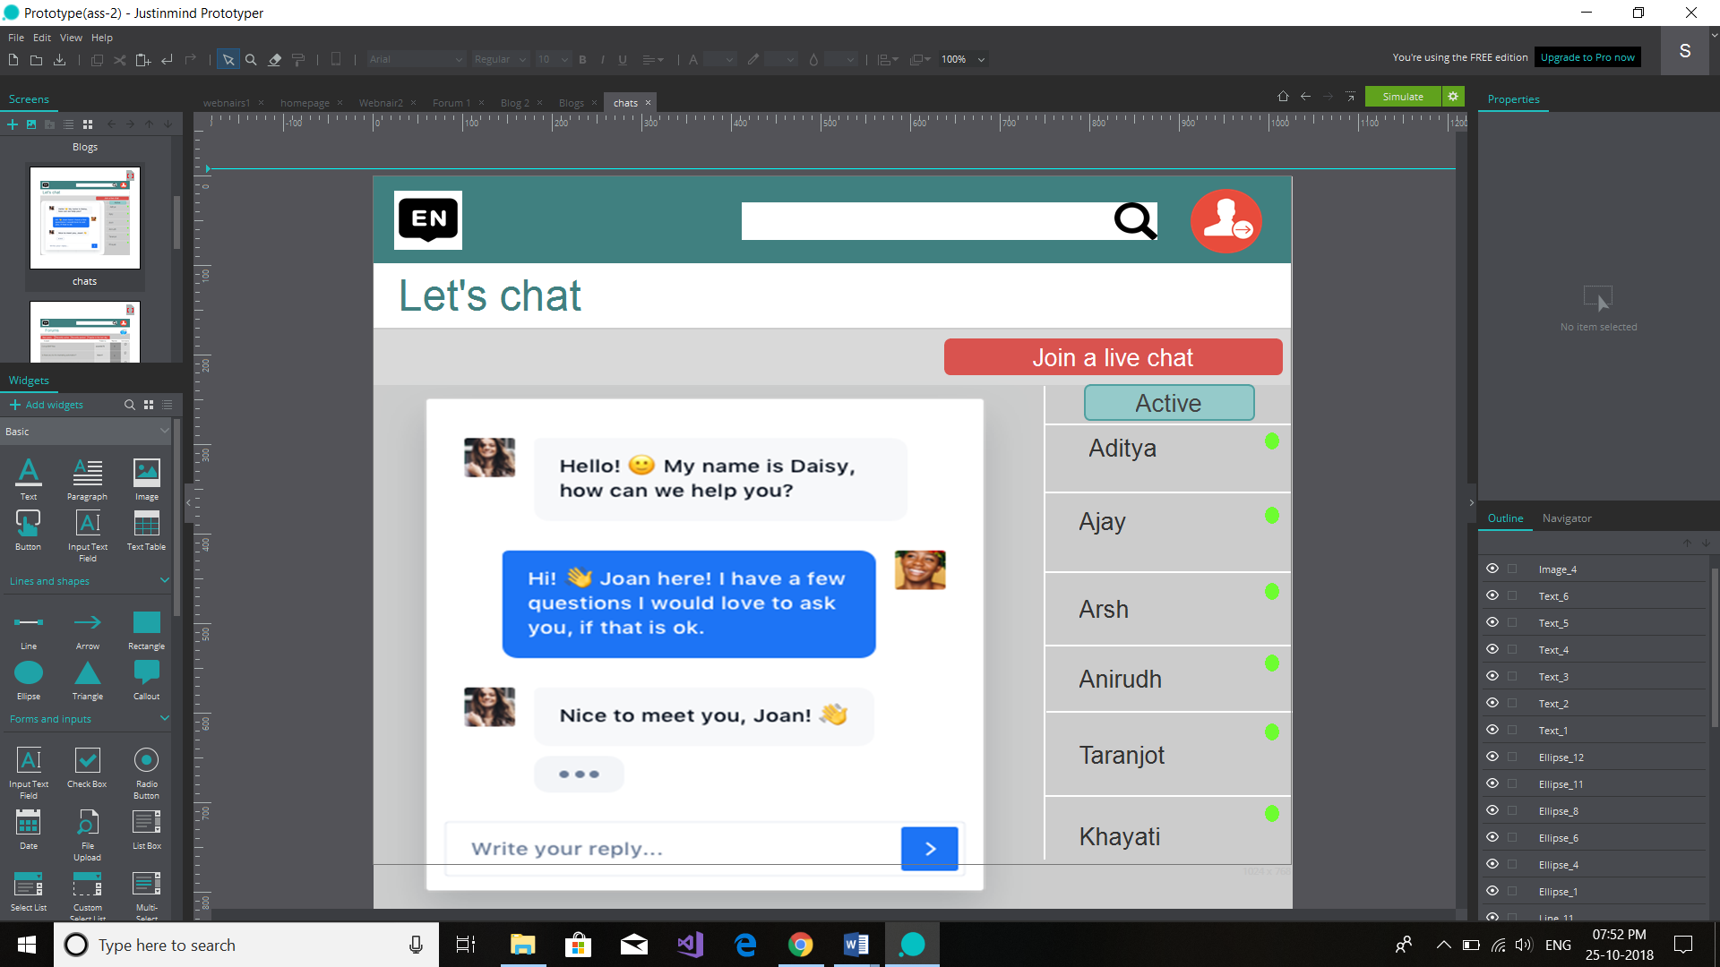

This page will appear when you will click on connect with. It has the feature of online chatting, and to join a live chat. The active persons will be visible in the sidebar with green coloured dot.

**Personas**

Here are the personas of three people from different fields.

**Ritu**

“I want a sort of website that has description about the new technology.”

Age- 17

Occupation- Student.

Family- Single, mother, father, brother.

Technical profile- Comfortable with technology

Internet use- 85% at information, shopping, entertainment.

Favourite sites- eBay.com, youtube.com

Bio- She loves to buy new phone every year. Rita spends her 4 hours of the day on computer and play games . Ritu will be a frameworks programming developer, a "data junkie" and to days gone by couple years, need been extremely intrigued by following parts from claiming as much wellbeing and execution. Ritu needs to track as much mood, happiness, rest calibre what's more entryway as much consuming What's more practice propensities influences as much great constantly. In spite of the fact that he best drinks Sporadically for companions on the weekend, he might want with chop down with respect to liquor admission complex.

**Joginder Singh**

“I want a kind of website that has the full information about how to use some features of new technology with the live chats and webinars.”

Age- 25

Occupation- Software Developer.

Family- Married

Technical profile- Comfortable with technology

Household use- $40,000per month

Internet use- 90% at work, entertainment

Favourite sites-Instagram.com, eBay.com, youtube.com.

Bio- Joginder Singh has been attempting for client help for as long as fifteen a considerable length of time and adores it. He is Verwoerd geek smart and revels in making a difference others. Around a Everyday basis, he gives client administration Furthermore audits accounts centring ahead KPI. The point when there's a problem, he dependably prefers should manage customers personally. He needs those framework with be simple Furthermore natural In this way he might Figure results effortlessly.

**Mehak**

“I want a sort of website that will simplify the planning of my business trips*.*”

Age- 35

Occupation- Regional Director

Family- Single

Technical profile- Comfortable with technology

Internet use- 80% at information, entertainment.

Favourite sites- Facebook.com, youtube.com.

Bio- Mehak is a territorial executive who sets out 4-8 times every month to worth of effort. She need a particular area for which she travels, Also she frequently all the visits the same urban communities What's more sits tight In those same inn. She will be baffled Eventually Tom's perusing those way that regardless how every now and again she takes comparable trips, she goes through hours of her day booking head out. She anticipates that her venture out answers for a chance to be Similarly as composed Concerning illustration she may be.

**Prototype**

Prototypes has been made in the Justinmind software. It has been attached with the Mail.

**Conclusion**

This website will provide all the features needed and users will interact with the company in the easy and better way by its help. It is best to organize the meetings for long distant clients, users, employees and business partners which will be free of any cost and will save the capital of the company as well as do all the required work. As it is the era of technology our company should also have such type pf website to enhance the user experience . It will also help us to know the limitations of our product which we can improve in our upcoming launch. Moreover it can led to better income with less expenditure.