Project: Title

# Team Members

**Task 01:**

1. TechHouse(Software House)
2. A free learning site help to learn things easily only without worrying about fees.
3. Our main goal is to educate all who are not financially strong but want to learn something, Any body can take these courses who have some computer background
4. We design these courses for everyone. Anybody can use these courses all ages people, no gender restrictions. But before start any of these courses you must have some computer knowledge.

**Task 02:**

1. Homepage
   1. Courses Outline
   2. Courses
      * 1. HTML
        2. CSS
        3. JavaScript
2. About the company
   1. About Us
   2. Contact Us
3. Login page
   1. Login/page
   2. Signup/page

**Task 03:**

A:

**This is our homepage:**

It contains

* **Company name**

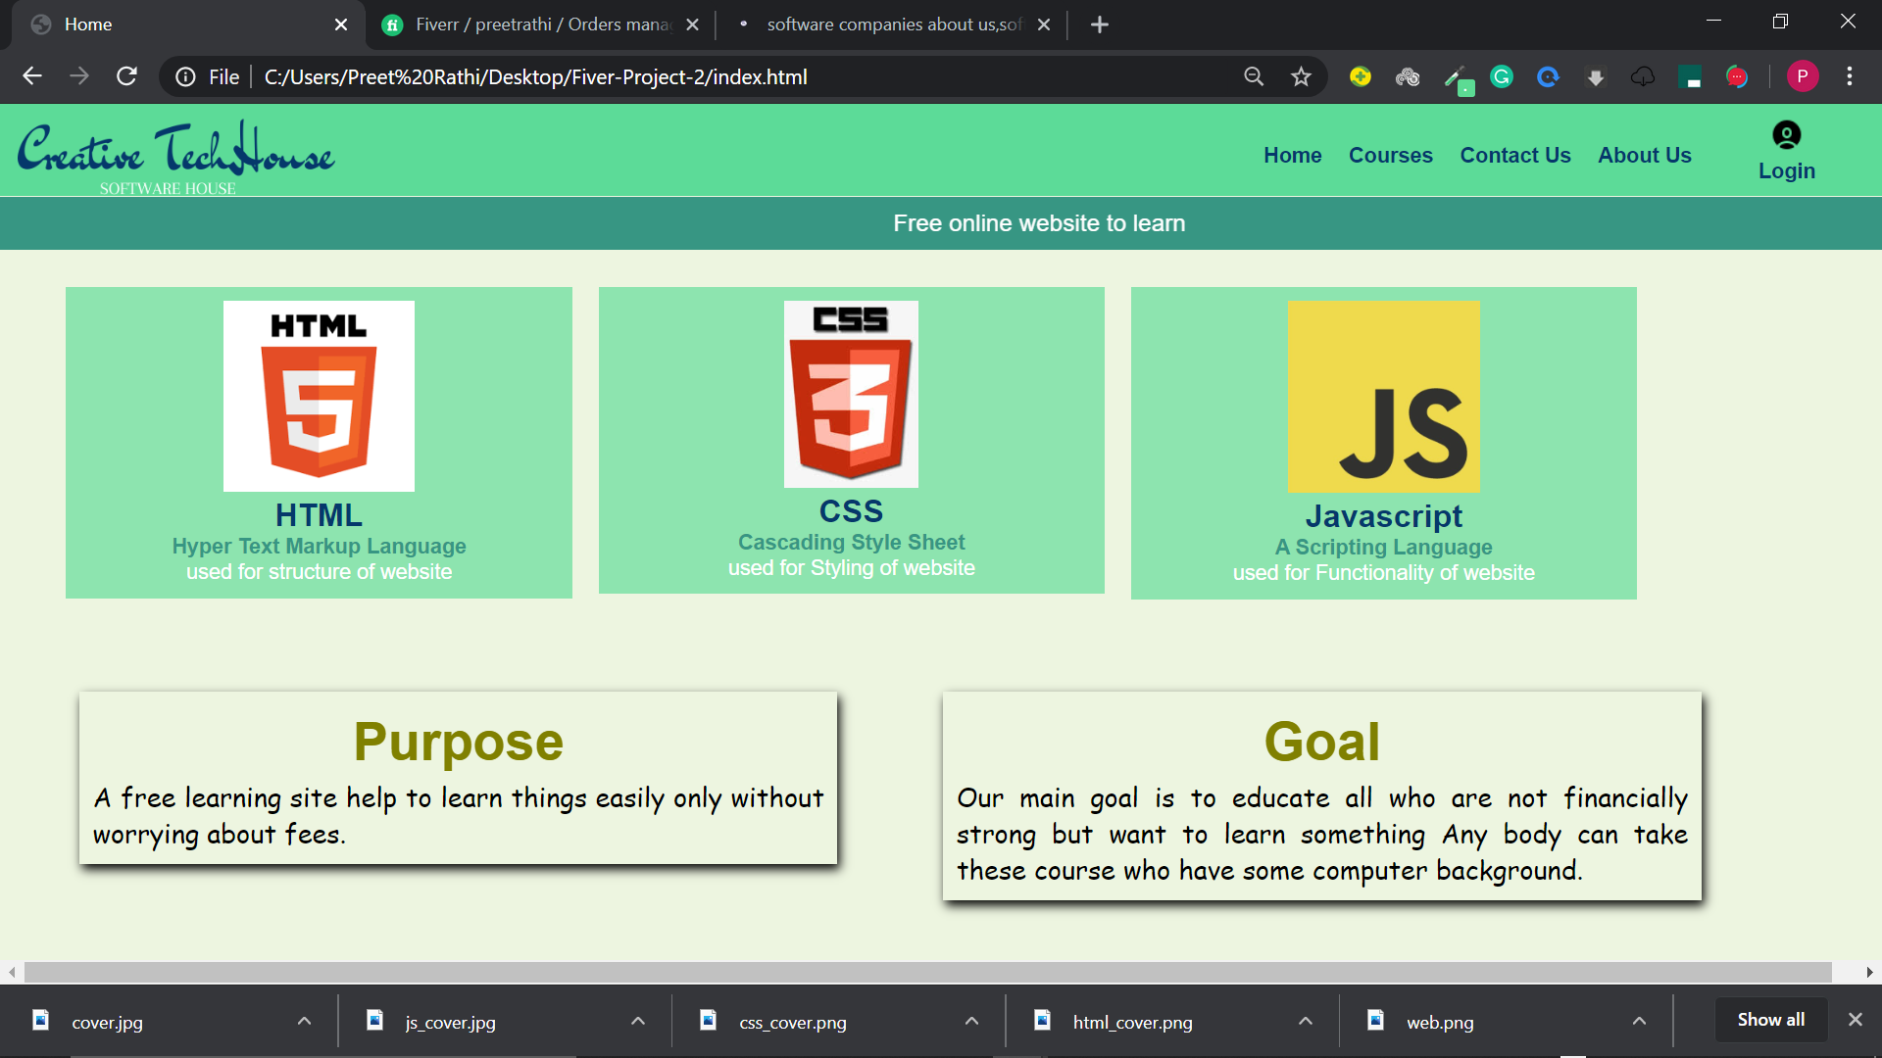

* **Useful links (Navbar text Home, Courses, Contact us, About Us, login)**



* **Purpose of website**

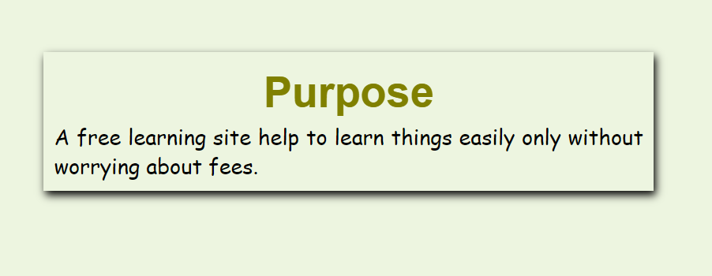

* **Goal of website**

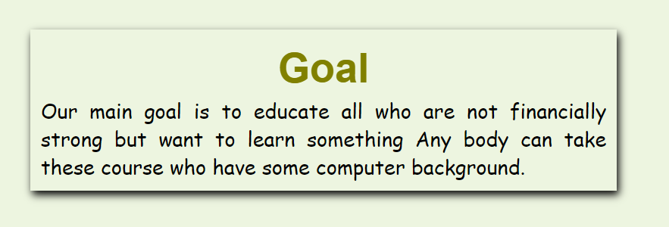

* **Other Pages**

**Course section of website:**

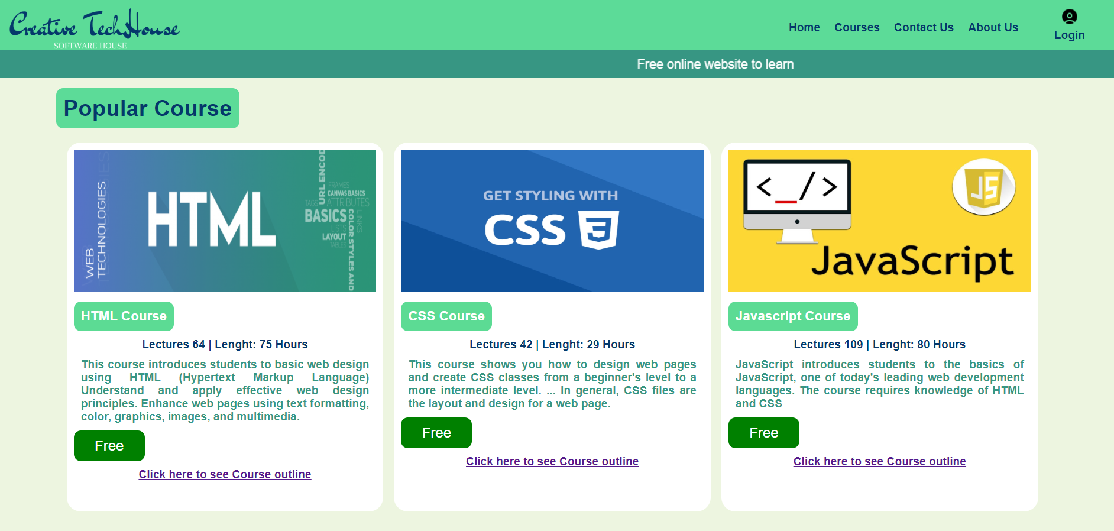

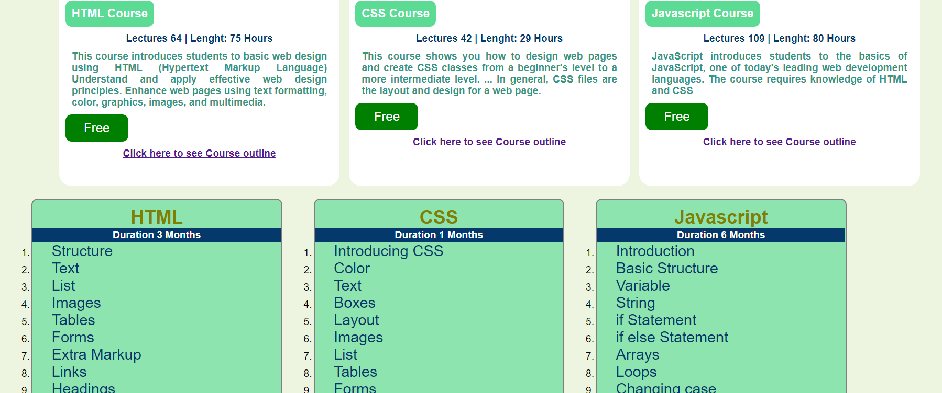

**Contact Us page of Website**

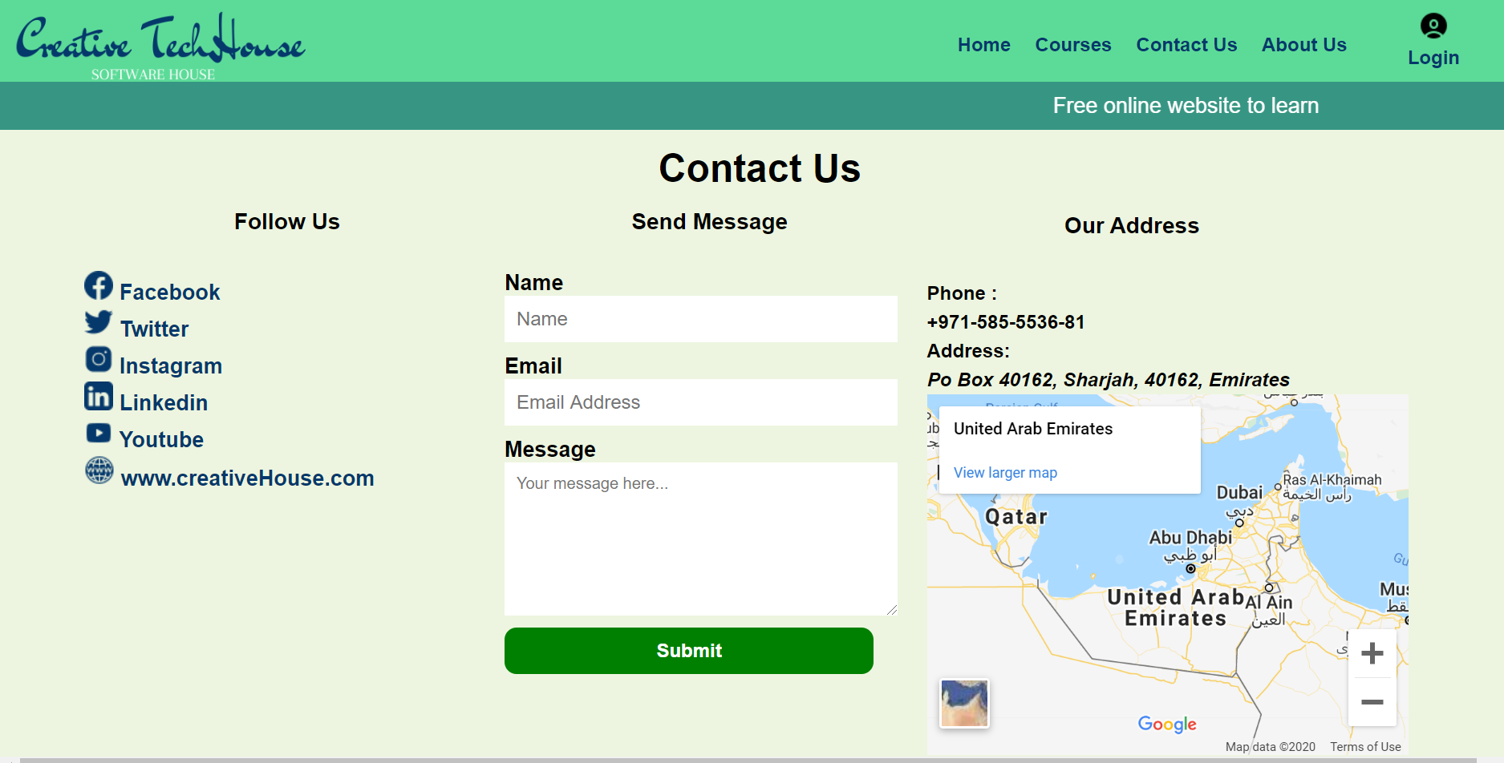

**About Us Page of Website**

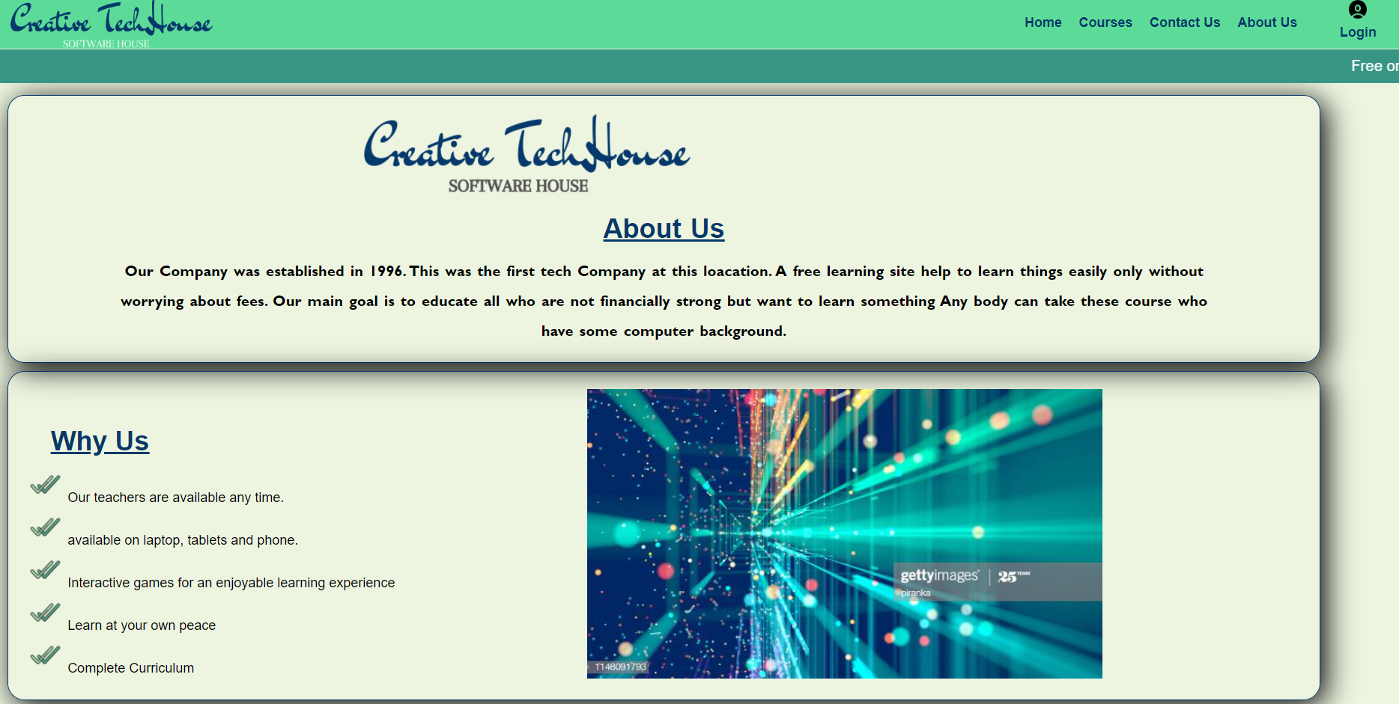

**Login Page**

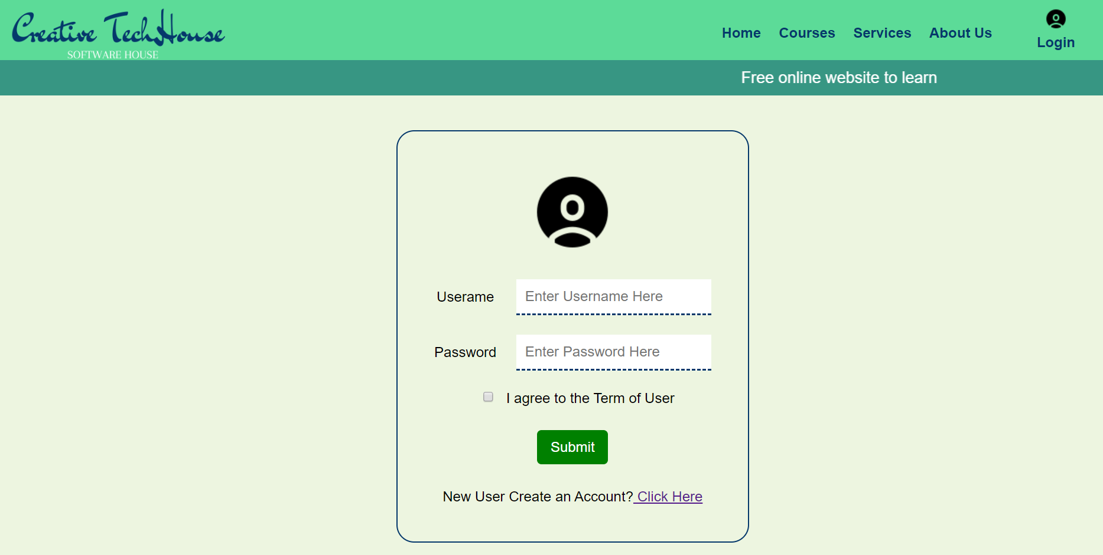

**Sign Up page**

