Crime Analysis Dashboard
An interactive Power BI dashboard analysing crime patterns across countries, time of day, months, years and crime types, with a focus on resolution performance.
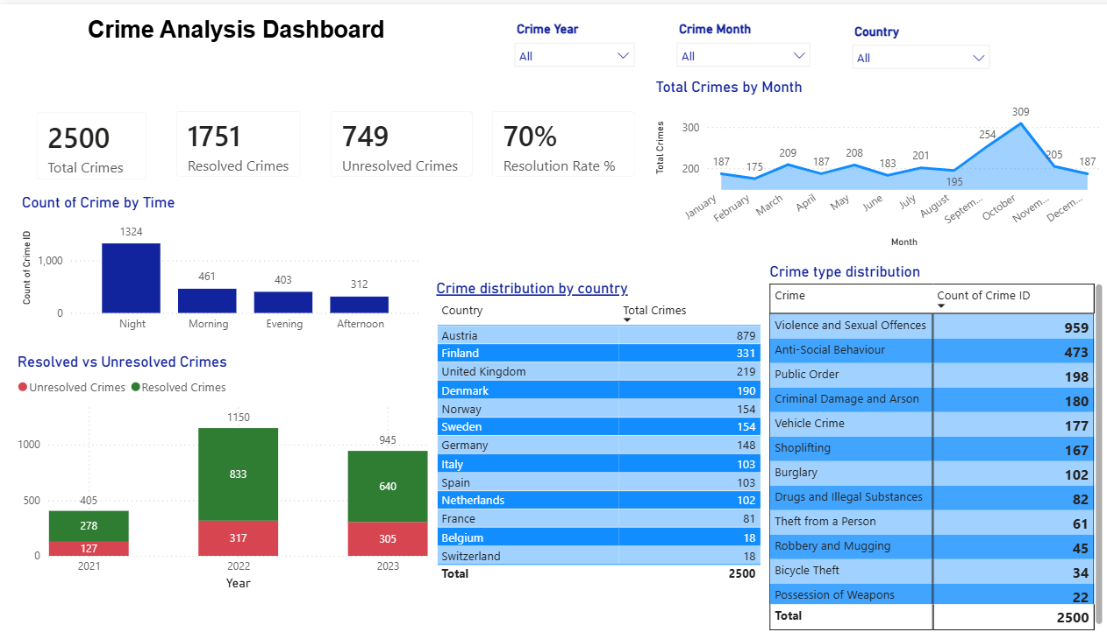

Objective
To understand where, when and what kind of crimes occur, and how effectively they are resolved, in order to support data-driven decisions on resource allocation and prevention.
Dataset
- Records: 2,500 crimes
- Countries: 13 (Austria, Finland, United Kingdom, Denmark, Norway, Sweden, Germany, Italy, Spain, Netherlands, France, Belgium, Switzerland)
- Period: 2021 to 2023
Tools Used
- Power BI Desktop
- Power Query (data cleaning and transformation)
- DAX (measures)
Dashboard Features
- KPI cards: Total, Resolved and Unresolved crimes, and Resolution Rate %
- Slicers: Crime Year, Crime Month, Country
- Visuals:
  - Total crimes by month (trend)
  - Count of crime by time of day
  - Resolved vs unresolved crimes by year
  - Crime distribution by country
  - Crime type distribution
Key Insights
- Overall resolution rate is 70%: 1,751 of 2,500 crimes were resolved and 749 remain unresolved.
- Night is the riskiest period: 1,324 crimes (about 53%) occurred at night, far ahead of morning (461), evening (403) and afternoon (312).
- Violence and Sexual Offences dominate: 959 cases (about 38%), followed by Anti-Social Behaviour (473, about 19%).
- October is the peak month: 309 crimes, against a monthly range of roughly 175 to 209 for most other months.
- Resolution rate varies by year: about 69% in 2021, 72% in 2022 and 68% in 2023.
- Austria has the highest count: 879 crimes (about 35% of records), followed by Finland (331) and the United Kingdom (219). This may reflect how the data was collected rather than true crime levels.
Recommendations
- Increase patrols and surveillance during night hours, particularly in high-volume countries.
- Prioritise prevention and response strategies for violent and sexual offences.
- Investigate the October spike (seasonal events, reporting patterns) before planning resources.
- Review why unresolved cases remain high in certain years and crime types.
How to Use
- Download the .pbix file from the dashboard/ folder.
- Open it in Power BI Desktop (free).
- Use the slicers (Year, Month, Country) to explore the data.
Sample DAX Measures
Update these to match the table and column names in your model.
DAX
Total Crimes = COUNT(Crime[Crime ID])

Resolved Crimes = CALCULATE([Total Crimes], Crime[Status] = "Resolved")
Unresolved Crimes = [Total Crimes] - [Resolved Crimes]
Resolution Rate % = DIVIDE([Resolved Crimes], [Total Crimes])
Limitations
- Counts are absolute and not normalised per capita, so country comparisons should be read with caution.
- 2021 appears to contain fewer records than 2022 and 2023, which may indicate partial data.
- The dataset size is small (2,500 records), so findings are indicative rather than conclusive.

