WEEK1:
WEEK2:
Postfix.c:
#include <stdio.h>
#include <ctype.h>
char stack[50];
int top = -1;
void push(char x){
stack[++top] = x;
}
char pop(){
if (top==-1)
return -1;
else
return stack[top--];
}
int priority(char x){
if (x== '*' || x =='/') {
return 2;}
if (x== '+' || x== '-') {
return 1;}
return 0;}
int main(){
char infix[50], postfix[50];
int i, j = 0;
char x;
printf("Enter the expression: ");
scanf("%s", infix);
for (i = 0; infix[i] != '\0'; i++){
x = infix[i];
if (isalnum(x)){
postfix[j++] = x;
}
else if (x == '('){
push(x);}
else if (x == ')') {
while (top != -1 && stack[top] != '('){
postfix[j++] = pop();}
pop();}
else {
while (top != -1 && priority(stack[top]) >= priority(x)) {
postfix[j++] = pop();}
push(x);}}
while (top != -1) {
postfix[j++] = pop();}
postfix[j] = '\0';
printf("Postfix expression: %s\n", postfix);
return 0;}

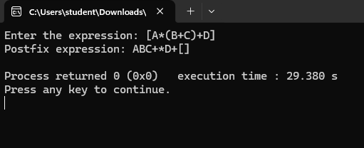

Valid.c:
#include <stdio.h>
#include <string.h>
char stack[1000];
int top = -1;
void push(char item) {
stack[++top] = item;}
char pop() {
if (top == -1) {
return '\0';
}
return stack[top--];}
int main() {
char exp[10005];
int i;
int valid = 1;
if (scanf("%999s", exp) != 1) {
valid = 0;}
for (i = 0; exp[i] != '\0'; i++) {
char ch = exp[i];
if (ch == '(' || ch == '{' || ch == '[') {
push(ch);}
else if (ch == ')' || ch == '}' || ch == ']') {
if (top == -1) {
valid = 0;
break;}
char top_element = pop();
if ((ch == ')' && top_element != '(') ||
(ch == '}' && top_element != '{') ||
(ch == ']' && top_element != '[')) {
valid = 0;
break;
}
}
}
if (top != -1) {
valid = 0;}
if (valid) {
printf("valid\n");}
else {
printf("invalid\n");}

return 0;
}


