# **Smart Lighting System**

ECE/EEE/INSTR F241 – Microprocessor Programming & Interfacing

BITS- Pilani Goa Campus



**By batch no 94:**

Praveen Sridhar: 2018A7PS0166G

Palak Goel : 2018AAPS0286G

Prasad Jadhav : 2018AAPS0564G

Preeyam Sahu : 2018A7PS0191G

Keshav Goyal : 2018A3PS0317G

**P13.Smart Lighting System Description:**

This is a lighting system for a conference room. As the seats get filled the light should be turned on. The rows are filled from row1 onwards. There are 4 lights per row. As each row begins to get filled the lights get turned on. As each rows empties completely the light gets turned off. You can assume there are at least 5 rows. Entry to the auditorium is restricted to a certain point of time. Exit can be at any point of time.

**System Details:**

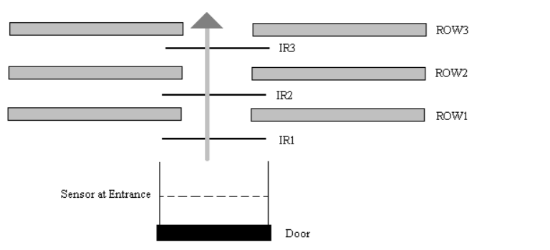

**Specifications:**

1. There are 2 IR proximity sensors present at the gate (Master sensor) and at every row.

2. When a person passes through the sensors, the sensor gives a logic 1.

3. If sensor 1 is triggered first, it is treated as entry. If sensor 2 is triggered first, it is treated as exit

**Assumptions Made:**

1. There is only one gate, through which both Entry and Exit occur.

2. When the people enter the room, they will occupy the rows in the order row1,row2,row3 and so on.

3. The maximum number of people who can sit in a row is 10.

4. We have a total of 6 rows

5. When people will be leaving the room, any person from any row may stand and go out of the room

6. Only one person can exit or enter, at a particular time.

7. When a person would be coming inside the room, he would simply come and sit and while leaving he would just stand up and go out, i.e., any person will not be making any transitions between rows inside the room.

**Components Used and quantity:**

1. Microprocessor 8086 -1

2. Decoder 74HC138 -1

3. Programmable Peripheral Interface 8255A -1

4. Sensor - PIR Motion Detection Sensor Module [RKI-1370]

6. Octal Latch 74LS373 - 3

7. Bidirectional Buffer 74LS245 -2

8. Unidirectional Buffer 74LS244 - 1

9. Clock generator 8284A -1

10. ROM 2716 -4

11. RAM 6116 -2

12. AND 7408 - 2 ICs

13. OR 7432 - 1 IC

14. NOT 7404 -1 IC

15. LED common cathode configuration - 4 per row; 24 total

17. 5V Battery (For Vcc)

**Memory Organization:**

The system uses 4KB of RAM and 8KB of ROM. RAM consists of two 2K chips and ROM

consists of 4K chips. They are organized into odd and even bank to facilitate both byte and word size data transfers.

Read Only Memory (2732): Starting Address: 00000h, Ending Address: 01FFFh

Random Access Memory (6116): Starting Address: 02000h, Ending Address: 02FFFh

**I/O Interfacing: (Using I/O mapped I/O)**

**Mapping of 8255:**

Port A: 00h (Input from sensors)

Port B: 02h (Input from sensors)

Port C: 04h (Output to LED)

Control Register: 06h

**Hardware Circuit:**

**1. Memory Interfacing:**

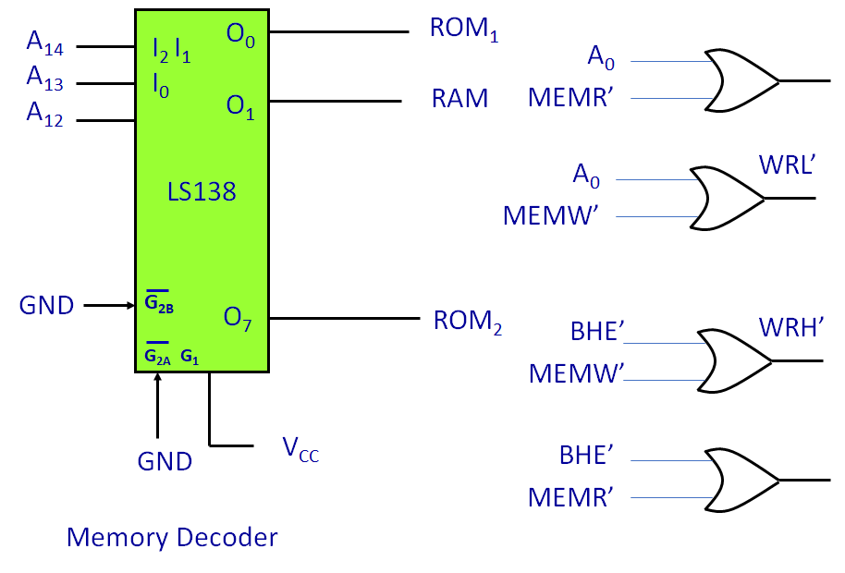

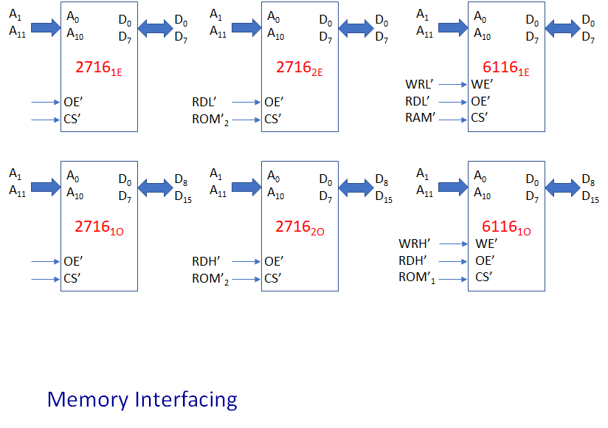

**2. 8086 System Bus(Address):**

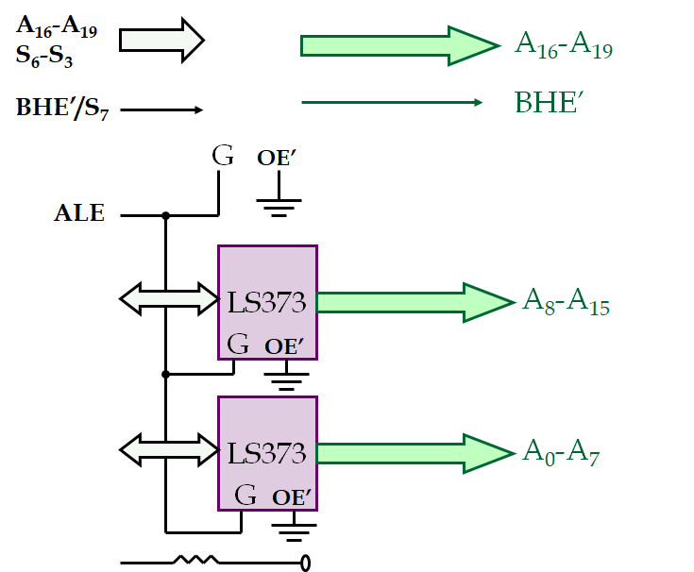

**3. 8086 inputs (8284 clock generator):**

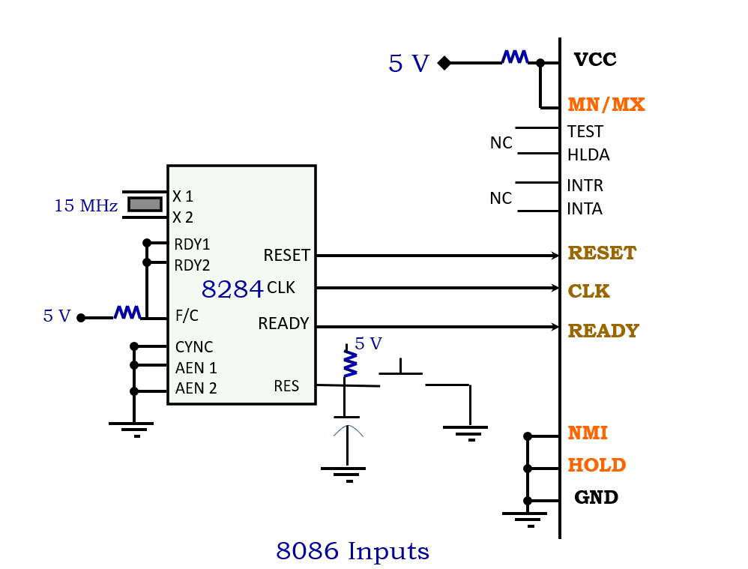

**4. 8086 System Bus(Data & Control):**

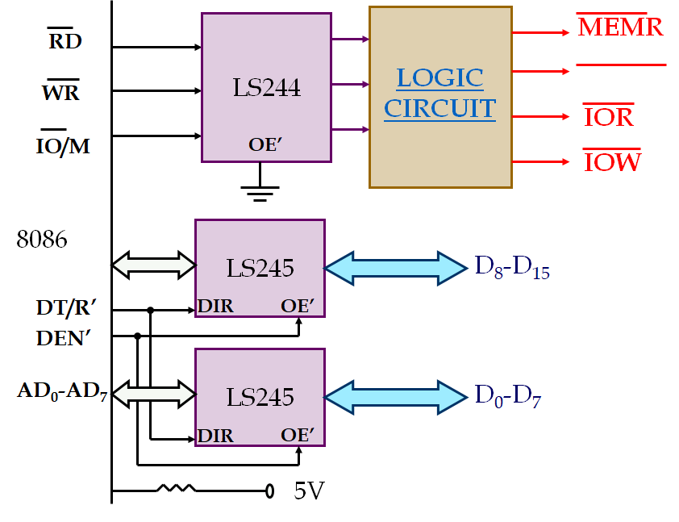

**5. Logic Circuit:**

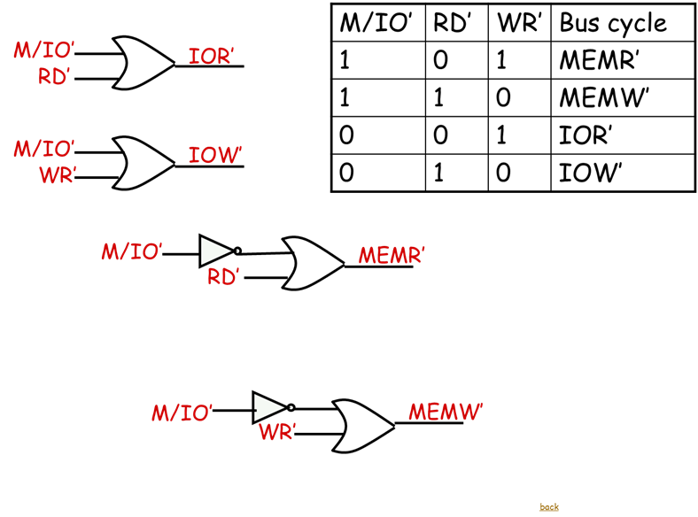

**6. LS138(Chip Select Decoding Logic):**

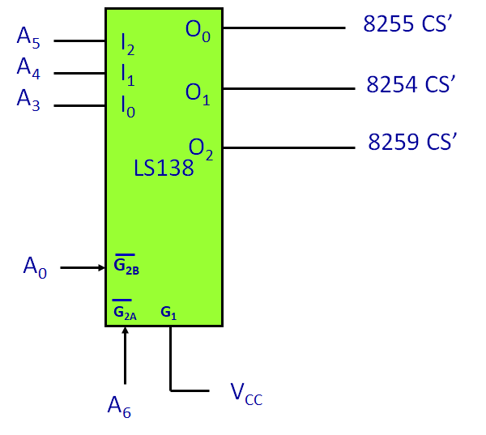

**7.8255:**

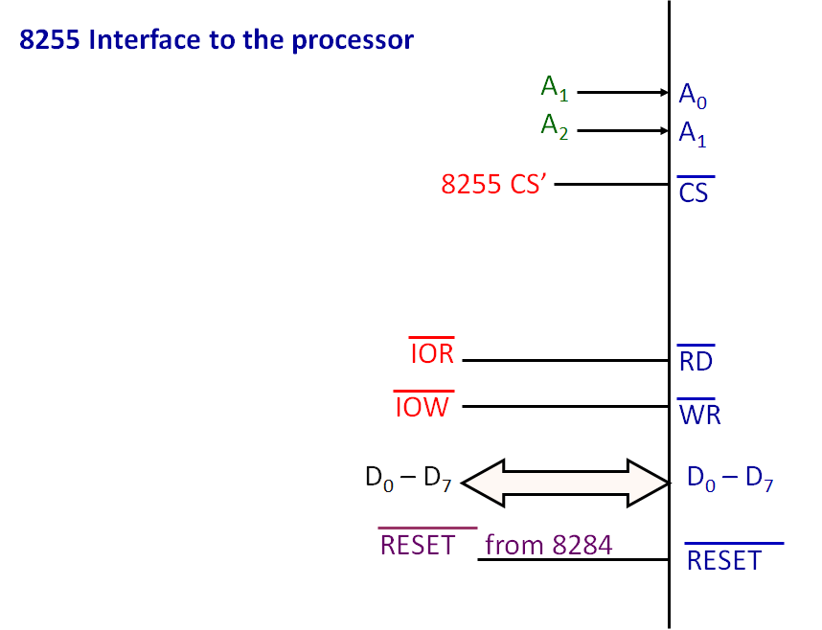

**8.Circuit Diagram:**

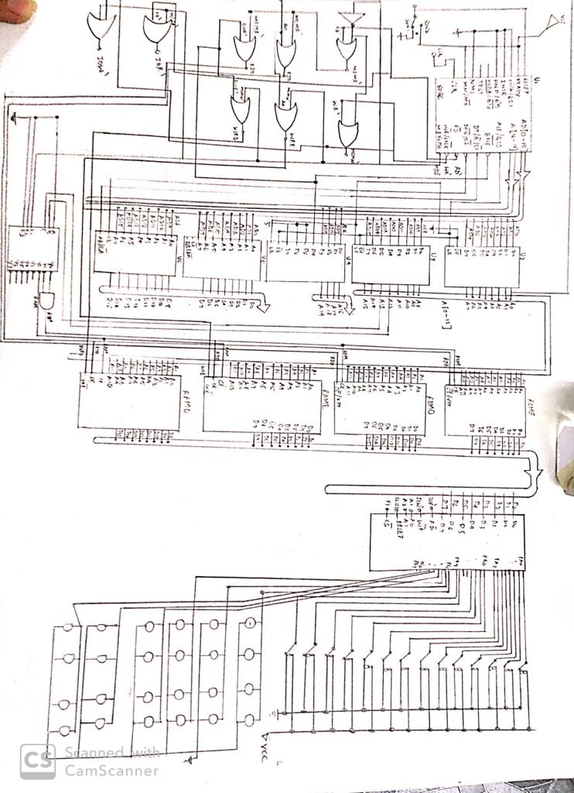

**9.RK-1370 sensor diagram:**

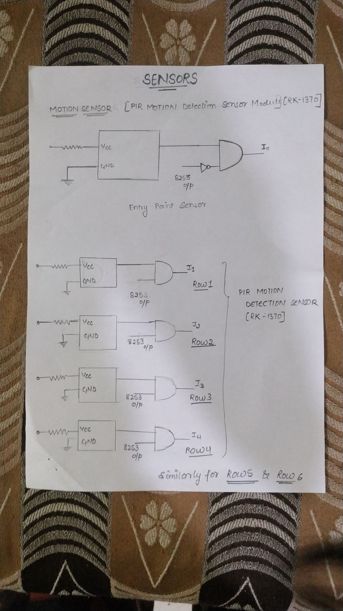

**Flowchart:**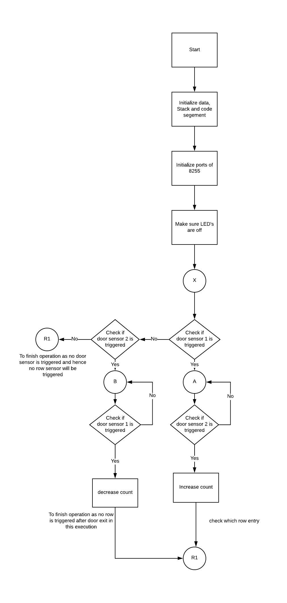

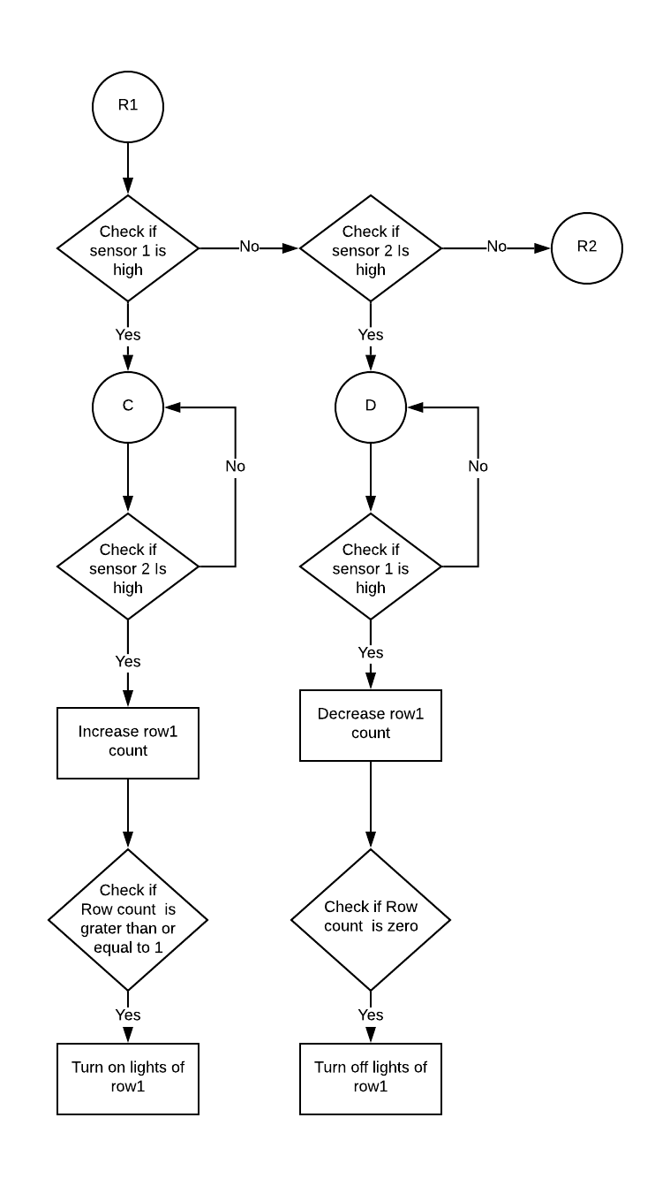

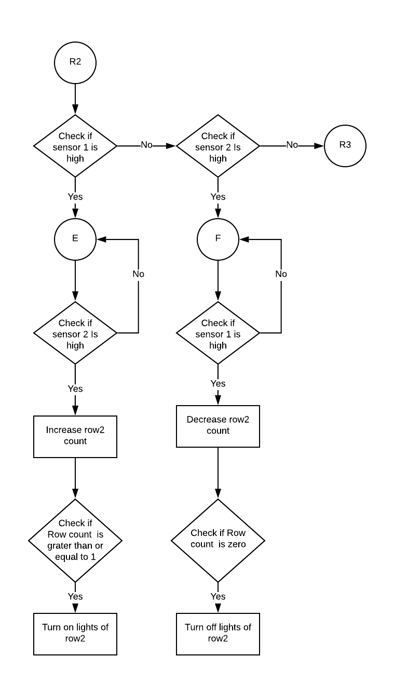

Similar flowchart to check for Row3, Row4, Row5 and Row6. After this we restart execution and check from the beginning once the door sensor is triggered again.

**Variations in Proteus implementation with justification:**

1. IR sensors are modelled as switches due to absence of an IR sensor library in Proteus.
2. Simulating a person walking through is done by turning the switches on and off immediately
3. Delay called after sensor1 at the door and every row (for entry) to give time for the person to trigger both sensors

**Attachments:**

**Manuals:**

[**https://robokits.download/downloads/PIR%20Sensor%20Module.pdf**](https://robokits.download/downloads/PIR%20Sensor%20Module.pdf)

Attached as PIR Sensor Module.pdf

This Passive Infrared Sensor (PIR) module is used for motion detection. It can be used as motion detector on your robot. It can work from 5V to 9V DC and gives digital output. It requires 10-60 seconds of settling time before starting its operation. It consists of a pyroelectric sensor that detects motion by measuring change in the infrared levels emitted by the objects. It can detect motion up to 6 meters. The sensor RKI-1370 was chosen because it has a good range, small in size and cheap. It would be suitable to use this for a medium sized room (6m range).

**Design:**

Attached in the zip as G94.pdsprj (Proteus 8.6)

**Code:**

Attached in the zip file as code.asm

**Binary file after assembly:**

Attached as p3.bin