Conditional Statements
If-else
code:
class Account{
public static void main(String[] args){
double balance = 600;
System.out.println("Amount to withdraw");
double amount = 500;

if (amount <= 0 || amount > balance){
System.out.println("Withdrawal has failed");
}else{
balance-=amount;
System.out.println("Withdrawal has succeeded");
}
}
}

Output:
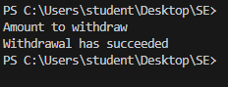

If else-if else
Code:
class Account{
public static void main(String[] args){
double balance = 600;
System.out.println("Amount to withdraw");
double amount = 500;
if(amount<=0){
System.out.println("Withdrawal has failed as the amount is negative");
}
else if(amount>balance){
System.out.println("Withdrawal has failed as the balance is low");
}
else{
balance-=amount;
System.out.println("Withdrawal has succeeded");
}
}
}

Output:
Switch-Case
Code:
class Account {
public static void main(String[] args) {
int choice = 0;
choice = 2; r
switch(choice) {
case 1:
System.out.println("Entry deposition");
break;
case 2:
System.out.println("Display operation");
break;
case 3:
System.out.println("Deposit operation");
break;
default:
System.out.println("Invalid choice");
}
}
}
Output:
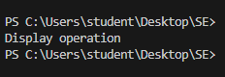

Do-While Loop
Code:
import java.util.Scanner;
class Account {
public static void main(String[] args) {
double balance = 0;
double minbal = 500;
double depositAmt = 0;
do {
System.out.println("$100 have been added to the account");
depositAmt +=100;
} while(depositAmt < minbal);
balance = depositAmt;
System.out.println("Transaction Complete");
}
}

Output:
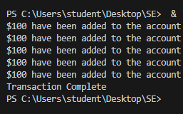

While Loop
Code:
import java.util.Scanner;
class Account {
public static void main(String[] args) {
double balance = 0;
double minbal = 500;
double depositAmt = 0;
while (depositAmt < minbal) {
System.out.println("$100 have been added to account");
depositAmt += 100;
}
balance = depositAmt;
System.out.println("Transaction Complete");
}
}

Output:
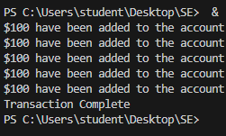
For Loop
Code:
class Account {
public static void main(String[] args) {
double balance = 6000, rateOfInterest = 0.10, interest = 0;
double withdrawal = 500, deposit = 600;
for(int i = 1; i <= 12; ++i) {
balance += deposit;
balance -= deposit;
interest = balance * rateOfInterest;
balance += interest;
System.out.println("The interest for the month " + i + " is " + interest);
}
System.out.println("The balance at the end of the year is " + balance);
}
}
Output:
