The Bee Example
Being an examination of sprite based animation and sound with Microsoft’s Beta Game SDK.

By John M. Hall

The ‘Bee’ example uses a large portion of the new API’s in Microsoft’s Game SDK to perform the following:
- A phased sprite is moved around the users desktop in an animation loop.
- Color Key blue screen techniques are used to place the sprite on top of the background GDI screen.
- Page Flipping and Off screen video memory are used to drive the animation at high frame rates without tearing.
- While the sprite is moving, a large uncompressed wave file is being played. The original test case (not distributed due to copyright problems) is a 3.2Mb file with 18 seconds of 44Khz 16 bit stereo sound.

Currently, the Bee example requires that your video system be in a 8bpp palettized mode.

Conceptual overview of the Animation

This example uses page flipping. While the primary buffer is visible to the user, the program is free to render the next frame in the back buffer. After the next frame is done,
the primary buffer is flipped and the video memory for these buffers is logically rotated.

The frame rate is limited by the update frequency of the monitor, the speed with which new frames can be rendered, and any other tasks the program may need to perform. With one back buffer, we would expect the main animation loop to be something like:

While( not done)
{
Draw next frame on back buffer.
Flip().
While( not done flipping)
{
Perform non-Frame operations.
}
}

The Bee example actually uses 3 drawing surfaces or buffers. When first created, these surfaces look like:

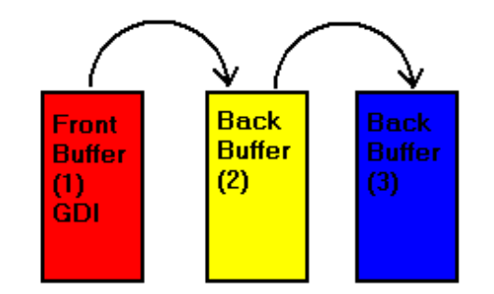

The only buffer GDI is aware of is the front buffer. After creation, the Primary Buffer or Front Buffer (yes, we are using Buffer and Surface interchangeably) points to the same memory as GDI does. This is an important point: GDI doesn’t know what DirectDraw is doing. I’ll have some comments on other ways to deal with GDI later on. For now, however, the goal is to duplicate the current users screen. This example depends on switching GDI to the back of the attachment list and leaving it there. We do this by copying the contents of the GDI screen and flipping. After the flip, things are arranged like so:
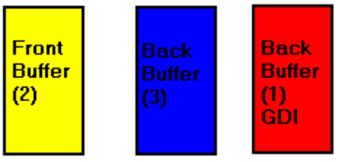
GDI is now hidden from the user, and any changes that GDI decides to make will not be reflected until our application decides to make them viewable. The user isn’t aware of this, however, because we copied the bits to what is now the front buffer before we flipped.
A normal ‘flip’ will rotate the front buffer to the end of the attachment list. However, we can specify which buffer we wish to rotate to the front. In our animation loop we will always draw on the middle back buffer and flip to that buffer. Our second flip will look like:
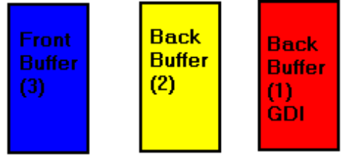
In our animation loop, we will cycle between this arrangement and the previous one, keeping GDI safely off the viewable screen.

The Animation Loop

The pseudo code for the final animation loop looks like this:

While( not done)
{
Copy the GDI surface to the back buffer.
Determine the location and type of bee I want to display.
Place the Bee on the Back Buffer.
Flip primary buffer to the Back Buffer.
Do the sound loop until the Flip has completed.
}

Phased Sprites and the Animation Path

If you are not already familiar with phased sprites I recommend the book Animation Techniques in Win32 by Nigel Thompson. The phased sprite we are using comes from the graphic art included in the book, and many of the supporting classes used in this example were converted from code included in this work.

The bitmap ‘Bee.bmp’ contains 19 images of a 3-D modeled bee, in 4 rows and 5 columns. The 20th image is blank. All of the individual bee’s are done on a blue screen or transparent color.

The Animation path is specified in an array (aBeeCell). Each element contains the (x,y) position that the sprite is supposed to occupy and the (row,col) of the phased image that should be used.

However, the (x,y) positions in the aBeeCell array are fairly course, jumping by as much as 100 pixels per frame. Instead of adding a lot more elements to the array to smooth out and slow down the motion of our sprite, GetNextCell() was introduced. GetNextCell() will move along the path specified by two adjoining array elements at a speed dictated by dwSpeed (set to 6 for this example) and report the current phase back to the main animation loop.

GetNextCell() generates its path by using a modified General Bresenham’s Algorithm as a Digital Differential Analyzer (DDA). One reference to this algorithm can be found in David F. Rogers Procedural Elements For Computer Graphics. The key reason for using a DDA in drawing lines or paths is that it solves a real-number problem with integer arithmetic.

Initialization of the Animation.

In order to use DirectDraw or DirectSound you have to get a pointer to the COM objects IDirectDraw and IDirectSound. These are not actually COM objects; you can’t call CoCreateInstance and get a pointer to them, for example. Instead, the API’s DirectDrawCreate() and DirectSoundCreate() are used to obtain these pointers. Once obtained, you can expect them to behave like COM interfaces. Just remember that the video card and sound card are shared resources, and it is possible that your reference count on the base objects will start at a number other than 1.

Ddraw.dll and Dsound.dll are dynamically loaded. A static link would have worked.

Error conditions are designed to report themselves and, depending upon the severity, abort the function cleanly. The LogIt() function could easily be modified to use other means of recording problems in debugging.

After creating the IDirectDraw object, our flipping buffers are created with CreateSurface(). After creating the primary surface (pIDSPrimary) we obtain the middle back buffer from GetAttachedSurface(). The GDI surface pointer is obtained after we
have initialized our phased sprite.

CDIB::NewDib() takes a pointer to our phased image on disk (in Dib Format) and places it in an offscreen surface. An Offscreen surface is a buffer in video memory that will not
be displayed directly, but can be blt’d where we need it to be. The CDIB class located in dddib.cpp has been modified from the example code in Nigel’s Win32 Animation Techniques. This code takes into consideration different DIB layouts (Win 3.x, PM, and Win32). Some files don’t place their most important colors at the beginning of their color table, and NewDib therefore has a ‘resort’ option. If you are interested in playing around with bits in a surface directly, you should look at how NewDib() locks down the surface and takes into consideration the stride of the surface when writing bits.

NewDib() was created as a static function. Using a static function in a class is a good way to solve the problem of creating a new class on the free store when that creation can fail. A static function can be called outside the class hierarchy, access private member variables, and return a pointer to the new class on success or NULL on failure.

Once the bits have been read of the disk and stored in video memory, the next problem is making sure that the bits look the way you want them too. DirectDraw never uses a logical palette. All data in a DirectDraw surface refers to palette indexes (on a palettized device) or the actual color. DirectDraw uses GDI PaletteEntries rather than RGBQUAD’s to specify color information.

The class CPE handles PaletteEntries. When I create it with SYSPAL_STATIC the class automatically retrieves GDI’s reserved colors (top 10 and bottom 10 colors). Unless you are taking control of the entire screen, you should plan on leaving these colors alone. Otherwise, everything outside your app will look really bad.

CDIB::ResetColors() takes our CPE and builds the palette entries for an identity palette. Once that is done, the actual bits in the image are re-organized to reflect the new color table. CreatePalette() and SetPalette() complete the work necessary to use an appropriate palette.

SetNumRowsAndColumns() and SetColorKey() finish the initialization of our phased sprite. The first function allows us to compute the location of our individual images. SetColorKey() sets the transparent color. In this case, we default to the rule that our image always has a transparent color in the upper left hand corner.

Final preparation for the animation loop requires that we copy the bits from the GDI surface to the back buffer, flip the GDI surface to the back, and get a pointer to the GDI surface for future use.

Now about playing sounds.

DirectSound currently only supports the uncompressed PCM format. The CWAV class in wav.cpp encapsulates the functionality to load a PCM .wav file and load it for playing into a DirectSoundBuffer.

CWAV::NewWav() comes in two versions that animate uses. First, the wave file specified is loaded into a secondary sound buffer. Then, a primary sound buffer is created from the format information obtained from the wave file. Wav.cpp in the misc subdirectory contains code necessary to read a wave file and create a compatible sound buffer. At this time it can’t be trusted to handle non-PCM format data correctly.

CWAV::Copy() uses the WavBlt DirectSoundBuffer command to copy sound data from the secondary sound buffer to the primary one and to reload the secondary buffer from disk. WavBlt isn’t necessarily the easiest API to use for this, but by demonstrating its use the reader should have a head start on mixing and combining multiple sounds.

CWAV::bFinished() determines if all the sound in the buffer has been played.
CWAV::GetInvalidSize() determines how much of the primary sound buffer has been played and therefore needs to be replaced.

Cleanup.

Cleanup involves waiting for any pending flips to complete, flipping the system to the GDI surface, and then releasing objects acquired.

The surrounding shell.

This application was developed using VC++2.0 and the MFC libraries. It is a dialog based application. The only interesting thing is starting and stopping the animation. In beedlg.cpp, to start the animation we start a thread which starts another thread to do the actual animation and then waits on that thread for completion. Also note the use of InterlockedExchange(). InterlockedExchange() is an automic Test and Set.

Other Comments on dealing with GDI.

It is expected that most users of the Game SDK will want to take over the entire screen, and even to switch the mode of the video hardware. The recommended way of doing this is to create a Window that covers the entire screen, paint it black, then obtain exclusive mode and place the video system in your desired mode (typically, 640 x 480 x 8).

In this manner, GDI will never try and draw because nothing it controls will have an invalid rectangle. You will then be able to manipulate the same memory that GDI is using.

Be careful with the API GetGDISurface(). This will give you the current GDI surface. However, if you subsequently use Flip() in a manner that causes GDI’s memory to rotate then the DirectSurface pointer you obtained from GetGDISurface() will no longer be pointing at the GDI memory.

