CUSTOMER ENGAGEMENT & PRODUCT UTILIZATION ANALYTICS
Executive Summary
Management Brief: Retention Strategy Recommendations

Prepared by: Harendra
MBA (Business Analytics)
Focus: Business Analytics | Finance & Operations
2026

Executive Summary
This executive brief summarizes the final customer-retention analysis conducted on 10,000 banking customer records. The analysis focuses on engagement, product utilization, financial value and relationship strength to identify customers who require proactive retention, reactivation or cross-sell action.

At-a-Glance KPIs
KPI | Result | Interpretation
Total customers | 10,000 | Customer base analyzed
Overall churn | 20.37% | Baseline retention risk
Active customer churn | 14.27% | Lower observed churn
Inactive customer churn | 26.85% | 12.58 pp above active customers
High-value disengaged customers | 1,247 | Priority premium-retention population
High-value disengaged churn | 30.47% | Elevated observed churn
Two-product churn | 7.58% | Lowest major product-count churn rate

What the Analysis Says
- Engagement is an early-warning signal. Inactive customers show 26.85% observed churn compared with 14.27% among active customers.
- Product depth is useful but non-linear. One-product customers show 27.71% churn, two-product customers 7.58%, while 3–4 product customers show unusually high rates that require investigation.
- High financial value does not guarantee loyalty. The 1,247 high-value disengaged customers show 30.47% observed churn.
- The Relationship Strength Index is directionally aligned with retention, creating a practical framework for customer-level prioritization.

Recommended Actions
Priority | Action | Why it matters
1 | Premium retention watchlist | Protect high-value customers whose engagement has weakened.
2 | Engagement reactivation | Target inactive customers before churn becomes irreversible.
3 | Need-based cross-sell | Deepen relationships for active single-product customers without indiscriminate selling.
4 | Investigate 3–4 product anomaly | Determine whether extreme churn reflects product complexity, customer experience or small-sample instability.
5 | Risk-based resource allocation | Prioritize retention resources using observed risk rather than one-size-fits-all campaigns.

Decision Framework
Strong Relationship → Maintain and reward. Growth Opportunity → Need-based cross-sell. Disengaged → Reactivate. At-Risk Premium → Priority intervention. Complex / Investigate → Root-cause analysis before intervention.

Dashboard
Live Streamlit application: https://customerengagementretentionanalytics.streamlit.app
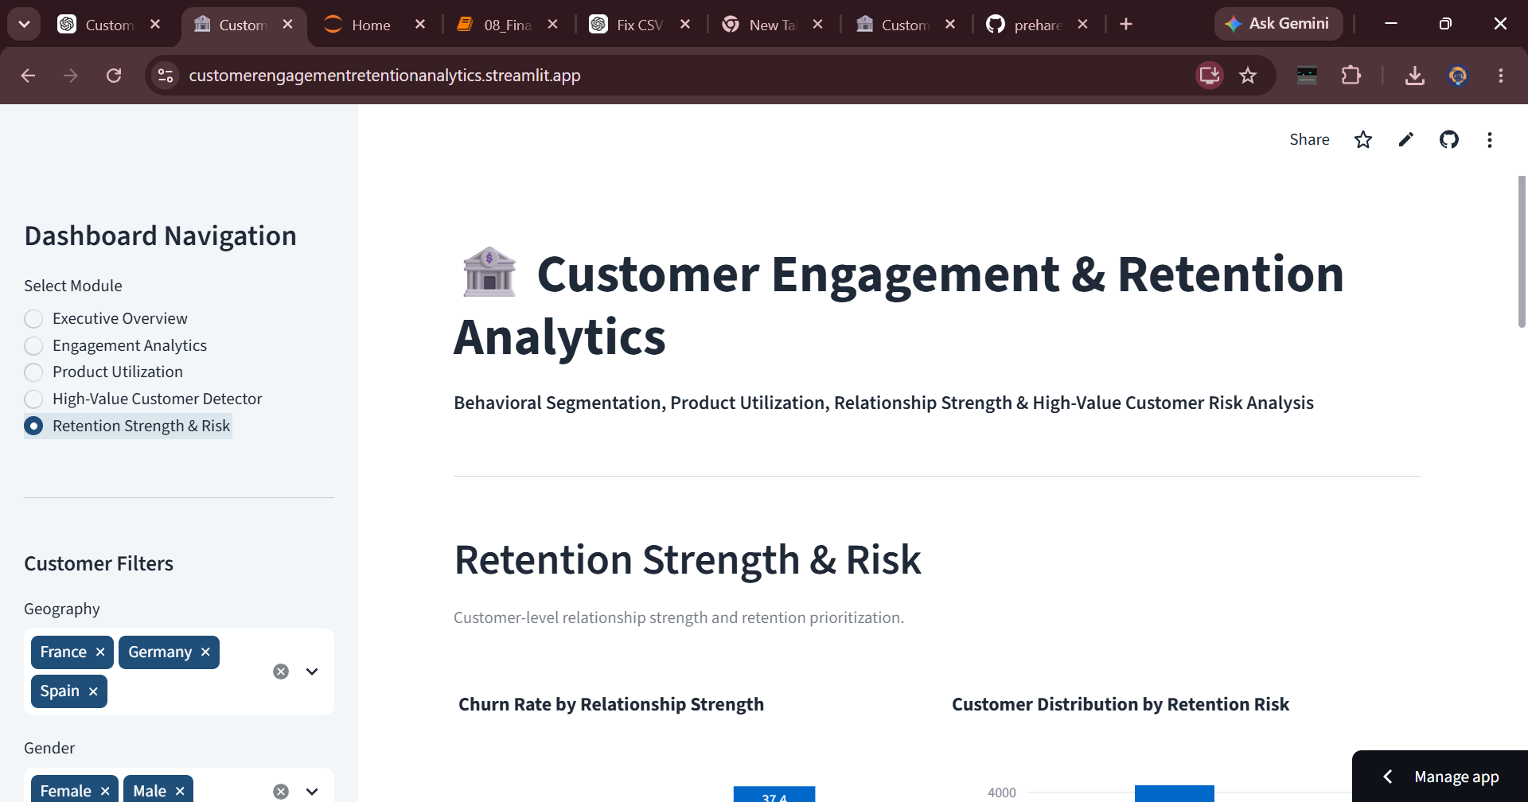
Live dashboard preview.

Management Caveat
These findings are observational and should be interpreted as associations. The 3–4 product segments are relatively small and show unusually high observed churn; operational decisions should validate the underlying product combinations, customer experience and data quality before applying broad policy changes.

