CUSTOMER ENGAGEMENT & PRODUCT UTILIZATION ANALYTICS
Research Paper
Behavioral Segmentation, Relationship Strength & Retention Strategy

Prepared by: Harendra
MBA (Business Analytics)
Focus: Business Analytics | Finance & Operations
2026

Abstract
This study examines customer retention through engagement, product utilization and relationship strength rather than relying primarily on demographic or financial characteristics. The analysis uses 10,000 banking customer records and combines data validation, feature engineering, exploratory analysis, behavioral segmentation, financial-value analysis, a rule-based Relationship Strength Index (RSI), retention-risk scoring, and statistical validation. The observed overall churn rate is 20.37%. Inactive customers have a 26.85% churn rate versus 14.27% among active customers, a gap of 12.58 percentage points. Single-product customers show 27.71% churn, while two-product customers show 7.58%. At the same time, 3- and 4-product customers show unusually high observed churn, demonstrating that product depth is not linearly related to retention and requires diagnostic investigation. A high-value disengaged segment of 1,247 customers has an observed churn rate of 30.47%. These findings support an engagement-driven retention framework that combines early-warning monitoring, targeted cross-sell, premium-customer outreach, and risk-based resource allocation.

1. Introduction
Customer churn is not solely a financial problem. A customer can maintain a high balance and salary while interacting less with the bank, using a narrow set of products, or weakening the relationship. This creates a silent-risk population: financially meaningful customers whose behavioral engagement has deteriorated. The project therefore reframes retention as a relationship-management problem, asking how engagement and product utilization can be used to identify risk earlier and prioritize interventions more precisely.

2. Problem Statement
Banks may have extensive customer-level data but still lack a practical framework that connects activity, product depth and financial value to retention action. Generic retention campaigns can waste resources on customers who are already strongly attached while missing valuable customers who are becoming disengaged. This study addresses that gap by building a customer-level behavioral and relationship-strength framework.

3. Objectives
- Evaluate the relationship between customer engagement and churn.
- Measure the relationship between product depth and retention.
- Identify high-value customers who are inactive or otherwise disengaged.
- Develop a Relationship Strength Index and retention-risk classification.
- Validate key behavioral relationships using statistical tests.
- Translate analytical findings into specific retention and cross-sell actions.

4. Dataset & Data Validation
The dataset contains 10,000 customer records and 14 original variables. The original data contains no missing values, no duplicate rows and no duplicate Customer IDs. Binary fields such as HasCrCard, IsActiveMember and Exited contain valid 0/1 values. Numerical ranges were inspected for plausibility before analysis.
Validation Check | Result
Rows / Columns | 10,000 / 14
Missing values | 0
Duplicate rows | 0
Duplicate Customer IDs | 0
Binary fields | Valid 0/1 values
Overall churn | 20.37%

5. Methodology
The project follows an end-to-end analytics workflow: data validation, feature engineering, EDA, engagement segmentation, financial-value analysis, relationship scoring, statistical validation and dashboard implementation.

5.1 Feature Engineering
- Age and financial segments were created for business-friendly reporting.
- Product depth was grouped into Single Product, Two Products and 3+ Products.
- Engagement profiles were created from activity status and product depth.
- High-value customers were defined using the 75th percentile of Balance (₹127,644.24 in the dataset).
- High-value disengaged customers were defined as high-balance and inactive.
- Relationship and retention scores were created as interpretable rule-based business scores and then checked against observed churn.

5.2 Engagement Segmentation
Engagement Profile | Customers | Observed Churn
Active Engaged | 2,588 | 9.66%
Active Low-Product | 2,563 | 18.92%
Inactive Multi-Product | 2,328 | 16.24%
Inactive Disengaged | 2,521 | 36.65%

5.3 Product Utilization
Products | Customers | Churned | Observed Churn
1 | 5,084 | 1,409 | 27.71%
2 | 4,590 | 348 | 7.58%
3 | 266 | 220 | 82.71%
4 | 60 | 60 | 100.00%

The two-product segment has the lowest observed churn among the major product counts (7.58%). The 3- and 4-product segments have extreme observed churn (82.71% and 100%), but their population sizes are much smaller (266 and 60 respectively). These rates should therefore be treated as diagnostic signals and not as evidence that additional products cause churn.
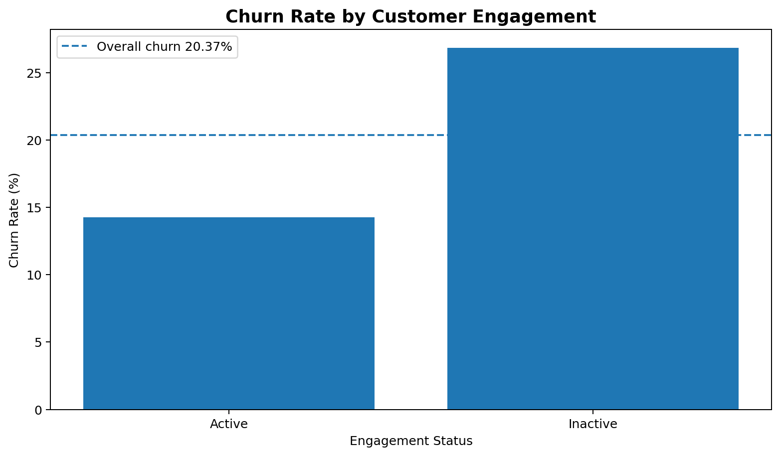
Figure 1. Churn rate by engagement status.
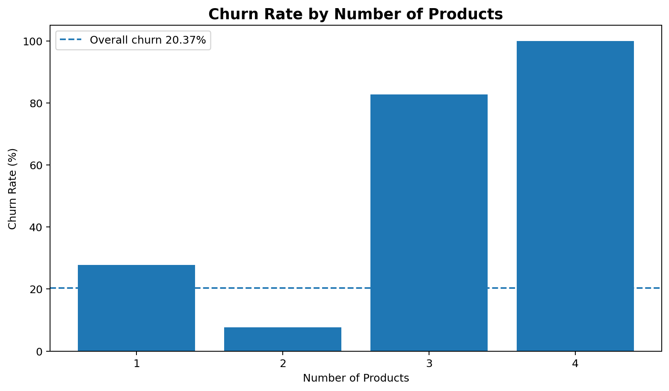
Figure 2. Churn rate by number of products.
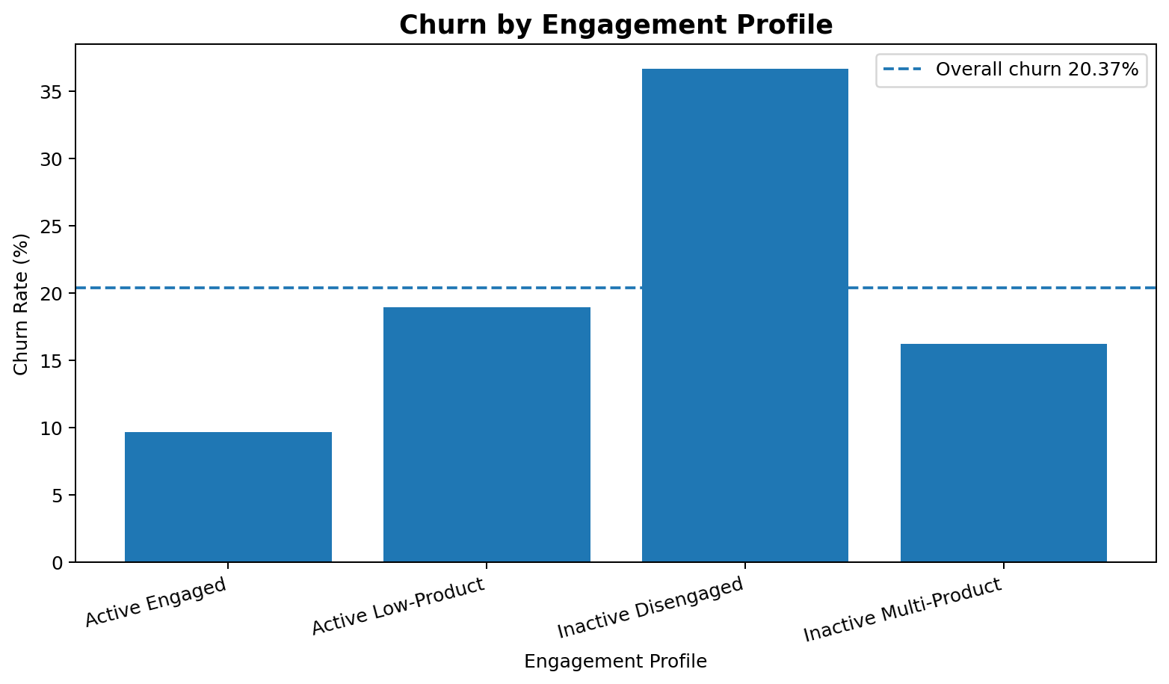
Figure 3. Churn rate by engagement profile.

6. Financial Commitment vs Engagement
The 75th percentile balance threshold is ₹127,644.24. Customers above this threshold were treated as high-value for segmentation. A high-value disengaged customer is both high-balance and inactive. The resulting segment contains 1,247 customers with an observed churn rate of 30.47%. This is materially above the overall churn rate of 20.37%.
Customer Value Segment | Customers | Observed Churn
High Value - Disengaged | 1,247 | 30.47%
High Value - Engaged | 1,253 | 16.92%
Standard Value - Disengaged | 3,602 | 25.60%
Standard Value - Engaged | 3,898 | 13.42%

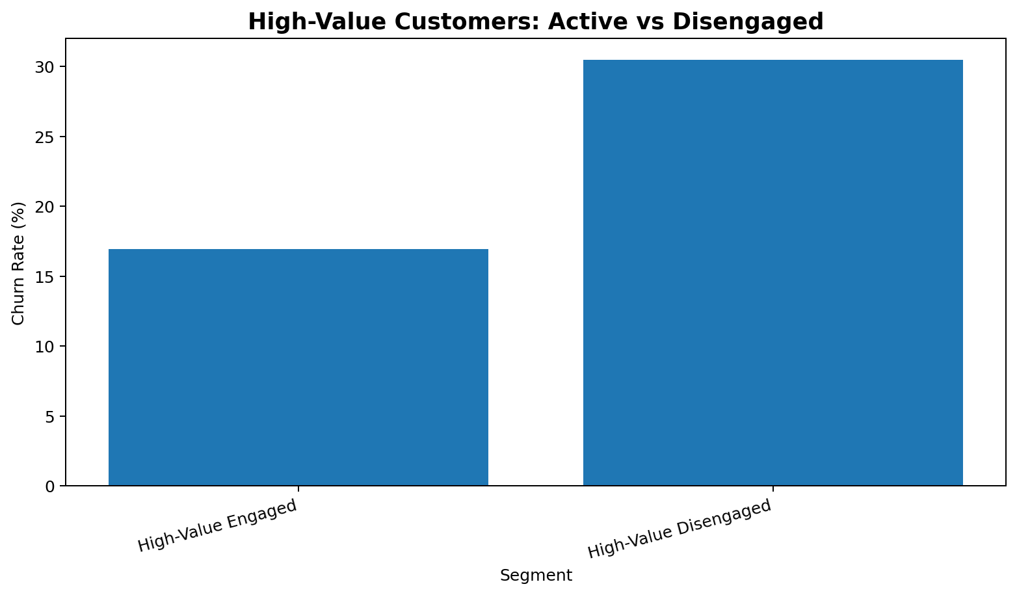
Figure 4. High-value customers: active versus disengaged.
The business implication is that financial value should be combined with engagement status. A high-balance inactive customer is not necessarily loyal; the combination of financial value and behavioral disengagement should trigger proactive relationship management.

7. Relationship Strength Index
The Relationship Strength Index is an interpretable 0–100 business score constructed from engagement, product depth, credit-card ownership and financial value. The index is intentionally rule-based so that a non-technical stakeholder can understand why a customer receives a given score. Because the dataset contains an unusual 3–4 product churn pattern, product-depth points are not assigned monotonically; the scoring framework is treated as a preliminary decision-support index rather than a proven causal or predictive model.
Observed churn declines substantially as relationship strength increases: Very Weak 37.37%, Weak 33.43%, Moderate 16.68%, Strong 10.11%.
RSI Band | Customers | Observed Churn
Very Weak | 495 | 37.37%
Weak | 2,812 | 33.43%
Moderate | 3,586 | 16.68%
Strong | 3,107 | 10.11%

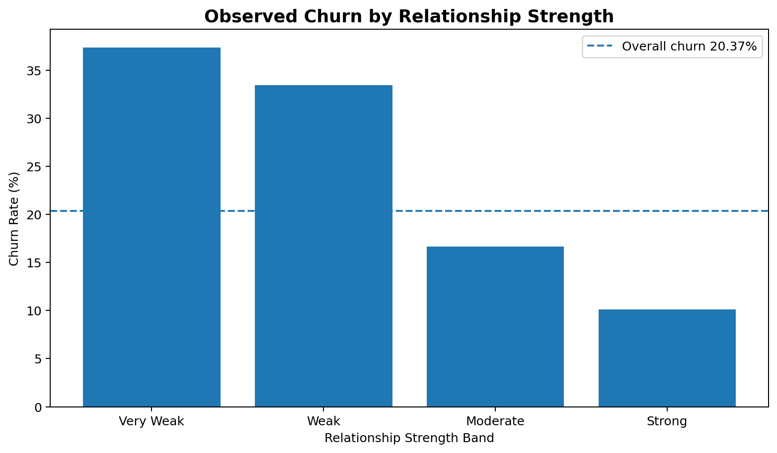
Figure 5. Observed churn by relationship strength band.

8. Retention Risk Scoring
A complementary retention-risk score is created as an inverse relationship-strength score with an additional premium-risk adjustment for high-value disengaged customers. The observed churn rate increases across risk bands: 10.65% for Low Risk, 17.66% for Medium Risk, 24.70% for High Risk and 38.28% for Critical Risk.
Risk Band | Customers | Observed Churn
Low Risk | 2,489 | 10.65%
Medium Risk | 2,662 | 17.66%
High Risk | 4,081 | 24.70%
Critical Risk | 768 | 38.28%

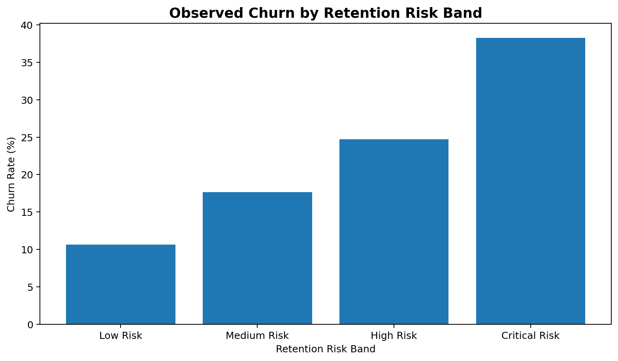
Figure 6. Observed churn by retention-risk band.

9. Statistical Validation
Statistical testing was used to distinguish descriptive patterns from evidence of association. Chi-square tests were applied to categorical variables, with Cramér’s V used as an effect-size measure. Mann–Whitney U tests were used for numerical variables because several financial variables are skewed. Point-biserial correlation was used for continuous score versus binary churn relationships. Statistical significance was evaluated at α = 0.05; the results are interpreted as associations rather than causal effects.
Variable | Test | p-value | Effect size / note
Engagement status | Chi-square | <0.001 | 0.156
Number of products | Chi-square | <0.001 | 0.387
Credit-card ownership | Chi-square | <0.001 | 0.492
Geography | Chi-square | <0.001 | 0.173
Gender | Chi-square | <0.001 | 0.106
High-value disengagement | Chi-square | <0.001 | 0.094
Engagement profile | Chi-square | <0.001 | 0.207
Customer value segment | Chi-square | <0.001 | 0.175

Numerical Variable | Retained Median | Churned Median | Mann–Whitney p
Balance | 92,072.68 | 109,349.29 | <0.001
Estimated Salary | 99,645.04 | 102,460.84 | 0.227
Age | 36 | 45 | <0.001
Credit Score | 653 | 646 | 0.020
Tenure | 5 | 5 | 0.162
Relationship Strength Index | 65 | 45 | <0.001
Retention Risk Score | 35 | 55 | <0.001

The point-biserial correlation between the Relationship Strength Index and churn is r = -0.119 (p < 0.001), indicating a negative association: higher relationship strength is associated with lower observed churn. The corresponding correlation for retention-risk score is r = 0.119 (p < 0.001), indicating that higher risk scores align with higher observed churn.

10. Key Findings
- Engagement is a major retention signal: inactive customers churn at 26.85% versus 14.27% for active customers, a gap of 12.58 percentage points and an inactive-to-active churn ratio of approximately 1.88x.
- Product depth is non-linear: one-product customers churn at 27.71% versus 7.58% for two-product customers, while 3–4 product customers exhibit extreme observed churn that requires diagnostic investigation.
- High-value disengagement is actionable: 1,247 high-balance inactive customers have an observed churn rate of 30.47%.
- Relationship strength is directionally aligned with retention: stronger relationship bands show lower observed churn.
- A risk-based segmentation framework can concentrate retention resources where the observed churn signal is strongest.

11. Business Recommendations
Priority Segment | Recommended Action | Primary KPI
At-Risk Premium | Proactive retention outreach and relationship-manager intervention | Reactivation / retention rate
Disengaged | Digital reactivation and targeted engagement campaigns | Active-member conversion
Growth Opportunity | Need-based cross-sell for active single-product customers | Product adoption rate
Strong Relationship | Loyalty benefits and relationship maintenance | Retention / loyalty rate
Complex / Investigate | Investigate product combinations, service issues and customer experience | Churn reduction / root-cause closure

12. Streamlit Decision-Support Application
The final application packages the analytical layer into five interactive modules: Executive Overview, Engagement Analytics, Product Utilization, High-Value Customer Detector, and Retention Strength & Risk. Users can filter by geography, gender, engagement, product count and balance range, and can download customer watchlists and retention scorecards.
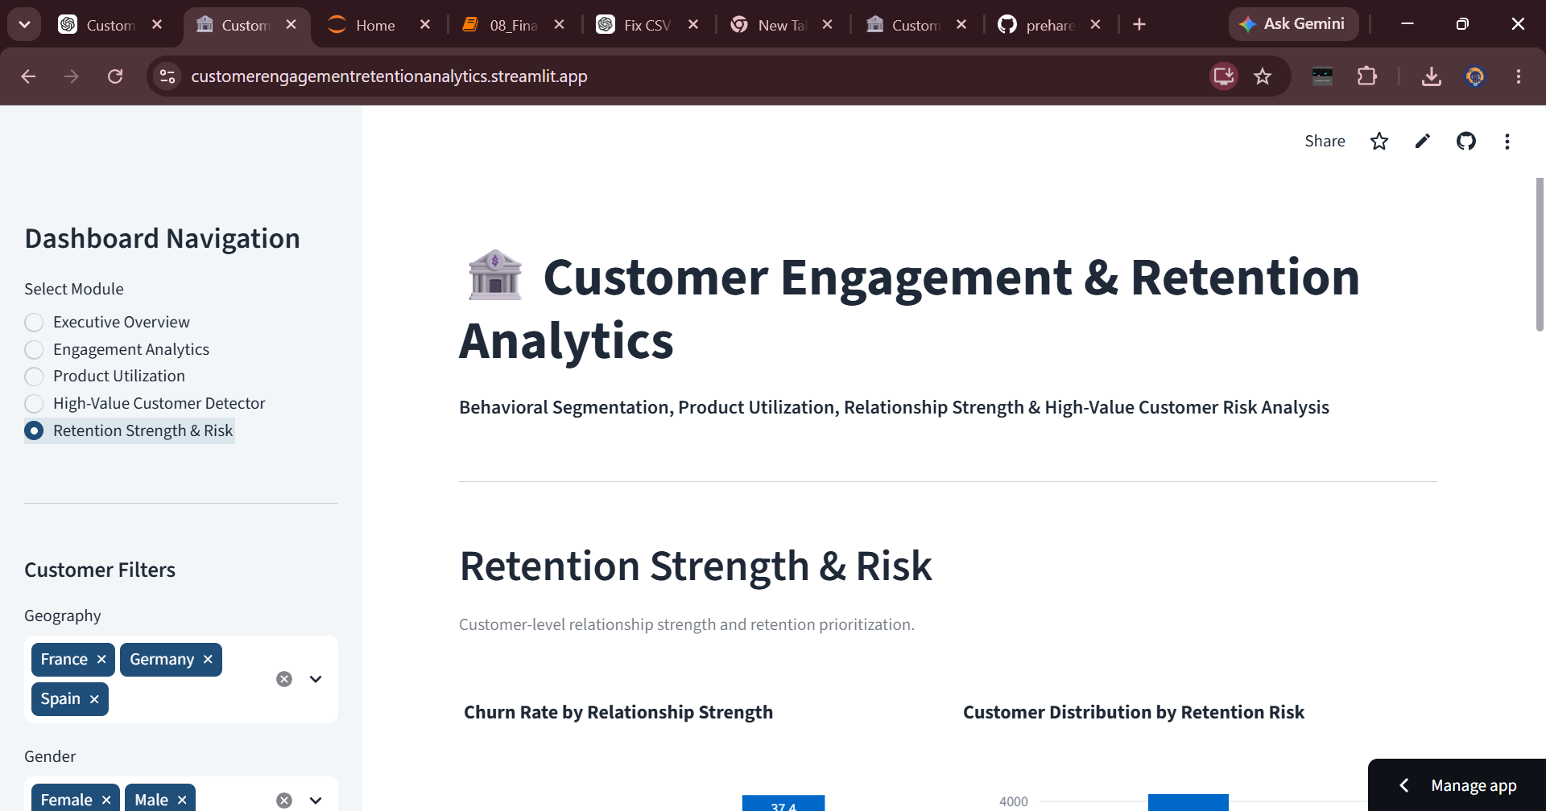
Figure 7. Live Streamlit dashboard: Retention Strength & Risk module.

13. Limitations
- The dataset is cross-sectional; longitudinal behavior and campaign response are not available.
- The Relationship Strength Index and retention-risk score are interpretable business rules, not causal models.
- The 3- and 4-product groups are small relative to the full dataset, so their extreme churn rates require caution.
- Customer complaints, product-level transactions, interaction frequency and channel-level engagement are not available.
- Observed associations should not be interpreted as proof that a behavior causes churn.

14. Future Scope
- Add explainable machine-learning churn prediction.
- Add product-combination and product-level journey analysis.
- Estimate customer lifetime value and profitability risk.
- Integrate CRM or campaign-response data.
- Run A/B tests to measure retention interventions.
- Automate high-risk customer alerts for relationship teams.

15. Conclusion
The project demonstrates that retention strategy can be strengthened by moving from a generic churn lens to a behavioral relationship lens. Engagement status, product utilization, financial value and relationship strength together provide a more actionable framework for prioritizing retention resources. The most important management opportunity is not to maximize product count indiscriminately, but to identify customers whose relationship with the bank is weakening and intervene with a strategy appropriate to their value, engagement state and product profile.

References
- Agresti, A. (2013). Categorical Data Analysis. Wiley.
- Cohen, J. (1988). Statistical Power Analysis for the Behavioral Sciences. Lawrence Erlbaum Associates.
- Mann, H. B., & Whitney, D. R. (1947). On a Test of Whether One of Two Random Variables is Stochastically Larger than the Other. Annals of Mathematical Statistics, 18(1), 50–60.

