**General Inspection**  
Colour  
Amputations  
Obesity  
Ask about pain and note discomforts  
  
**Hands**Temperature  
Clubbing  
Peripheral cyanosis  
Capillary Refill  
Anaemic palmar creases  
Cigarette tar staining  
Splinter haemorrhages of nails  
Radial pulse palpation  
Ulnar pulse palpation  
Allen’s test – Grip wrist tight until patient’s hand goes pale. Release. Expect colour to return in < 5 seconds.  
Collapsing radial pulse – Note changes to pulse when raised above heart level  
  
**Arms**  
Xanthomata – fat deposits   
Brachial pulse  
  
**Neck**  
Carotid pulse palpation  
Carotid auscultation  
Raised jugular venous pressure  
  
**Face**  
Corneal arcus  
Xanthalesma – fat deposits around eyes  
Central cyanosis e.g. Tongue  
Anaemia  
  
**Chest – Inspection**Scars  
Visible pulsations  
Pacemaker or patches  
  
**Chest – Palpation**Apex beat – 5th intercostal space, mid-clavicular line  
Heaves – Heel of hand placed on sternal border towards heart  
Thrills – Palpate each valve site for murmur  
 **Chest – Auscultation**Heart valve: Aortic site  
Heart valve: Pulmonary site  
Heart valve: Tricuspid site  
Heart valve: Mitral site  
Lung base for oedema  
  
**Oedema inspection**Sacrum  
Legs, feet and ankles  
  
**Abdominal exam**  
Hepatosplenomegaly  
Palpate aorta  
Auscultate aorta  
Palpate femoral pulses  
Auscultate femoral pulses

**Legs and feet**  
Colour  
Hair loss  
Temperature  
Capillary refill  
Varicosities  
Ulceration / Gangrene  
Scars  
Popliteal pulse  
Posterior tibialis  
Dorsalis pedis  
  
**Further investigation**

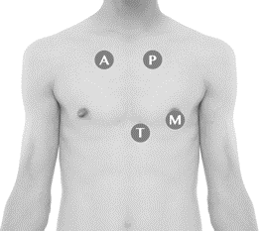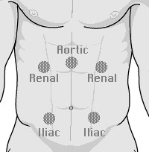12-lead ECG  
Temperature