Data Guardian — Social Media Privacy & Legal Policy Research Dashboard
Project Report
Submitted by: Prekchha Thakur
Course Project | Educational Prototype | Python / Streamlit

1. Project Overview
Data Guardian is a fully self-contained, interactive web dashboard built with Python and Streamlit. It is designed to help everyday users — including those with no legal or technical background — understand the privacy practices, legal terms, and cybersecurity risks of nine major social media and digital platforms.
The application requires no API keys, no internet connection for its summarizer, and no paid subscriptions. It runs entirely on a local machine with a single command: streamlit run data_guardian_app.py. The dashboard was built as an educational prototype. All app data is demonstration material sourced from publicly available privacy policies. Nothing in the application constitutes legal advice.

2. Technologies Used
- Technology: Python 3.9+ — Core programming language for all logic and data.
- Technology: Streamlit >= 1.32.0 — Web dashboard framework handling both UI rendering and server logic. No separate frontend or backend server is needed.
- Technology: Python Standard Library (re, math, heapq, collections, textwrap) — Used exclusively in the local extractive summarizer. No external AI or API.
- Technology: CSS injected via Streamlit — WCAG AA accessible colour palette and layout styling, all inline.

3. Dashboard Sections

3.1 Upload Latest Privacy Policy
The primary research workspace. Users select one of nine platforms (WhatsApp, Instagram, Facebook, Telegram, Snapchat, Flipkart, Google, Gmail, GitHub) and one of six policy categories (Privacy Policy, Terms of Service, Community Guidelines, Third-Party Material, Limitation of Liability, Arbitration & Legal Dispute Waivers). A region selector (India / United States / Global) adjusts which official document URL is shown. Users open the official document, paste its text, and click Summarize Policy. The local summarizer generates a structured plain-English summary with no API key required.

3.2 App Privacy Library
A browsable catalogue of app profiles with a plain-language summary, a full permissions tab (what each permission means, risk level, and recommended action), a data sharing tab, a security risks tab, and a sources tab with the official privacy policy URL.

3.3 Permission Explorer
Covers every major device permission. Each entry explains what the permission does, what data it exposes, when it may be unnecessary, potential privacy risks, and the recommended action. A risk-level filter (Lower Concern / Review Recommended / Higher Concern) allows focused browsing.

3.4 Third-Party Data Access
Explains who else may receive user data — third-party apps (OAuth), embedded SDKs, advertising networks, and business partners. An interactive data-flow explorer lets users select a data category and see the flow to possible recipients, with risk ratings. A key-concepts glossary covers OAuth, tracking pixels, cookies, and session tokens.

3.5 Review My Access
A step-by-step action centre organised into three categories: Device Permissions (Location, Camera, Microphone, Contacts); Connected Applications (Facebook, Google, Instagram); and Data Sharing & Tracking Settings. Each item provides both Android and iOS instructions and a Mark as Reviewed button. A progress bar tracks completion across all items.

3.6 Cybersecurity Learning Centre
Contains 12 educational topics (Excessive Permissions, OAuth & API Authorization, Third-Party Application Risks, Access Token Theft, Phishing, XSS, CSRF, Malicious SDKs, Tracking Pixels, Data Profiling, End-to-End Encryption & Metadata, Basic Account Security) and 3 documented case studies (Facebook & Cambridge Analytica 2014–2018; Snapchat Find Friends Incident 2014; Cross-Site Tracking via Embedded Social Plugins).

4. Accessibility Design
The colour palette was designed specifically for low-vision users. All colours meet the WCAG AA minimum contrast ratio of 4.5:1 for normal text:
- Background #0b1a28 (very dark navy, not pure black — avoids high-contrast glare)
- Primary text #f0f4f8 (near-white warm tint) — contrast ratio ≥ 15:1
- Accent teal #00e8bb — contrast ratio 5.1:1
- Warning amber #ffd166 — contrast ratio 7.8:1
- Danger red #ff6b6b — contrast ratio 4.6:1
- Success green #4dffaa — contrast ratio 6.2:1
Additional accessibility measures: base font size 17px (raised from 16px); line-height 1.7; letter-spacing 0.012em; 3px teal focus ring on all interactive elements; colour never the sole indicator (icons and labels always paired with colour); badge borders increased from 1px to 2px.

5. How the Local Summarizer Works
The summarization engine (sections/summarizer.py) is built entirely from Python's standard library. No AI service, no internet connection, and no API key is required. It uses a TF-IDF-inspired extractive approach:
- Step 1 — The pasted policy text is split into sentences using a regex sentence splitter.
- Step 2 — Each sentence is scored by summing the normalised frequency of its non-stopword words across the whole document.
- Step 3 — The highest-scoring sentences are matched to category-specific heading keywords and arranged under structured headings (e.g. Information Collected, Information Sharing, User Privacy Controls).
- Step 4 — The output is labelled clearly as an extractive summary — not legal advice. Sentences are copied verbatim from the pasted document; nothing is rewritten or invented.

6. Project File Structure
- data_guardian_app.py — Main entry point: Streamlit page config, sidebar navigation, and section routing.
- sections/styles.py — WCAG AA accessible CSS injected globally into the dashboard.
- sections/upload_policy.py — Upload Latest Privacy Policy section.
- sections/app_library.py — App Privacy Library with detailed app profiles.
- sections/permission_explorer.py — Permission Explorer with risk levels and guidance.
- sections/third_party.py — Third-Party Data Access with interactive flow diagram and glossary.
- sections/review_access.py — Review My Access action centre with progress tracking.
- sections/learning_centre.py — Cybersecurity Learning Centre with topics and case studies.
- sections/summarizer.py — Local extractive summarization engine (Python standard library only).
- sections/policy_data.py — All platform data, official policy URLs, availability metadata.
- sections/data.py — App catalogue, permissions knowledge base, risk labels, glossary.
- requirements.txt — Python dependencies (streamlit>=1.32.0).
- README.md — Project overview, setup instructions, usage guide.

7. Setup & Run Instructions
Requirements: Python 3.9 or later and pip. No other software needed.
- Step 1 — Install dependencies (one time): pip install -r requirements.txt
- Step 2 — Start the dashboard: streamlit run data_guardian_app.py
- Step 3 — Open the URL Streamlit prints in the terminal (e.g. http://localhost:8501) in your browser.

8. Online Deployment for Teachers / Examiners
To share the dashboard with a teacher or examiner from a different computer, deploy to Streamlit Community Cloud (free):
- 1. Push the project to a public GitHub repository.
- 2. Go to share.streamlit.io and sign in with GitHub.
- 3. Click New app, select the repository, set main file path to data_guardian_app.py, click Deploy.
- 4. A permanent public URL is generated in approximately 2 minutes.

9. Dashboard Screenshots
To add screenshots: run the app, open each section in your browser, and take a screenshot (Windows+Shift+S on Windows or Cmd+Shift+4 on Mac). Insert each screenshot below in place of the placeholder text.
Screenshot 1 — Sidebar Navigation & App Header
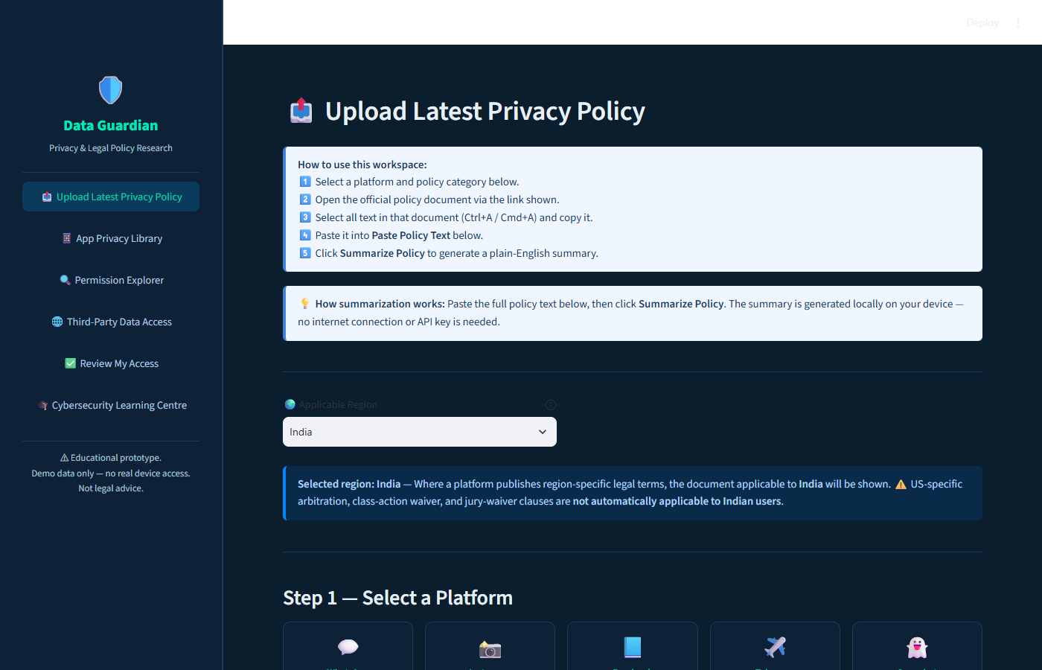
Figure 1: Data Guardian sidebar navigation and Upload Latest Privacy Policy section.
Screenshot 2 — Upload Latest Privacy Policy (platform selector)
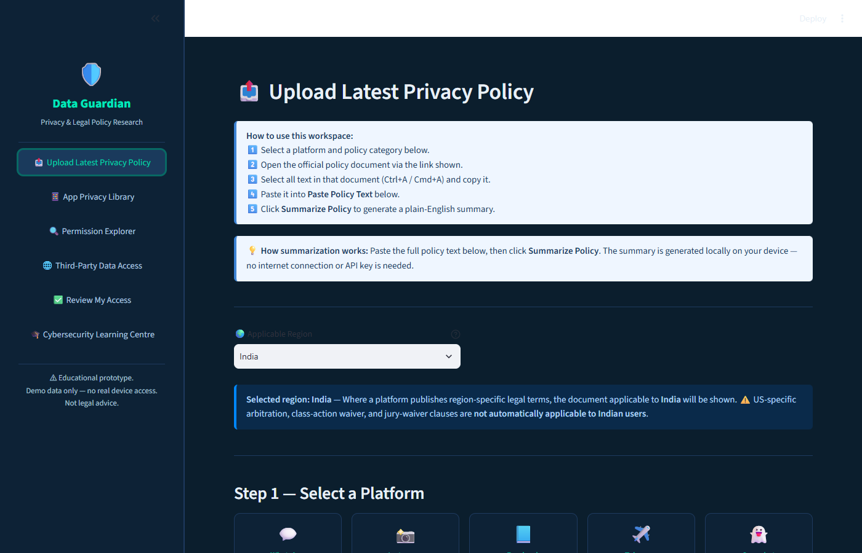
Figure 2: Upload Latest Privacy Policy — landing page with instructions and region selector.
Screenshot 3 — Policy Summarizer Output
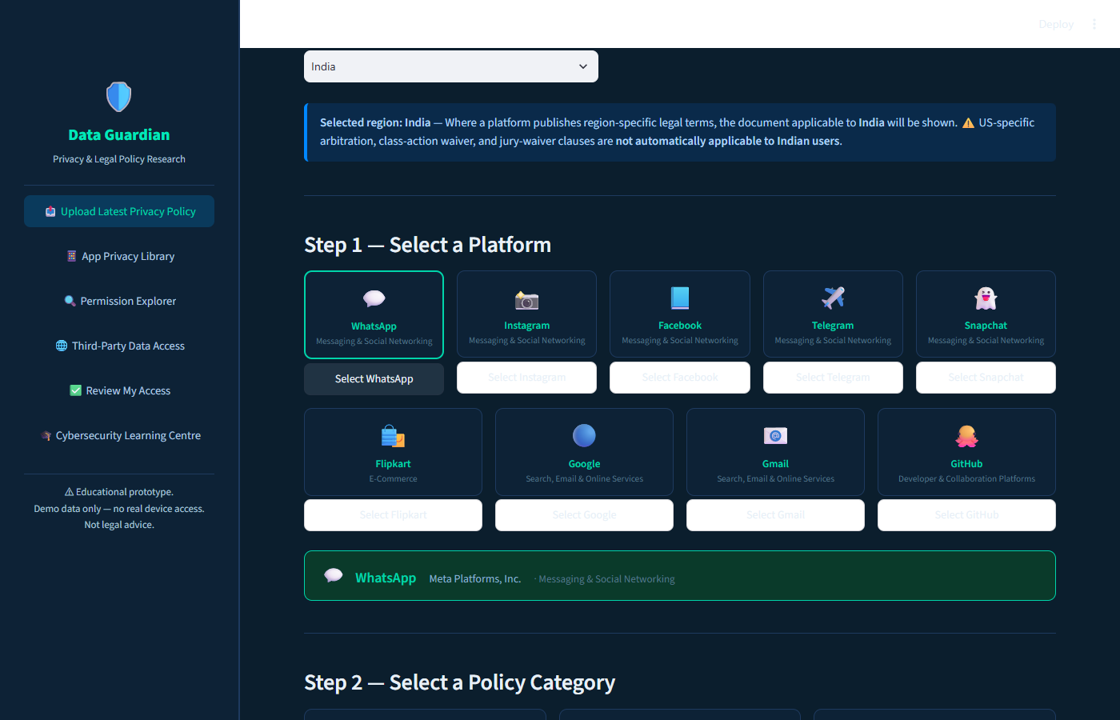
Figure 3: Platform selector showing all 9 platforms. WhatsApp is selected (teal border) and Step 2 — Select a Policy Category is visible below.
Screenshot 4 — App Privacy Library
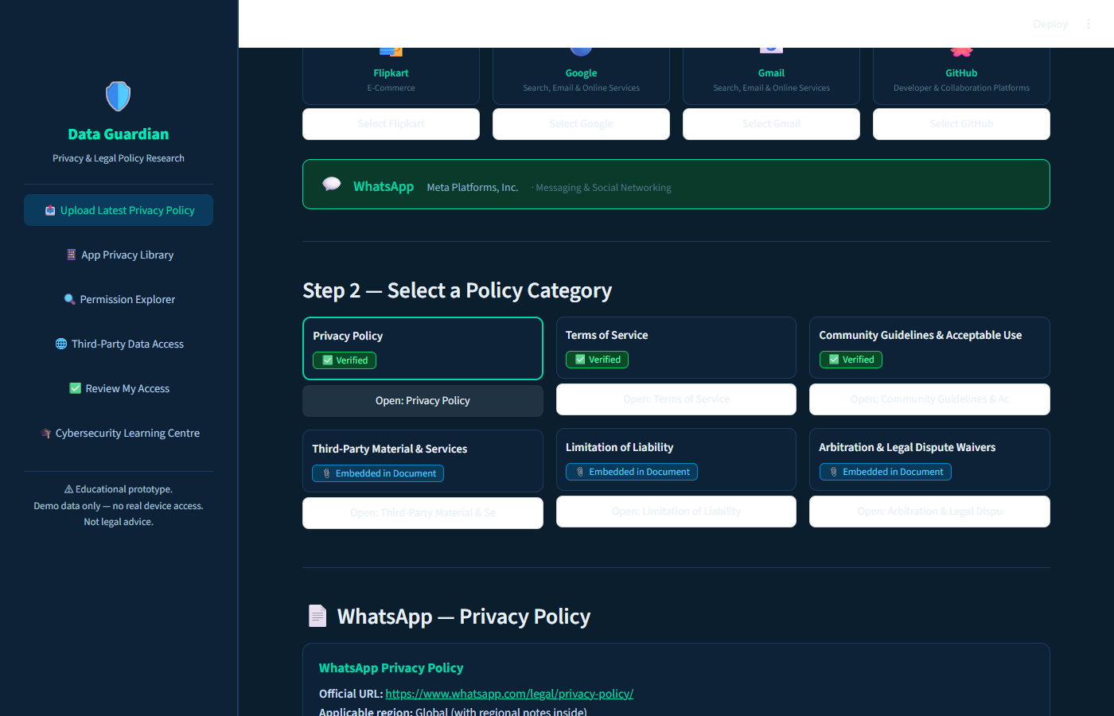
Figure 4: Policy workspace — official document link, availability status, and paste area for WhatsApp Privacy Policy.
Screenshot 5 — Permission Explorer
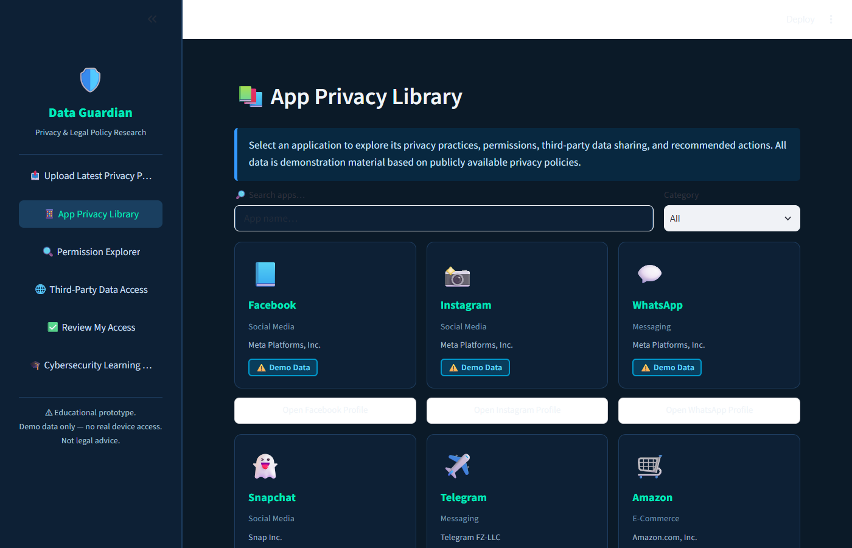
Figure 5: App Privacy Library — browsable catalogue of app profiles with category and demo-data status badges.
Screenshot 6 — Third-Party Data Access (flow diagram)
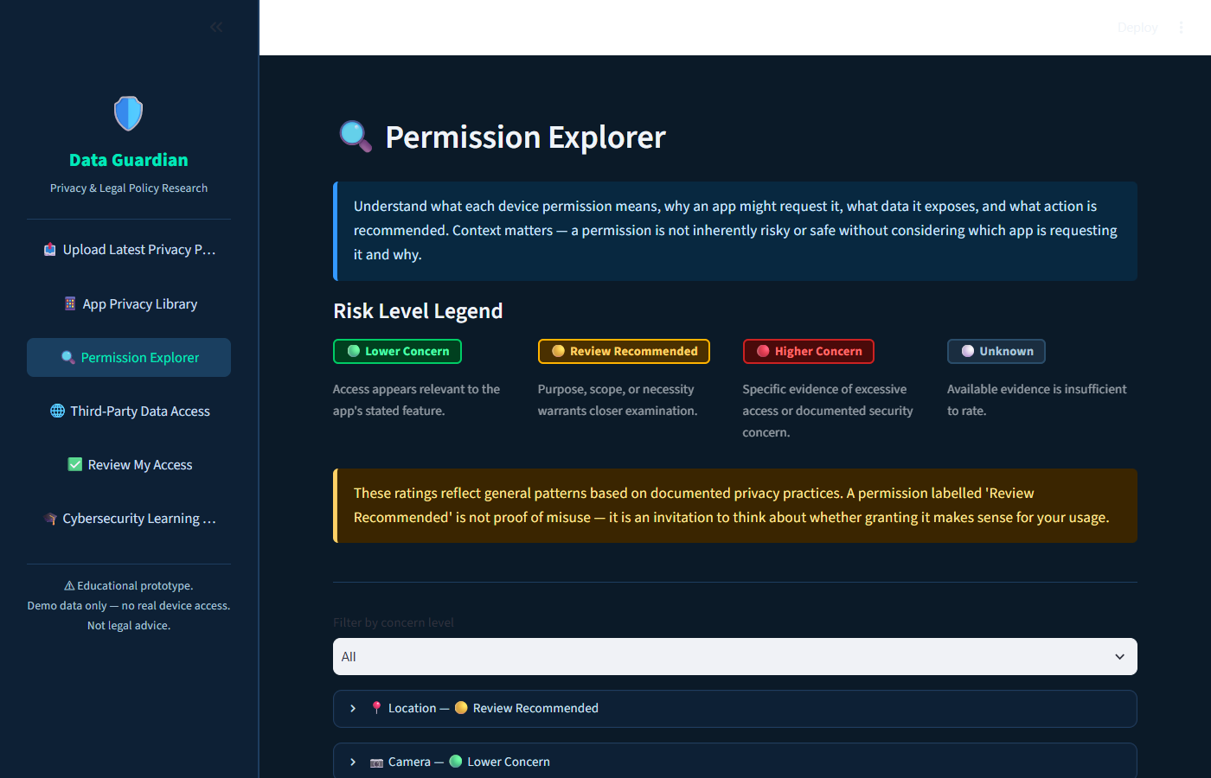
Figure 6: Permission Explorer — Risk Level Legend and collapsible permission list with plain-text risk labels.
Screenshot 7 — Review My Access
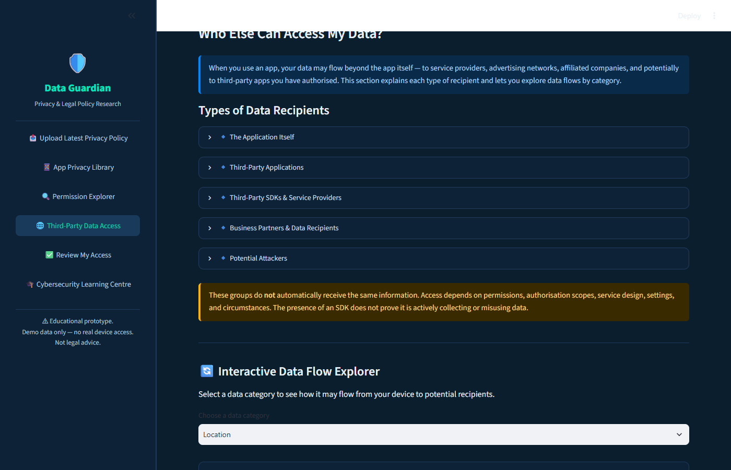
Figure 7: Third-Party Data Access — types of data recipients and interactive data-flow explorer.
Screenshot 8 — Cybersecurity Learning Centre
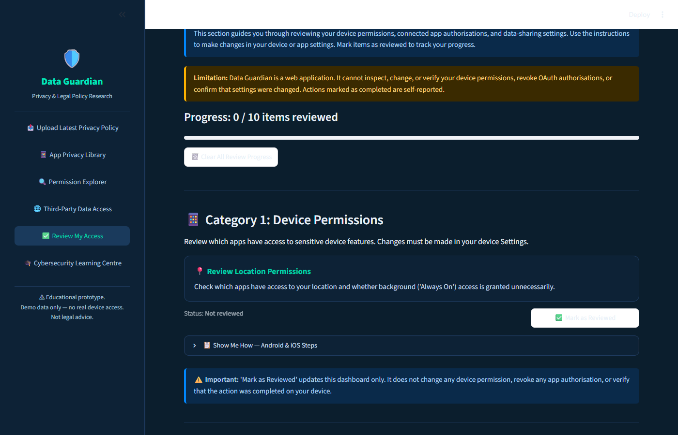
Figure 8: Review My Access — progress bar and step-by-step action centre for device permissions.
Screenshot 9 — Cybersecurity Learning Centre
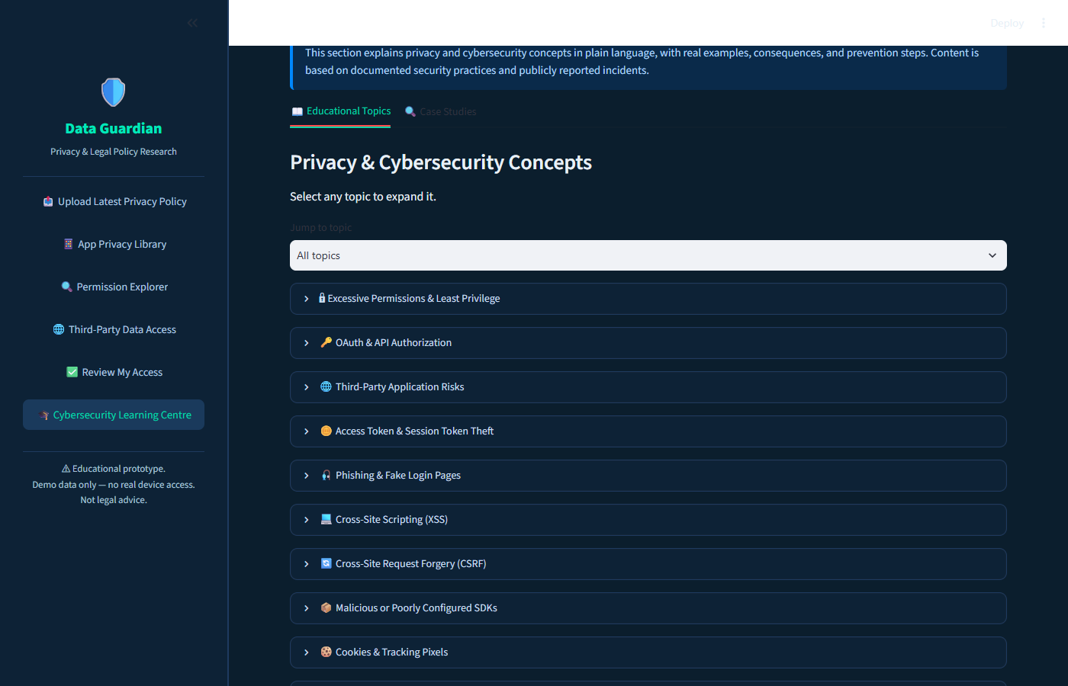
Figure 9: Cybersecurity Learning Centre — educational topics with expandable entries and case studies tab.

10. Key Limitations
- The summarizer selects existing sentences from the pasted document — it does not generate new explanations or rewrite text.
- Policy links verified as of June 2025. Always verify against the current official source.
- Data Guardian is a web app. It cannot read, modify, or verify device permissions or revoke OAuth authorisations.
- All app data is demonstration material for educational purposes. Nothing here is legal advice.

