Федеральное государственное автономное

образовательное учреждение

высшего образования

«СИБИРСКИЙ ФЕДЕРАЛЬНЫЙ УНИВЕРСИТЕТ»

Институт Космических и информационных технологий

институт

Кафедра «Информатика»

кафедра

**ОТЧЕТ О ЛАБОРАТОРНОЙ РАБОТЕ**

Лабораторная работа No 5. Взаимодействие процессов в ОС GNU/Linux

тема

Преподаватель _________ А.С. Кузнецов

подпись, дата инициалы, фамилия

Студент КИ18-17/1б 031831229 _________ В.А. Прекель

номер группы, зачетной книжки подпись, дата инициалы, фамилия

Красноярск 2019

Содержание

Содержание 2

1 Цель работы с постановкой задачи 4

1.1 Цель работы 4

1.2 Задача работы 4

1.3 Описание и пояснение к работе 5

2 Исходные тексты программ (с комментариями в стиле системы doxygen) 6

3 Содержимое скрипта configure 6

3.1 configure 6

3.2 сonfigure.ac 6

3.3 Makefile.am 7

3.4 build/Makefile.am 7

4 Примеры работы программ в виде перехватов содержимого экрана 7

4.1 Запуск №1 (WSL Ubuntu 18.04, GCC) 8

4.1.1. Сборка с помощью autotools 8

4.1.2. Запуск клиента без запущенного сервера 13

4.1.3. Запуск сервера 14

4.1.4. Запуск клиента 14

4.1.5. Результат работы сервера 15

4.2 Запуск №2 (Клиент – Windows, MSVC; удалённый сервер – Ubuntu 16.04, GCC) 15

4.2.1. Сборка с помощью autotools на удалённом сервере 16

4.2.2. Сборка на клиенте с помощью CMake и msbuild 20

4.2.3. Запуск клиента без запущенного сервера 21

4.2.4. Запуск сервера 22

4.2.5. Запуск клиента 22

4.2.6. Результат работы сервера 22

# Цель работы с постановкой задачи

## Цель работы

Изучение особенностей межпроцессного взаимодействия в ОС GNU/Linux.

## Задача работы

Требуется: разработать две программы: первая реализует серверную часть, вторая — клиентскую часть. Обмен данными между ними организуется посредством механизма Internet-сокетов и протокола TCP либо UDP. Результат выполнения выводится на терминал/консоль. Должен использоваться интерфейс командной строки (CLI). При реализации обязательно использование изученных в лекционном курсе системных вызовов (ОС Linux), предназначенных для работы с сокетами. Программный код, относящийся к пользовательскому интерфейсу, должен быть физически отделен от кода, реализующего межпроцессное взаимодействие, и оба они, в свою очередь, отделены от кода реализации основной логики, например, вычислений. Допускается реализация одной программы в форме Windows-приложения, авторой — в форме Linux-приложения. Далее оговаривается функционал клиентской и серверной частей. Обе части должны быть устойчивы к некорректному пользовательскому вводу. В нечетных вариантах заданий используются потоковые сокеты, в четных — дейтаграммные сокеты.

**Вариант 17.** Клиент отсылает серверу элементы введенной пользователем квадратной матрицы, а также два введенных им числа – номер столбца и номер строки. Сервер принимает матрицу и номер столбца N и номер строки M, выводит ее на экран, затем «вычеркивает» из матрицы столбец с номером N и строку с номером M, выводит измененную матрицу на экран, вычисляет и выводит на экран значение ее определителя.

## Описание и пояснение к работе

Используется система сборки Autotools на Linux и CMake на Windows и Linux. Используется интерфейс командной строки. Для сборки, вывода справки клиента и сервера требуется:

*# linux, autotools, make, gcc*./configure  
make  
./build/Lab_05_Client -h  
./build/Lab_05_Server -h  
  
*# linux, autotools, make, clang*./configure CC=clang  
make  
./build/Lab_05_Client -h  
./build/Lab_05_Server -h  
  
*# linux, cmake, make, gcc*cd build  
cmake ..  
make  
./Lab_05_Client/Lab_05_Client -h  
./Lab_05_Server/Lab_05_Server -h  
  
*# linux, cmake, make, clang*cd build  
cmake -DCMAKE_C_COMPILER=clang ..  
make  
./Lab_05_Client/Lab_05_Client -h  
./Lab_05_Server/Lab_05_Server -h  
  
*# windows, cmake, msbuild, msvc*cd build  
cmake ..  
msbuild .\ALL_BUILD.vcxproj  
.\Lab_05_Client\Debug\Lab_05_Client.exe -h  
.\Lab_05_Server\Debug\Lab_05_Server.exe -h  
  
*# windows, cmake, mingw32-make, mingw*cd build  
cmake -G **"MinGW Makefiles"** ..  
mingw32-make  
.\Lab_05_Client\Lab_05_Client.exe -h  
.\Lab_05_Server\Lab_05_Server.exe -h  
  
*# windows, cmake, mingw32-make, clang*cd build  
cmake -G **"MinGW Makefiles"** -DCMAKE_C_COMPILER=clang -DCMAKE_CXX_COMPILER=clang++ ..  
mingw32-make  
.\Lab_05_Client\Lab_05_Client.exe -h  
.\Lab_05_Server\Lab_05_Server.exe -h

# Исходные тексты программ (с комментариями в стиле системы doxygen)

Исходные тексты программ предоставлены в архиве.

# Содержимое скрипта configure

## configure

Предоставлен в архиве.

## сonfigure.ac

# -*- Autoconf -*-  
# Process this file with autoconf to produce a configure script.  
  
AC_PREREQ([2.69])  
AC_INIT([Lab_05], [0.1], [misterptits@yandex.ru])  
AC_CONFIG_SRCDIR([Lab_05_Client/main.c])  
#AC_CONFIG_HEADERS([config.h])  
  
# Checks for programs.  
AC_PROG_CC  
  
# Checks for libraries.  
  
# Checks for header files.  
AC_CHECK_HEADERS([arpa/inet.h fcntl.h limits.h malloc.h netinet/in.h stddef.h stdint.h stdlib.h string.h sys/socket.h unistd.h])  
  
# Checks for typedefs, structures, and compiler characteristics.  
AC_CHECK_HEADER_STDBOOL  
AC_TYPE_SIZE_T  
AC_TYPE_UINT16_T  
AC_TYPE_UINT32_T  
  
# Checks for library functions.  
AC_FUNC_MALLOC  
AC_FUNC_REALLOC  
AC_FUNC_STRERROR_R  
AC_CHECK_FUNCS([socket strchr])  
  
AM_INIT_AUTOMAKE  
AC_PROG_RANLIB  
  
AC_CONFIG_FILES([build/Makefile  
 Makefile])  
AC_OUTPUT

## Makefile.am

SUBDIRS = build

## build/Makefile.am

AUTOMAKE_OPTIONS = subdir-objects  
  
noinst_LIBRARIES = libLab_05_Lib.a libLab_05_MatrixLib.a   
bin_PROGRAMS = Lab_05_Client Lab_05_Server  
  
libLab_05_MatrixLib_a_SOURCES = \  
 ../Lab_05_MatrixLib/Matrix.c  
  
libLab_05_Lib_a_SOURCES = \  
 ../Lab_05_Lib/Input.c \  
 ../Lab_05_Lib/ParseInt.c \  
 ../Lab_05_Lib/ReturnCodes.c \  
 ../Lab_05_Lib/LastErrorMessage.c \  
 ../Lab_05_Lib/Request.c \  
 ../Lab_05_Lib/Socket.c  
libLab_05_Lib_a_CFLAGS = -I../Lab_05_MatrixLib   
libLab_05_Lib_a_LIBADD = libLab_05_MatrixLib.a  
  
Lab_05_Client_SOURCES = \  
 ../Lab_05_Client/Args.c \  
 ../Lab_05_Client/Client.c \  
 ../Lab_05_Client/main.c  
Lab_05_Client_CFLAGS = -I../Lab_05_MatrixLib -I../Lab_05_Lib  
Lab_05_Client_LDADD = libLab_05_MatrixLib.a libLab_05_Lib.a  
  
Lab_05_Server_SOURCES = \  
 ../Lab_05_Server/Args.c \  
 ../Lab_05_Server/Server.c \  
 ../Lab_05_Server/main.c  
Lab_05_Server_CFLAGS = -I../Lab_05_MatrixLib -I../Lab_05_Lib  
Lab_05_Server_LDADD = libLab_05_MatrixLib.a libLab_05_Lib.a

# Примеры работы программ в виде перехватов содержимого экрана

## Запуск №1 (WSL Ubuntu 18.04, GCC)

### Сборка с помощью autotools

vladislav@DESKTOP-ODR692H:/mnt/c/Users/vladislav/Projects/SystemProgramming/0x0A/Lab_05**$** ./configure  
checking **for** gcc... gcc  
checking whether the C compiler works... yes  
checking **for** C compiler default output file name... a.out  
checking **for** suffix of executables...  
checking whether we are cross compiling... no  
checking **for** suffix of object files... o  
checking whether we are using the GNU C compiler... yes  
checking whether gcc accepts -g... yes  
checking **for** gcc option to accept ISO C89... none needed  
checking whether gcc understands -c and -o together... yes  
checking how to run the C preprocessor... gcc -E  
checking **for** grep that handles long lines and -e... /bin/grep  
checking **for** egrep... /bin/grep -E  
checking **for** ANSI C header files... yes  
checking **for** sys/types.h... yes  
checking **for** sys/stat.h... yes  
checking **for** stdlib.h... yes  
checking **for** string.h... yes  
checking **for** memory.h... yes  
checking **for** strings.h... yes  
checking **for** inttypes.h... yes  
checking **for** stdint.h... yes  
checking **for** unistd.h... yes  
checking arpa/inet.h usability... yes  
checking arpa/inet.h presence... yes  
checking **for** arpa/inet.h... yes  
checking fcntl.h usability... yes  
checking fcntl.h presence... yes  
checking **for** fcntl.h... yes  
checking limits.h usability... yes  
checking limits.h presence... yes  
checking **for** limits.h... yes  
checking malloc.h usability... yes  
checking malloc.h presence... yes  
checking **for** malloc.h... yes  
checking netinet/in.h usability... yes  
checking netinet/in.h presence... yes  
checking **for** netinet/in.h... yes  
checking stddef.h usability... yes  
checking stddef.h presence... yes  
checking **for** stddef.h... yes  
checking **for** stdint.h... (cached) yes  
checking **for** stdlib.h... (cached) yes  
checking **for** string.h... (cached) yes  
checking sys/socket.h usability... yes  
checking sys/socket.h presence... yes  
checking **for** sys/socket.h... yes  
checking **for** unistd.h... (cached) yes  
checking **for** stdbool.h that conforms to C99... yes  
checking **for** _Bool... yes  
checking **for** size_t... yes  
checking **for** uint16_t... yes  
checking **for** uint32_t... yes  
checking **for** stdlib.h... (cached) yes  
checking **for** GNU libc compatible malloc... yes  
checking **for** stdlib.h... (cached) yes  
checking **for** GNU libc compatible realloc... yes  
checking whether strerror_r is declared... yes  
checking **for** strerror_r... yes  
checking whether strerror_r returns char *... no  
checking **for** socket... yes  
checking **for** strchr... yes  
checking **for** a BSD-compatible install... /usr/bin/install -c  
checking whether build environment is sane... yes  
checking **for** a thread-safe mkdir -p... /bin/mkdir -p  
checking **for** gawk... gawk  
checking whether make sets **$**(MAKE)... yes  
checking **for** style of include used by make... GNU  
checking whether make supports nested variables... yes  
checking dependency style of gcc... gcc3  
checking **for** ranlib... ranlib  
checking that generated files are newer than configure... **done**configure: creating ./config.status  
config.status: creating build/Makefile  
config.status: creating Makefile  
config.status: executing depfiles commands  
vladislav@DESKTOP-ODR692H:/mnt/c/Users/vladislav/Projects/SystemProgramming/0x0A/Lab_05**$** make  
Making all in build  
make[1]: Entering directory **'/mnt/c/Users/vladislav/Projects/SystemProgramming/0x0A/Lab_05/build'**gcc -DPACKAGE_NAME=\"Lab_05\" -DPACKAGE_TARNAME=\"lab_05\" -DPACKAGE_VERSION=\"0.1\" -DPACKAGE_STRING=\"Lab_05\ 0.1\" -DPACKAGE_  
BUGREPORT=\"misterptits@yandex.ru\" -DPACKAGE_URL=\"\" -DSTDC_HEADERS=1 -DHAVE_SYS_TYPES_H=1 -DHAVE_SYS_STAT_H=1 -DHAVE_STDLIB_H  
=1 -DHAVE_STRING_H=1 -DHAVE_MEMORY_H=1 -DHAVE_STRINGS_H=1 -DHAVE_INTTYPES_H=1 -DHAVE_STDINT_H=1 -DHAVE_UNISTD_H=1 -DHAVE_ARPA_IN  
ET_H=1 -DHAVE_FCNTL_H=1 -DHAVE_LIMITS_H=1 -DHAVE_MALLOC_H=1 -DHAVE_NETINET_IN_H=1 -DHAVE_STDDEF_H=1 -DHAVE_STDINT_H=1 -DHAVE_STD  
LIB_H=1 -DHAVE_STRING_H=1 -DHAVE_SYS_SOCKET_H=1 -DHAVE_UNISTD_H=1 -DHAVE__BOOL=1 -DHAVE_STDLIB_H=1 -DHAVE_MALLOC=1 -DHAVE_STDLIB  
_H=1 -DHAVE_REALLOC=1 -DHAVE_DECL_STRERROR_R=1 -DHAVE_STRERROR_R=1 -DHAVE_SOCKET=1 -DHAVE_STRCHR=1 -DPACKAGE=\"lab_05\" -DVERSIO  
N=\"0.1\" -I. -I../Lab_05_MatrixLib -g -O2 -MT ../Lab_05_Lib/libLab_05_Lib_a-Input.o -MD -MP -MF ../Lab_05_Lib/.deps/libLab_  
05_Lib_a-Input.Tpo -c -o ../Lab_05_Lib/libLab_05_Lib_a-Input.o `test -f **'../Lab_05_Lib/Input.c' ||** echo **'./'**`../Lab_05_Lib/Input  
.c  
mv -f ../Lab_05_Lib/.deps/libLab_05_Lib_a-Input.Tpo ../Lab_05_Lib/.deps/libLab_05_Lib_a-Input.Po  
gcc -DPACKAGE_NAME=\"Lab_05\" -DPACKAGE_TARNAME=\"lab_05\" -DPACKAGE_VERSION=\"0.1\" -DPACKAGE_STRING=\"Lab_05\ 0.1\" -DPACKAGE_  
BUGREPORT=\"misterptits@yandex.ru\" -DPACKAGE_URL=\"\" -DSTDC_HEADERS=1 -DHAVE_SYS_TYPES_H=1 -DHAVE_SYS_STAT_H=1 -DHAVE_STDLIB_H  
=1 -DHAVE_STRING_H=1 -DHAVE_MEMORY_H=1 -DHAVE_STRINGS_H=1 -DHAVE_INTTYPES_H=1 -DHAVE_STDINT_H=1 -DHAVE_UNISTD_H=1 -DHAVE_ARPA_IN  
ET_H=1 -DHAVE_FCNTL_H=1 -DHAVE_LIMITS_H=1 -DHAVE_MALLOC_H=1 -DHAVE_NETINET_IN_H=1 -DHAVE_STDDEF_H=1 -DHAVE_STDINT_H=1 -DHAVE_STD  
LIB_H=1 -DHAVE_STRING_H=1 -DHAVE_SYS_SOCKET_H=1 -DHAVE_UNISTD_H=1 -DHAVE__BOOL=1 -DHAVE_STDLIB_H=1 -DHAVE_MALLOC=1 -DHAVE_STDLIB  
_H=1 -DHAVE_REALLOC=1 -DHAVE_DECL_STRERROR_R=1 -DHAVE_STRERROR_R=1 -DHAVE_SOCKET=1 -DHAVE_STRCHR=1 -DPACKAGE=\"lab_05\" -DVERSIO  
N=\"0.1\" -I. -I../Lab_05_MatrixLib -g -O2 -MT ../Lab_05_Lib/libLab_05_Lib_a-ParseInt.o -MD -MP -MF ../Lab_05_Lib/.deps/libL  
ab_05_Lib_a-ParseInt.Tpo -c -o ../Lab_05_Lib/libLab_05_Lib_a-ParseInt.o `test -f **'../Lab_05_Lib/ParseInt.c' ||** echo **'./'**`../Lab_  
05_Lib/ParseInt.c  
mv -f ../Lab_05_Lib/.deps/libLab_05_Lib_a-ParseInt.Tpo ../Lab_05_Lib/.deps/libLab_05_Lib_a-ParseInt.Po  
gcc -DPACKAGE_NAME=\"Lab_05\" -DPACKAGE_TARNAME=\"lab_05\" -DPACKAGE_VERSION=\"0.1\" -DPACKAGE_STRING=\"Lab_05\ 0.1\" -DPACKAGE_  
BUGREPORT=\"misterptits@yandex.ru\" -DPACKAGE_URL=\"\" -DSTDC_HEADERS=1 -DHAVE_SYS_TYPES_H=1 -DHAVE_SYS_STAT_H=1 -DHAVE_STDLIB_H  
=1 -DHAVE_STRING_H=1 -DHAVE_MEMORY_H=1 -DHAVE_STRINGS_H=1 -DHAVE_INTTYPES_H=1 -DHAVE_STDINT_H=1 -DHAVE_UNISTD_H=1 -DHAVE_ARPA_IN  
ET_H=1 -DHAVE_FCNTL_H=1 -DHAVE_LIMITS_H=1 -DHAVE_MALLOC_H=1 -DHAVE_NETINET_IN_H=1 -DHAVE_STDDEF_H=1 -DHAVE_STDINT_H=1 -DHAVE_STD  
LIB_H=1 -DHAVE_STRING_H=1 -DHAVE_SYS_SOCKET_H=1 -DHAVE_UNISTD_H=1 -DHAVE__BOOL=1 -DHAVE_STDLIB_H=1 -DHAVE_MALLOC=1 -DHAVE_STDLIB  
_H=1 -DHAVE_REALLOC=1 -DHAVE_DECL_STRERROR_R=1 -DHAVE_STRERROR_R=1 -DHAVE_SOCKET=1 -DHAVE_STRCHR=1 -DPACKAGE=\"lab_05\" -DVERSIO  
N=\"0.1\" -I. -I../Lab_05_MatrixLib -g -O2 -MT ../Lab_05_Lib/libLab_05_Lib_a-ReturnCodes.o -MD -MP -MF ../Lab_05_Lib/.deps/l  
ibLab_05_Lib_a-ReturnCodes.Tpo -c -o ../Lab_05_Lib/libLab_05_Lib_a-ReturnCodes.o `test -f **'../Lab_05_Lib/ReturnCodes.c' ||** echo  
**'./'**`../Lab_05_Lib/ReturnCodes.c  
mv -f ../Lab_05_Lib/.deps/libLab_05_Lib_a-ReturnCodes.Tpo ../Lab_05_Lib/.deps/libLab_05_Lib_a-ReturnCodes.Po  
gcc -DPACKAGE_NAME=\"Lab_05\" -DPACKAGE_TARNAME=\"lab_05\" -DPACKAGE_VERSION=\"0.1\" -DPACKAGE_STRING=\"Lab_05\ 0.1\" -DPACKAGE_  
BUGREPORT=\"misterptits@yandex.ru\" -DPACKAGE_URL=\"\" -DSTDC_HEADERS=1 -DHAVE_SYS_TYPES_H=1 -DHAVE_SYS_STAT_H=1 -DHAVE_STDLIB_H  
=1 -DHAVE_STRING_H=1 -DHAVE_MEMORY_H=1 -DHAVE_STRINGS_H=1 -DHAVE_INTTYPES_H=1 -DHAVE_STDINT_H=1 -DHAVE_UNISTD_H=1 -DHAVE_ARPA_IN  
ET_H=1 -DHAVE_FCNTL_H=1 -DHAVE_LIMITS_H=1 -DHAVE_MALLOC_H=1 -DHAVE_NETINET_IN_H=1 -DHAVE_STDDEF_H=1 -DHAVE_STDINT_H=1 -DHAVE_STD  
LIB_H=1 -DHAVE_STRING_H=1 -DHAVE_SYS_SOCKET_H=1 -DHAVE_UNISTD_H=1 -DHAVE__BOOL=1 -DHAVE_STDLIB_H=1 -DHAVE_MALLOC=1 -DHAVE_STDLIB  
_H=1 -DHAVE_REALLOC=1 -DHAVE_DECL_STRERROR_R=1 -DHAVE_STRERROR_R=1 -DHAVE_SOCKET=1 -DHAVE_STRCHR=1 -DPACKAGE=\"lab_05\" -DVERSIO  
N=\"0.1\" -I. -I../Lab_05_MatrixLib -g -O2 -MT ../Lab_05_Lib/libLab_05_Lib_a-LastErrorMessage.o -MD -MP -MF ../Lab_05_Lib/.d  
eps/libLab_05_Lib_a-LastErrorMessage.Tpo -c -o ../Lab_05_Lib/libLab_05_Lib_a-LastErrorMessage.o `test -f **'../Lab_05_Lib/LastErro  
rMessage.c' ||** echo **'./'**`../Lab_05_Lib/LastErrorMessage.c  
mv -f ../Lab_05_Lib/.deps/libLab_05_Lib_a-LastErrorMessage.Tpo ../Lab_05_Lib/.deps/libLab_05_Lib_a-LastErrorMessage.Po  
gcc -DPACKAGE_NAME=\"Lab_05\" -DPACKAGE_TARNAME=\"lab_05\" -DPACKAGE_VERSION=\"0.1\" -DPACKAGE_STRING=\"Lab_05\ 0.1\" -DPACKAGE_  
BUGREPORT=\"misterptits@yandex.ru\" -DPACKAGE_URL=\"\" -DSTDC_HEADERS=1 -DHAVE_SYS_TYPES_H=1 -DHAVE_SYS_STAT_H=1 -DHAVE_STDLIB_H  
=1 -DHAVE_STRING_H=1 -DHAVE_MEMORY_H=1 -DHAVE_STRINGS_H=1 -DHAVE_INTTYPES_H=1 -DHAVE_STDINT_H=1 -DHAVE_UNISTD_H=1 -DHAVE_ARPA_IN  
ET_H=1 -DHAVE_FCNTL_H=1 -DHAVE_LIMITS_H=1 -DHAVE_MALLOC_H=1 -DHAVE_NETINET_IN_H=1 -DHAVE_STDDEF_H=1 -DHAVE_STDINT_H=1 -DHAVE_STD  
LIB_H=1 -DHAVE_STRING_H=1 -DHAVE_SYS_SOCKET_H=1 -DHAVE_UNISTD_H=1 -DHAVE__BOOL=1 -DHAVE_STDLIB_H=1 -DHAVE_MALLOC=1 -DHAVE_STDLIB  
_H=1 -DHAVE_REALLOC=1 -DHAVE_DECL_STRERROR_R=1 -DHAVE_STRERROR_R=1 -DHAVE_SOCKET=1 -DHAVE_STRCHR=1 -DPACKAGE=\"lab_05\" -DVERSIO  
N=\"0.1\" -I. -I../Lab_05_MatrixLib -g -O2 -MT ../Lab_05_Lib/libLab_05_Lib_a-Request.o -MD -MP -MF ../Lab_05_Lib/.deps/libLa  
b_05_Lib_a-Request.Tpo -c -o ../Lab_05_Lib/libLab_05_Lib_a-Request.o `test -f **'../Lab_05_Lib/Request.c' ||** echo **'./'**`../Lab_05_L  
ib/Request.c  
mv -f ../Lab_05_Lib/.deps/libLab_05_Lib_a-Request.Tpo ../Lab_05_Lib/.deps/libLab_05_Lib_a-Request.Po  
gcc -DPACKAGE_NAME=\"Lab_05\" -DPACKAGE_TARNAME=\"lab_05\" -DPACKAGE_VERSION=\"0.1\" -DPACKAGE_STRING=\"Lab_05\ 0.1\" -DPACKAGE_  
BUGREPORT=\"misterptits@yandex.ru\" -DPACKAGE_URL=\"\" -DSTDC_HEADERS=1 -DHAVE_SYS_TYPES_H=1 -DHAVE_SYS_STAT_H=1 -DHAVE_STDLIB_H  
=1 -DHAVE_STRING_H=1 -DHAVE_MEMORY_H=1 -DHAVE_STRINGS_H=1 -DHAVE_INTTYPES_H=1 -DHAVE_STDINT_H=1 -DHAVE_UNISTD_H=1 -DHAVE_ARPA_IN  
ET_H=1 -DHAVE_FCNTL_H=1 -DHAVE_LIMITS_H=1 -DHAVE_MALLOC_H=1 -DHAVE_NETINET_IN_H=1 -DHAVE_STDDEF_H=1 -DHAVE_STDINT_H=1 -DHAVE_STD  
LIB_H=1 -DHAVE_STRING_H=1 -DHAVE_SYS_SOCKET_H=1 -DHAVE_UNISTD_H=1 -DHAVE__BOOL=1 -DHAVE_STDLIB_H=1 -DHAVE_MALLOC=1 -DHAVE_STDLIB  
_H=1 -DHAVE_REALLOC=1 -DHAVE_DECL_STRERROR_R=1 -DHAVE_STRERROR_R=1 -DHAVE_SOCKET=1 -DHAVE_STRCHR=1 -DPACKAGE=\"lab_05\" -DVERSIO  
N=\"0.1\" -I. -I../Lab_05_MatrixLib -g -O2 -MT ../Lab_05_Lib/libLab_05_Lib_a-Socket.o -MD -MP -MF ../Lab_05_Lib/.deps/libLab  
_05_Lib_a-Socket.Tpo -c -o ../Lab_05_Lib/libLab_05_Lib_a-Socket.o `test -f **'../Lab_05_Lib/Socket.c' ||** echo **'./'**`../Lab_05_Lib/S  
ocket.c  
mv -f ../Lab_05_Lib/.deps/libLab_05_Lib_a-Socket.Tpo ../Lab_05_Lib/.deps/libLab_05_Lib_a-Socket.Po  
depbase=`echo ../Lab_05_MatrixLib/Matrix.o | sed **'s|[^/]*$|.deps/&|;s|\.o$||'**`;\  
gcc -DPACKAGE_NAME=\"Lab_05\" -DPACKAGE_TARNAME=\"lab_05\" -DPACKAGE_VERSION=\"0.1\" -DPACKAGE_STRING=\"Lab_05\ 0.1\" -DPACKAGE_  
BUGREPORT=\"misterptits@yandex.ru\" -DPACKAGE_URL=\"\" -DSTDC_HEADERS=1 -DHAVE_SYS_TYPES_H=1 -DHAVE_SYS_STAT_H=1 -DHAVE_STDLIB_H  
=1 -DHAVE_STRING_H=1 -DHAVE_MEMORY_H=1 -DHAVE_STRINGS_H=1 -DHAVE_INTTYPES_H=1 -DHAVE_STDINT_H=1 -DHAVE_UNISTD_H=1 -DHAVE_ARPA_IN  
ET_H=1 -DHAVE_FCNTL_H=1 -DHAVE_LIMITS_H=1 -DHAVE_MALLOC_H=1 -DHAVE_NETINET_IN_H=1 -DHAVE_STDDEF_H=1 -DHAVE_STDINT_H=1 -DHAVE_STD  
LIB_H=1 -DHAVE_STRING_H=1 -DHAVE_SYS_SOCKET_H=1 -DHAVE_UNISTD_H=1 -DHAVE__BOOL=1 -DHAVE_STDLIB_H=1 -DHAVE_MALLOC=1 -DHAVE_STDLIB  
_H=1 -DHAVE_REALLOC=1 -DHAVE_DECL_STRERROR_R=1 -DHAVE_STRERROR_R=1 -DHAVE_SOCKET=1 -DHAVE_STRCHR=1 -DPACKAGE=\"lab_05\" -DVERSIO  
N=\"0.1\" -I. -g -O2 -MT ../Lab_05_MatrixLib/Matrix.o -MD -MP -MF $depbase.Tpo -c -o ../Lab_05_MatrixLib/Matrix.o ../Lab_05_  
MatrixLib/Matrix.c **&&**\  
mv -f $depbase.Tpo $depbase.Po  
rm -f libLab_05_MatrixLib.a  
ar cru libLab_05_MatrixLib.a ../Lab_05_MatrixLib/Matrix.o  
ar: `u**' modifier ignored since `D'** is the default (see `U**')  
ranlib libLab_05_MatrixLib.a  
rm -f libLab_05_Lib.a  
ar cru libLab_05_Lib.a ../Lab_05_Lib/libLab_05_Lib_a-Input.o ../Lab_05_Lib/libLab_05_Lib_a-ParseInt.o ../Lab_05_Lib/libLab_05_Li  
b_a-ReturnCodes.o ../Lab_05_Lib/libLab_05_Lib_a-LastErrorMessage.o ../Lab_05_Lib/libLab_05_Lib_a-Request.o ../Lab_05_Lib/libLab_  
05_Lib_a-Socket.o libLab_05_MatrixLib.a  
ar: `u'** modifier ignored since `D**' is the default (see `U'**)  
ranlib libLab_05_Lib.a  
gcc -DPACKAGE_NAME=\"Lab_05\" -DPACKAGE_TARNAME=\"lab_05\" -DPACKAGE_VERSION=\"0.1\" -DPACKAGE_STRING=\"Lab_05\ 0.1\" -DPACKAGE_  
BUGREPORT=\"misterptits@yandex.ru\" -DPACKAGE_URL=\"\" -DSTDC_HEADERS=1 -DHAVE_SYS_TYPES_H=1 -DHAVE_SYS_STAT_H=1 -DHAVE_STDLIB_H  
=1 -DHAVE_STRING_H=1 -DHAVE_MEMORY_H=1 -DHAVE_STRINGS_H=1 -DHAVE_INTTYPES_H=1 -DHAVE_STDINT_H=1 -DHAVE_UNISTD_H=1 -DHAVE_ARPA_IN  
ET_H=1 -DHAVE_FCNTL_H=1 -DHAVE_LIMITS_H=1 -DHAVE_MALLOC_H=1 -DHAVE_NETINET_IN_H=1 -DHAVE_STDDEF_H=1 -DHAVE_STDINT_H=1 -DHAVE_STD  
LIB_H=1 -DHAVE_STRING_H=1 -DHAVE_SYS_SOCKET_H=1 -DHAVE_UNISTD_H=1 -DHAVE__BOOL=1 -DHAVE_STDLIB_H=1 -DHAVE_MALLOC=1 -DHAVE_STDLIB  
_H=1 -DHAVE_REALLOC=1 -DHAVE_DECL_STRERROR_R=1 -DHAVE_STRERROR_R=1 -DHAVE_SOCKET=1 -DHAVE_STRCHR=1 -DPACKAGE=\"lab_05\" -DVERSIO  
N=\"0.1\" -I. -I../Lab_05_MatrixLib -I../Lab_05_Lib -g -O2 -MT ../Lab_05_Client/Lab_05_Client-Args.o -MD -MP -MF ../Lab_05_Cl  
ient/.deps/Lab_05_Client-Args.Tpo -c -o ../Lab_05_Client/Lab_05_Client-Args.o `test -f **'../Lab_05_Client/Args.c' ||** echo **'./'**`..  
/Lab_05_Client/Args.c  
mv -f ../Lab_05_Client/.deps/Lab_05_Client-Args.Tpo ../Lab_05_Client/.deps/Lab_05_Client-Args.Po  
gcc -DPACKAGE_NAME=\"Lab_05\" -DPACKAGE_TARNAME=\"lab_05\" -DPACKAGE_VERSION=\"0.1\" -DPACKAGE_STRING=\"Lab_05\ 0.1\" -DPACKAGE_  
BUGREPORT=\"misterptits@yandex.ru\" -DPACKAGE_URL=\"\" -DSTDC_HEADERS=1 -DHAVE_SYS_TYPES_H=1 -DHAVE_SYS_STAT_H=1 -DHAVE_STDLIB_H  
=1 -DHAVE_STRING_H=1 -DHAVE_MEMORY_H=1 -DHAVE_STRINGS_H=1 -DHAVE_INTTYPES_H=1 -DHAVE_STDINT_H=1 -DHAVE_UNISTD_H=1 -DHAVE_ARPA_IN  
ET_H=1 -DHAVE_FCNTL_H=1 -DHAVE_LIMITS_H=1 -DHAVE_MALLOC_H=1 -DHAVE_NETINET_IN_H=1 -DHAVE_STDDEF_H=1 -DHAVE_STDINT_H=1 -DHAVE_STD  
LIB_H=1 -DHAVE_STRING_H=1 -DHAVE_SYS_SOCKET_H=1 -DHAVE_UNISTD_H=1 -DHAVE__BOOL=1 -DHAVE_STDLIB_H=1 -DHAVE_MALLOC=1 -DHAVE_STDLIB  
_H=1 -DHAVE_REALLOC=1 -DHAVE_DECL_STRERROR_R=1 -DHAVE_STRERROR_R=1 -DHAVE_SOCKET=1 -DHAVE_STRCHR=1 -DPACKAGE=\"lab_05\" -DVERSIO  
N=\"0.1\" -I. -I../Lab_05_MatrixLib -I../Lab_05_Lib -g -O2 -MT ../Lab_05_Client/Lab_05_Client-Client.o -MD -MP -MF ../Lab_05_  
Client/.deps/Lab_05_Client-Client.Tpo -c -o ../Lab_05_Client/Lab_05_Client-Client.o `test -f **'../Lab_05_Client/Client.c' ||** echo  
 **'./'**`../Lab_05_Client/Client.c  
mv -f ../Lab_05_Client/.deps/Lab_05_Client-Client.Tpo ../Lab_05_Client/.deps/Lab_05_Client-Client.Po  
gcc -DPACKAGE_NAME=\"Lab_05\" -DPACKAGE_TARNAME=\"lab_05\" -DPACKAGE_VERSION=\"0.1\" -DPACKAGE_STRING=\"Lab_05\ 0.1\" -DPACKAGE_  
BUGREPORT=\"misterptits@yandex.ru\" -DPACKAGE_URL=\"\" -DSTDC_HEADERS=1 -DHAVE_SYS_TYPES_H=1 -DHAVE_SYS_STAT_H=1 -DHAVE_STDLIB_H  
=1 -DHAVE_STRING_H=1 -DHAVE_MEMORY_H=1 -DHAVE_STRINGS_H=1 -DHAVE_INTTYPES_H=1 -DHAVE_STDINT_H=1 -DHAVE_UNISTD_H=1 -DHAVE_ARPA_IN  
ET_H=1 -DHAVE_FCNTL_H=1 -DHAVE_LIMITS_H=1 -DHAVE_MALLOC_H=1 -DHAVE_NETINET_IN_H=1 -DHAVE_STDDEF_H=1 -DHAVE_STDINT_H=1 -DHAVE_STD  
LIB_H=1 -DHAVE_STRING_H=1 -DHAVE_SYS_SOCKET_H=1 -DHAVE_UNISTD_H=1 -DHAVE__BOOL=1 -DHAVE_STDLIB_H=1 -DHAVE_MALLOC=1 -DHAVE_STDLIB  
_H=1 -DHAVE_REALLOC=1 -DHAVE_DECL_STRERROR_R=1 -DHAVE_STRERROR_R=1 -DHAVE_SOCKET=1 -DHAVE_STRCHR=1 -DPACKAGE=\"lab_05\" -DVERSIO  
N=\"0.1\" -I. -I../Lab_05_MatrixLib -I../Lab_05_Lib -g -O2 -MT ../Lab_05_Client/Lab_05_Client-main.o -MD -MP -MF ../Lab_05_Cl  
ient/.deps/Lab_05_Client-main.Tpo -c -o ../Lab_05_Client/Lab_05_Client-main.o `test -f **'../Lab_05_Client/main.c' ||** echo **'./'**`..  
/Lab_05_Client/main.c  
mv -f ../Lab_05_Client/.deps/Lab_05_Client-main.Tpo ../Lab_05_Client/.deps/Lab_05_Client-main.Po  
gcc -I../Lab_05_MatrixLib -I../Lab_05_Lib -g -O2 -o Lab_05_Client ../Lab_05_Client/Lab_05_Client-Args.o ../Lab_05_Client/Lab_0  
5_Client-Client.o ../Lab_05_Client/Lab_05_Client-main.o libLab_05_MatrixLib.a libLab_05_Lib.a  
gcc -DPACKAGE_NAME=\"Lab_05\" -DPACKAGE_TARNAME=\"lab_05\" -DPACKAGE_VERSION=\"0.1\" -DPACKAGE_STRING=\"Lab_05\ 0.1\" -DPACKAGE_  
BUGREPORT=\"misterptits@yandex.ru\" -DPACKAGE_URL=\"\" -DSTDC_HEADERS=1 -DHAVE_SYS_TYPES_H=1 -DHAVE_SYS_STAT_H=1 -DHAVE_STDLIB_H  
=1 -DHAVE_STRING_H=1 -DHAVE_MEMORY_H=1 -DHAVE_STRINGS_H=1 -DHAVE_INTTYPES_H=1 -DHAVE_STDINT_H=1 -DHAVE_UNISTD_H=1 -DHAVE_ARPA_IN  
ET_H=1 -DHAVE_FCNTL_H=1 -DHAVE_LIMITS_H=1 -DHAVE_MALLOC_H=1 -DHAVE_NETINET_IN_H=1 -DHAVE_STDDEF_H=1 -DHAVE_STDINT_H=1 -DHAVE_STD  
LIB_H=1 -DHAVE_STRING_H=1 -DHAVE_SYS_SOCKET_H=1 -DHAVE_UNISTD_H=1 -DHAVE__BOOL=1 -DHAVE_STDLIB_H=1 -DHAVE_MALLOC=1 -DHAVE_STDLIB  
_H=1 -DHAVE_REALLOC=1 -DHAVE_DECL_STRERROR_R=1 -DHAVE_STRERROR_R=1 -DHAVE_SOCKET=1 -DHAVE_STRCHR=1 -DPACKAGE=\"lab_05\" -DVERSIO  
N=\"0.1\" -I. -I../Lab_05_MatrixLib -I../Lab_05_Lib -g -O2 -MT ../Lab_05_Server/Lab_05_Server-Args.o -MD -MP -MF ../Lab_05_Se  
rver/.deps/Lab_05_Server-Args.Tpo -c -o ../Lab_05_Server/Lab_05_Server-Args.o `test -f **'../Lab_05_Server/Args.c' ||** echo **'./'**`..  
/Lab_05_Server/Args.c  
mv -f ../Lab_05_Server/.deps/Lab_05_Server-Args.Tpo ../Lab_05_Server/.deps/Lab_05_Server-Args.Po  
gcc -DPACKAGE_NAME=\"Lab_05\" -DPACKAGE_TARNAME=\"lab_05\" -DPACKAGE_VERSION=\"0.1\" -DPACKAGE_STRING=\"Lab_05\ 0.1\" -DPACKAGE_  
BUGREPORT=\"misterptits@yandex.ru\" -DPACKAGE_URL=\"\" -DSTDC_HEADERS=1 -DHAVE_SYS_TYPES_H=1 -DHAVE_SYS_STAT_H=1 -DHAVE_STDLIB_H  
=1 -DHAVE_STRING_H=1 -DHAVE_MEMORY_H=1 -DHAVE_STRINGS_H=1 -DHAVE_INTTYPES_H=1 -DHAVE_STDINT_H=1 -DHAVE_UNISTD_H=1 -DHAVE_ARPA_IN  
ET_H=1 -DHAVE_FCNTL_H=1 -DHAVE_LIMITS_H=1 -DHAVE_MALLOC_H=1 -DHAVE_NETINET_IN_H=1 -DHAVE_STDDEF_H=1 -DHAVE_STDINT_H=1 -DHAVE_STD  
LIB_H=1 -DHAVE_STRING_H=1 -DHAVE_SYS_SOCKET_H=1 -DHAVE_UNISTD_H=1 -DHAVE__BOOL=1 -DHAVE_STDLIB_H=1 -DHAVE_MALLOC=1 -DHAVE_STDLIB  
_H=1 -DHAVE_REALLOC=1 -DHAVE_DECL_STRERROR_R=1 -DHAVE_STRERROR_R=1 -DHAVE_SOCKET=1 -DHAVE_STRCHR=1 -DPACKAGE=\"lab_05\" -DVERSIO  
N=\"0.1\" -I. -I../Lab_05_MatrixLib -I../Lab_05_Lib -g -O2 -MT ../Lab_05_Server/Lab_05_Server-Server.o -MD -MP -MF ../Lab_05_  
Server/.deps/Lab_05_Server-Server.Tpo -c -o ../Lab_05_Server/Lab_05_Server-Server.o `test -f **'../Lab_05_Server/Server.c' ||** echo  
 **'./'**`../Lab_05_Server/Server.c  
mv -f ../Lab_05_Server/.deps/Lab_05_Server-Server.Tpo ../Lab_05_Server/.deps/Lab_05_Server-Server.Po  
gcc -DPACKAGE_NAME=\"Lab_05\" -DPACKAGE_TARNAME=\"lab_05\" -DPACKAGE_VERSION=\"0.1\" -DPACKAGE_STRING=\"Lab_05\ 0.1\" -DPACKAGE_  
BUGREPORT=\"misterptits@yandex.ru\" -DPACKAGE_URL=\"\" -DSTDC_HEADERS=1 -DHAVE_SYS_TYPES_H=1 -DHAVE_SYS_STAT_H=1 -DHAVE_STDLIB_H  
=1 -DHAVE_STRING_H=1 -DHAVE_MEMORY_H=1 -DHAVE_STRINGS_H=1 -DHAVE_INTTYPES_H=1 -DHAVE_STDINT_H=1 -DHAVE_UNISTD_H=1 -DHAVE_ARPA_IN  
ET_H=1 -DHAVE_FCNTL_H=1 -DHAVE_LIMITS_H=1 -DHAVE_MALLOC_H=1 -DHAVE_NETINET_IN_H=1 -DHAVE_STDDEF_H=1 -DHAVE_STDINT_H=1 -DHAVE_STD  
LIB_H=1 -DHAVE_STRING_H=1 -DHAVE_SYS_SOCKET_H=1 -DHAVE_UNISTD_H=1 -DHAVE__BOOL=1 -DHAVE_STDLIB_H=1 -DHAVE_MALLOC=1 -DHAVE_STDLIB  
_H=1 -DHAVE_REALLOC=1 -DHAVE_DECL_STRERROR_R=1 -DHAVE_STRERROR_R=1 -DHAVE_SOCKET=1 -DHAVE_STRCHR=1 -DPACKAGE=\"lab_05\" -DVERSIO  
N=\"0.1\" -I. -I../Lab_05_MatrixLib -I../Lab_05_Lib -g -O2 -MT ../Lab_05_Server/Lab_05_Server-main.o -MD -MP -MF ../Lab_05_Se  
rver/.deps/Lab_05_Server-main.Tpo -c -o ../Lab_05_Server/Lab_05_Server-main.o `test -f **'../Lab_05_Server/main.c' ||** echo **'./'**`..  
/Lab_05_Server/main.c  
mv -f ../Lab_05_Server/.deps/Lab_05_Server-main.Tpo ../Lab_05_Server/.deps/Lab_05_Server-main.Po  
gcc -I../Lab_05_MatrixLib -I../Lab_05_Lib -g -O2 -o Lab_05_Server ../Lab_05_Server/Lab_05_Server-Args.o ../Lab_05_Server/Lab_0  
5_Server-Server.o ../Lab_05_Server/Lab_05_Server-main.o libLab_05_MatrixLib.a libLab_05_Lib.a  
make[1]: Leaving directory **'/mnt/c/Users/vladislav/Projects/SystemProgramming/0x0A/Lab_05/build'**make[1]: Entering directory **'/mnt/c/Users/vladislav/Projects/SystemProgramming/0x0A/Lab_05'**make[1]: Nothing to be **done for 'all-am'**.  
make[1]: Leaving directory **'/mnt/c/Users/vladislav/Projects/SystemProgramming/0x0A/Lab_05'**vladislav@DESKTOP-ODR692H:/mnt/c/Users/vladislav/Projects/SystemProgramming/0x0A/Lab_05**$**

### Запуск клиента без запущенного сервера

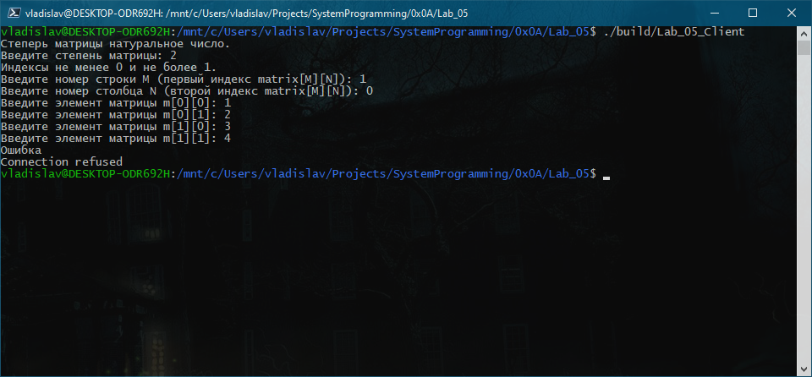

1. Ошибка если сервер не запущен

### Запуск сервера

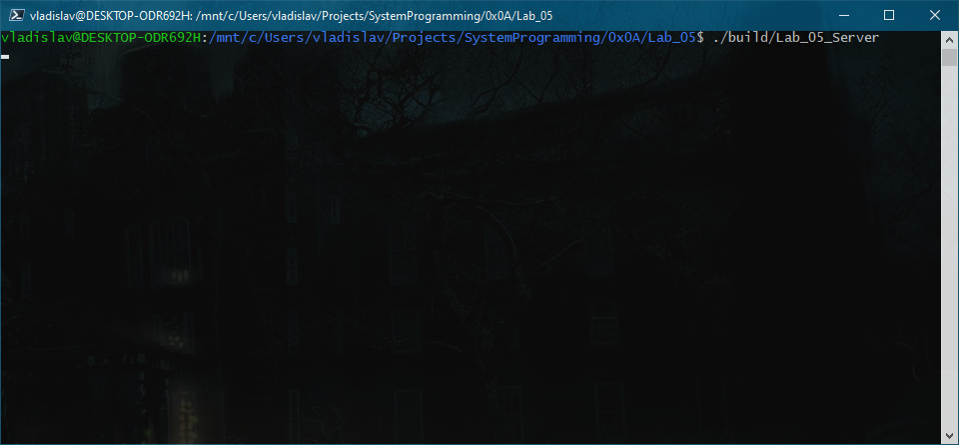

1. Сервер ожидает подключения от клиента

### Запуск клиента

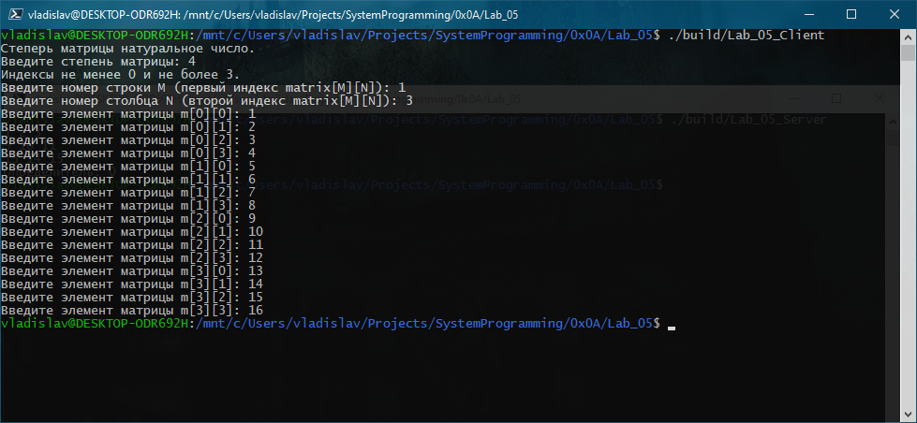

1. Клиент считал данные, передал и успешно завершился

### Результат работы сервера

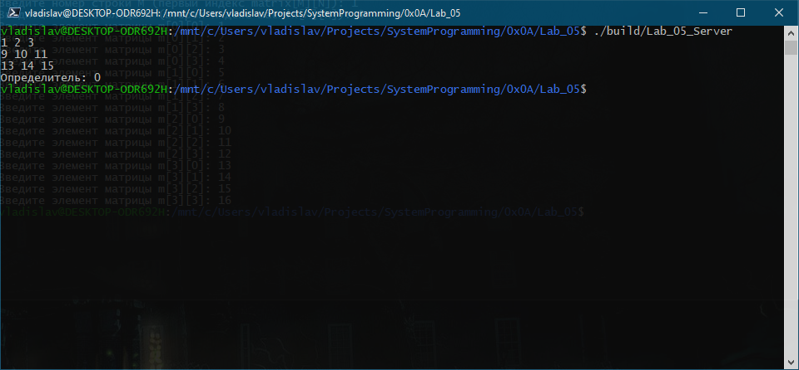

1. Сервер принял, вычислил, вывел результат и успешно завершился

## Запуск №2 (Клиент – Windows, MSVC; удалённый сервер – Ubuntu 16.04, GCC)

### Сборка с помощью autotools на удалённом сервере

vladislav@MySandbox:~/Projects/SystemProgramming/0x0A/Lab_05**$** ./configure  
checking **for** gcc... gcc  
checking whether the C compiler works... yes  
checking **for** C compiler default output file name... a.out  
checking **for** suffix of executables...  
checking whether we are cross compiling... no  
checking **for** suffix of object files... o  
checking whether we are using the GNU C compiler... yes  
checking whether gcc accepts -g... yes  
checking **for** gcc option to accept ISO C89... none needed  
checking whether gcc understands -c and -o together... yes  
checking how to run the C preprocessor... gcc -E  
checking **for** grep that handles long lines and -e... /bin/grep  
checking **for** egrep... /bin/grep -E  
checking **for** ANSI C header files... yes  
checking **for** sys/types.h... yes  
checking **for** sys/stat.h... yes  
checking **for** stdlib.h... yes  
checking **for** string.h... yes  
checking **for** memory.h... yes  
checking **for** strings.h... yes  
checking **for** inttypes.h... yes  
checking **for** stdint.h... yes  
checking **for** unistd.h... yes  
checking arpa/inet.h usability... yes  
checking arpa/inet.h presence... yes  
checking **for** arpa/inet.h... yes  
checking fcntl.h usability... yes  
checking fcntl.h presence... yes  
checking **for** fcntl.h... yes  
checking limits.h usability... yes  
checking limits.h presence... yes  
checking **for** limits.h... yes  
checking malloc.h usability... yes  
checking malloc.h presence... yes  
checking **for** malloc.h... yes  
checking netinet/in.h usability... yes  
checking netinet/in.h presence... yes  
checking **for** netinet/in.h... yes  
checking stddef.h usability... yes  
checking stddef.h presence... yes  
checking **for** stddef.h... yes  
checking **for** stdint.h... (cached) yes  
checking **for** stdlib.h... (cached) yes  
checking **for** string.h... (cached) yes  
checking sys/socket.h usability... yes  
checking sys/socket.h presence... yes  
checking **for** sys/socket.h... yes  
checking **for** unistd.h... (cached) yes  
checking **for** stdbool.h that conforms to C99... yes  
checking **for** _Bool... yes  
checking **for** size_t... yes  
checking **for** uint16_t... yes  
checking **for** uint32_t... yes  
checking **for** stdlib.h... (cached) yes  
checking **for** GNU libc compatible malloc... yes  
checking **for** stdlib.h... (cached) yes  
checking **for** GNU libc compatible realloc... yes  
checking whether strerror_r is declared... yes  
checking **for** strerror_r... yes  
checking whether strerror_r returns char *... no  
checking **for** socket... yes  
checking **for** strchr... yes  
checking **for** a BSD-compatible install... /usr/bin/install -c  
checking whether build environment is sane... yes  
checking **for** a thread-safe mkdir -p... /bin/mkdir -p  
checking **for** gawk... no  
checking **for** mawk... mawk  
checking whether make sets **$**(MAKE)... yes  
checking **for** style of include used by make... GNU  
checking whether make supports nested variables... yes  
checking dependency style of gcc... gcc3  
checking **for** ranlib... ranlib  
checking that generated files are newer than configure... **done**configure: creating ./config.status  
config.status: creating build/Makefile  
config.status: creating Makefile  
config.status: executing depfiles commands  
vladislav@MySandbox:~/Projects/SystemProgramming/0x0A/Lab_05**$** make  
Making all in build  
make[1]: Entering directory **'/home/vladislav/Projects/SystemProgramming/0x0A/Lab_05/build'**gcc -DPACKAGE_NAME=\"Lab_05\" -DPACKAGE_TARNAME=\"lab_05\" -DPACKAGE_VERSION=\"0.1\" -DPACKAGE_STRING=\"Lab_05\ 0.1\" -DPACKAGE_BUGREPORT=\"misterptits@yandex.ru\" -DPACKAGE_URL=\"\" -DSTDC_HEADERS=1 -DHAVE_SYS_TYPES_H=1 -DHAVE_SYS_STAT_H=1 -DHAVE_STDLIB_H=1 -DHAVE_STRING_H=1 -DHAVE_MEMORY_H=1 -DHAVE_STRINGS_H=1 -DHAVE_INTTYPES_H=1 -DHAVE_STDINT_H=1 -DHAVE_UNISTD_H=1 -DHAVE_ARPA_INET_H=1 -DHAVE_FCNTL_H=1 -DHAVE_LIMITS_H=1 -DHAVE_MALLOC_H=1 -DHAVE_NETINET_IN_H=1 -DHAVE_STDDEF_H=1 -DHAVE_STDINT_H=1 -DHAVE_STDLIB_H=1 -DHAVE_STRING_H=1 -DHAVE_SYS_SOCKET_H=1 -DHAVE_UNISTD_H=1 -DHAVE__BOOL=1 -DHAVE_STDLIB_H=1 -DHAVE_MALLOC=1 -DHAVE_STDLIB_H=1 -DHAVE_REALLOC=1 -DHAVE_DECL_STRERROR_R=1 -DHAVE_STRERROR_R=1 -DHAVE_SOCKET=1 -DHAVE_STRCHR=1 -DPACKAGE=\"lab_05\" -DVERSION=\"0.1\" -I. -I../Lab_05_MatrixLib -g -O2 -MT ../Lab_05_Lib/libLab_05_Lib_a-Input.o -MD -MP -MF ../Lab_05_Lib/.deps/libLab_05_Lib_a-Input.Tpo -c -o ../Lab_05_Lib/libLab_05_Lib_a-Input.o `test -f **'../Lab_05_Lib/Input.c' ||** echo **'./'**`../Lab_05_Lib/Input.c  
mv -f ../Lab_05_Lib/.deps/libLab_05_Lib_a-Input.Tpo ../Lab_05_Lib/.deps/libLab_05_Lib_a-Input.Po  
gcc -DPACKAGE_NAME=\"Lab_05\" -DPACKAGE_TARNAME=\"lab_05\" -DPACKAGE_VERSION=\"0.1\" -DPACKAGE_STRING=\"Lab_05\ 0.1\" -DPACKAGE_BUGREPORT=\"misterptits@yandex.ru\" -DPACKAGE_URL=\"\" -DSTDC_HEADERS=1 -DHAVE_SYS_TYPES_H=1 -DHAVE_SYS_STAT_H=1 -DHAVE_STDLIB_H=1 -DHAVE_STRING_H=1 -DHAVE_MEMORY_H=1 -DHAVE_STRINGS_H=1 -DHAVE_INTTYPES_H=1 -DHAVE_STDINT_H=1 -DHAVE_UNISTD_H=1 -DHAVE_ARPA_INET_H=1 -DHAVE_FCNTL_H=1 -DHAVE_LIMITS_H=1 -DHAVE_MALLOC_H=1 -DHAVE_NETINET_IN_H=1 -DHAVE_STDDEF_H=1 -DHAVE_STDINT_H=1 -DHAVE_STDLIB_H=1 -DHAVE_STRING_H=1 -DHAVE_SYS_SOCKET_H=1 -DHAVE_UNISTD_H=1 -DHAVE__BOOL=1 -DHAVE_STDLIB_H=1 -DHAVE_MALLOC=1 -DHAVE_STDLIB_H=1 -DHAVE_REALLOC=1 -DHAVE_DECL_STRERROR_R=1 -DHAVE_STRERROR_R=1 -DHAVE_SOCKET=1 -DHAVE_STRCHR=1 -DPACKAGE=\"lab_05\" -DVERSION=\"0.1\" -I. -I../Lab_05_MatrixLib -g -O2 -MT ../Lab_05_Lib/libLab_05_Lib_a-ParseInt.o -MD -MP -MF ../Lab_05_Lib/.deps/libLab_05_Lib_a-ParseInt.Tpo -c -o ../Lab_05_Lib/libLab_05_Lib_a-ParseInt.o `test -f **'../Lab_05_Lib/ParseInt.c' ||** echo **'./'**`../Lab_05_Lib/ParseInt.c  
mv -f ../Lab_05_Lib/.deps/libLab_05_Lib_a-ParseInt.Tpo ../Lab_05_Lib/.deps/libLab_05_Lib_a-ParseInt.Po  
gcc -DPACKAGE_NAME=\"Lab_05\" -DPACKAGE_TARNAME=\"lab_05\" -DPACKAGE_VERSION=\"0.1\" -DPACKAGE_STRING=\"Lab_05\ 0.1\" -DPACKAGE_BUGREPORT=\"misterptits@yandex.ru\" -DPACKAGE_URL=\"\" -DSTDC_HEADERS=1 -DHAVE_SYS_TYPES_H=1 -DHAVE_SYS_STAT_H=1 -DHAVE_STDLIB_H=1 -DHAVE_STRING_H=1 -DHAVE_MEMORY_H=1 -DHAVE_STRINGS_H=1 -DHAVE_INTTYPES_H=1 -DHAVE_STDINT_H=1 -DHAVE_UNISTD_H=1 -DHAVE_ARPA_INET_H=1 -DHAVE_FCNTL_H=1 -DHAVE_LIMITS_H=1 -DHAVE_MALLOC_H=1 -DHAVE_NETINET_IN_H=1 -DHAVE_STDDEF_H=1 -DHAVE_STDINT_H=1 -DHAVE_STDLIB_H=1 -DHAVE_STRING_H=1 -DHAVE_SYS_SOCKET_H=1 -DHAVE_UNISTD_H=1 -DHAVE__BOOL=1 -DHAVE_STDLIB_H=1 -DHAVE_MALLOC=1 -DHAVE_STDLIB_H=1 -DHAVE_REALLOC=1 -DHAVE_DECL_STRERROR_R=1 -DHAVE_STRERROR_R=1 -DHAVE_SOCKET=1 -DHAVE_STRCHR=1 -DPACKAGE=\"lab_05\" -DVERSION=\"0.1\" -I. -I../Lab_05_MatrixLib -g -O2 -MT ../Lab_05_Lib/libLab_05_Lib_a-ReturnCodes.o -MD -MP -MF ../Lab_05_Lib/.deps/libLab_05_Lib_a-ReturnCodes.Tpo -c -o ../Lab_05_Lib/libLab_05_Lib_a-ReturnCodes.o `test -f **'../Lab_05_Lib/ReturnCodes.c' ||** echo **'./'**`../Lab_05_Lib/ReturnCodes.c  
mv -f ../Lab_05_Lib/.deps/libLab_05_Lib_a-ReturnCodes.Tpo ../Lab_05_Lib/.deps/libLab_05_Lib_a-ReturnCodes.Po  
gcc -DPACKAGE_NAME=\"Lab_05\" -DPACKAGE_TARNAME=\"lab_05\" -DPACKAGE_VERSION=\"0.1\" -DPACKAGE_STRING=\"Lab_05\ 0.1\" -DPACKAGE_BUGREPORT=\"misterptits@yandex.ru\" -DPACKAGE_URL=\"\" -DSTDC_HEADERS=1 -DHAVE_SYS_TYPES_H=1 -DHAVE_SYS_STAT_H=1 -DHAVE_STDLIB_H=1 -DHAVE_STRING_H=1 -DHAVE_MEMORY_H=1 -DHAVE_STRINGS_H=1 -DHAVE_INTTYPES_H=1 -DHAVE_STDINT_H=1 -DHAVE_UNISTD_H=1 -DHAVE_ARPA_INET_H=1 -DHAVE_FCNTL_H=1 -DHAVE_LIMITS_H=1 -DHAVE_MALLOC_H=1 -DHAVE_NETINET_IN_H=1 -DHAVE_STDDEF_H=1 -DHAVE_STDINT_H=1 -DHAVE_STDLIB_H=1 -DHAVE_STRING_H=1 -DHAVE_SYS_SOCKET_H=1 -DHAVE_UNISTD_H=1 -DHAVE__BOOL=1 -DHAVE_STDLIB_H=1 -DHAVE_MALLOC=1 -DHAVE_STDLIB_H=1 -DHAVE_REALLOC=1 -DHAVE_DECL_STRERROR_R=1 -DHAVE_STRERROR_R=1 -DHAVE_SOCKET=1 -DHAVE_STRCHR=1 -DPACKAGE=\"lab_05\" -DVERSION=\"0.1\" -I. -I../Lab_05_MatrixLib -g -O2 -MT ../Lab_05_Lib/libLab_05_Lib_a-LastErrorMessage.o -MD -MP -MF ../Lab_05_Lib/.deps/libLab_05_Lib_a-LastErrorMessage.Tpo -c -o ../Lab_05_Lib/libLab_05_Lib_a-LastErrorMessage.o `test -f **'../Lab_05_Lib/LastErrorMessage.c' ||** echo **'./'**`../Lab_05_Lib/LastErrorMessage.c  
mv -f ../Lab_05_Lib/.deps/libLab_05_Lib_a-LastErrorMessage.Tpo ../Lab_05_Lib/.deps/libLab_05_Lib_a-LastErrorMessage.Po  
gcc -DPACKAGE_NAME=\"Lab_05\" -DPACKAGE_TARNAME=\"lab_05\" -DPACKAGE_VERSION=\"0.1\" -DPACKAGE_STRING=\"Lab_05\ 0.1\" -DPACKAGE_BUGREPORT=\"misterptits@yandex.ru\" -DPACKAGE_URL=\"\" -DSTDC_HEADERS=1 -DHAVE_SYS_TYPES_H=1 -DHAVE_SYS_STAT_H=1 -DHAVE_STDLIB_H=1 -DHAVE_STRING_H=1 -DHAVE_MEMORY_H=1 -DHAVE_STRINGS_H=1 -DHAVE_INTTYPES_H=1 -DHAVE_STDINT_H=1 -DHAVE_UNISTD_H=1 -DHAVE_ARPA_INET_H=1 -DHAVE_FCNTL_H=1 -DHAVE_LIMITS_H=1 -DHAVE_MALLOC_H=1 -DHAVE_NETINET_IN_H=1 -DHAVE_STDDEF_H=1 -DHAVE_STDINT_H=1 -DHAVE_STDLIB_H=1 -DHAVE_STRING_H=1 -DHAVE_SYS_SOCKET_H=1 -DHAVE_UNISTD_H=1 -DHAVE__BOOL=1 -DHAVE_STDLIB_H=1 -DHAVE_MALLOC=1 -DHAVE_STDLIB_H=1 -DHAVE_REALLOC=1 -DHAVE_DECL_STRERROR_R=1 -DHAVE_STRERROR_R=1 -DHAVE_SOCKET=1 -DHAVE_STRCHR=1 -DPACKAGE=\"lab_05\" -DVERSION=\"0.1\" -I. -I../Lab_05_MatrixLib -g -O2 -MT ../Lab_05_Lib/libLab_05_Lib_a-Request.o -MD -MP -MF ../Lab_05_Lib/.deps/libLab_05_Lib_a-Request.Tpo -c -o ../Lab_05_Lib/libLab_05_Lib_a-Request.o `test -f **'../Lab_05_Lib/Request.c' ||** echo **'./'**`../Lab_05_Lib/Request.c  
mv -f ../Lab_05_Lib/.deps/libLab_05_Lib_a-Request.Tpo ../Lab_05_Lib/.deps/libLab_05_Lib_a-Request.Po  
gcc -DPACKAGE_NAME=\"Lab_05\" -DPACKAGE_TARNAME=\"lab_05\" -DPACKAGE_VERSION=\"0.1\" -DPACKAGE_STRING=\"Lab_05\ 0.1\" -DPACKAGE_BUGREPORT=\"misterptits@yandex.ru\" -DPACKAGE_URL=\"\" -DSTDC_HEADERS=1 -DHAVE_SYS_TYPES_H=1 -DHAVE_SYS_STAT_H=1 -DHAVE_STDLIB_H=1 -DHAVE_STRING_H=1 -DHAVE_MEMORY_H=1 -DHAVE_STRINGS_H=1 -DHAVE_INTTYPES_H=1 -DHAVE_STDINT_H=1 -DHAVE_UNISTD_H=1 -DHAVE_ARPA_INET_H=1 -DHAVE_FCNTL_H=1 -DHAVE_LIMITS_H=1 -DHAVE_MALLOC_H=1 -DHAVE_NETINET_IN_H=1 -DHAVE_STDDEF_H=1 -DHAVE_STDINT_H=1 -DHAVE_STDLIB_H=1 -DHAVE_STRING_H=1 -DHAVE_SYS_SOCKET_H=1 -DHAVE_UNISTD_H=1 -DHAVE__BOOL=1 -DHAVE_STDLIB_H=1 -DHAVE_MALLOC=1 -DHAVE_STDLIB_H=1 -DHAVE_REALLOC=1 -DHAVE_DECL_STRERROR_R=1 -DHAVE_STRERROR_R=1 -DHAVE_SOCKET=1 -DHAVE_STRCHR=1 -DPACKAGE=\"lab_05\" -DVERSION=\"0.1\" -I. -I../Lab_05_MatrixLib -g -O2 -MT ../Lab_05_Lib/libLab_05_Lib_a-Socket.o -MD -MP -MF ../Lab_05_Lib/.deps/libLab_05_Lib_a-Socket.Tpo -c -o ../Lab_05_Lib/libLab_05_Lib_a-Socket.o `test -f **'../Lab_05_Lib/Socket.c' ||** echo **'./'**`../Lab_05_Lib/Socket.c  
mv -f ../Lab_05_Lib/.deps/libLab_05_Lib_a-Socket.Tpo ../Lab_05_Lib/.deps/libLab_05_Lib_a-Socket.Po  
depbase=`echo ../Lab_05_MatrixLib/Matrix.o | sed **'s|[^/]*$|.deps/&|;s|\.o$||'**`;\  
gcc -DPACKAGE_NAME=\"Lab_05\" -DPACKAGE_TARNAME=\"lab_05\" -DPACKAGE_VERSION=\"0.1\" -DPACKAGE_STRING=\"Lab_05\ 0.1\" -DPACKAGE_BUGREPORT=\"misterptits@yandex.ru\" -DPACKAGE_URL=\"\" -DSTDC_HEADERS=1 -DHAVE_SYS_TYPES_H=1 -DHAVE_SYS_STAT_H=1 -DHAVE_STDLIB_H=1 -DHAVE_STRING_H=1 -DHAVE_MEMORY_H=1 -DHAVE_STRINGS_H=1 -DHAVE_INTTYPES_H=1 -DHAVE_STDINT_H=1 -DHAVE_UNISTD_H=1 -DHAVE_ARPA_INET_H=1 -DHAVE_FCNTL_H=1 -DHAVE_LIMITS_H=1 -DHAVE_MALLOC_H=1 -DHAVE_NETINET_IN_H=1 -DHAVE_STDDEF_H=1 -DHAVE_STDINT_H=1 -DHAVE_STDLIB_H=1 -DHAVE_STRING_H=1 -DHAVE_SYS_SOCKET_H=1 -DHAVE_UNISTD_H=1 -DHAVE__BOOL=1 -DHAVE_STDLIB_H=1 -DHAVE_MALLOC=1 -DHAVE_STDLIB_H=1 -DHAVE_REALLOC=1 -DHAVE_DECL_STRERROR_R=1 -DHAVE_STRERROR_R=1 -DHAVE_SOCKET=1 -DHAVE_STRCHR=1 -DPACKAGE=\"lab_05\" -DVERSION=\"0.1\" -I. -g -O2 -MT ../Lab_05_MatrixLib/Matrix.o -MD -MP -MF $depbase.Tpo -c -o ../Lab_05_MatrixLib/Matrix.o ../Lab_05_MatrixLib/Matrix.c **&&**\  
mv -f $depbase.Tpo $depbase.Po  
rm -f libLab_05_MatrixLib.a  
ar cru libLab_05_MatrixLib.a ../Lab_05_MatrixLib/Matrix.o  
ar: `u**' modifier ignored since `D'** is the default (see `U**')  
ranlib libLab_05_MatrixLib.a  
rm -f libLab_05_Lib.a  
ar cru libLab_05_Lib.a ../Lab_05_Lib/libLab_05_Lib_a-Input.o ../Lab_05_Lib/libLab_05_Lib_a-ParseInt.o ../Lab_05_Lib/libLab_05_Lib_a-ReturnCodes.o ../Lab_05_Lib/libLab_05_Lib_a-LastErrorMessage.o ../Lab_05_Lib/libLab_05_Lib_a-Request.o ../Lab_05_Lib/libLab_05_Lib_a-Socket.o libLab_05_MatrixLib.a  
ar: `u'** modifier ignored since `D**' is the default (see `U'**)  
ranlib libLab_05_Lib.a  
gcc -DPACKAGE_NAME=\"Lab_05\" -DPACKAGE_TARNAME=\"lab_05\" -DPACKAGE_VERSION=\"0.1\" -DPACKAGE_STRING=\"Lab_05\ 0.1\" -DPACKAGE_BUGREPORT=\"misterptits@yandex.ru\" -DPACKAGE_URL=\"\" -DSTDC_HEADERS=1 -DHAVE_SYS_TYPES_H=1 -DHAVE_SYS_STAT_H=1 -DHAVE_STDLIB_H=1 -DHAVE_STRING_H=1 -DHAVE_MEMORY_H=1 -DHAVE_STRINGS_H=1 -DHAVE_INTTYPES_H=1 -DHAVE_STDINT_H=1 -DHAVE_UNISTD_H=1 -DHAVE_ARPA_INET_H=1 -DHAVE_FCNTL_H=1 -DHAVE_LIMITS_H=1 -DHAVE_MALLOC_H=1 -DHAVE_NETINET_IN_H=1 -DHAVE_STDDEF_H=1 -DHAVE_STDINT_H=1 -DHAVE_STDLIB_H=1 -DHAVE_STRING_H=1 -DHAVE_SYS_SOCKET_H=1 -DHAVE_UNISTD_H=1 -DHAVE__BOOL=1 -DHAVE_STDLIB_H=1 -DHAVE_MALLOC=1 -DHAVE_STDLIB_H=1 -DHAVE_REALLOC=1 -DHAVE_DECL_STRERROR_R=1 -DHAVE_STRERROR_R=1 -DHAVE_SOCKET=1 -DHAVE_STRCHR=1 -DPACKAGE=\"lab_05\" -DVERSION=\"0.1\" -I. -I../Lab_05_MatrixLib -I../Lab_05_Lib -g -O2 -MT ../Lab_05_Client/Lab_05_Client-Args.o -MD -MP -MF ../Lab_05_Client/.deps/Lab_05_Client-Args.Tpo -c -o ../Lab_05_Client/Lab_05_Client-Args.o `test -f **'../Lab_05_Client/Args.c' ||** echo **'./'**`../Lab_05_Client/Args.c  
mv -f ../Lab_05_Client/.deps/Lab_05_Client-Args.Tpo ../Lab_05_Client/.deps/Lab_05_Client-Args.Po  
gcc -DPACKAGE_NAME=\"Lab_05\" -DPACKAGE_TARNAME=\"lab_05\" -DPACKAGE_VERSION=\"0.1\" -DPACKAGE_STRING=\"Lab_05\ 0.1\" -DPACKAGE_BUGREPORT=\"misterptits@yandex.ru\" -DPACKAGE_URL=\"\" -DSTDC_HEADERS=1 -DHAVE_SYS_TYPES_H=1 -DHAVE_SYS_STAT_H=1 -DHAVE_STDLIB_H=1 -DHAVE_STRING_H=1 -DHAVE_MEMORY_H=1 -DHAVE_STRINGS_H=1 -DHAVE_INTTYPES_H=1 -DHAVE_STDINT_H=1 -DHAVE_UNISTD_H=1 -DHAVE_ARPA_INET_H=1 -DHAVE_FCNTL_H=1 -DHAVE_LIMITS_H=1 -DHAVE_MALLOC_H=1 -DHAVE_NETINET_IN_H=1 -DHAVE_STDDEF_H=1 -DHAVE_STDINT_H=1 -DHAVE_STDLIB_H=1 -DHAVE_STRING_H=1 -DHAVE_SYS_SOCKET_H=1 -DHAVE_UNISTD_H=1 -DHAVE__BOOL=1 -DHAVE_STDLIB_H=1 -DHAVE_MALLOC=1 -DHAVE_STDLIB_H=1 -DHAVE_REALLOC=1 -DHAVE_DECL_STRERROR_R=1 -DHAVE_STRERROR_R=1 -DHAVE_SOCKET=1 -DHAVE_STRCHR=1 -DPACKAGE=\"lab_05\" -DVERSION=\"0.1\" -I. -I../Lab_05_MatrixLib -I../Lab_05_Lib -g -O2 -MT ../Lab_05_Client/Lab_05_Client-Client.o -MD -MP -MF ../Lab_05_Client/.deps/Lab_05_Client-Client.Tpo -c -o ../Lab_05_Client/Lab_05_Client-Client.o `test -f **'../Lab_05_Client/Client.c' ||** echo **'./'**`../Lab_05_Client/Client.c  
mv -f ../Lab_05_Client/.deps/Lab_05_Client-Client.Tpo ../Lab_05_Client/.deps/Lab_05_Client-Client.Po  
gcc -DPACKAGE_NAME=\"Lab_05\" -DPACKAGE_TARNAME=\"lab_05\" -DPACKAGE_VERSION=\"0.1\" -DPACKAGE_STRING=\"Lab_05\ 0.1\" -DPACKAGE_BUGREPORT=\"misterptits@yandex.ru\" -DPACKAGE_URL=\"\" -DSTDC_HEADERS=1 -DHAVE_SYS_TYPES_H=1 -DHAVE_SYS_STAT_H=1 -DHAVE_STDLIB_H=1 -DHAVE_STRING_H=1 -DHAVE_MEMORY_H=1 -DHAVE_STRINGS_H=1 -DHAVE_INTTYPES_H=1 -DHAVE_STDINT_H=1 -DHAVE_UNISTD_H=1 -DHAVE_ARPA_INET_H=1 -DHAVE_FCNTL_H=1 -DHAVE_LIMITS_H=1 -DHAVE_MALLOC_H=1 -DHAVE_NETINET_IN_H=1 -DHAVE_STDDEF_H=1 -DHAVE_STDINT_H=1 -DHAVE_STDLIB_H=1 -DHAVE_STRING_H=1 -DHAVE_SYS_SOCKET_H=1 -DHAVE_UNISTD_H=1 -DHAVE__BOOL=1 -DHAVE_STDLIB_H=1 -DHAVE_MALLOC=1 -DHAVE_STDLIB_H=1 -DHAVE_REALLOC=1 -DHAVE_DECL_STRERROR_R=1 -DHAVE_STRERROR_R=1 -DHAVE_SOCKET=1 -DHAVE_STRCHR=1 -DPACKAGE=\"lab_05\" -DVERSION=\"0.1\" -I. -I../Lab_05_MatrixLib -I../Lab_05_Lib -g -O2 -MT ../Lab_05_Client/Lab_05_Client-main.o -MD -MP -MF ../Lab_05_Client/.deps/Lab_05_Client-main.Tpo -c -o ../Lab_05_Client/Lab_05_Client-main.o `test -f **'../Lab_05_Client/main.c' ||** echo **'./'**`../Lab_05_Client/main.c  
mv -f ../Lab_05_Client/.deps/Lab_05_Client-main.Tpo ../Lab_05_Client/.deps/Lab_05_Client-main.Po  
gcc -I../Lab_05_MatrixLib -I../Lab_05_Lib -g -O2 -o Lab_05_Client ../Lab_05_Client/Lab_05_Client-Args.o ../Lab_05_Client/Lab_05_Client-Client.o ../Lab_05_Client/Lab_05_Client-main.o libLab_05_MatrixLib.a libLab_05_Lib.a  
gcc -DPACKAGE_NAME=\"Lab_05\" -DPACKAGE_TARNAME=\"lab_05\" -DPACKAGE_VERSION=\"0.1\" -DPACKAGE_STRING=\"Lab_05\ 0.1\" -DPACKAGE_BUGREPORT=\"misterptits@yandex.ru\" -DPACKAGE_URL=\"\" -DSTDC_HEADERS=1 -DHAVE_SYS_TYPES_H=1 -DHAVE_SYS_STAT_H=1 -DHAVE_STDLIB_H=1 -DHAVE_STRING_H=1 -DHAVE_MEMORY_H=1 -DHAVE_STRINGS_H=1 -DHAVE_INTTYPES_H=1 -DHAVE_STDINT_H=1 -DHAVE_UNISTD_H=1 -DHAVE_ARPA_INET_H=1 -DHAVE_FCNTL_H=1 -DHAVE_LIMITS_H=1 -DHAVE_MALLOC_H=1 -DHAVE_NETINET_IN_H=1 -DHAVE_STDDEF_H=1 -DHAVE_STDINT_H=1 -DHAVE_STDLIB_H=1 -DHAVE_STRING_H=1 -DHAVE_SYS_SOCKET_H=1 -DHAVE_UNISTD_H=1 -DHAVE__BOOL=1 -DHAVE_STDLIB_H=1 -DHAVE_MALLOC=1 -DHAVE_STDLIB_H=1 -DHAVE_REALLOC=1 -DHAVE_DECL_STRERROR_R=1 -DHAVE_STRERROR_R=1 -DHAVE_SOCKET=1 -DHAVE_STRCHR=1 -DPACKAGE=\"lab_05\" -DVERSION=\"0.1\" -I. -I../Lab_05_MatrixLib -I../Lab_05_Lib -g -O2 -MT ../Lab_05_Server/Lab_05_Server-Args.o -MD -MP -MF ../Lab_05_Server/.deps/Lab_05_Server-Args.Tpo -c -o ../Lab_05_Server/Lab_05_Server-Args.o `test -f **'../Lab_05_Server/Args.c' ||** echo **'./'**`../Lab_05_Server/Args.c  
mv -f ../Lab_05_Server/.deps/Lab_05_Server-Args.Tpo ../Lab_05_Server/.deps/Lab_05_Server-Args.Po  
gcc -DPACKAGE_NAME=\"Lab_05\" -DPACKAGE_TARNAME=\"lab_05\" -DPACKAGE_VERSION=\"0.1\" -DPACKAGE_STRING=\"Lab_05\ 0.1\" -DPACKAGE_BUGREPORT=\"misterptits@yandex.ru\" -DPACKAGE_URL=\"\" -DSTDC_HEADERS=1 -DHAVE_SYS_TYPES_H=1 -DHAVE_SYS_STAT_H=1 -DHAVE_STDLIB_H=1 -DHAVE_STRING_H=1 -DHAVE_MEMORY_H=1 -DHAVE_STRINGS_H=1 -DHAVE_INTTYPES_H=1 -DHAVE_STDINT_H=1 -DHAVE_UNISTD_H=1 -DHAVE_ARPA_INET_H=1 -DHAVE_FCNTL_H=1 -DHAVE_LIMITS_H=1 -DHAVE_MALLOC_H=1 -DHAVE_NETINET_IN_H=1 -DHAVE_STDDEF_H=1 -DHAVE_STDINT_H=1 -DHAVE_STDLIB_H=1 -DHAVE_STRING_H=1 -DHAVE_SYS_SOCKET_H=1 -DHAVE_UNISTD_H=1 -DHAVE__BOOL=1 -DHAVE_STDLIB_H=1 -DHAVE_MALLOC=1 -DHAVE_STDLIB_H=1 -DHAVE_REALLOC=1 -DHAVE_DECL_STRERROR_R=1 -DHAVE_STRERROR_R=1 -DHAVE_SOCKET=1 -DHAVE_STRCHR=1 -DPACKAGE=\"lab_05\" -DVERSION=\"0.1\" -I. -I../Lab_05_MatrixLib -I../Lab_05_Lib -g -O2 -MT ../Lab_05_Server/Lab_05_Server-Server.o -MD -MP -MF ../Lab_05_Server/.deps/Lab_05_Server-Server.Tpo -c -o ../Lab_05_Server/Lab_05_Server-Server.o `test -f **'../Lab_05_Server/Server.c' ||** echo **'./'**`../Lab_05_Server/Server.c  
mv -f ../Lab_05_Server/.deps/Lab_05_Server-Server.Tpo ../Lab_05_Server/.deps/Lab_05_Server-Server.Po  
gcc -DPACKAGE_NAME=\"Lab_05\" -DPACKAGE_TARNAME=\"lab_05\" -DPACKAGE_VERSION=\"0.1\" -DPACKAGE_STRING=\"Lab_05\ 0.1\" -DPACKAGE_BUGREPORT=\"misterptits@yandex.ru\" -DPACKAGE_URL=\"\" -DSTDC_HEADERS=1 -DHAVE_SYS_TYPES_H=1 -DHAVE_SYS_STAT_H=1 -DHAVE_STDLIB_H=1 -DHAVE_STRING_H=1 -DHAVE_MEMORY_H=1 -DHAVE_STRINGS_H=1 -DHAVE_INTTYPES_H=1 -DHAVE_STDINT_H=1 -DHAVE_UNISTD_H=1 -DHAVE_ARPA_INET_H=1 -DHAVE_FCNTL_H=1 -DHAVE_LIMITS_H=1 -DHAVE_MALLOC_H=1 -DHAVE_NETINET_IN_H=1 -DHAVE_STDDEF_H=1 -DHAVE_STDINT_H=1 -DHAVE_STDLIB_H=1 -DHAVE_STRING_H=1 -DHAVE_SYS_SOCKET_H=1 -DHAVE_UNISTD_H=1 -DHAVE__BOOL=1 -DHAVE_STDLIB_H=1 -DHAVE_MALLOC=1 -DHAVE_STDLIB_H=1 -DHAVE_REALLOC=1 -DHAVE_DECL_STRERROR_R=1 -DHAVE_STRERROR_R=1 -DHAVE_SOCKET=1 -DHAVE_STRCHR=1 -DPACKAGE=\"lab_05\" -DVERSION=\"0.1\" -I. -I../Lab_05_MatrixLib -I../Lab_05_Lib -g -O2 -MT ../Lab_05_Server/Lab_05_Server-main.o -MD -MP -MF ../Lab_05_Server/.deps/Lab_05_Server-main.Tpo -c -o ../Lab_05_Server/Lab_05_Server-main.o `test -f **'../Lab_05_Server/main.c' ||** echo **'./'**`../Lab_05_Server/main.c  
mv -f ../Lab_05_Server/.deps/Lab_05_Server-main.Tpo ../Lab_05_Server/.deps/Lab_05_Server-main.Po  
gcc -I../Lab_05_MatrixLib -I../Lab_05_Lib -g -O2 -o Lab_05_Server ../Lab_05_Server/Lab_05_Server-Args.o ../Lab_05_Server/Lab_05_Server-Server.o ../Lab_05_Server/Lab_05_Server-main.o libLab_05_MatrixLib.a libLab_05_Lib.a  
make[1]: Leaving directory **'/home/vladislav/Projects/SystemProgramming/0x0A/Lab_05/build'**make[1]: Entering directory **'/home/vladislav/Projects/SystemProgramming/0x0A/Lab_05'**make[1]: Nothing to be **done for 'all-am'**.  
make[1]: Leaving directory **'/home/vladislav/Projects/SystemProgramming/0x0A/Lab_05'**

### Сборка на клиенте с помощью CMake и msbuild

PS C:\Users\vladislav\Projects\SystemProgramming\0x0A\Lab_05\build**>** cmake .. -- Building for: Visual Studio 16 2019  
-- Selecting Windows SDK version 10.0.18362.0 to target Windows 10.0.18363.  
-- The C compiler identification is MSVC 19.24.28207.0  
-- The CXX compiler identification is MSVC 19.24.28207.0  
-- Check **for** working C compiler: C:/Program Files (x86)/Microsoft Visual Studio/2019/Preview/VC/Tools/MSVC/14.24.28207/bin/Hostx64/x64/cl.exe  
-- Check **for** working C compiler: C:/Program Files (x86)/Microsoft Visual Studio/2019/Preview/VC/Tools/MSVC/14.24.28207/bin/Hostx64/x64/cl.exe -- works  
-- Detecting C compiler ABI info  
-- Detecting C compiler ABI info - **done**-- Detecting C compile features  
-- Detecting C compile features - **done**-- Check **for** working CXX compiler: C:/Program Files (x86)/Microsoft Visual Studio/2019/Preview/VC/Tools/MSVC/14.24.28207/bin/Hostx64/x64/cl.exe  
-- Check **for** working CXX compiler: C:/Program Files (x86)/Microsoft Visual Studio/2019/Preview/VC/Tools/MSVC/14.24.28207/bin/Hostx64/x64/cl.exe -- works  
-- Detecting CXX compiler ABI info  
-- Detecting CXX compiler ABI info - **done**-- Detecting CXX compile features  
-- Detecting CXX compile features - **done**-- Configuring **done**-- Generating **done**-- Build files have been written to: C:/Users/vladislav/Projects/SystemProgramming/0x0A/Lab_05/build  
PS C:\Users\vladislav\Projects\SystemProgramming\0x0A\Lab_05\build**>** msbuild .\ALL_BUILD.vcxproj Microsoft (R) Build Engine version 16.4.0-preview-19502-03+3af680463 **for** .NET Framework  
Copyright (C) Microsoft Corporation. All rights reserved.  
  
Build started 19.11.2019 21:50:58.

Пропущена работа msbuild

**20 Warning(s)  
 0 Error(s)  
  
Time Elapsed 00:00:06.55**

### Запуск клиента без запущенного сервера

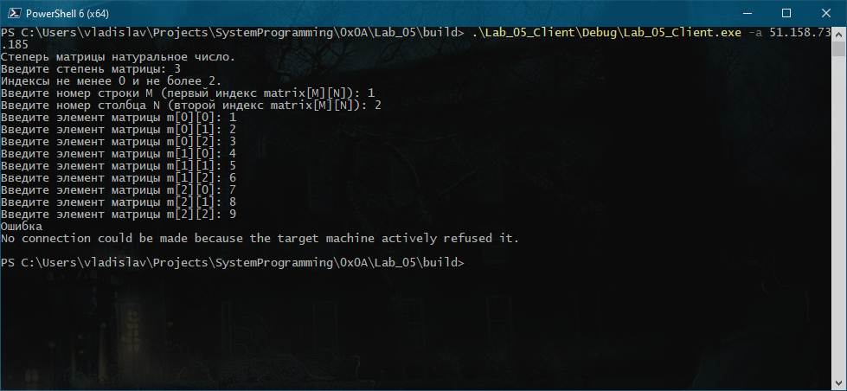

1. Ошибка если сервер не запущен

### Запуск сервера

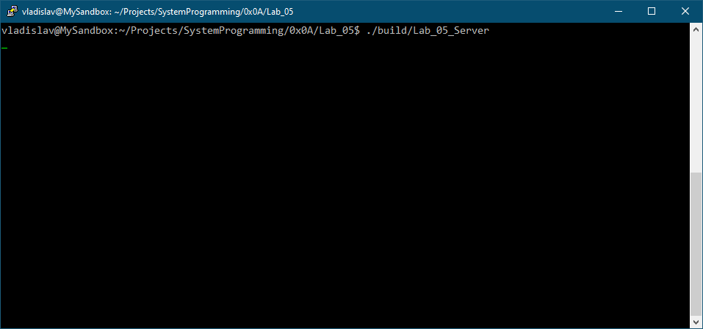

1. Сервер ожидает подключения от клиента

### Запуск клиента

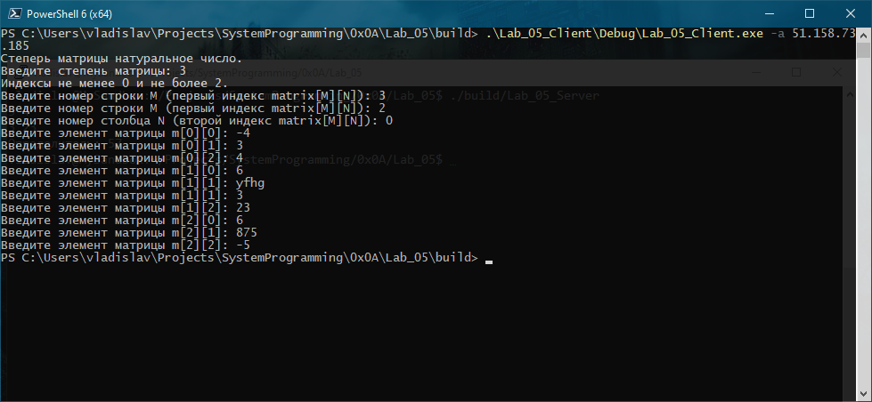

1. Клиент считал данные, передал и успешно завершился

### Результат работы сервера

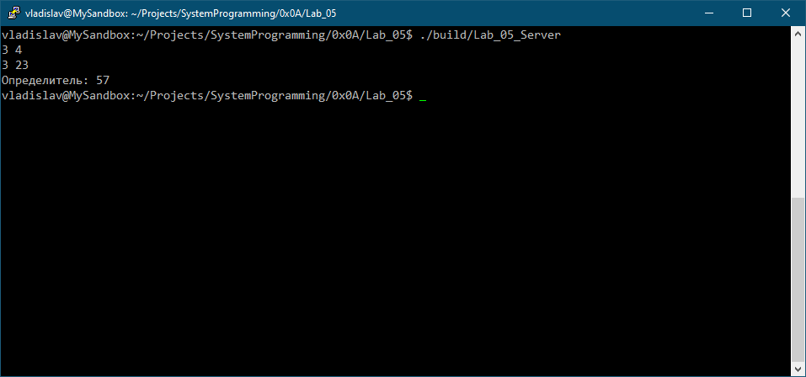

1. Сервер принял, вычислил, вывел результат и успешно завершился