AI-based Generalizable Model (GzMPDD) to detect plant leaf disease using YOLOv8n

|  |  |  |
| --- | --- | --- |
| Samiul Haque Azmi  *School of Computer Science and Engineering* *VIT Bhopal University* Sehore, India [samiul.23bce10842@vitbhopal.ac.in](mailto:samiul.23bce10842@vitbhopal.ac.in) | Preksha Agarwal *School of Computer Science and Engineering* *VIT Bhopal University* Sehore, India [preksha.23bce10948@vitbhopal.ac.in](mailto:preksha.23bce10948@vitbhopal.ac.in) | Vinayak Sharma *School of Computer Science and Engineering* *VIT Bhopal University* Sehore, India [vinayak.23bce10766@vitbhopal.ac.in](mailto:vinayak.23bce10766@vitbhopal.ac.in) |
| Priya *School of Computer Science and Engineering* *VIT Bhopal University* Sehore, India [priya.23bce10599@vitbhopal.ac.in](mailto:priya.23bce10599@vitbhopal.ac.in) | Shorya Dixit *School of Computer Science and Engineering* *VIT Bhopal University* Sehore, India [shorya.23bce10614@vitbhopal.ac.in](mailto:shorya.23bce10614@vitbhopal.ac.in) | Vishal Singh Bhati *School of Computer Science and Engineering* *VIT Bhopal University* Sehore, India [vishalsinghbhati@vitbhopal.ac.in](mailto:vishalsinghbhati@vitbhopal.ac.in) |

*Abstract*—Plant diseases threaten global agriculture, causing significant crop and economic losses. Current AI-based detection models lack generalization, limiting their effectiveness across diverse plant species and environmental conditions. This project aims to develop a generalizable AI model capable of detecting common diseases in various plant species, particularly taxonomically similar ones, by addressing these limitations to enhance the scope and robustness of plant disease detection systems. The system will target agricultural professionals and farmers, providing them with an automated and real-time solution to detect diseases based on input images. Current approaches struggle with the generalization of plant disease detection across different species and environments, as background noise and inconsistent image quality often reduce the performance of existing models. Traditional methods include extraction techniques such as LBP and HOG for texture analysis, while modern solutions include deep learning models such as CNN and YOLO, which provide more accurate detection. This paper proposes a hybrid detection system based on YOLOv8, including a background removal model to preprocess images. The primary dataset consists of 19 classes (7 types of plants and 12 distinct diseases), summing up to 14 distinct disease-plant pairs, alongside an auxiliary dataset that includes different plant species with the same diseases as the primary dataset. Experiments suggest that removing background noise improves the detection accuracy of YOLOv8 by focusing only on the leaf region, and the inclusion of an additional dataset improves the identification of diseases for related plant species. This method promises to provide a reliable and scalable solution for detecting plant diseases by using YOLOv8 with background removal and dual-dataset disease matching.

Keywords—Generalizable Model (GzMPDD)

# Introduction

Efficient farming and healthy crops are critical for sustainable agriculture to meet the growing food demands of the world. Diseases, if not detected, can lead to substantial reductions in crop yield and quality, resulting in severe economic losses and threatening food security on a larger scale [1]. Hence, timely and accurate identification of diseases and the implementation of effective management and control measures are crucial [2]. With the rapid advancement and widespread application of technologies such as computer vision, machine learning, and artificial intelligence, these high-tech tools have become core elements of smart agriculture. They can automatically collect and analyze various types of information in agricultural production, providing an opportunity to curb their spread and minimize damage [3][4][5][6][7][8]. Traditional manual inspections, though beneficial, are slow, tedious, and prone to errors, further compounded by environmental challenges such as changing light conditions and noisy fields. Conventional approaches such as Local Binary Patterns (LBP) and Histogram of Oriented Gradients (HOG) have been utilized for feature extraction, while more advanced deep learning-based methods, particularly Convolutional Neural Networks (CNNs), have shown promising results [3]. However, these methods often face challenges such as limited generalization across different plant species, susceptibility to environmental variations, and high computational requirements [9]. Recent research has explored deep learning frameworks, including MobileNet-based models and lightweight CNN architectures, to improve detection efficiency and scalability [5]. While these methods enhance precision, they still struggle with the complexity of real-world agricultural environments, particularly in recognizing diseases across different species. A review of existing literature highlights two major limitations in current plant disease detection techniques. **Firstly, performance issues related to different plant species: ** Many models are crop-specific and fail to generalize when applied to different plant species, reducing their practical applicability, especially for farmers dealing with multiple crops or unknown species. **Secondly, the influence of background noise on field images: ** Field images are often affected by environmental factors such as overlapping leaves, varying lighting conditions, and cluttered backgrounds, which con fuse detection models and degrade their accuracy [10]. These challenges significantly hinder the effectiveness of automated plant disease detection in real-world applications.

To overcome these challenges, this paper leverages the state-of-the-art YOLOv8 for disease detection and introduces a novel two-step framework. Firstly, background noise is mitigated using pre-trained segmentation models, allowing the model to focus on plant features and symptoms, thereby improving accuracy [10]. Secondly, a dual dataset approach is employed, incorporating a primary dataset with labeled data for 10 plant species and an auxiliary dataset containing cross-species disease pat terns. This methodology addresses species-specific limitations by enabling cross-species generalization [11]. The lightweight architecture of YOLOv8 ensures real-time mobile compatible disease detection, making it suitable for dynamic farming environments [12].

The key contributions of this work are as follows:

* The introduction of a segmentation-based preprocessing step to improve disease feature extraction.
* A dual-dataset training approach to enhance model generalization across species.
* The use of YOLOv8 for real-time, mobile-compatible disease detection, ensuring robustness in field conditions, and
* A labeling methodology that trains the model to detect similar symptoms in taxonomically related species, making it more adaptable to real-world agricultural challenges.

This innovative combination of dataset structure, segmentation, and YOLOv8 integration creates a practical and scalable solution for modern agriculture, enabling early and efficient disease management while promoting sustainable practices [13].

# Related Work/Literature

The identification of plant diseases is a key research area in agriculture and computer vision. Detection methods are broadly classified into non-learning-based techniques, which rely on hand-crafted feature extraction, and learning-based methods, which utilize machine learning for improved accuracy. This section explores both approaches, highlighting their advantages, limitations, and recent advancements.

## Traditional Feature-Based Methods for Plant Disease Detection

Traditional methods for detecting plant disease involve hand-crafted feature extraction techniques. While these methods are efficient in terms of computation and somewhat intuitive, they have limitations, particularly when applied to large datasets due to their complexity and variability. One such technique is Local Binary Patterns (LBP) and Histogram of Oriented Gradients (HOG), which are commonly used to extract textural and structural features from plant images. LBP has been widely used to capture the surface textures of diseased leaves, providing a relatively quick and inexpensive method to identify basic diseases. However, these methods are unable to capture more detailed patterns and struggle with larger or more varied datasets, leading to reduced accuracy [11]. Another set of key point-based methods includes Scale-Invariant Feature 3 Transform (SIFT) and Speeded-Up Robust Features (SURF), which focus on detecting significant visual features such as lesions or discolorations in plant images. These methods work effectively under controlled conditions, but are highly sensitive to variations in scale, rotation, and lighting. As a result, they are less reliable in real-world scenarios, where such variations are frequent [10].

## Machine Learning-Based Methods for Plant Disease Detection

Advancements in machine learning have significantly improved the accuracy and scalability of plant disease detection using learning-based methods. These models can learn complex patterns and adapt to different datasets, which helps overcome most of the limitations of traditional approaches. One notable learning-based method is Convolutional neural networks (CNNs)are widely used for leaf disease detection due to their strong performance in image analysis and pattern recognition [14]. They can extract complex disease features from numerous images of the leaf of the plant [15]. For exam ple, CNNs have been used to detect grapevine diseases by examining the fine details of leaf images [11]. However, CNNs require large amounts of well-annotated data to perform effectively, which limits their scalability to new crops or conditions that are not included in the training data set [13]. Another significant development in plant disease detection is the use of YOLO-based models, which have revolutionized the field by combining precision with fast processing speeds. YOLOv5, for example, has been used to identify plant diseases in multiple crops, providing farmers with quick and action able information on the diseases affecting their crops. The latest version, YOLOv8, has surpassed previous versions in terms of accuracy and processing speed. Its lightweight design enables it to be deployed on mobile devices, allowing even farmers in remote areas to benefit from advanced plant disease detection [11] [10].

# Proposed Method

## Problem setting:

The proposed system overcomes the issues by taking a picture of a plant and its species name as the input. Then it diagnoses the disease, pinpoints the affected areas, and makes a diagnosis according to the plant species. In this regard, the system streamlines the process to offer a friendly and easily applicable tool for farmers and agricultural experts.

## Framework Overview:

The system is structured into three key phases to address the identified challenges. The first phase, Background Removal, employs a pre-trained segmentation model to isolate the leaves from the background. This step eliminates noise caused by overlapping vegetation or inconsistent lighting, allowing the model to focus solely on the features of the plant, which significantly improves detection accuracy by reducing irrelevant information [10]. The second phase, Disease Detection with YOLOv8, utilizes the advanced capabilities of YOLOv8 to analyze the processed image and detect diseases. Trained on a primary dataset consisting of specific plant species and their associated diseases, YOLOv8 ensures high-speed and accurate detection. Its lightweight architecture sup ports real-time applications, making it a practical solution for field use [11] [13]. The third phase, Cross-Species Disease Mapping, incorporates an auxiliary data set that contains data from additional plant species. This enables the system to recognize common disease symptoms in different plants, thereby expanding its application beyond the primary data set. By mapping diseases in species, the system addresses the issue of limited generalizability [11] [10] [16].

## Algorithm:

**Algorithm 1:** Plant Disease Recognition Algorithm

**Input:** User-provided image and plant name.

**Output:** Identified plant-disease pair or "NO MATCH FOUND".

1. **Input Acquisition:** Take input from the user as an image and plant name.
2. **Background Removal:** Use a background removal model to remove the background from the image.
3. **Image Recognition:** Check if the image matches any known disease in the dataset.
4. **Decision Point: Matching Disease-Plant Pair**
   * If a match is found:
     + Save the plant-disease pair.
     + Proceed to Step 6.
   * Else:
     + Proceed to Step 5.
5. **Auxiliary Match Algorithm:**
   * Use an auxiliary algorithm to check the disease by comparing it with the dataset.
   * Attempt to find a matching plant-disease pair.
6. **Decision Point:**
   * If a match is found:
     + Save the plant name and associated disease.
     + Proceed to Step 7.
   * Else:
     + Return "NO MATCH FOUND".
7. **Final Output:** Return the name of the plant and the identified disease.

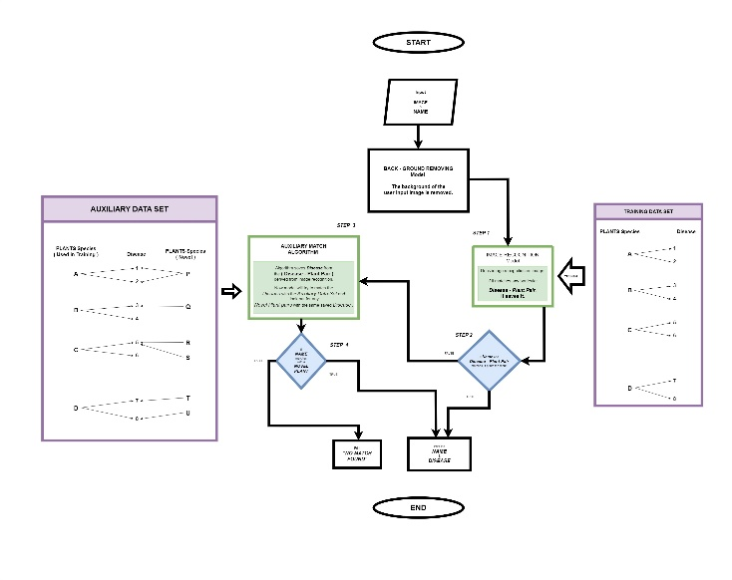

## Proposed Architecture:

The proposed architecture takes advantage of the superior capabilities of YOLOv8 to provide a robust and efficient solution for the detection of plant disease. The background elimination technique is one of the primary features of this architecture, where it isolates the plant from distracting elements such as overlapping leaves, soil, or inconsistent lighting. In doing so, the system focuses only on the plant and ensures that the symptoms of the disease are identified more accurately and precisely [10]. Another innovative feature is the dual-dataset approach, which significantly makes 7 the model adaptable and superior over a wide range of plant species. The combination of the real-time detection capabilities of YOLOv8 with the dual dataset approach creates a highly adaptable and scalable architecture. By addressing challenges such as background noise and species-specific limitations, this system is reorganized as a reliable tool for farmers, capable of providing actionable insights for managing plant health efficiently [11] [10] [13].

## Discussion of proposed work:

The proposed work presents a comprehensive and scalable approach to plant disease detection using YOLOv8, a state-of-the-art object detection model, to tackle agricultural challenges with enhanced accuracy and efficiency. By leveraging advanced computer vision and deep learning techniques, the system is designed to enable real-time monitoring of plant health, ensuring adaptability across diverse plant species while maintaining high-speed and precision in disease identification. The architecture incorporates a unique multi-dataset approach, integrating both a primary and an auxiliary dataset. The primary dataset is specifically curated to focus on ten selected plant species, with two common diseases for each species, ensuring high detection precision for the targeted crops. In contrast, the auxiliary dataset is designed to extend the model’s generalization capability by including various plant species that exhibit similar disease patterns. This approach enhances the model’s adaptability, enabling it to identify diseases in plant species not explicitly present in the primary dataset.

To further improve disease detection accuracy, the architecture employs a background removal and segmentation technique before feeding images into the model. This preprocessing step isolates plant leaves from irrelevant background elements such as overlapping foliage, soil textures, and inconsistent lighting conditions. By focusing solely on the affected plant parts, the model can accurately analyse disease symptoms without interference from external noise, significantly reducing false positives and enhancing detection performance. The segmentation process relies on a pre-trained model optimized for plant leaf isolation, ensuring that only the relevant portions of the image contribute to the final disease classification.

The model is trained on a well-structured dataset comprising high-resolution images, where plant species and disease labels are treated separately. Unlike conventional approaches that merge both aspects into a single label, this methodology enables the YOLOv8 model to learn disease-specific visual characteristics independently of the plant species. This separation improves the model’s flexibility, allowing it to generalize effectively to new, unseen plant species while maintaining its ability to recognize diseases based on distinctive visual symptoms. The dataset consists of 4,221 labelled images, carefully split into training, validation, and testing sets to ensure a comprehensive evaluation of the model’s performance.

Training is conducted over 246 epochs, where the initial 125 epochs focus on learning general disease features, while the remaining epochs fine-tune the model to optimize accuracy. Data augmentation techniques such as random rotations, flipping, brightness adjustments, and noise injection are applied to enhance the model’s robustness in real-world conditions. The training process is carried out using an Nvidia GeForce RTX 3070 GPU with 12GB of VRAM, allowing efficient processing of high-resolution images while maintaining rapid inference times. By the end of the training phase, the model achieves strong generalization capabilities, enabling it to detect plant diseases across a wide variety of species, including those not explicitly present in the training dataset.

Once trained, the system operates by processing user-input images through a structured pipeline that includes background removal, segmentation, and disease detection. After background elimination, the refined image is analysed by the YOLOv8 model, which detects disease symptoms based on learned visual patterns such as leaf discoloration, lesions, and irregular textures. The output consists of bounding boxes around affected regions, accompanied by confidence scores indicating the severity and likelihood of disease presence. These real-time detections provide actionable insights to farmers, enabling them to implement timely interventions such as targeted pesticide application, disease-specific treatments, and environmental modifications to prevent further spread.

A critical advantage of this architecture is its ability to perform cross-species disease detection through the auxiliary dataset. By learning patterns from diverse plant species affected by similar diseases, the model can generalize its knowledge and accurately diagnose infections in previously unseen crops. This capability makes the system highly scalable for deployment in varied agricultural environments, where different plant species require monitoring. Furthermore, the model’s real-time processing speed ensures that large-scale agricultural applications can efficiently integrate it into automated crop health monitoring systems, reducing the reliance on manual inspections and traditional disease identification methods.

By combining real-time object detection, background segmentation, multi-dataset learning, and deep learning-based disease classification, the proposed architecture provides a robust and efficient solution for plant disease detection. The integration of these advanced AI techniques not only enhances the precision of disease diagnosis but also contributes to improved crop yield management and sustainable farming practices. As agricultural challenges continue to evolve, AI-driven solutions like YOLOv8 offer scalable and adaptive tools that revolutionize disease management, empowering farmers with data-driven decision-making capabilities while minimizing environmental impact.

# Experimentation

## Dataset Description:

### Primary Dataset:

A trimmed data set that focuses on 10 specific plant species, together with two diseases of each. This ensures that the model has high precision in the detection of disease for the targeted crops [11]. The dataset has been curated based on the taxonomy of plants and the taxonomy of disease-causing pathogens. The plant leaves are labeled and annotated to identify species, while diseases are annotated independently to identify specific conditions 2. Unlike many previous studies, where plant species and diseases were combined as a single label, our method separates plant species and diseases into distinct annotations. This enables the model to detect specific diseases based solely on their physical visual characteristics. Training on this dataset enhances the model’s generalization capabilities, allowing it to identify diseases not only in the plants present in the dataset but also in other taxonomically related plant species. The data set used has been curated for research in pathology and agricultural diagnostics. It is specially designed for the identification of plant disease using image-based analysis. The data set contains 4221 images of leaves from various plants, classified 8 into 19 distinct labels, where 12 labels represent plant diseases, and 7 labels correspond to plant species. The high-resolution images, standardized at 640 x 640 pixels, ensure quality for both visual inspection and computational modeling. Labels include plant types such as Apple, Grape, Orange, Pepper, Potato, Squash, and Tomato, as well as diseases such as Bacterial Spot, Black Rot, Black Rot Gb, Esca, Huanglongbing, Late Blight, Mosaic Virus, Powdery Mildew, Rust, Scab, Spider Mite Leaf Spot, and Yellow Leaf Curl. This data set comprises a specific mapping between diseases and plant types, that is, tomato is associated with diseases like Tomato Bacterial Spot, Tomato Spider Mite Leaf Spot, Tomato Yellow Leaf Curl, Tomato Late blight, and Tomato Mosaic Virus. Similarly, Apple is linked with Apple Scab, Apple Rust, and Apple Black Rot; Potato with Potato Late Blight; Pepper with Pepper Bacterial Spot; Squash with Squash Powdery Mildew; Orange with Orange Huanglongbing; and Grape with Grape Esca and Grape Black Rot. To facilitate model training and evaluation, the dataset is divided into three subsets: 3843 (91%) images for training, 274 (6%) images for validation and 104 (2%) images for testing. The key features of the data set include its high image quality, the diversity of labels, and detailed mapping of plant diseases that support practical applications in plant pathology and agronomy

### Auxiliary Dataset:

In order to generalize the solution in multiple plant species, the system is integrated with an auxiliary dataset, which consists of data of other plants that have a similar disease pattern. It allows the model to understand the symptoms that are common in different species and thereby apply to a wider crop range [10] [13].

|  |  |
| --- | --- |
| PLANTS | DISEASES |
| Apple | Scab, Black Rot, Rust |
| Squash | Powdery Mildew |
| Tomato | Bacterial Spot, Spider Mite Leaf Spot, Mosaic, Yellow Leaf Curl, Late Blight |
| Potato | Late Blight |
| Pepper | Bacterial Spot |
| Orange | Huanglongbing |
| Grapevine | Esca, Black Rot Gb |

## Implementation Setup:

The implementation setup involved two key stages: data preprocessing and model training. In the data preprocessing stage, annotation was performed using Roboflow, where Regions of Interest (ROI) for diseased and healthy leaves were labeled manually. Annotations were exported in YOLO format, containing class labels and normalized bounding box coordinates. To enhance dataset diversity and model robustness, various data augmentation techniques were applied, including random rotations (90°), 9 f lips, brightness adjustments (-10% to +10%), noise injection (0.53%), and random cropping. These techniques improved the model’s generalizability for real-world variations [10]. Figure 2 illustrates an example where yellow annotations represent the plant name (Pepper), while pink annotations indicate the disease name (Bacterial Spot). The development of the disease detection system was facilitated by multiple libraries and tools. Roboflow was utilized for annotation and augmentation, ensuring smooth exportation in YOLO format for compatibility with YOLOv8. Essential Python libraries such as NumPy and OpenCV were used for image manipulation, Matplotlib for visualization, Pandas for metadata management, and Ultralytics for accessing the YOLOv8 framework. The YOLO format ensured smooth dataset integration with the training pipeline.

In the model training stage, the YOLOv8 model was trained on a primary dataset specifically curated for this research. The dataset contained high-resolution images of plant leaves, labeled to identify both plant species and diseases, covering 7 distinct plant species and 12 disease classes, totaling 4,221 images. The data was split into 91% for training, 6% for validation, and 2% for testing, ensuring a comprehensive evaluation of the model’s performance. Unlike previous studies that combined plant species and disease labels, this dataset treated them separately, allowing the YOLOv8 model to focus purely on disease detection based on visual characteristics. This approach improved flexibility, enabling the model to generalize to unseen plant species while accurately detecting diseases. The training process spanned 246 epochs, with the first 125 epochs focusing on learning general patterns and the remaining 121 epochs dedicated to fine-tuning the model for optimal performance. Various augmentation techniques, such as random rotations, flipping, noise injection, and brightness 10 adjustments, were applied during training to enhance the model’s robustness in real world conditions. The model was trained with a batch size of 16 using an Nvidia GeForce RTX 3070 GPU with 12GB VRAM, ensuring efficient processing of high-resolution images while maintaining accuracy. At the end of training, the YOLOv8 model demonstrated strong generalization capabilities, accurately detecting plant diseases even in species not included in the original dataset. This ability to generalize is crucial for real-world agricultural applications, where diverse plant species may be encountered.

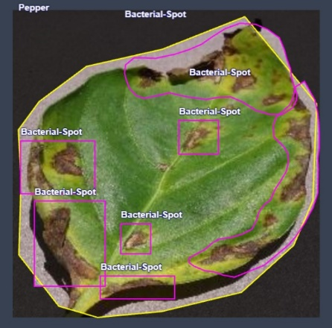

## Experiments done:

Once the YOLOv8 model is trained, it is used for disease detection in user-provided images, but first, a preprocessing phase is performed, including background removal and segmentation. This step isolates plant leaves from the background using a pre trained segmentation model, removing noise like overlapping leaves, soil textures, or other environmental elements to enhance detection accuracy. After segmentation, the refined image is analyzed by the YOLOv8 model, which detects disease symptoms based on features like color changes, lesions, and abnormal textures. The output includes bounding boxes, disease labels, and confidence scores, enabling timely intervention for disease management. To improve adaptability, an auxiliary dataset containing images of various plant species affected by the same diseases is incorporated, allowing the model to generalize across species. This ensures accurate disease detection for diverse agricultural environments, making the system scalable for real-time applications and effective disease management.

|  |  |  |  |
| --- | --- | --- | --- |
| Epoch | Precision (%) | Recall  (%) | F1 Score (%) |
| 30 | 66.779 | 61.628 | 64.1 |
| 50 | 55.261 | 68.744 | 61.27 |
| 125 | 51.649 | 65.495 | 57.75 |
| 246 | 54.546 | 56.833 | 55.66 |

# Results and Discussion

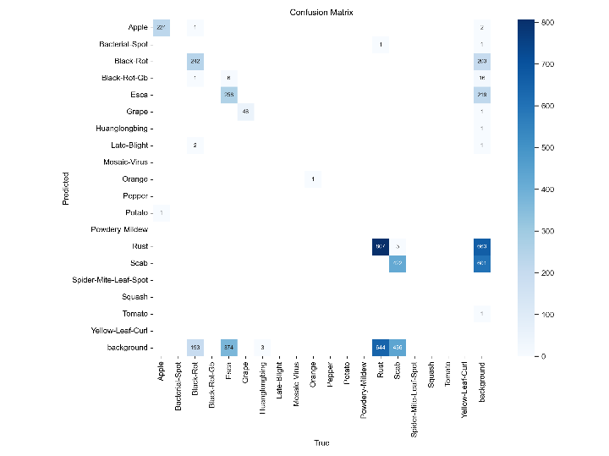

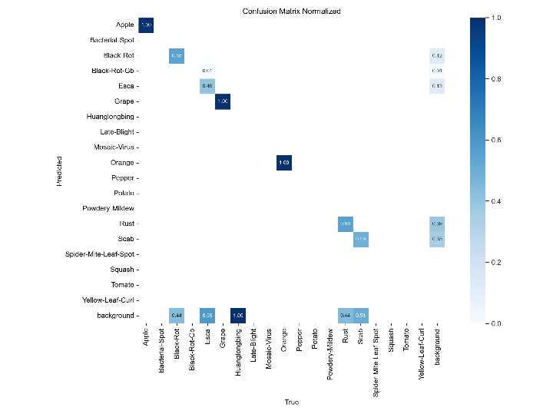

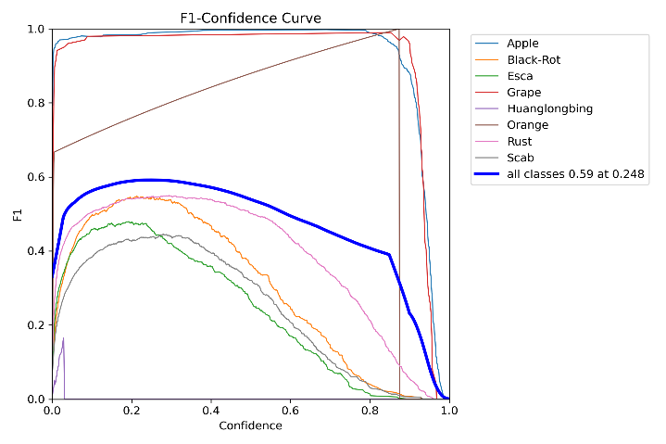

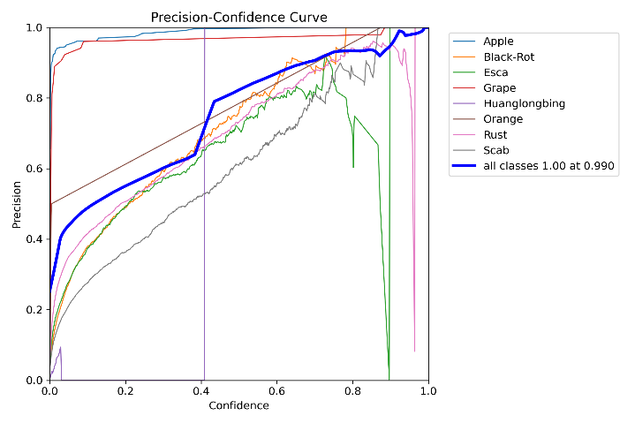

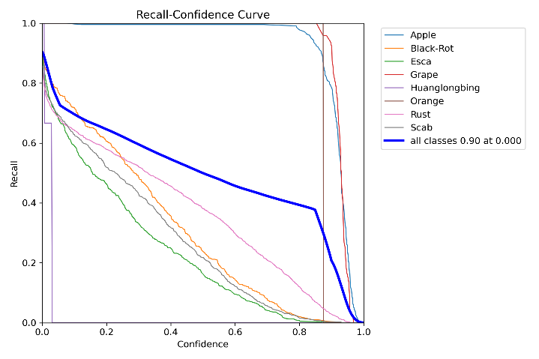

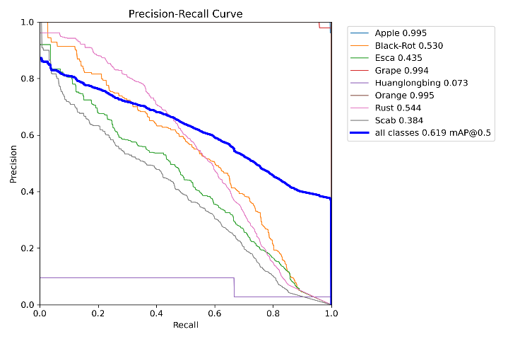

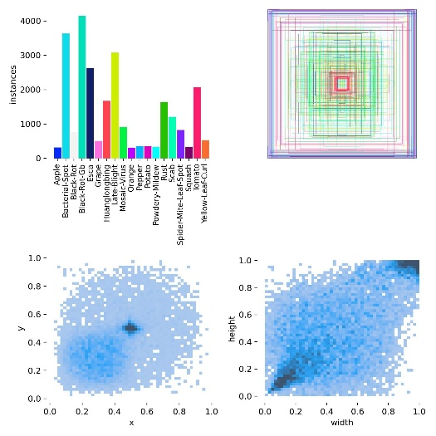

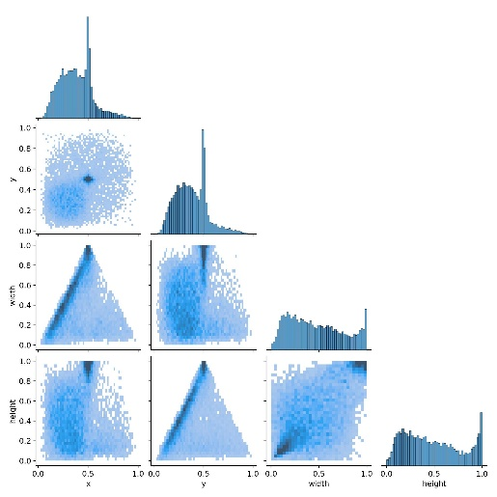

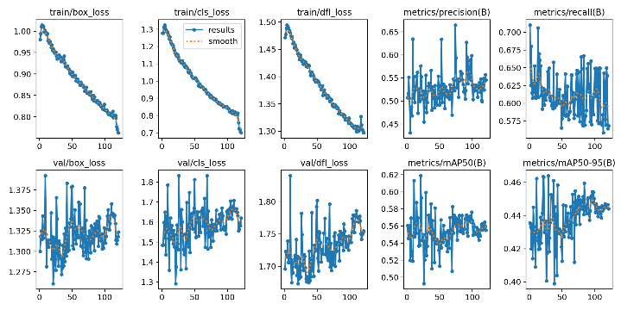

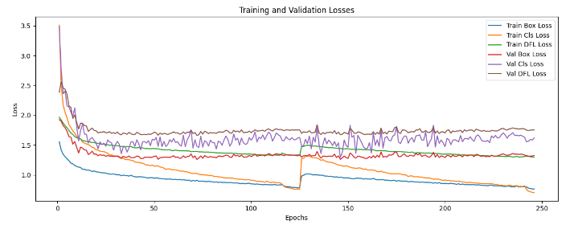

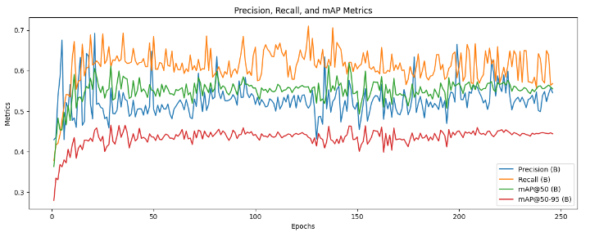

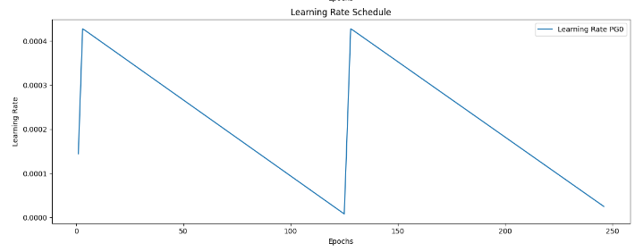

# Compare with existing work

|  |  |  |  |  |  |  |
| --- | --- | --- | --- | --- | --- | --- |
|  | Model Used | Precision | Recall | F1 Score | mAP50 | mAP50-95 |
| 1 | YOLOv8-ACCW[11] | - | - | 92.4 | 92.8 | 73.8 |
| 2 | [10] | 35.22 | 33.78 | 34.48 | - | - |
| 3 | EfficientNetB0[13] | 98.27 | 98.26 | 98.26 | - | - |
| 4 | GzMPDD  (Our) | 54.54 | 56.83 | 55.65 | 55.52 | 44.41 |

# Conclusion

In conclusion, this study introduces a novel and generalizable AI-based plant disease detection system leveraging YOLOv8. The system demonstrates enhanced performance through an innovative architecture that integrates background removal, a dual-dataset approach, and advanced segmentation techniques. By focusing on decou pled species and disease labels, the model ensures better diagnostic precision and adaptability. The inclusion of an auxiliary data set expands the utility of the model across diverse plant species and environmental conditions, addressing key limitations of exist ing methods. The experimental results highlight the potential of the proposed system to transform plant disease management, supporting sustainable agricultural practices with a reliable and scalable real-time solution.

##### References

1. Nagaraju, M., Chawla, P.: Systematic review of deep learning techniques in plant disease detection. *International Journal of System Assurance Engineering and Management*, **11**(3), 547–560 (2020).
2. Yin, X., Li, W., Li, Z., Yi, L.: Recognition of grape leaf diseases using MobileNetV3 and deep transfer learning. *International Journal of Agricultural and Biological Engineering*, **15**(3), 184–194 (2022).
3. Ferentinos, K.P.: Deep learning models for plant disease detection and diagnosis. *Computers and Electronics in Agriculture*, **145**, 311–318 (2018).
4. Ibrahimi, A.E., Akchioui, N.E.: A review on plant disease detection using artificial intelligence techniques. In: *AIP Conference Proceedings*, **2814** (2023). AIP Publishing.
5. Jia, L., Wang, T., Chen, Y., Zang, Y., Li, X., Shi, H., Gao, L.: MobileNet-CA-YOLO: An improved YOLOv7 based on MobileNetV3 and attention mechanism for rice pest and disease detection. *Agriculture*, **13**(7), 1285 (2023).
6. Salman, Z., Muhammad, A., Piran, M.J., Han, D.: Crop-saving with AI: Latest trends in deep learning techniques for plant pathology. *Frontiers in Plant Science*, **14**, 1224709 (2023).
7. Thakur, A., Venu, S., Gurusamy, M.: An extensive review on agricultural robots with a focus on their perception systems. *Computers and Electronics in Agriculture*, **212**, 108146 (2023).
8. Jia, Z.-W., Hao, J., Hou, Y.-M., Wang, R.-B., Zhang, R.-Y., Yao, S.-M., Zhang, J., Ke, H., Shao, Y.: Study on rapid detection and identification of multi-category apple leaf disease. (2022). *(Additional journal or conference details needed for completeness.)*
9. Goncharov, P., Ososkov, G., Nechaevskiy, A., Uzhinskiy, A., Nestsiarenia, I.: Disease detection on plant leaves by deep learning. In: *Advances in Neural Computation, Machine Learning, and Cognitive Research II: Selected Papers from the XX International Conference on Neuroinformatics, October 8-12, 2018, Moscow, Russia*, pp. 151–159 (2019). Springer.
10. Moupojou, E., Retraint, F., Tapamo, H., Nkenlifack, M., Kacfah, C., Tagne, A.: Segment Anything Model & fully convolutional data description for plant multi-disease detection on field images. *IEEE Access* (2024).
11. Chen, Z., Feng, J., Yang, Z., Wang, Y., Ren, M., et al.: YOLOv8-ACCW: Lightweight grape leaf disease detection method based on improved YOLOv8. *IEEE Access* (2024).
12. Pan, N., Yang, W., Luo, Y., Wang, Y.: Identification of leaf disease based on memristor convolutional neural networks. *IEEE Access* (2024).
13. Nigar, N., Faisal, H.M., Umer, M., Oki, O., Lukose, J.: Improving plant disease classification with a deep learning-based prediction model using explainable artificial intelligence. *IEEE Access* (2024).
14. Shoaib, M., Shah, B., Ei-Sappagh, S., Ali, A., Ullah, A., Alenezi, F., Gechev, T., Hussain, T., Ali, F.: Advanced deep learning models-based plant disease detection: A review of recent research. *Frontiers in Plant Science*, **14**, 1158933 (2023).
15. Eunice, J., Popescu, D.E., Chowdary, M.K., Hemanth, J.: Deep learning-based leaf disease detection in crops using images for agricultural applications. *Agronomy*, **12**(10), 2395 (2022).
16. Bhati, V.S., Tiwari, N., Chawla, M.: A generalized zero-shot deep learning classifier for emotion recognition using facial expression images. *IEEE Access*, **13**, 18687–18700 (2025). <https://doi.org/10.1109/ACCESS.2025.3533580>