A Transconductance-Enhanced Latch Comparator for Energy-Efficient High-Speed ADCs

Abstract –

This work presents a low-power, high-speed dynamic comparator featuring a transconductance-enhanced latching stage for analog-to-digital converter (ADC) applications. Unlike conventional cross-coupled inverters, the proposed latch biases all transistors in strong inversion during the reset phase, significantly improving effective transconductance at the start of comparison. This enhancement shortens regeneration time, reduces metastability, and lowers energy consumption. Designed in 180-nm CMOS and operating at a 1.2 V supply, the comparator achieves up to 2 GS/s sampling speed with only 110 fJ per comparison. Simulation and measurement results confirm reduced delay, low power consumption, and compact area compared to conventional designs, making it suitable for high-performance, low-voltage ADCs.

Keywords - Dynamic Comparator, Transconductance Enhancement, Latch Regeneration, Low Power, High Speed, Analog-to-Digital Converter (ADC)

Introduction

Comparators represent one of the most fundamental blocks involved in analog and mixed-signal circuits. They are decision-making elements that compare two analog input signals and generate a digital output that reflects which one of the inputs is larger. In other words, a comparator is like a translator from analog to digital for one bit-it accomplishes the detection of differences in signals with high precision and speed. Comparators play an important role in a wide range of electronic systems, from ADCs and data receivers to signal-processing circuits.
In high-speed ADCs, the performance of a comparator has a direct effect on speed and accuracy. The comparator must be able to resolve small voltage differences in a short time while consuming minimal power. As technology scales and supply voltages drop, fast comparison with low energy consumption becomes increasingly challenging. This is where dynamic comparators come into play.

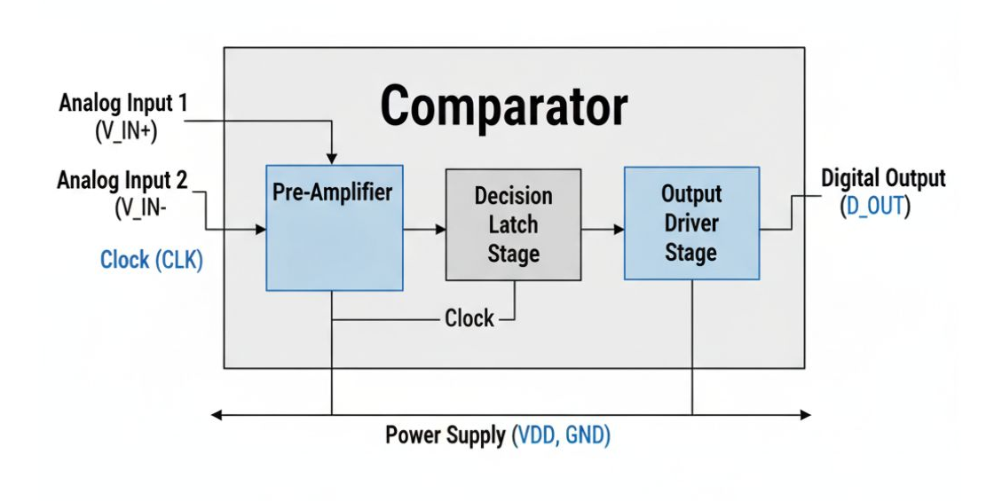
Fig 1. A internal representation of comparator

Dynamic comparators, as opposed to static comparators, consume power only in a comparison phase. Dynamic comparators are based on regenerative positive feedback that amplifies the input difference into a full logic-level output in a very short time. Low static power and high operating speed make them very suitable for high-performance ADCs. However, during the regeneration phase, their performance is naturally limited by the transconductance of input and latch transistors. If the effective transconductance at the start of regeneration is low, there is an increase in delay that could lead to metastability and higher energy consumption.

To overcome this limitation, several techniques for transconductance enhancement have been proposed. By enhancing the latch transconductance at the beginning of the comparison, the comparator will regenerate faster with reduced delay and lower power. The enhanced transconductance will keep all the important transistors in strong inversion for maximum gain and speedy decision-making. Of course, this is very useful in low-power and high-speed ADCs where both accuracy and power efficiency are crucial.

In this, a novel latch comparator with transconductance enhancement is proposed to surmount the speed and energy challenges of the state-of-the-art dynamic comparators. This design biases all latch transistors in strong inversion during the reset phase, boosting the initial transconductance and enhancing the efficiency of comparison generally. This makes the proposed structure highly suitable for next-generation low-voltage, high-speed ADC architectures.

II. Conventional Two-Stage Dynamic Comparator

A conventional two-stage dynamic comparator, shown in Fig. 1, mainly consists of two blocks: one preamplifier stage and one latch or regenerative stage. The preamplifier first converts small input voltage differences into a larger differential signal, while the latch rapidly amplifies this difference to produce a full digital output.

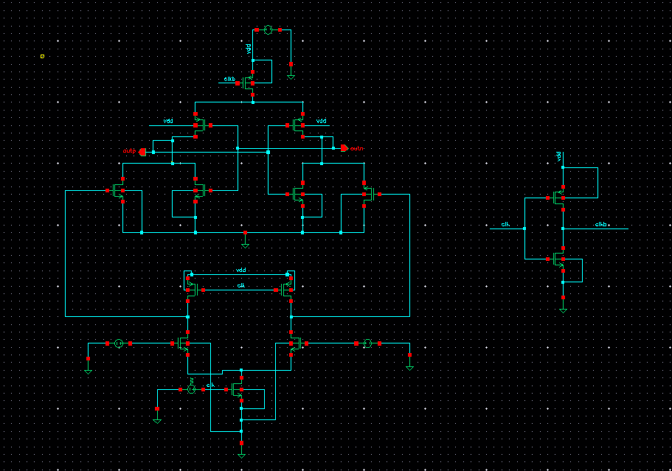
Fig 2. A Conventional Two-Stage Dynamic Comparator in Cadence Virtuoso

Parameter Values :
M0-1 | 2 / 0.18 µm
M2-3 | 1 / 0.18 µm
M4-5 | 0.5 / 0.18 µm
M6-7 | 2 / 0.18 µm
M8-9 | 1.8 / 0.18 µm
M10-11 | 4 / 0.18 µm
M12 | 0.44 / 0.18 µm
V_{DD} | 1.2 V
Vinp | 0.6 mV
Vinn | 0.9 mV
Clk -> Vpulse | V1 = 0 V  V2 = 1.2 V  Period = 3 ns

In the reset phase, CLK = 0, M4 and M5 are turned ON while M10 and M11 are OFF. Hence, the transistors charge the intermediate nodes Dn and Dp to the supply voltage (VDD). Meanwhile, the output nodes OUTp and OUTn are discharged to ground through M8 and M9. This is important to ensure that the comparator starts each comparison in a clean, defined initial condition.
During the comparison phase, when CLK = VDD, M10 and M11 switch on while M4 and M5 switch off. As a result, the nodes Dn and Dp start to discharge at different rates due to the differential input voltages Vinp and Vinn. Now, assuming that Vinn is fixed at 600 mV, and Vinp is swept during a parametric analysis —

When Vinp < Vinn (600 mV) → the Dp node discharges faster than Dn. The latch amplifies this difference and drives OUTn high and OUTp low.

If Vinp > Vinn (600 mV) → the other way around: Dn discharges faster and OUTp high and OUTn low
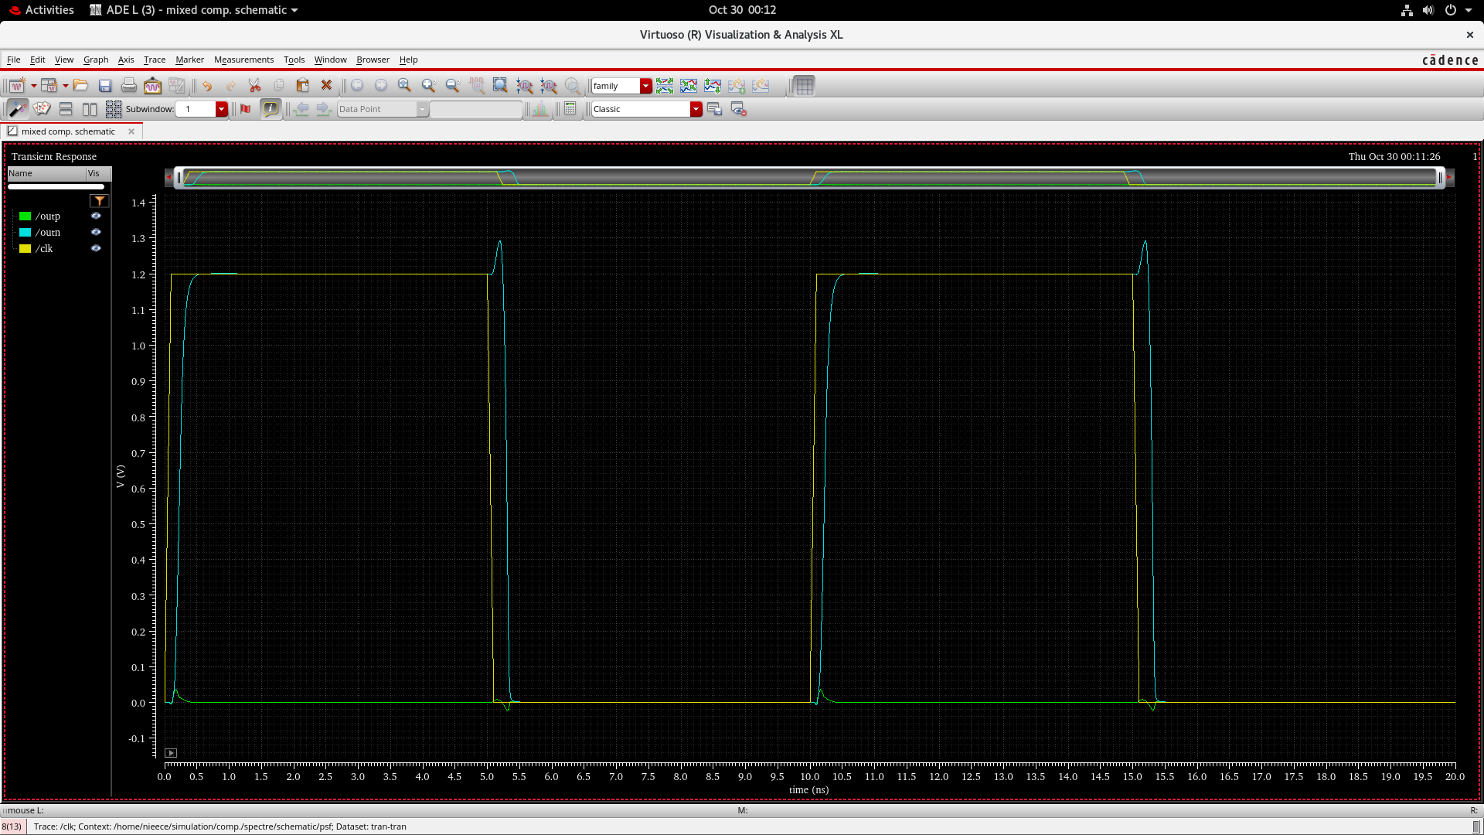
Fig 3. A conventional Two-Stage Dynamic Comparator simulated in Cadence Virtuoso using 180nm technology

This behavior clearly reveals how the comparator makes the decision on which input is higher and, therefore, how it converts an analog voltage difference into a digital output.
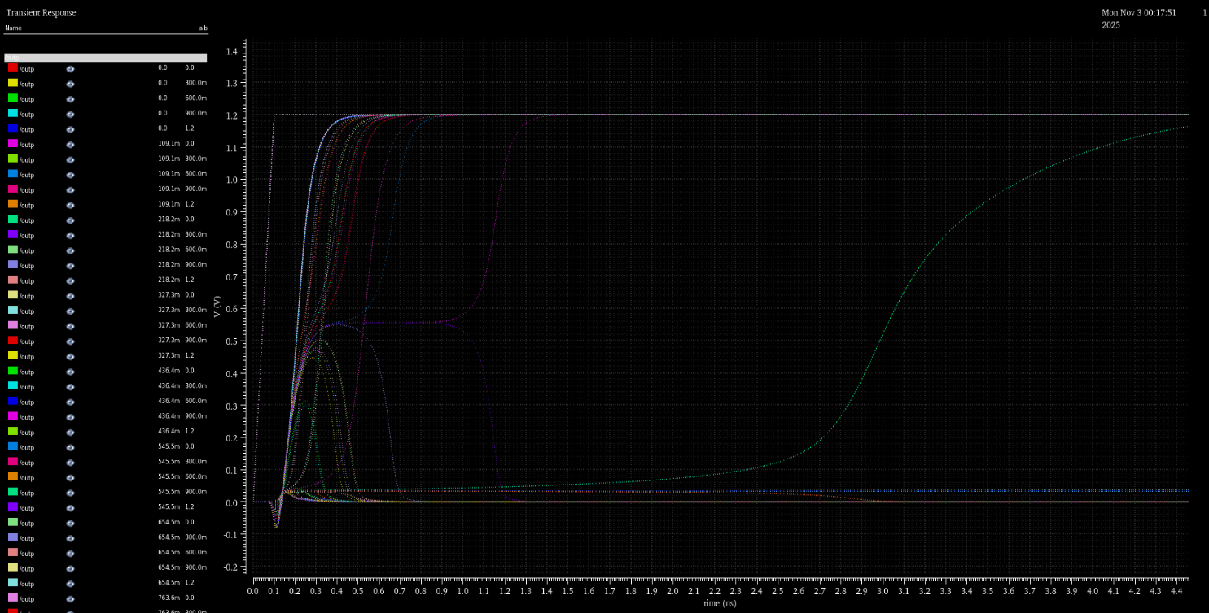
Fig 3. A conventional Two-Stage Dynamic Comparator simulated with sweeping both V_{inn} and V_{inp} from 0 to V_{DD} is analysed in parametric analysis

Further, in order to analyze the behavior of comparators in more detail, Vinp and Vinn can be varied from 0 to VDD in simulation. In this case, the threshold value of the output switching, where OUTp and OUTn flip states, can be observed-ideally occurring around Vinp = Vinn. The transition region in the waveform indicates a comparator's sensitivity and the speed of its decision-making. Hence, by sweeping the input voltages in this manner, we can clearly observe that the comparator acts like a decision circuit, producing a logical '1' if Vinp > Vinn and a logical '0' otherwise. The two-stage architecture offers advantages such as lower kickback noise, good performance at low supply oltage, and flexible trade-offs between offset, speed, and power dissipation.

