**Pet Classification Model Using CNN.**

Begin by creating the ipynb file in the same parent folder where the downloaded data set is kept. The CNN model should have the following layers:   
● Input layer   
● Convolutional layer 1 with 32 filters of kernel size[5,5]   
● Pooling layer 1 with pool size[2,2] and stride 2   
● Convolutional layer 2 with 64 filters of kernel size[5,5]   
● Pooling layer 2 with pool size[2,2] and stride 2   
● Dense layer whose output size is fixed in the hyper parameter: fc_size=32   
● Dropout layer with dropout probability 0.4   
Predict the class by doing a sigmoid on the output of the dropout layers.   
This should be followed by training and evaluation:   
● For the training step, define the loss function and minimize it   
● For the evaluation step, calculate the accuracy   
Run the program for 100, 200, and 300 iterations, respectively. Follow this by a report on the final accuracy and loss on the evaluation data.

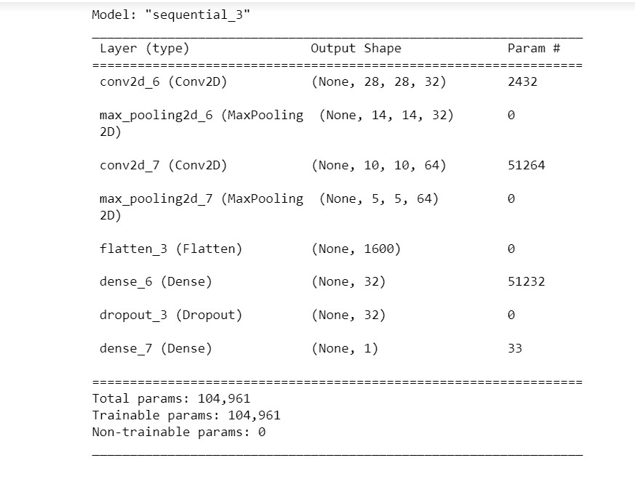

The first time with 100 iterations, the final accuracy is around 95%, which can be considered as a good accuracy and the loss is also minimized consecutively.

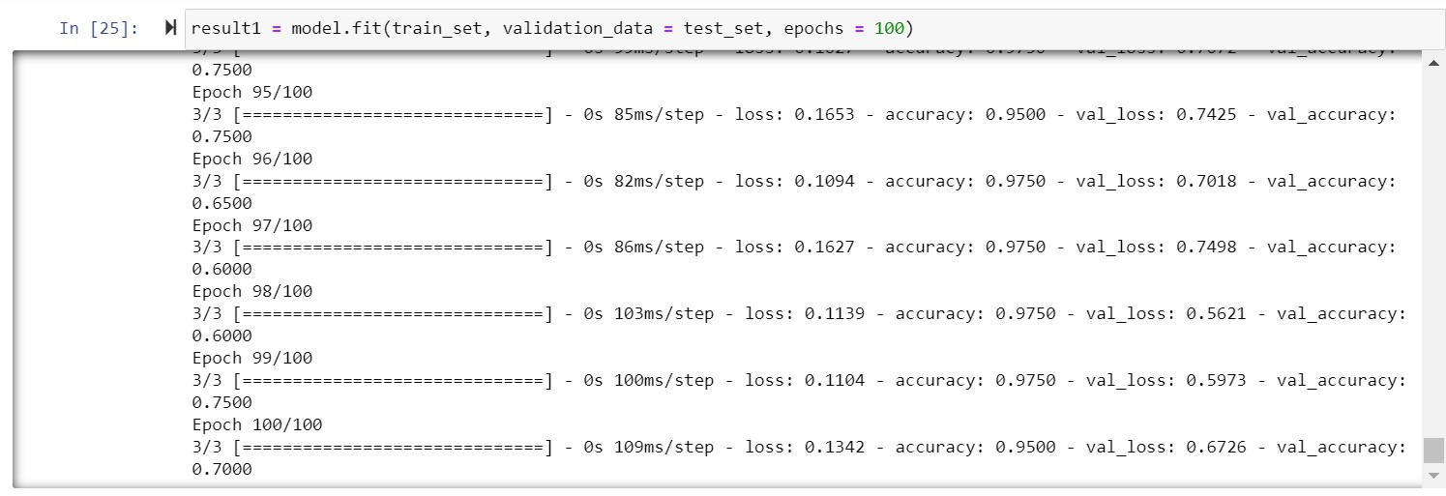

The model fitting with 200 iterations is definitely over fitted as the accuracy for this is 1 for more than last 80 iterations.

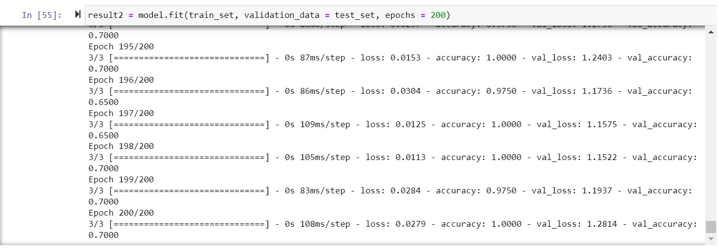

Similarly, if the model is already overfitted in 200 iterations, it is bound to be overfitted of 300 iterations.

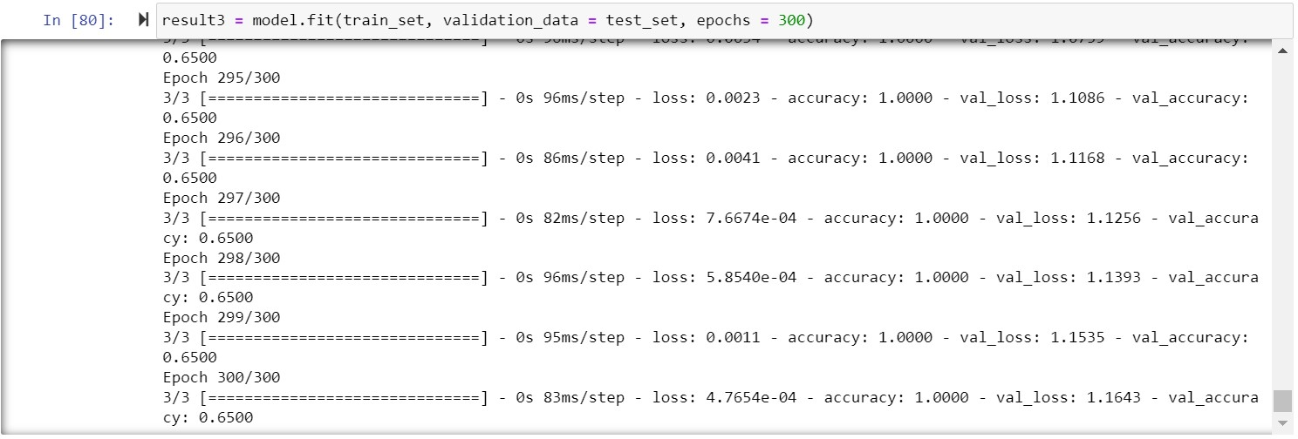

Hence, by looking at the scenario, it is determined that 100 is the correct number of iterations for this dataset and this model build-up.