Professional Programming Practice – Assignment 4

Prekshya Sharma - 11625754

BUG 3 – Inappropriate ratio of winnings and loses
Description: Crown and Anchor games have an approximate 8% bias to the house. So the win : (win + lose) ratio should approximately equal 0.42. This does not appear to be the case.

- Replication.
At the end of the game it shows the percentage of winning and losing of the game. While the ratio expected is around 0.42, the game produces massive ratio reaching up to 0.62:
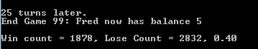


2. Simplification.
After studying the code, this bug is related to 2 other bugs:
Bug 4 – The 3 dice values remain the same in every turn and every game at one play.
Bug 5 – The dice value SPADE never appears when players roll the dice.

Please see the upcomming reports regarding these 2 bugs to see this bug get fixed.

3. Tracing.
See the next 2 bugs’ report

4. Resolution.
After resolving the other 2 bugs, after which the dice values are generated randomly & accurately and the SPADE value appears, this bug is also fixed which produce the ratio of winning/losing of appropriately 0.42 as bellow:

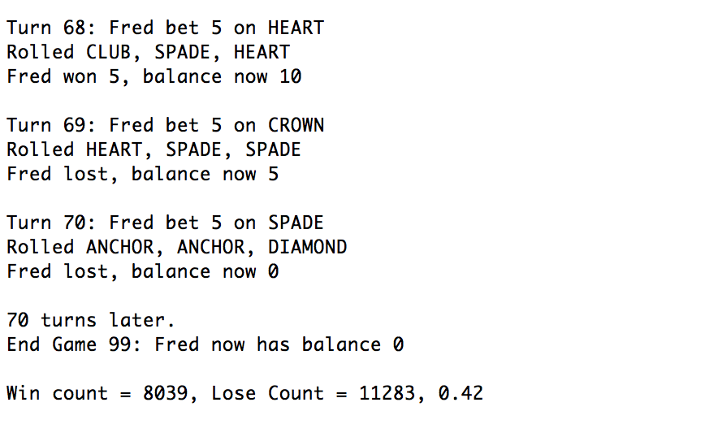

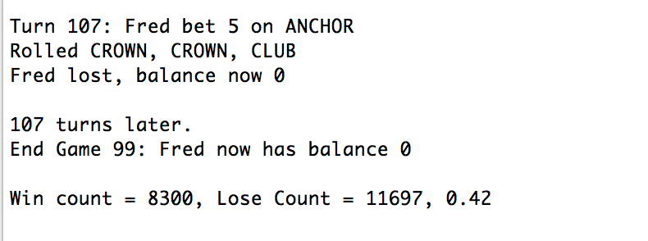

Note that these 2 screenshots are created after the bug 4 and 5 fixed

