Professional Programming Practice – Assignment 4

Prekshya Sharma - 11625754

BUG 8 – Bet amount inflexible
Description: The player is not allowed to enter his amount of bet. The bet amount is hard coded

- Replication
In the main class, the bet amount is initialised equals 5. And in every turn and game, the bet amount is the same:
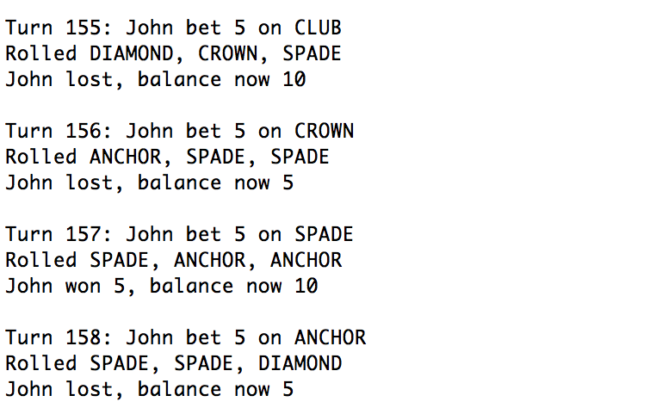

2. Simplification
The bug occurs here when the balance is assigned to the playerBalance variable which privously hard coded.

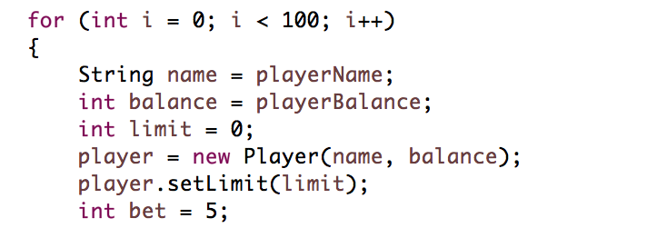
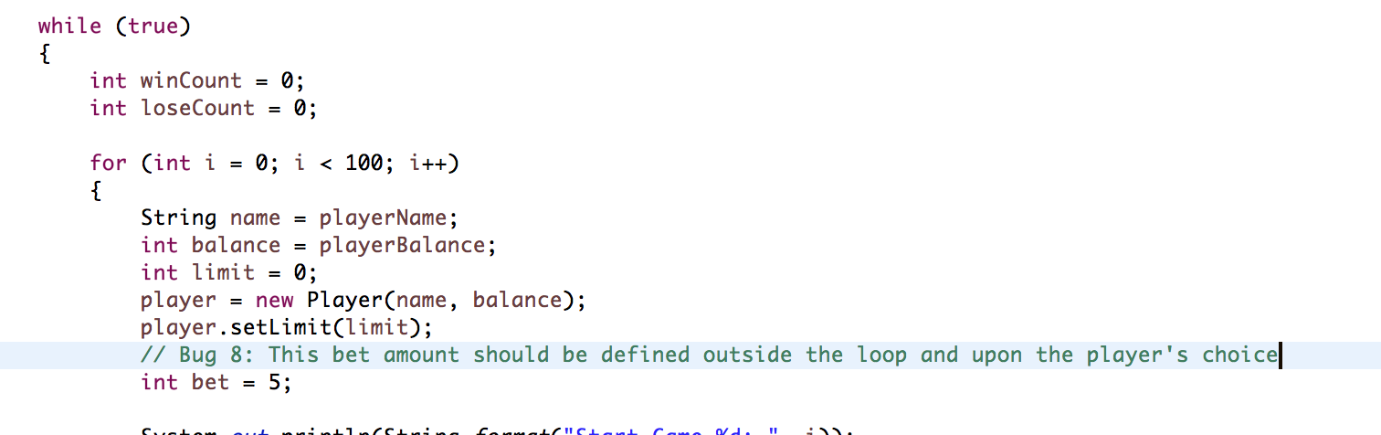

3. Tracing
To the point of bug, code should be inserted to solve the issue:

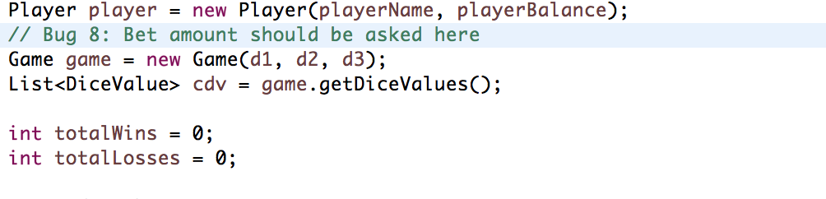

4. Resolution
Just as asking for player’s age, name and balance. Code to ask for bet amount is the same. 5 by default (in case player enters nothing or a string or out of range permitted).
Here are screenshots after bug fixed:

