E-calender

1. A login page for the app.
2. Only manager should be able to login to it

1. Login page should redirect to dashboard
2. Dashboard should have dashboard bar and logout button in every page

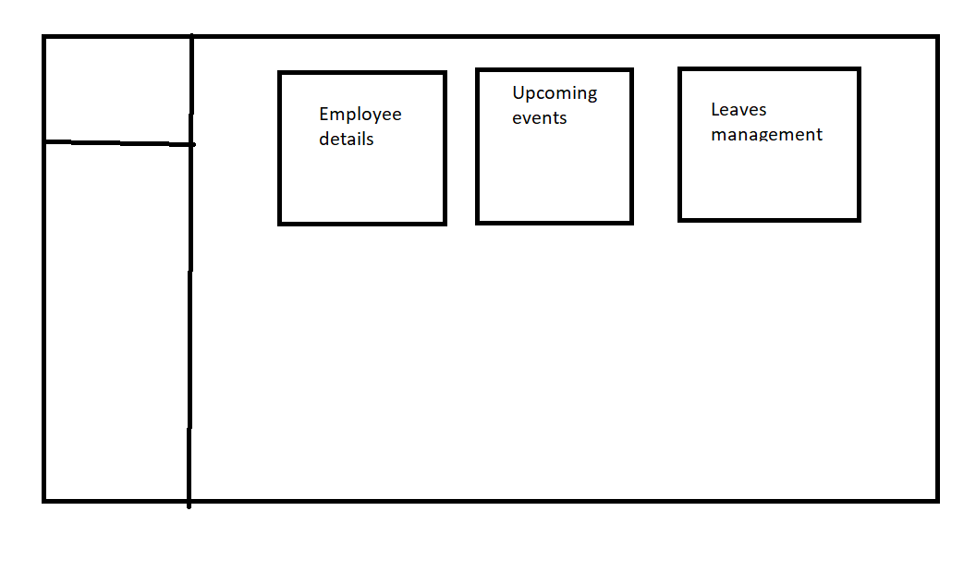

1. upon clicking on employee details. A new page should open that would be having employee details
2. Employee details should have emp name, emp id , designation, project working (on benck or assigned to project)
3. Add search bar to the employee details page.

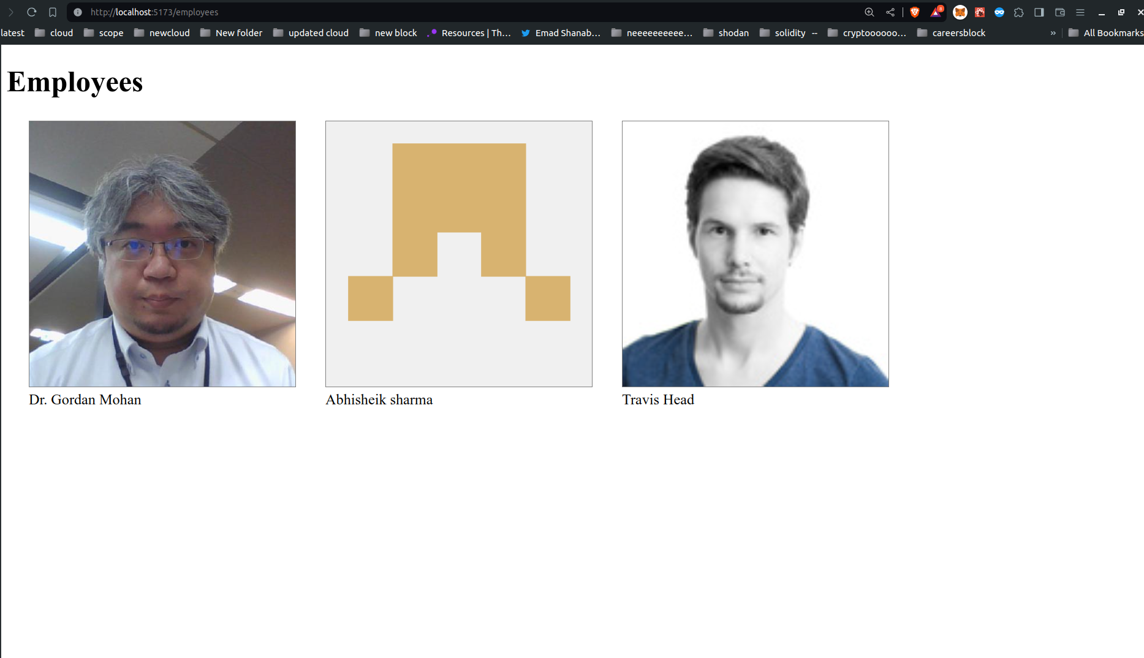

1. Upon clicking on upcoming events a new page should open and display the upcoming events of the organization like common meetings,birthdays,public holiday in the form of calender
2. Upon clicking the 3rd tile like leaves management it should open a new page where it should display employee name on clicking the employee name it should popup a model and display each employee number of total leaves assigned and leaves availed should be displayed .It should be displayed in pie chart