Cybersecurity SOC Incident-Response

Copilot

Name : Prem M Roll No : 24ALR044

Problem Statement
Security Operations Center (SOC) teams receive large volumes of security alerts from endpoints, networks, cloud services and security tools. Analysts may struggle to quickly understand incidents, identify their severity, correlate related alerts, investigate indicators of compromise and determine the appropriate response actions.

How It Helps the Business or Public Organisation
The solution can help security teams reduce alert-investigation time, prioritize critical incidents and provide analysts with structured investigation and response guidance. It can improve consistency in incident handling while allowing human analysts to remain responsible for final security decisions.

Problem It Solves
It addresses alert overload, slow manual investigation, fragmented security information, difficulty correlating multiple alerts and inconsistent incident-response procedures. It also helps junior analysts understand security events and follow standardized investigation workflows.

Proposed GenAI Solution
Build a RAG-based SOC Incident-Response Copilot over a controlled knowledge base containing fictional or publicly available security policies, incident-response playbooks, threat-intelligence information and security documentation.
Analysts can provide alerts, logs or incident summaries, and the Copilot can explain the incident, identify potentially related events, summarize indicators of compromise and suggest investigation steps.
The system can classify incidents by severity, generate an investigation timeline and recommend response actions based on approved playbooks. It should provide evidence and source citations for its recommendations rather than making unsupported claims.
The Copilot will work primarily as a chatbot, allowing analysts to ask questions about security incidents using natural language.

Two Main Features

1. SOC Chatbot for Incident Investigation
The analyst can interact with the Copilot through a chatbot and ask questions such as:
- What happened in this alert?
- Is this activity suspicious?
- What is the severity?
- What are the indicators of compromise?
- Which MITRE ATT&CK technique is involved?
- What should I investigate next?
- What response action is recommended?
The chatbot will use RAG to retrieve relevant security information before generating its answer.

2. Automatic Incident Report Generation
After analysing an incident, the Copilot can generate a structured incident report containing:
- Incident summary
- Incident severity
- Affected user or system
- Indicators of compromise
- Event timeline
- Possible attack technique
- Evidence and sources
- Investigation findings
- Recommended response actions
This reduces the time required for analysts to manually prepare incident documentation.

Suggested Data
- Synthetic SOC alerts
- Firewall logs
- Authentication logs
- Endpoint logs
- Network traffic summaries
- Threat-intelligence reports
- MITRE ATT&CK techniques
- Incident-response playbooks
- Security policies
- Vulnerability information
- Fictional incident cases

Tools and Models
Use a RAG architecture with a vector database, embeddings, an LLM, log-parsing tools, structured JSON processing and rule-based severity classification.
Useful technologies may include:
- Python
- FastAPI
- FAISS or another vector database
- Sentence Transformers
- LLM / GenAI API
- MITRE ATT&CK knowledge sources
- React-based chatbot interface

Expected Deliverables
- SOC chatbot interface
- Alert and log input
- Incident summarization
- Severity classification
- IOC extraction
- Alert correlation
- Incident timeline generation
- MITRE ATT&CK technique mapping
- Investigation recommendations
- Response-playbook suggestions
- RAG-based security knowledge search
- Evidence/source citation
- Automatic incident report generation

Evaluation KPIs
Measure:
- Alert-classification accuracy
- Incident-severity accuracy
- IOC extraction accuracy
- MITRE ATT&CK mapping accuracy
- Retrieval relevance
- Chatbot answer accuracy
- Citation correctness
- Incident-report completeness
- Response-recommendation usefulness
- Hallucination or unsupported-answer rate
- Average analyst investigation time

Risks and Guardrails
The Copilot should not automatically execute destructive security actions such as deleting files, disabling accounts or blocking network infrastructure without explicit human approval.
It must clearly distinguish observed evidence from assumptions, cite the sources used for recommendations and avoid fabricating indicators or investigation results.
Sensitive logs and credentials must be protected, and the system should minimize unnecessary collection or exposure of personal and confidential information.
The chatbot should provide recommendations and assistance, while the final security decision remains with the human SOC analyst.
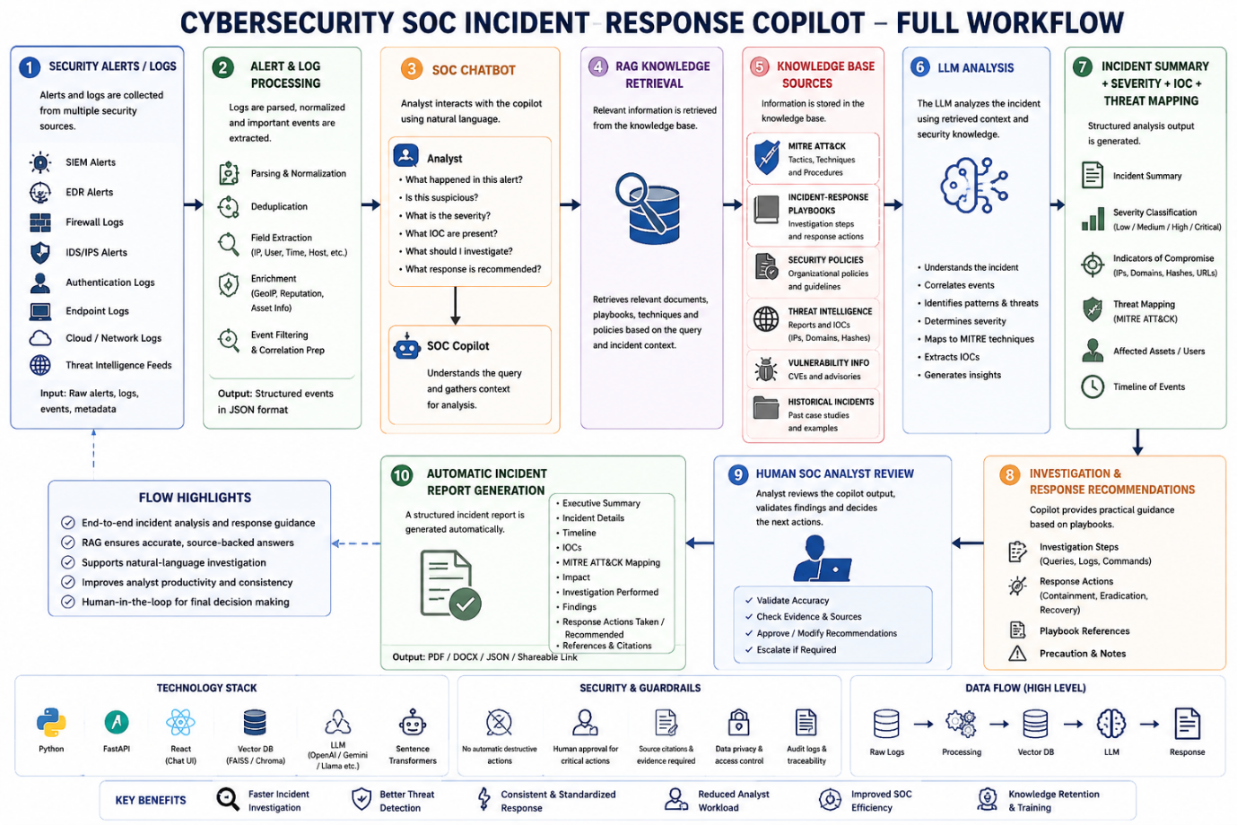

Overall Goal
The Cybersecurity SOC Incident-Response Copilot aims to function as a GenAI-powered chatbot assistant for SOC analysts. It helps analysts understand security alerts, investigate incidents, identify potential threats and receive evidence-based response guidance through natural-language conversation.
The system also generates structured incident reports after investigation, helping reduce manual work while keeping final security decisions under human control.

