10. Deploy artifcat into sit server

Connect to sit machine with git bash
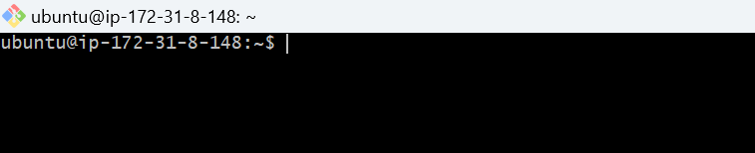

Update the apt repository

Sudo apt-get update

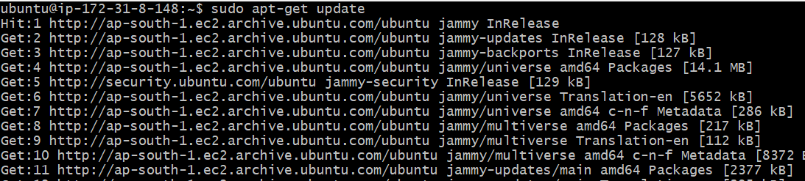

Install tomcat 9
Sudo apt-get install -y tomcat9

Now install tomcat9 admin as well

Sudo apt-get install tomcat9-admin

how can we access the tomcat

Take the publicip of sit server and add 8080(copy paste this command on the browser)

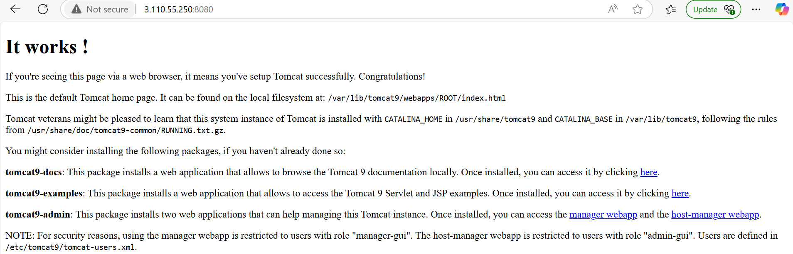

Now go to below path

Cd /etc/tomcat9
$ll

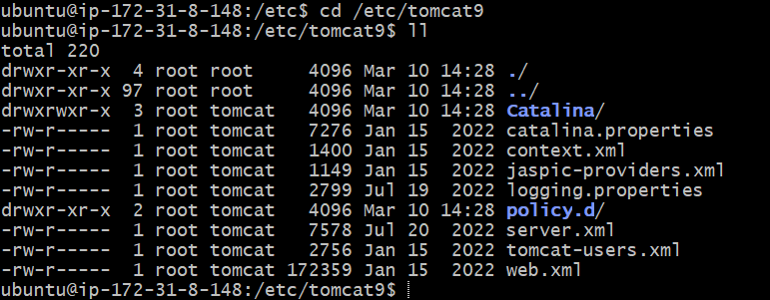

now we need to add user in the tomcat-users.xml file

Sudo vim tomcat-users.xml

Go to the insert mode
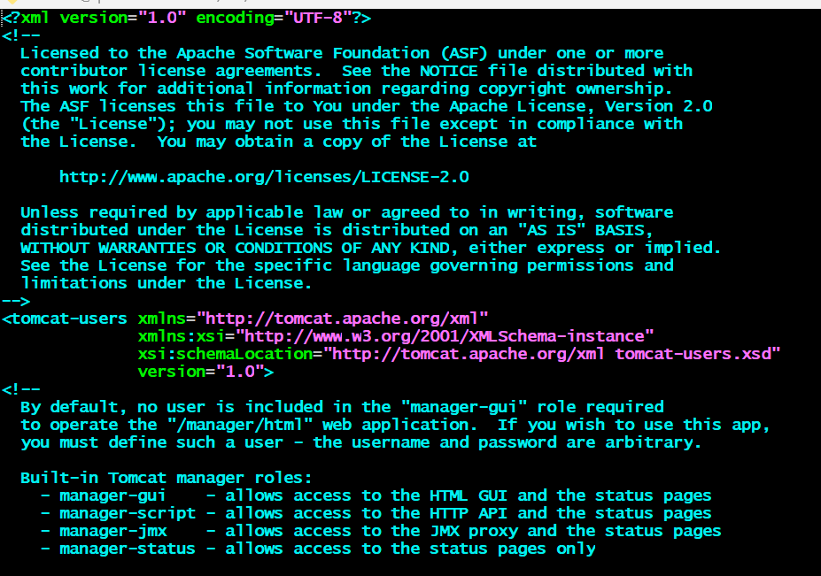

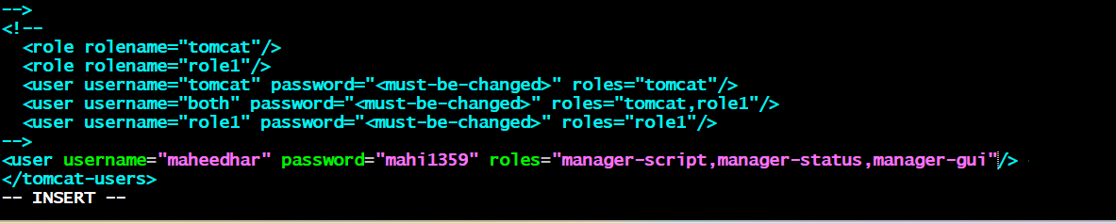

:wq

Now restart the tomcat service

$sudo service tomcat9 restart

Now u can add one plugin in the jenkins (deploy to container)

Manage jenkins-->plugins-->available plugins-->select deploy to container and install it

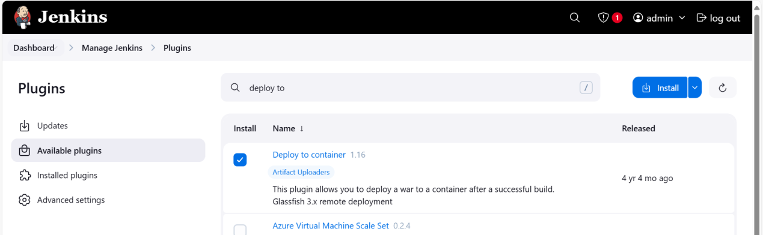

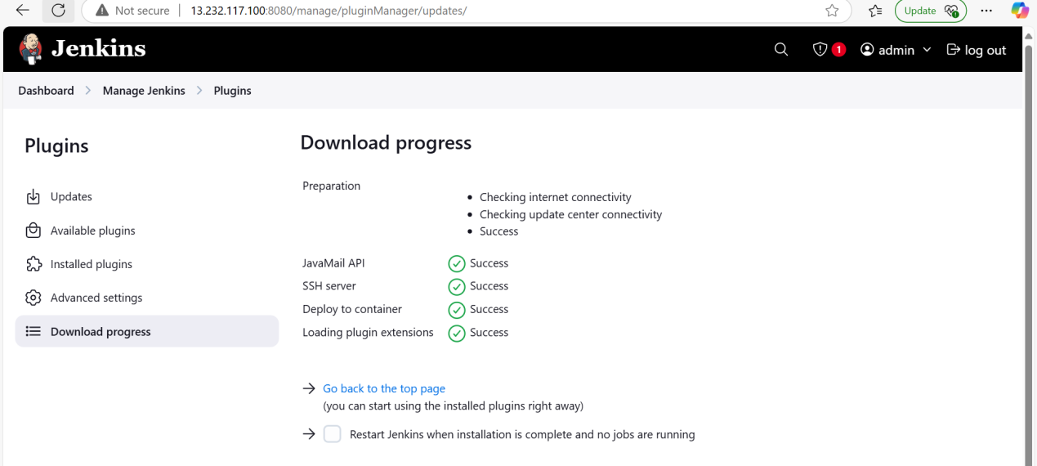

Now go to the jenkins dashboard
Select the war job
Select the configure

Select the post build action and searh deploy war/ear to a container

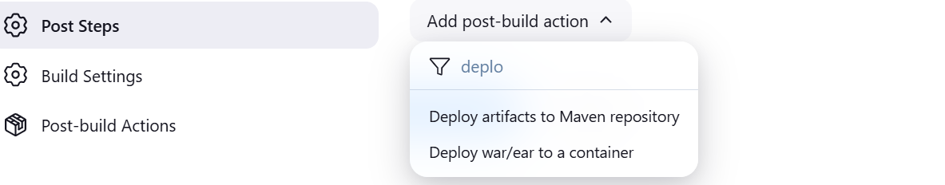

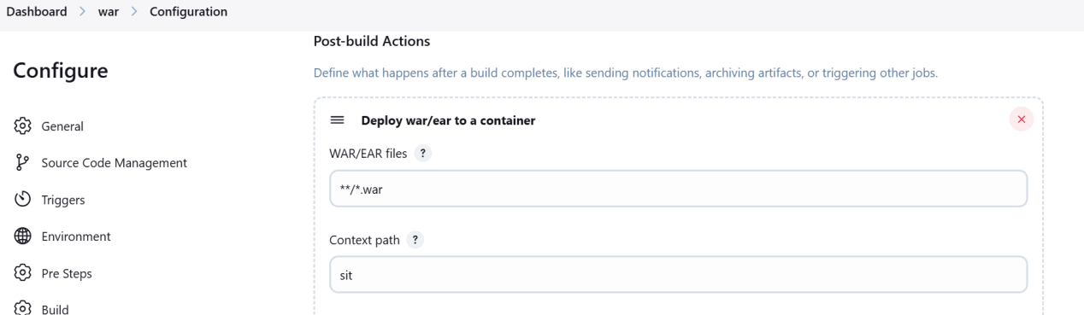

Add container tomcat 9

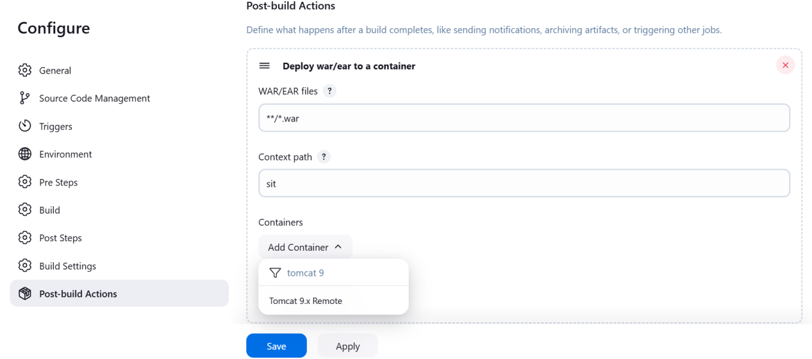

Add the credentials

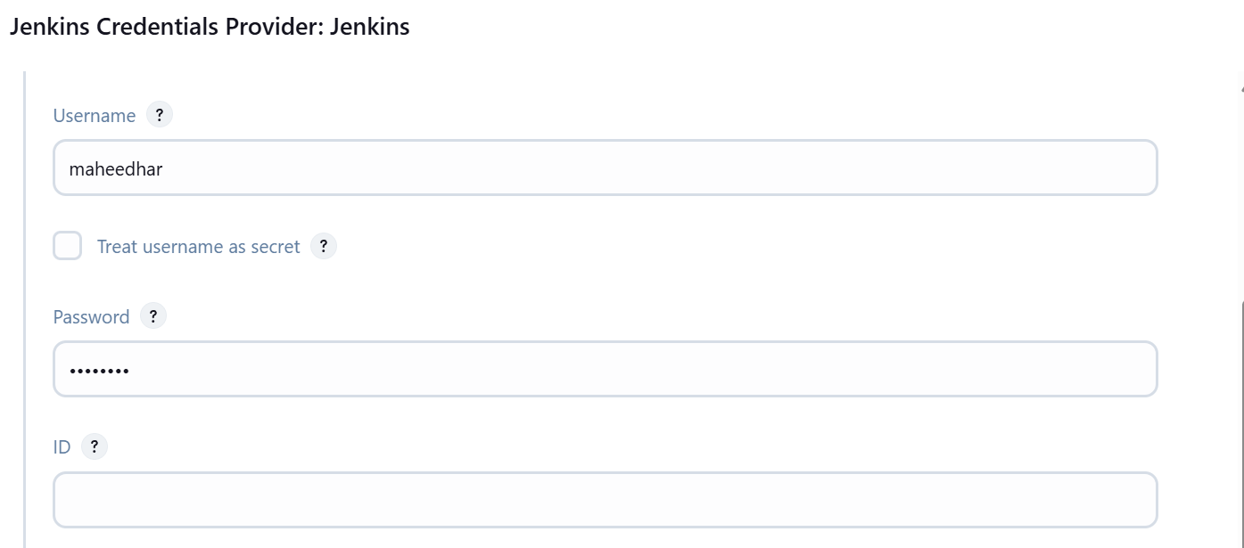

Select the credentials and give the tomcat url (sit server path along with 8080 port no)
Click on apply and save
And run the build now

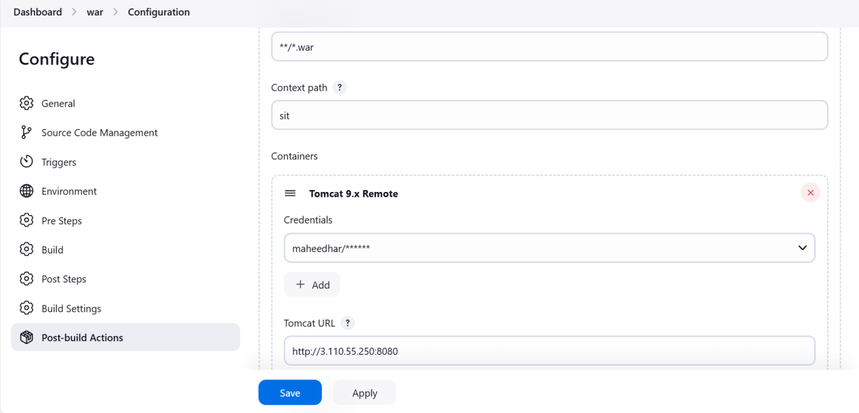

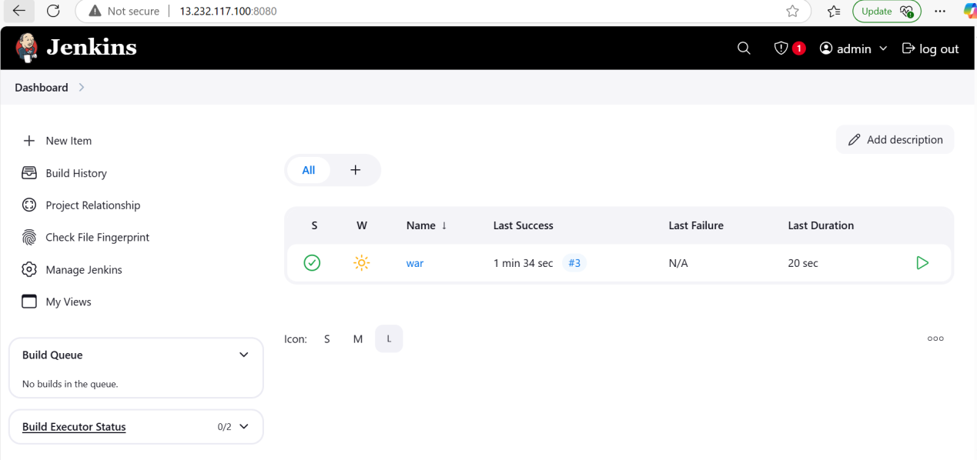

How can we check the artifact is deployed or not

Take the sit publicipaddress and port no and give the context path name

Ex: http://3.110.55.250:8080/sit



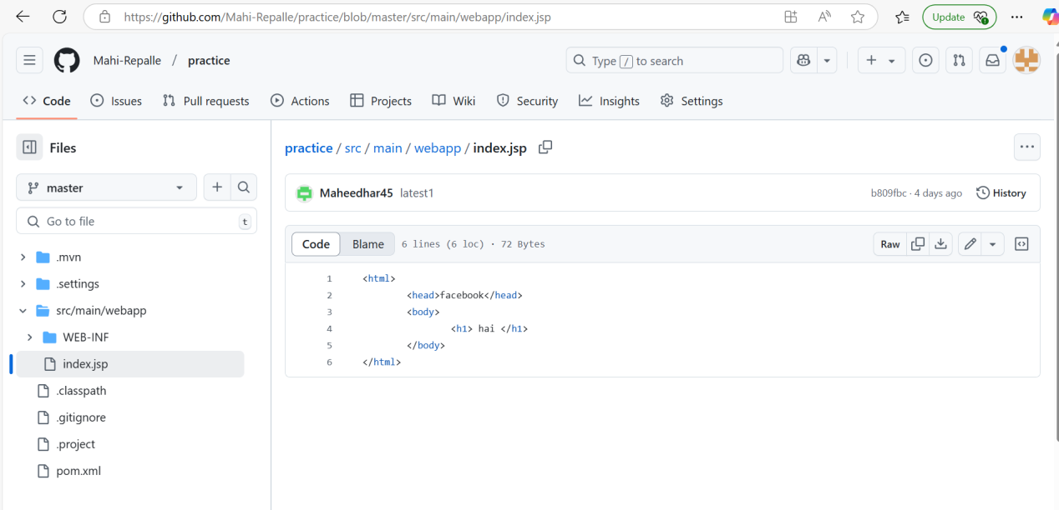

11. AUTOMATION THE JENKINS PIPELINE:

Whenever u made some changes in the source file jenkins job run automatically fetch the code from github to dev server and build the war file and deployed into sit

Admin@DESKTOP-ASGG5M3 MINGW64 /d/CMRIT_24_25/24-25_III_2/DEVOPS/DEVOPS_THEORY_LAB_DOCUMENTS/LAB_EXPERIMENTS/DEVOPS_LAB
$ git clone https://github.com/Mahi-Repalle/practice.git
Cloning into 'practice'...
remote: Enumerating objects: 59, done.
remote: Counting objects: 100% (59/59), done.
remote: Compressing objects: 100% (36/36), done.
remote: Total 59 (delta 9), reused 53 (delta 3), pack-reused 0 (from 0)
Receiving objects: 100% (59/59), 6.13 KiB | 392.00 KiB/s, done.
Resolving deltas: 100% (9/9), done.

Admin@DESKTOP-ASGG5M3 MINGW64 /d/CMRIT_24_25/24-25_III_2/DEVOPS/DEVOPS_THEORY_LAB_DOCUMENTS/LAB_EXPERIMENTS/DEVOPS_LAB
$ ll
total 11008
-rw-r--r-- 1 Admin 197121 1555602 Feb 1 20:22 Ansible_Setup.docx
-rw-r--r-- 1 Admin 197121 434977 Feb 20 19:38 'Deploy to Server.docx'
-rw-r--r-- 1 Admin 197121 850944 Jan 8 18:19 EXP1-STEPS.doc
-rw-r--r-- 1 Admin 197121 1886107 Jan 27 19:00 Experiment-2.pdf
-rw-r--r-- 1 Admin 197121 1279778 Jan 21 07:47 Jenkins_setup_on_AWS.docx
-rw-r--r-- 1 Admin 197121 1748522 Feb 15 06:44 War_With_Maven.doc
-rw-r--r-- 1 Admin 197121 314368 Feb 21 18:49 automation.doc
-rw-r--r-- 1 Admin 197121 1725354 Feb 19 20:24 docker.docx
drwxr-xr-x 1 Admin 197121 0 Mar 10 20:35 practice/
-rw-r--r-- 1 Admin 197121 1451061 Jan 26 20:35 'war file.docx'
-rw-r--r-- 1 Admin 197121 162 Feb 19 07:08 '~$docker.docx'
-rw-r--r-- 1 Admin 197121 162 Feb 20 06:31 '~$ploy to Server.docx'
-rw-r--r-- 1 Admin 197121 162 Feb 20 11:38 '~$r_With_Maven.doc'
-rw-r--r-- 1 Admin 197121 162 Feb 19 20:34 '~$sible_Setup.docx'

Admin@DESKTOP-ASGG5M3 MINGW64 /d/CMRIT_24_25/24-25_III_2/DEVOPS/DEVOPS_THEORY_LAB_DOCUMENTS/LAB_EXPERIMENTS/DEVOPS_LAB
$ cd “name of your repository”

Admin@DESKTOP-ASGG5M3 MINGW64 /d/CMRIT_24_25/24-25_III_2/DEVOPS/DEVOPS_THEORY_LAB_DOCUMENTS/LAB_EXPERIMENTS/DEVOPS_LAB/practice (master)
$ ll
total 4
-rw-r--r-- 1 Admin 197121 1896 Mar 10 20:35 pom.xml
drwxr-xr-x 1 Admin 197121 0 Mar 10 20:35 src/

Admin@DESKTOP-ASGG5M3 MINGW64 /d/CMRIT_24_25/24-25_III_2/DEVOPS/DEVOPS_THEORY_LAB_DOCUMENTS/LAB_EXPERIMENTS/DEVOPS_LAB/practice (master)
$ cd src

Admin@DESKTOP-ASGG5M3 MINGW64 /d/CMRIT_24_25/24-25_III_2/DEVOPS/DEVOPS_THEORY_LAB_DOCUMENTS/LAB_EXPERIMENTS/DEVOPS_LAB/practice/src (master)
$ ll
total 0
drwxr-xr-x 1 Admin 197121 0 Mar 10 20:35 main/

Admin@DESKTOP-ASGG5M3 MINGW64 /d/CMRIT_24_25/24-25_III_2/DEVOPS/DEVOPS_THEORY_LAB_DOCUMENTS/LAB_EXPERIMENTS/DEVOPS_LAB/practice/src (master)
$ cd main

Admin@DESKTOP-ASGG5M3 MINGW64 /d/CMRIT_24_25/24-25_III_2/DEVOPS/DEVOPS_THEORY_LAB_DOCUMENTS/LAB_EXPERIMENTS/DEVOPS_LAB/practice/src/main (master)
$ ll
total 0
drwxr-xr-x 1 Admin 197121 0 Mar 10 20:35 webapp/

Admin@DESKTOP-ASGG5M3 MINGW64 /d/CMRIT_24_25/24-25_III_2/DEVOPS/DEVOPS_THEORY_LAB_DOCUMENTS/LAB_EXPERIMENTS/DEVOPS_LAB/practice/src/main (master)
$ cd webapp

Admin@DESKTOP-ASGG5M3 MINGW64 /d/CMRIT_24_25/24-25_III_2/DEVOPS/DEVOPS_THEORY_LAB_DOCUMENTS/LAB_EXPERIMENTS/DEVOPS_LAB/practice/src/main/webapp (master)
$ ll
total 1
drwxr-xr-x 1 Admin 197121 0 Mar 10 20:35 WEB-INF/
-rw-r--r-- 1 Admin 197121 78 Mar 10 20:35 index.jsp

Admin@DESKTOP-ASGG5M3 MINGW64 /d/CMRIT_24_25/24-25_III_2/DEVOPS/DEVOPS_THEORY_LAB_DOCUMENTS/LAB_EXPERIMENTS/DEVOPS_LAB/practice/src/main/webapp (master)
$ vim index.jsp

Admin@DESKTOP-ASGG5M3 MINGW64 /d/CMRIT_24_25/24-25_III_2/DEVOPS/DEVOPS_THEORY_LAB_DOCUMENTS/LAB_EXPERIMENTS/DEVOPS_LAB/practice/src/main/webapp (master)
$ git status
On branch master
Your branch is up to date with 'origin/master'.

Changes not staged for commit:
(use "git add <file>..." to update what will be committed)
(use "git restore <file>..." to discard changes in working directory)
modified: index.jsp

no changes added to commit (use "git add" and/or "git commit -a")

Admin@DESKTOP-ASGG5M3 MINGW64 /d/CMRIT_24_25/24-25_III_2/DEVOPS/DEVOPS_THEORY_LAB_DOCUMENTS/LAB_EXPERIMENTS/DEVOPS_LAB/practice/src/main/webapp (master)
$ git add .

Admin@DESKTOP-ASGG5M3 MINGW64 /d/CMRIT_24_25/24-25_III_2/DEVOPS/DEVOPS_THEORY_LAB_DOCUMENTS/LAB_EXPERIMENTS/DEVOPS_LAB/practice/src/main/webapp (master)
$ git status
On branch master
Your branch is up to date with 'origin/master'.

Changes to be committed:
(use "git restore --staged <file>..." to unstage)
modified: index.jsp

Admin@DESKTOP-ASGG5M3 MINGW64 /d/CMRIT_24_25/24-25_III_2/DEVOPS/DEVOPS_THEORY_LAB_DOCUMENTS/LAB_EXPERIMENTS/DEVOPS_LAB/practice/src/main/webapp (master)
$ git commit -m "ab(message)"
[master 74b2935] ab
1 file changed, 1 insertion(+), 1 deletion(-)

Admin@DESKTOP-ASGG5M3 MINGW64 /d/CMRIT_24_25/24-25_III_2/DEVOPS/DEVOPS_THEORY_LAB_DOCUMENTS/LAB_EXPERIMENTS/DEVOPS_LAB/practice/src/main/webapp (master)
$ git push origin master
Enumerating objects: 11, done.
Counting objects: 100% (11/11), done.
Delta compression using up to 8 threads
Compressing objects: 100% (4/4), done.
Writing objects: 100% (6/6), 469 bytes | 469.00 KiB/s, done.
Total 6 (delta 1), reused 0 (delta 0), pack-reused 0 (from 0)
remote: Resolving deltas: 100% (1/1), completed with 1 local object.
To https://github.com/Mahi-Repalle/practice.git
b809fbc..74b2935 master -> master

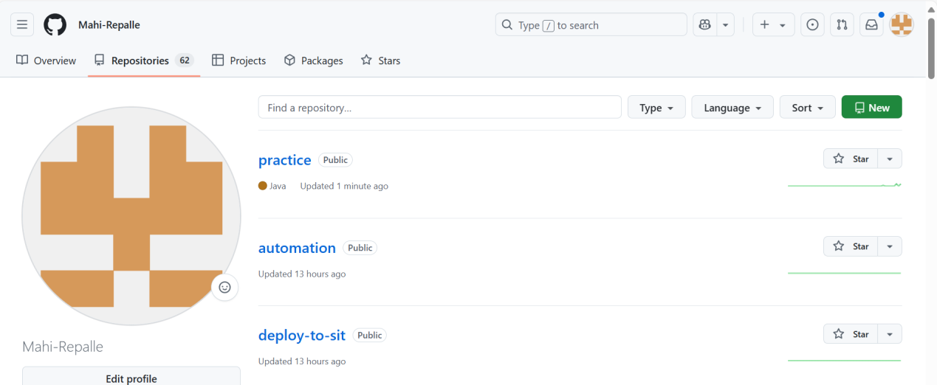

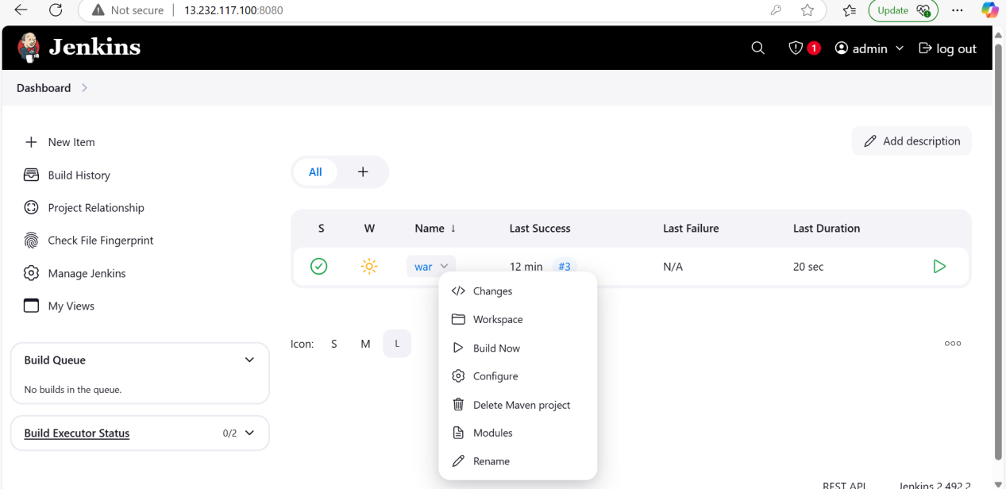

Triggers u can select the poll scm and give the crontab values

* * * * *

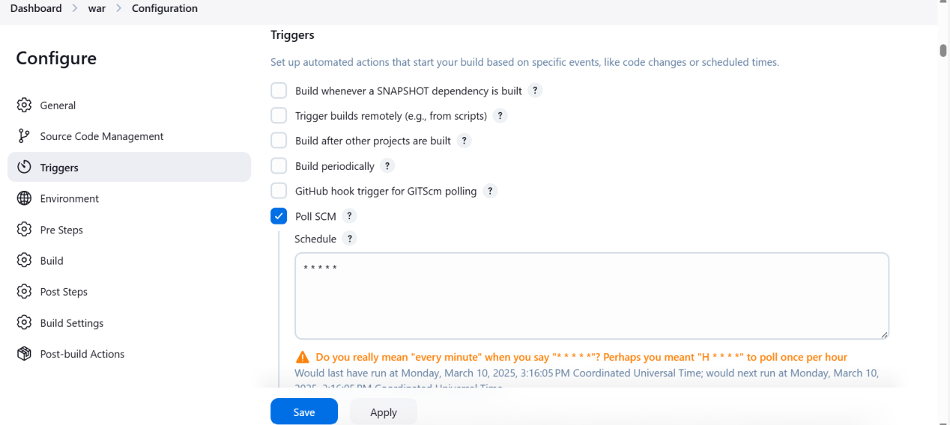

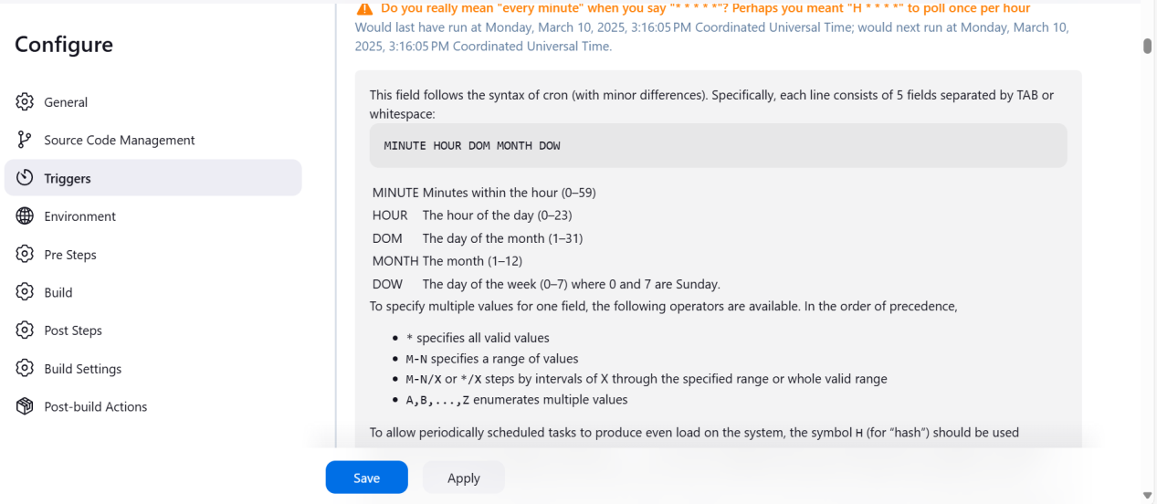

Click on apply and save the job

Don’t run the build now

Jenkins automatically trigger the job

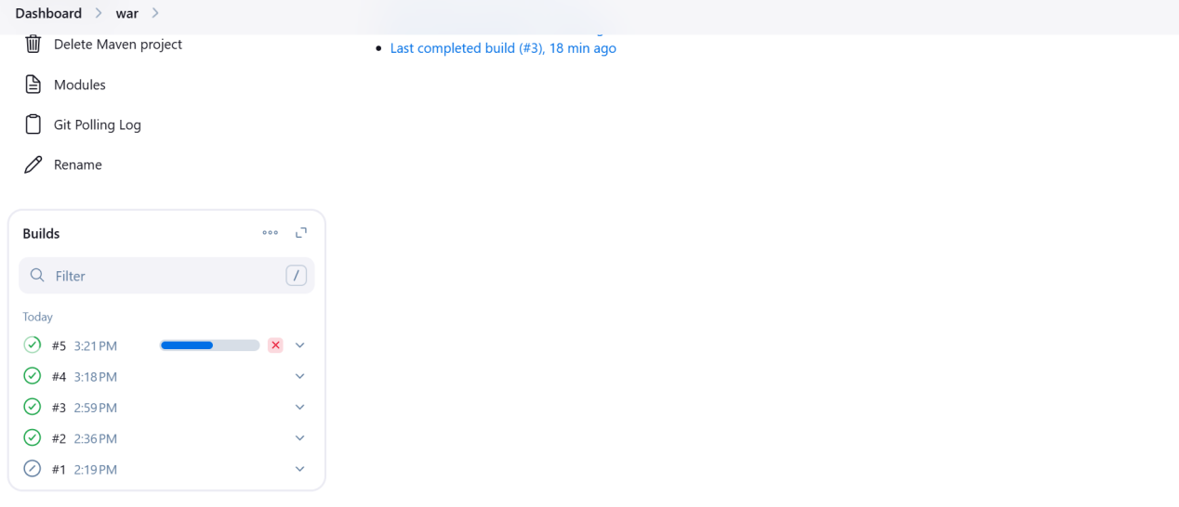

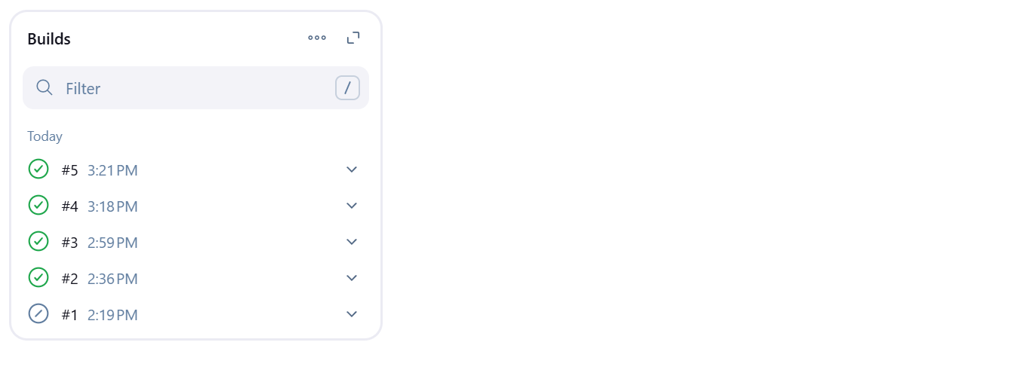

Now refresh the sit server latest code changes are reflected in the sit

