Automated Smart Street Light Fault Detection and Response System
¹Mohana Sundaram ,²Prem Arvinth G, ³Chandru S and ⁴Keerthika T
Department of Electronics and Communication
Sri Venkateswaraa College of Technology ,Sriperumbudur, India
Email: msundaramr@gmail.com , premarvinthg@gmail.com ,
keertikat@gmail.com , chandru.srinivasan16@gmail.com .

Abstract— Street lighting is a critical component of urban infrastructure, ensuring road safety, reducing accidents, and enhancing public security during night hours. Traditional streetlight maintenance relies heavily on manual inspection and public complaints, resulting in delayed fault detection, increased maintenance costs, and unnecessary energy wastage. This paper proposes a centralized row-wise monitoring architecture using an ESP32 microcontroller for efficient streetlight fault detection. Instead of equipping every pole with separate monitoring units, a group of streetlights is supervised collectively through shared sensing modules. The system continuously measures key electrical parameters—voltage, current, and brightness—to identify faults including lamp failure, overload, and power interruption. Fault conditions are determined using threshold-based logic: (1) low current combined with low LDR brightness indicates lamp failure; (2) high current indicates overload; (3) absence of voltage indicates power failure. When a fault is detected, an instant alert is transmitted through IoT communication via Wi-Fi to the monitoring authority. The proposed system reduces hardware complexity, minimizes network traffic, and enhances scalability for large-scale deployment.
Keywords— ESP32, Smart Street Light, Fault Detection, IoT, LDR Sensor, Voltage Sensor, Current Sensor, Embedded C, Arduino IDE.

Introduction
Street lighting infrastructure plays a crucial role in the development of modern cities and smart urban environments. Proper street illumination ensures safe movement of vehicles and pedestrians, reduces road accidents, and improves public security. With rapid urbanization and expansion of highway networks, thousands of streetlights are installed across urban and rural regions, making their maintenance a significant responsibility for municipal authorities [1], [3].

In conventional systems, faults are typically identified through manual inspection or public complaints. This reactive approach leads to delayed detection and prolonged non-functional lamps, causing poor visibility, increased accident risk, and unnecessary energy wastage [5], [6]. Although some modern systems implement IoT-based pole-wise monitoring [14], they significantly increase hardware cost and communication overhead.
This paper proposes a centralized row-wise monitoring architecture using the ESP32 microcontroller, where a group of streetlights is supervised collectively through shared sensing modules. The system employs voltage, current, and LDR sensors to detect faults in real time and transmits instant alerts via built-in Wi-Fi to the maintenance authority, thereby reducing hardware complexity and improving scalability [12], [16].

Related Work
Various approaches have been explored for smart streetlight monitoring. Tan et al. [2] proposed an adaptive traffic element-based streetlight control using IoT, focusing on brightness adjustment but lacking electrical fault detection. Anand et al. [3] introduced a federated learning-enabled smart streetlight monitoring application; however, the complexity of the machine learning model makes it unsuitable for low-cost embedded systems.

Goyal et al. [4] demonstrated AI-driven fault detection in smart grids using deep learning, achieving high accuracy but requiring substantial computational resources. Lambor et al. [5] presented an automated fault detection and tracking system using wireless sensor networks installed per pole, increasing hardware overhead. Karuppasamy et al. [6] proposed an automatic streetlight control and fault detection system using microcontrollers but did not address centralized row-wise supervision.

Mir et al. [9] applied machine learning and deep neural networks to enhance streetlight fault detection, while Bruno et al. [10] explored frequency support through LED streetlighting in power systems. Shaheen et al. [15] proposed model predictive control for adaptive energy-efficient streetlighting. The proposed work advances these approaches by adopting a cost-effective threshold-based embedded algorithm over complex AI models, achieving real-time fault detection suitable for microcontroller deployment [2], [5], [13].

System architecture

The proposed system employs an ESP32 microcontroller as the central processing and communication unit. Fig. 1 illustrates the overall block diagram. Streetlights are monitored row-wise using shared voltage, current, and LDR sensors connected to the ESP32. The controller processes sensor data, applies fault detection logic, and transmits alerts via Wi-Fi to a cloud server accessible by the monitoring system and maintenance team.

The system architecture comprises four main subsystems: (i) Sensing Unit, (ii) Data Acquisition and Processing Unit, (iii) Fault Detection Unit, and (iv) Communication and Alert System. This centralized approach significantly reduces the number of controllers and communication modules compared to pole-wise IoT monitoring systems [5], [14].

Hardware Components
A. ESP32 Microcontroller
The ESP32 serves as the central control unit, offering dual-core processing at up to 240 MHz, built-in 12-bit ADC channels, and integrated Wi-Fi (802.11 b/g/n) and Bluetooth capabilities. It operates at 3.3 V and provides sufficient GPIO pins for multi-sensor interfacing. The ADC resolution of 12 bits provides 4096 discrete levels (0–4095), enabling precise measurement of analog sensor signals.
B. Current Sensor
The current sensor measures the load current flowing through the streetlight line. It outputs an analog voltage proportional to the measured current, which is read by the ESP32 ADC. Under normal operation, the current remains within a specified range. Deviations indicate overload (excess current) or lamp failure/open circuit (low current).
C. Voltage Sensor
The voltage sensor monitors the supply voltage of the streetlight network. Sudden voltage drops, fluctuations, or complete absence of voltage indicate power failure or line disconnection. Combined with current measurements, it enhances fault classification accuracy.
D. LDR (Light Dependent Resistor)
The LDR sensor measures the brightness emitted by the streetlight. Even when electrical supply is present, the lamp may fail to illuminate due to filament breakage or LED failure. The LDR confirms actual lamp illumination. Its resistance varies inversely with light intensity, producing a voltage signal processed by the ESP32 ADC.
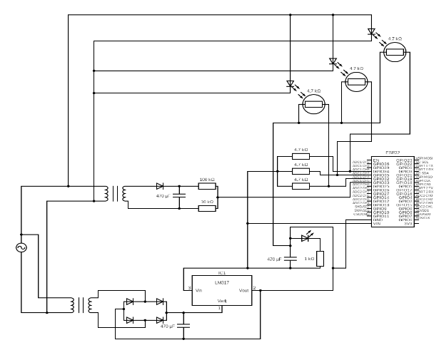
Fig. 1. Circuit Diagram of Smart Streetlight Fault Detection System.

Signal Processing And Fault Detection Equation
The analog sensor outputs are converted to digital values by the 12-bit ADC of the ESP32. The voltage conversion from ADC raw value is given by Equation (1):
$V_{sensor}=$(${ADC}_{raw}/{ADC}_{\max{}})×V_{REF}$ (1)

where ADCraw is the digital output (0–4095), ADCmax = 4095, and VREF = 3.3 V is the reference voltage. The estimated current drawn by each LED is derived from the sensor voltage as given by Equation (2):

$I_{load}=(\frac{V_{sensor}}{V_{REF}})×I_{max}$ (2)
where Imax = 5.0 A is the maximum rated current. The LDR raw value is simulated as:

${LDR}_{Raw}=Brightness×16$ (3)

where Brightness ∈ [0, 255] is mapped from the potentiometer ADC value. The LDR status is a binary indicator:
${LDR}_{status}=\left\{1, if {LDR}_{raw}>θ_{LDR}\right\}$ (4)

where $θ_{LDR}$ = 1000 ADC counts is the brightness threshold. A FAULT condition is declared when ${LDR}_{raw}$< $Q_{LDR}$. Power delivered to the streetlight row is estimated as:

$P=V_{sensor }×I_{Load}$ (5)

Fault detection algorithm
The algorithm implemented in the ESP32 microcontroller follows a continuous monitoring loop. Fig. 2 presents the system flowchart and Fig. 3 presents the fault detection via current fluctuation diagram.
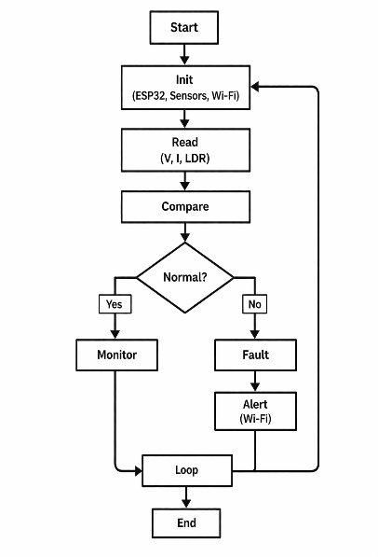
Fig. 2. Flowchart of Smart Streetlight Fault Detection System
The step-by-step algorithm is as follows:
1. Initialize ESP32, sensors, and Wi-Fi module.
2. Read voltage, current, and LDR values via ADC.
3. Apply Equations (1)–(3) to compute $V_{sensor}$, $I_{Load}$, and ${LDR}_{raw}$.
4. Compare parameters with predefined threshold limits.
5. If all values within range → continue monitoring loop.
6. If ${LDR}_{raw}$ < $θ_{LDR}$ → classify as FAULT; trigger alert.
7. Transmit alert message through Wi-Fi to cloud/monitoring server.
8. Continue monitoring loop; auto-resume after fault restoration.
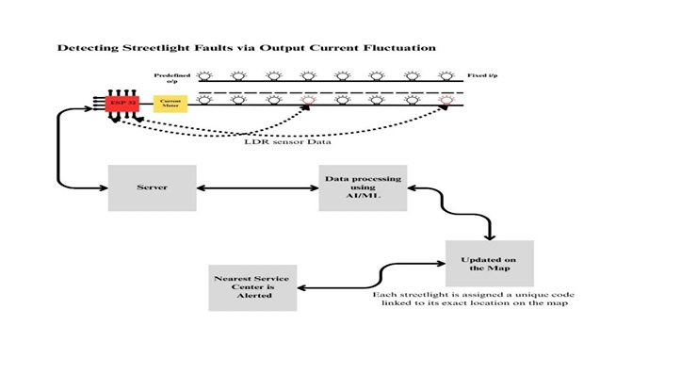
Fig. 3. Detecting Streetlight Faults via Output Current Fluctuation

Simulation And Results
The system was simulated using the Wokwi ESP32 simulator environment with potentiometers substituting as analog sensors. Four LEDs representing four streetlights (LED 1–4) were monitored simultaneously. Fig. 4 shows the simulation output captured from the serial monitor during the prototype run.
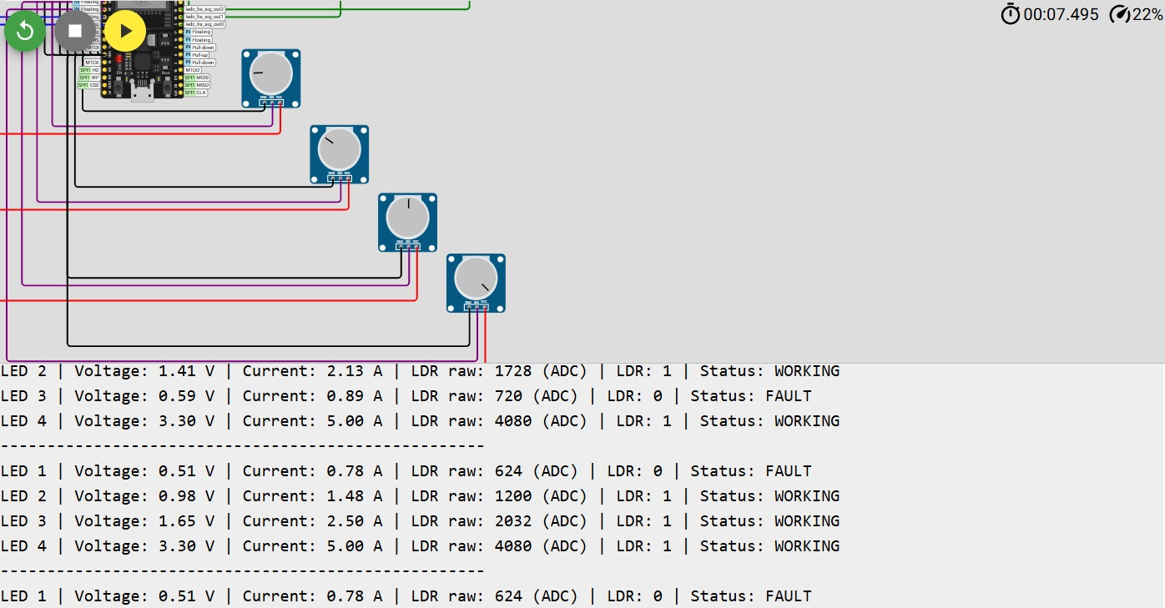

Fig. 4. Wokwi Simulation Output – Serial Monitor Showing LED Status, Voltage, Current, LDR, and Fault Detection
The serial monitor output confirms correct fault detection: LED 1 and LED 3 show FAULT status when ${LDR}_{raw}$ falls below the threshold of 1000 ADC counts (LDR status = 0), while LED 2 and LED 4 are WORKING. Table I summarizes representative observed results across multiple monitoring cycles.

Table I. Observed Test Results for Four LEDs
LED | Voltage (V) | Current (A) | LDR Raw | LDR Status | Fault Status
LED 1 | 0.51 | 0.78 | 624 | 0 (LOW) | FAULT
LED 2 | 0.98 | 1.48 | 1200 | 1 (HIGH) | WORKING
LED 3 | 1.65 | 2.50 | 2032 | 1 (HIGH) | WORKING
LED 4 | 3.30 | 5.00 | 4080 | 1 (HIGH) | WORKING

The results demonstrate that the system accurately identifies FAULT conditions when ${LDR}_{raw}$ < 1000 ADC. Voltage and current readings are consistent with Equations (1) and (2). LED 4 operating at maximum current (5.00 A) with maximum brightness (4080 ADC) confirms normal high-load operation, while LED 1 at 624 ADC LDR raw correctly triggers a FAULT.

Performance Analysis
The performance of the proposed system is evaluated against key metrics identified from literature [5], [6], [14], [16]. Compared to pole-wise IoT monitoring systems [14], the centralized row-wise architecture reduces hardware components per monitored unit, lowers communication overhead, and simplifies maintenance. The threshold-based detection algorithm achieves near-instantaneous fault identification without requiring AI model training or large datasets [4], [9].
Table II. Comparison of Proposed System with Existing Approaches
Parameter | Pole-wise IoT [14] | AI-based [9] | Proposed System
Hardware per Unit | High | High | Low
Real-time Fault Detection | Yes | Yes | Yes
Communication Overhead | High | Medium | Low
Scalability | Medium | Low | High
Deployment Cost | High | High | Low
Algorithm Complexity | Medium | High | Low

Advantages And Application
The proposed system offers the following key advantages:
• Automatic fault detection without manual inspection, reducing operational cost.
• Real-time monitoring and instant Wi-Fi alert generation to maintenance authorities.
• Centralized row-wise architecture reduces hardware and communication overhead versus pole-wise systems [14].
• Low-cost scalable implementation suitable for urban, semi-urban, and rural environments.
• Continuous operation without human intervention; automatic recovery after fault repair.
• Energy wastage prevention by early detection of lamp failure and overload conditions [13].

Application domains include urban road networks, national highways, smart city infrastructure, industrial premises, residential areas, parking lots, and campuses.

Conclusion
This paper presented an Automated Smart Street Light Fault Detection and Response System using a centralized row-wise ESP32-based architecture. The system continuously monitors voltage, current, and LDR brightness values using Equations (1)–(5) and classifies faults as lamp failure, overload, or power failure using threshold-based logic. Simulation results validated accurate fault detection with minimal hardware and low communication overhead.

Compared to pole-wise IoT monitoring and AI-based approaches, the proposed system achieves comparable real-time fault detection performance at significantly lower deployment cost and complexity. The design is scalable for smart city infrastructure and suitable for both urban and rural environments. Future integration with cloud platforms, predictive AI maintenance, and advanced communication protocols will further enhance its capabilities toward intelligent smart city lighting management.

Future enhancements to the proposed system include: (i) cloud-based dashboard integration for city-wide centralized monitoring; (ii) AI-based predictive maintenance using machine learning models trained on historical sensor data to forecast lamp degradation [4]; (iii) mobile application for real-time notifications to field technicians; (iv) integration with solar-powered streetlights for green energy monitoring; (v) adoption of advanced communication protocols such as LoRa or NB-IoT for long-range low-power deployment [7], [11]; and (vi) data analytics for energy consumption optimization and proactive maintenance scheduling [8].

References

[1] A. Thungtong, C. Chaichan, and K. Suwannarat, "A web-based control system for traditional street lighting that uses high-pressure sodium lamps," Research Article, Walailak University, Thailand.
[2] Y. Tan, S. Xu, and C. Su, "Adaptive Traffic Element-Based Streetlight Control Using Neighbor Discovery Algorithm Based on IoT Events," IEEE Internet of Things Journal, vol. 18, no. 9, Sept. 2020.
[3] D. Anand, I. Mavromatis, P. Carnelli, and A. Khan, "A Federated Learning-enabled Smart Street Light Monitoring Application: Benefits and Future Challenges," in Proc. ACM MORSE, Sydney, Australia, 2022.
[4] G. Goyal et al., "AI-Driven Fault Detection and Diagnosis in Smart Grids for Enhanced Power System Reliability," Journal of Information Systems Engineering and Management, vol. 10, 2025.
[5] S. Lambor et al., "Automated Fault Detection and Tracking in Street Lighting Networks," Vishwakarma Institute of Technology, Pune, India.
[6] V. Karuppasamy et al., "Automatic Street Light Control and Fault Detection System," International Research Journal on Advanced Engineering and Management, vol. 3, no. 3, Mar. 2025.
[7] M. S. U. Sourav et al., "CNN Based Intelligent Streetlight Management Using Smart CCTV Camera and Semantic Segmentation," Conference Paper.
[8] R. K. Kodali and S. Yerroju, "Energy Efficient Smart Street Light," National Institute of Technology Warangal, India, 2017.
[9] M. H. Mir et al., "Enhancing Street Light Fault Detection in Smart Cities Using Machine Learning and Deep Neural Network Approaches," in Proc. ICEECT, 2024.
[10] S. Bruno et al., "Fast Frequency Support Through LED Street Lighting in Small Non-Synchronous Power Systems," IEEE Transactions on Industry Applications, vol. 59, no. 2, 2023.
[11] S. Kouah et al., "Internet of Things-Based Multi-Agent System for the Control of Smart Street Lighting," Electronics, vol. 13, 2024.
[12] P. R. Taye et al., "IoT-Based Automatic Damaged Street Light Fault Detection and Monitoring System," IJSRET, vol. 11, no. 3, 2025.
[13] S. N. A. Kazmi et al., "IoT-Based Energy Efficient Smart Street Lighting Technique with Air Quality Monitoring," in Proc. ICOSST, 2020.
[14] A. T. M. M. Chowdhury et al., "IoT-Based Efficient Streetlight Controlling, Monitoring and Real-Time Error Detection System," IEEE Conference Paper.
[15] H. I. Shaheen et al., "Model Predictive Control for Adaptive Energy-Efficient Street Lighting," IEEE Transactions on Industrial Electronics, vol. 73, no. 2, 2026.
[16] S. More et al., "Smart Street Light Monitoring System for Enhanced Energy Efficiency," in Proc. ICESC, 2023.
[17] Republic of India: Energy-Efficient Street Lighting—Implementation and Financing Solutions, World Bank, 2015.
[18] S. M. et al., "Smart Street Lights Control System," International Journal of Progressive Research in Engineering Management and Science, vol. 5, no. 2, 2025.

