PWA EXPERIMENT NO: 11
Name: Prem Karira
Class: D15B
Roll No.: 27

Aim:
To analyze and evaluate the performance of a Progressive Web App (PWA) using Lighthouse, a powerful auditing tool provided by Google.

Theory:
Lighthouse is an open-source, automated tool developed by Google to improve the quality of web pages. It can audit a web app for performance, accessibility, best practices, SEO, and PWA compliance. Lighthouse provides detailed reports with suggestions and actionable insights to improve the web app.
When it comes to Progressive Web Apps, Lighthouse verifies whether the web application meets the core requirements of a PWA, such as:
- Valid HTTPS connection
- Web App Manifest file
- Service Worker registration
- Offline functionality
- Responsive design and fast load time
Lighthouse audits can be run directly from the Chrome DevTools, from the command line, or as a Node module.

Steps to Use Lighthouse in PWA:
- Open Chrome DevTools:
  - Launch your PWA in Google Chrome.
  - Right-click anywhere and select Inspect, or press Ctrl + Shift + I.
- Navigate to the Lighthouse Tab:
  - In DevTools, go to the Lighthouse tab.
  - Choose the categories you want to audit (Performance, PWA, Accessibility, etc.).
- Run Audit:
  - Select the device type (Mobile/Desktop).
  - Click "Analyze page load" or "Generate report".
- Review Results:
  - Lighthouse generates a detailed report.
  - It scores your app across different metrics and provides suggestions to improve.
- Apply Improvements:
  - Use the feedback provided to enhance your PWA's performance and compliance with web standards.

OUTPUT:
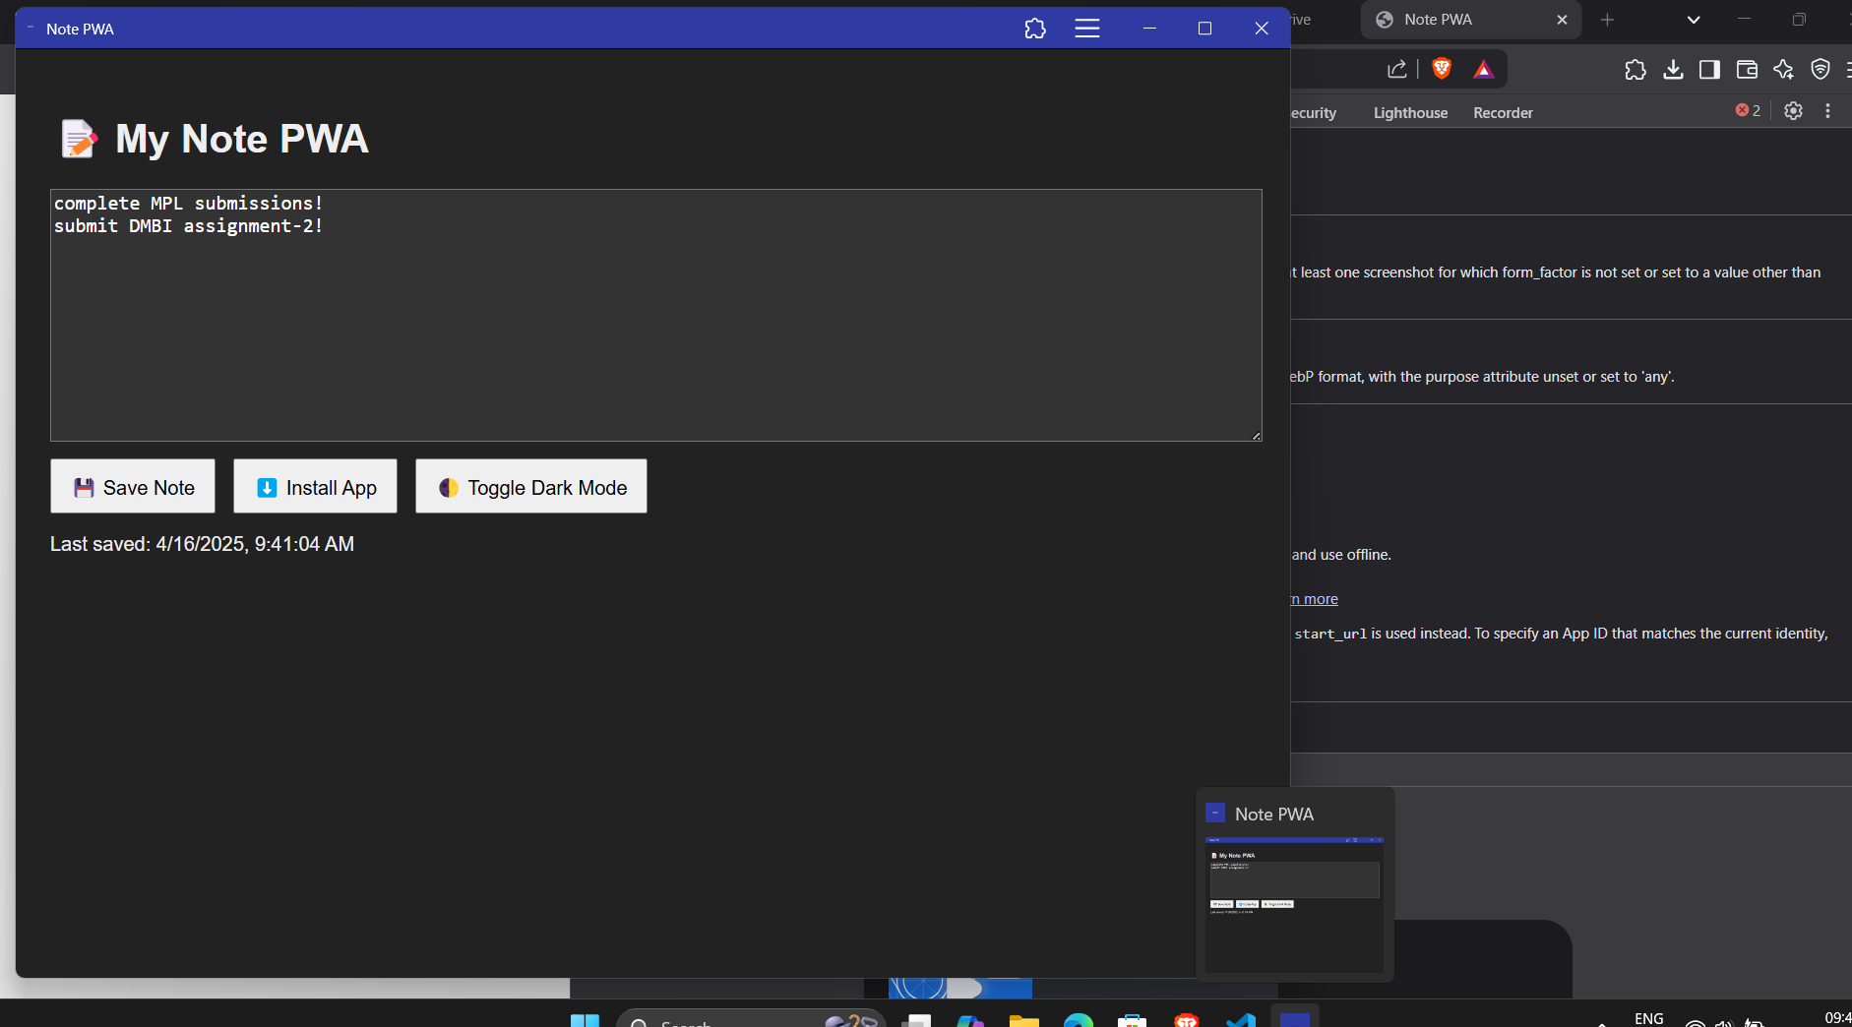

Conclusion:
By using Lighthouse, we successfully audited the Progressive Web App and gained detailed insights into its performance and reliability. This process is crucial for improving user experience, enhancing speed, and ensuring that the app meets modern web standards. It also helps in identifying areas of improvement that can make the PWA installable and performant across devices.

