PWA EXPERIMENT - 07
Name- PREM KARIRA
Roll no-27
D15B
Aim: Add to your home screen feature on a web application.

Theory
A Progressive Web App (PWA) bridges the gap between web and native apps by using modern web capabilities to deliver fast, reliable, and installable user experiences. One core PWA feature is the ability to "Add to Home Screen", allowing users to launch the app like a native application.
This is accomplished using:
- Manifest file (manifest.json) – Declares app metadata such as name, icons, theme color, and start URL.
- Service Worker – A JavaScript file that runs in the background and manages caching to support offline access.
- App Icons – Required in specific sizes (e.g., 192x192, 512x512) to be shown when installed on a device.
Procedure
- Created the manifest.json file with required metadata.
- Added icons in 192x192 and 512x512 pixel dimensions.
- Linked the manifest in index.html.
- Registered the service worker in JavaScript to handle offline support.
- Opened the site in Chrome and observed the “Install” or “Add to Home Screen” prompt.

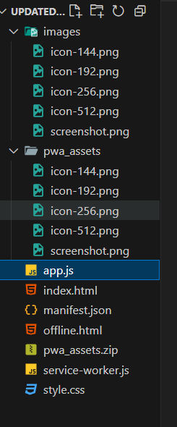
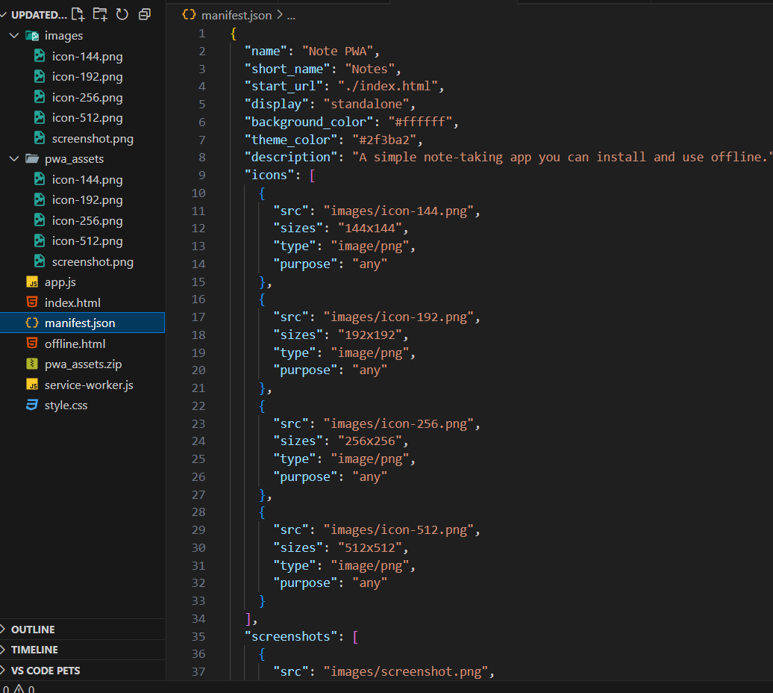
On adding Icon images and manifest.json file to the file structure, we could see the op on to install the website as if it were an application.
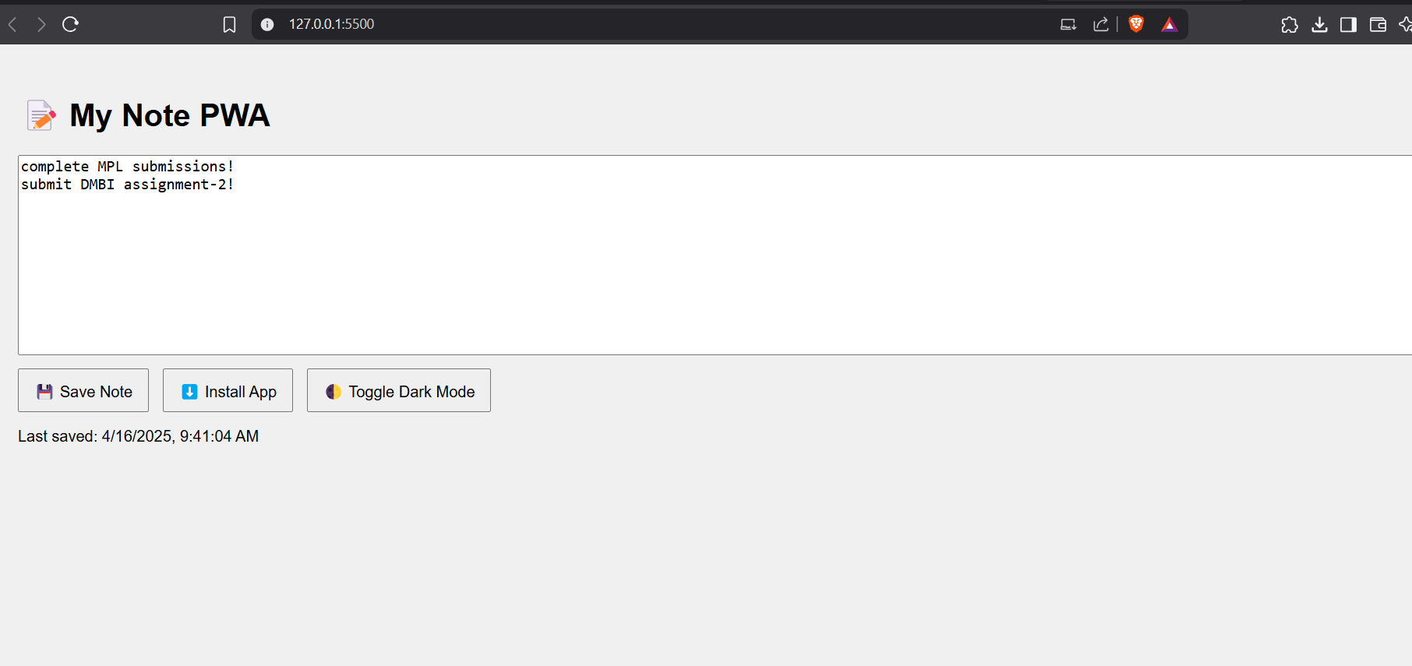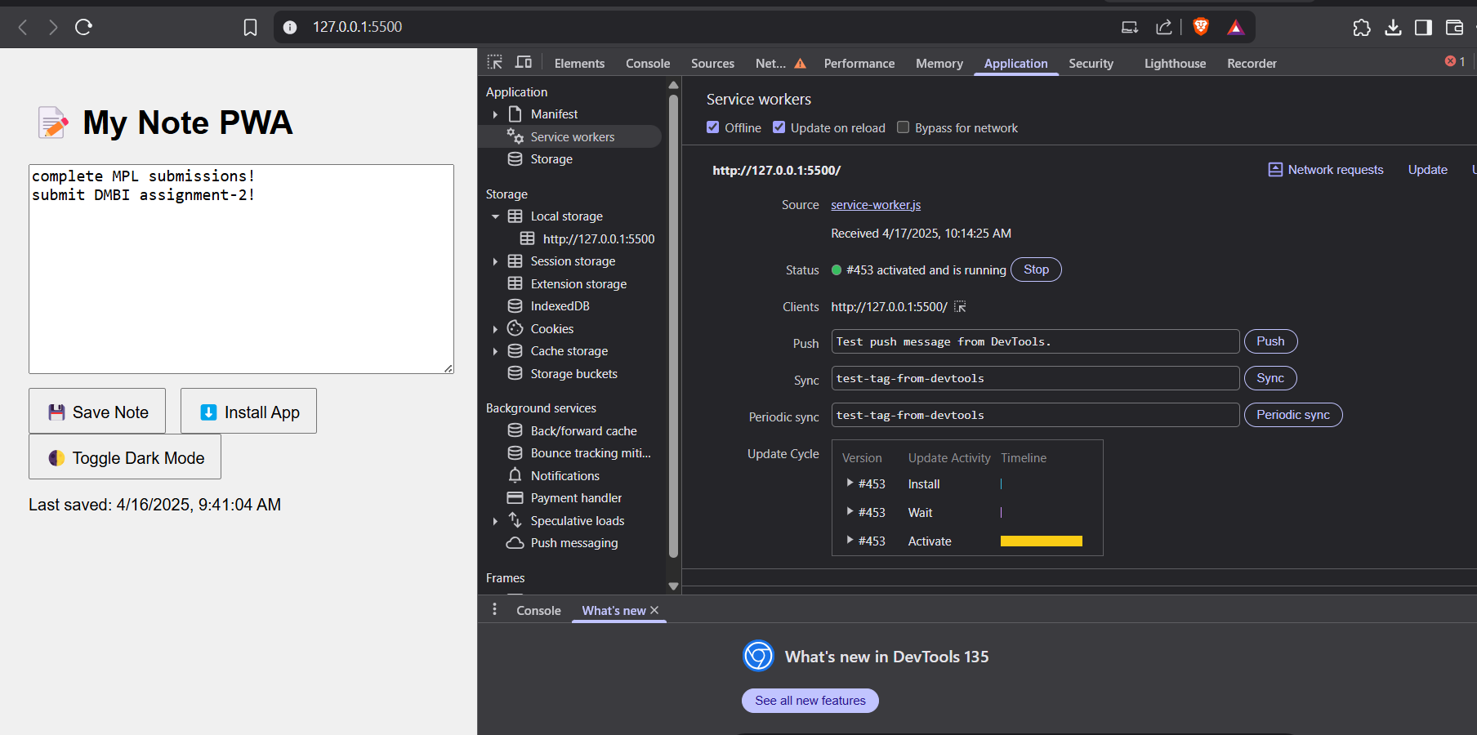
Conclusion: Through this experiment we learnt to add the ‘add to my webpage’ feature to our web applica on. This is the most fundamental step to be performed while building progressive web applica ons.

