MAD LAB EXPERIMENT NO. : 02
NAME : PREM KARIRA
CLASS : D15B
ROLL_NO: 27
Exploring Flutter Widgets
Flutter provides a rich set of widgets that can be categorized into two types: 1. Visible Widgets (Output and Input Widgets)
These widgets are responsible for displaying content and handling user interactions. a. Text Widget
• The Text widget is used to display text on the screen.
• It includes properties such as textAlign for alignment and style for customization. • Example:
• Text(
• 'Hello, Flutter!',
• textAlign: TextAlign.center,
• style: TextStyle(fontWeight: FontWeight.bold),)
b. Button Widgets
• Flutter does not provide a generic Button widget; instead, it has different button types like: o ElevatedButton (Previously RaisedButton)
o TextButton (Previously FlatButton)
o OutlinedButton
• Example of an ElevatedButton:
• ElevatedButton(
• onPressed: () {
• print("Button Clicked!"); },
• child: Text("Click Me"),)
c. Image Widget
• The Image widget allows displaying images from various sources:
o Asset images: Stored in the assets/ folder.
o Network images: Loaded from a URL.
o File images: Loaded from the local storage.
o Memory images: Loaded from memory.
• Example of an asset image:
• Image.asset('assets/sample.jpg')
2. Invisible Widgets (Layout and Control Widgets)
These widgets help in structuring the UI.
a. Container Widget
• A versatile widget used for styling, padding, and layout customization.
• Example:
• Container(
• padding: EdgeInsets.all(10),
• decoration: BoxDecoration(color: Colors.blue),
• child: Text("Flutter Container"),)
b. Row and Column Widgets
• Used for horizontal (Row) and vertical (Column) alignment of widgets. • Example:
• Row(
• mainAxisAlignment: MainAxisAlignment.center,
• children: [
• Text("Hello"),
• Text("Flutter"),],)
c. Scaffold Widget
• Provides the basic layout structure, including an AppBar, Body, and FloatingActionButton. • Example:
• Scaffold(
• appBar: AppBar(title: Text("Flutter App")),
• body: Center(child: Text("Welcome to Flutter!")),)

,
OUTPUT:
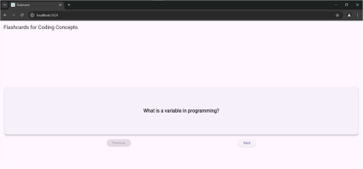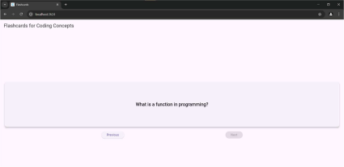
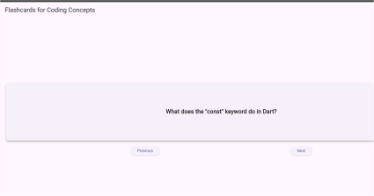
Conclusion
Flutter provides a robust and flexible widget-based UI framework for developing cross-platform applications. It classifies widgets into visible (output and input) and invisible (layout and control) categories, enabling a structured and reusable approach to UI design.
• Visible widgets, such as Text, Button, and Image, facilitate user interaction and content display.
• Invisible widgets, including Container, Row, Column, and Scaffold, contribute to efficient UI structuring and layout management.
With its real-time code reflection capabilities, an extensive widget library, and optimized performance, Flutter proves to be a highly effective framework for modern application development. A comprehensive understanding of these fundamental widgets serves as a strong foundation for building dynamic and interactive applications, such as a flashcard app for coding concepts.

