MPL EXPERIMENT NO: 04
PREM KARIRA
D15B – 27
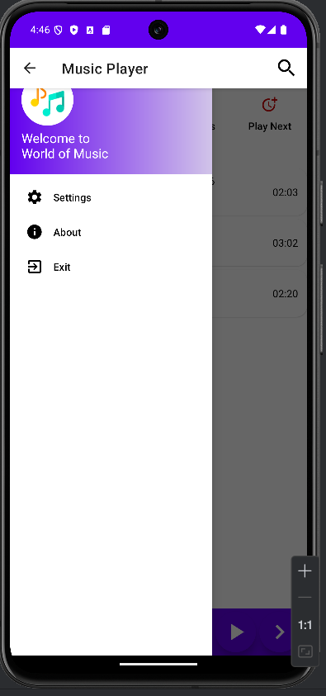
Exp 4 To create an interactive Form using form widget 