PWA EXPERIMENT NO: 10
Name: Prem Karira
Class: D15B
Roll No.: 27

Aim:
To study and implement the deployment of an Ecommerce Progressive Web Application (PWA) to GitHub Pages.

Theory:
A Progressive Web Application (PWA) is a type of application software delivered through the web, built using standard web technologies such as HTML, CSS, and JavaScript. It is designed to function across all platforms that use a standards-compliant browser, including desktop and mobile devices.
PWAs offer several advanced capabilities, such as:
- Offline functionality
- Push notifications
- Background synchronization
- Installability on user devices similar to native applications
These capabilities are made possible through the use of essential components like Service Workers, a Web App Manifest, and secure HTTPS connections.
In this experiment, the focus is on deploying an Ecommerce PWA using GitHub Pages. GitHub Pages is a static site hosting service that enables developers to publish web content directly from a GitHub repository. It is particularly effective for hosting static websites and front-end applications, including PWAs, as it supports HTTPS by default and is easy to configure.

Key Components:

1. Web App Manifest
A JSON file that contains metadata about the web application, such as its name, icons, start URL, and display preferences. This file plays a critical role in enabling the “Add to Home Screen” prompt and making the application installable.

2. Service Worker
A background script that allows the web application to function offline by caching files and handling network requests. It also enables other advanced features like push notifications and background sync.

3. GitHub Pages
A free hosting platform provided by GitHub for serving static content directly from a repository. It supports HTTPS, which is essential for running service workers, and allows easy public access to the hosted web application.

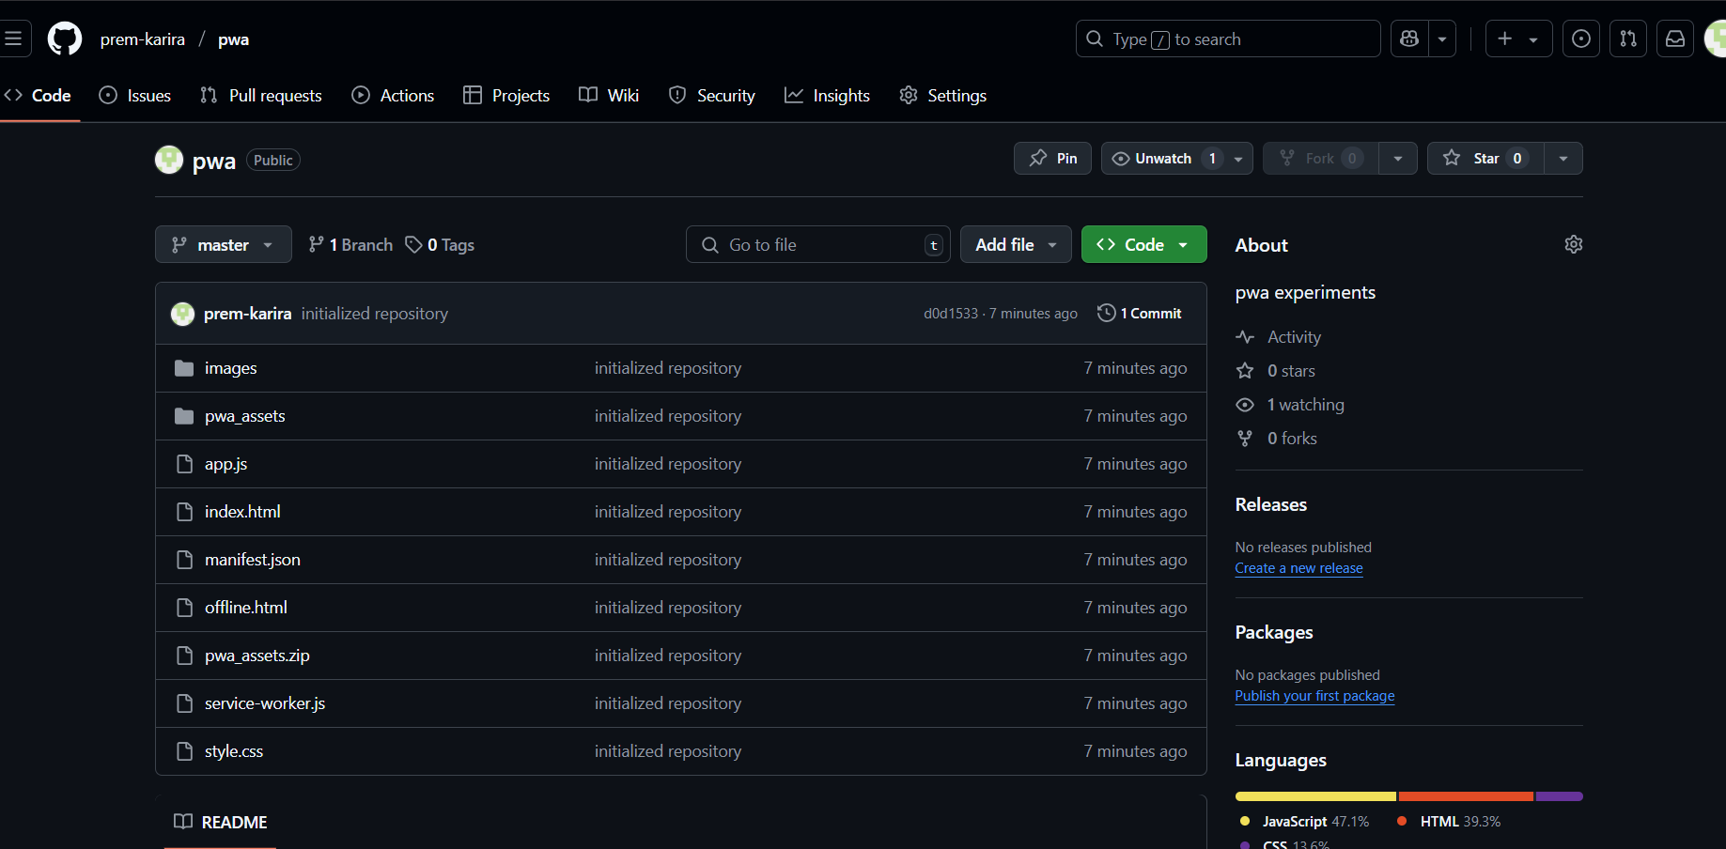
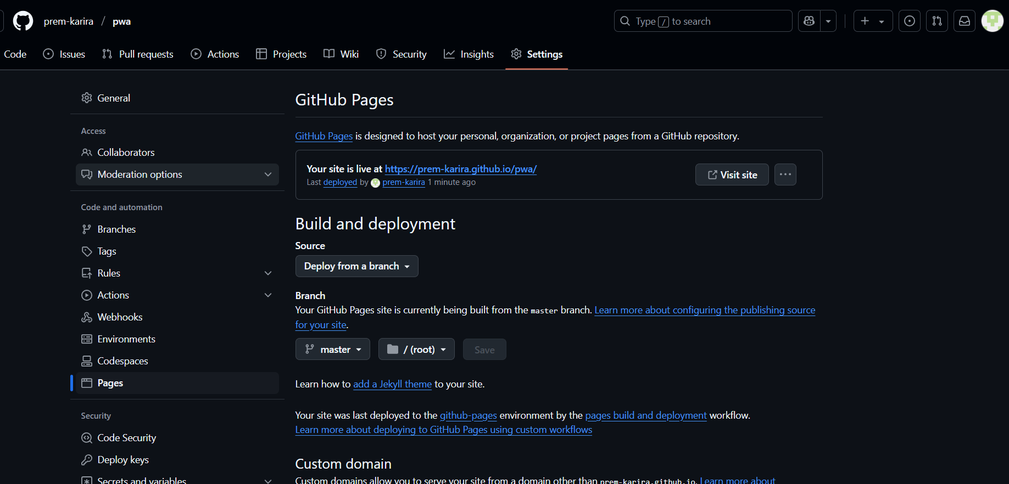

Link: https://prem-karira.github.io/pwa/

