EXPERIMENT 08
NAME : PREM KARIRA
CLASS : D15B
ROLL_NO : 27
Aim: To code and register a service worker, and complete the install and ac va on process for a new service worker for the E-commerce PWA.
Create service-worker.js
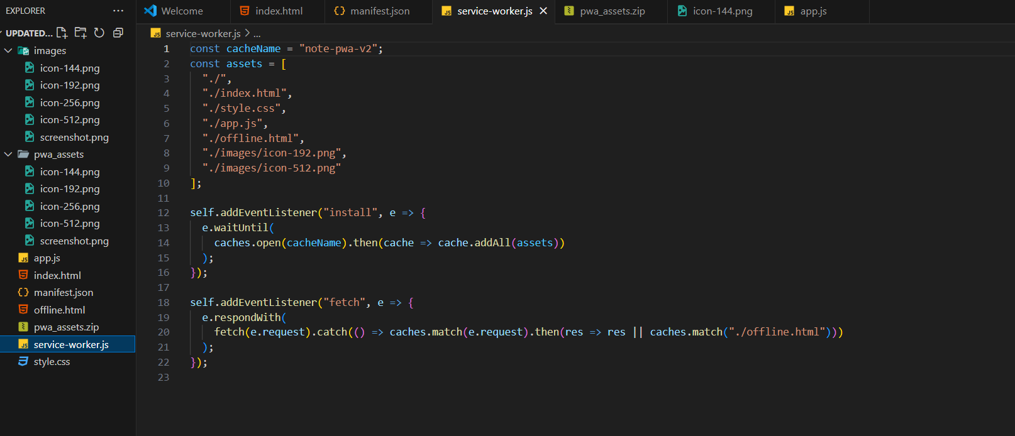
Create a cacheable file called offline.html to be displayed in the absence of an internet connection.
