PWA EXPERIMENT No : 09
NAME : PREM KARIRA
CLASS : D15B
ROLL_NO : 27
Aim: To implement Service worker events like fetch, sync and push for E-commerce Notes PWA. 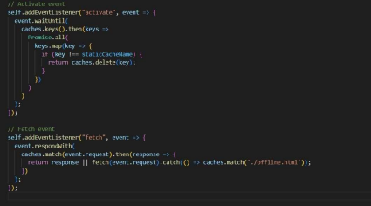
Make the following changes to the service-worker.js
// Install Event: Cache assets
// Activate Event: Cleanup old caches
// Fetch Event: Supports both Cache-First & Network-First
// Sync Event: Retry sending data when online
// Func on to send pending screenshots to the server
// Push Event: Display push notiications
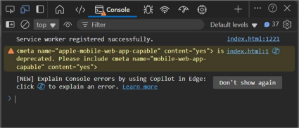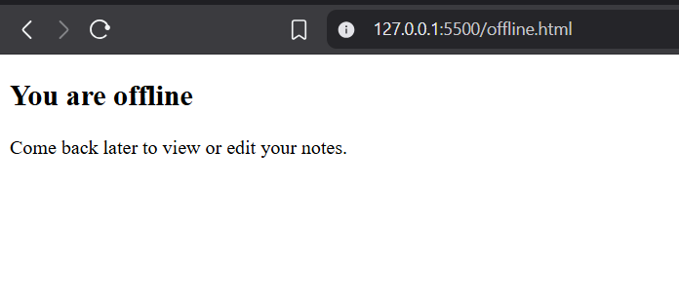
Conclusion: We implemented the functionality of offline web cache capture so that in the absence of a stable internet connection on, the app would display a generic waiting page.

