**Software Requirements Specification**

**eBay Replica**

**Version 1.0**

**Prem Sharma**

**Pranav Rai**

**Vibhor Joshi**

**Aakarsh Shukla**

**Kartik Yadav.**

**INTRODUCTION**

**Purpose:**

The purpose of this Software Requirements Specifications document is to showcase a model of the popular E-Commerce website Ebay. This endeavour has been undertaken as an informal project under the CS F212 course. This document shall elaborate the purposes and features of this E-Commerce website system, interfaces, constraints it’s subjected to and it’s interactions with different users. It is hoped reading this document will allow a competent developer team to begin building an E-Commerce website.

**Scope:**

This software system is a prototype scaled downed version of the actual Ebay website and will be designed to allow hassle-less browsing and offer a comfortable shopping experience to its users. This document consists of use cases, functional requirements and non-functional requirements which together ought to give a decent look into the software itself.

**References:**

IEEE Recommended Practice for Software Requirements Specifications

**Functional Requirments (Overall description):**

1. **System Environment**

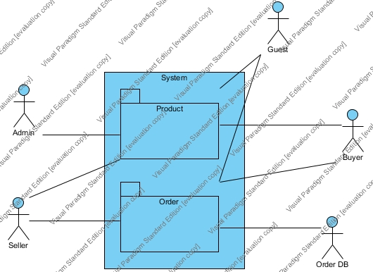

The above system has four active actors and one cooperating system. Admin can manage the product. The seller can instantiate a product. The Guest and the Buyer both can place an order for the product. And the order Database contains all the orders from the buyer. The buyer and seller interact through orders.

1. **Admin**

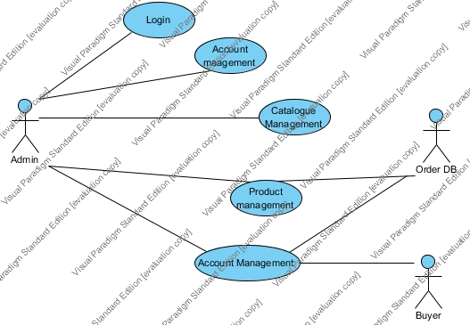

**Use Case: Login**

**1.Description:**

User will provide credentials to login into system.

**2.Trigger:**

User invokes login protocol.

**3.Preconditions:**

User has a registered account.

**4.Steps of Execution:**

4.1 User invokes a login protocol.

4.2 User provides credentials.

4.3 System checks for the user.

4.4 User logs into his account.

**5.Success:**

User logs into his account.

**6.Faliure:**

6.1 User does not have an account.

6.2 Credentials does not match to the registered account.

**Use Case: Account Management**

**1.Description:**

User updates his account information such as login credentials, address and contact information.

**2.Trigger:**

User invokes account management protocol.

**3.Preconditions:**

3.1 User has a registered account.

3.2 User is logged into his account.

**4.Steps of Execution:**

4.1 User invokes account management protocol.

4.2 User updates his information.

4.3 System asks for Login credentials.

4.4 System updates the information in the database.

4.5 Information regarding user is updated in the database.

**5.Success:**

Information regarding user is updated in the database.

**6.Faliure:**

6.1 Connection resets midway between update.

6.2 Credentials does not match to the registered account.

**Use Case: Catalogue management**

**1.Description:**

Administrator edits the catalogue of all the items.

**2.Trigger:**

Administrator starts to edit the catalogue database.

**3.Preconditions:**

User is an administrator.

**4.Steps of Execution:**

4.1 Administrator starts to edit the catalogue database.

4.2 Administrator updates the database.

4.3 System makes changes into the database.

4.4 Catalogue updated.

**5.Success:**

Catalogue updated.

**6.Faliure:**

6.1 update cancelled by administrator.

**Use Case: Product management**

**1.Description:**

Administrator can manage products present in the database and can delete faulty products.

**2.Trigger:**

Administrator starts to edit the catalogue database.

**3.Preconditions:**

User is an administrator.

**4.Steps of Execution:**

4.1 Administrator starts to edit the catalogue database.

4.2 Administrator deletes a product from the database.

4.3 System makes changes into the database.

4.4 Catalogue updated.

**5.Success:**

Catalogue updated.

**6.Faliure:**

6.1 update cancelled by administrator.

**Use Case: Account management**

**1.Description:**

Administrator can manage different users can provide seller access to a user and can ban a user from the site.

**2.Trigger:**

Administrator invokes account management protocol.

**3.Preconditions:**

User is an administrator.

**4.Steps of Execution:**

4.1 Administrator invokes account management protocol.

4.2 Administrator updates user database.

4.3 System makes changes into the database.

4.4 user database updated.

**5.Success:**

User Database updated.

**6.Faliure:**

6.1 update cancelled by administrator.

1. **Buyer**

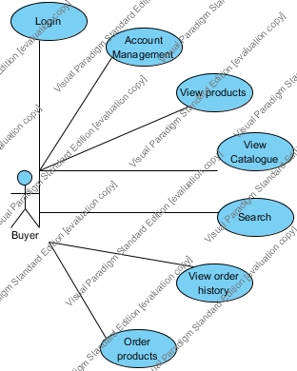

**Use Case: Login**

**1.Description:**

User will provide credentials to login into system.

**2.Trigger:**

User invokes login protocol.

**3.Preconditions:**

User has a registered account.

**4.Steps of Execution:**

4.1 User invokes a login protocol.

4.2 User provides credentials.

4.3 System checks for the user.

4.4 User logs into his account.

**5.Success:**

User logs into his account.

**6.Faliure:**

6.1 User does not have an account.

6.2 Credentials does not match to the registered account.

**Use Case: Account Management**

**1.Description:**

User updates his account information such as login credentials, address and contact information.

**2.Trigger:**

User invokes account management protocol.

**3.Preconditions:**

3.1 User has a registered account.

3.2 User is logged into his account.

**4.Steps of Execution:**

4.1 User invokes account management protocol.

4.2 User updates his information.

4.3 System asks for Login credentials.

4.4 System updates the information in the database.

4.5 Information regarding user is updated in the database.

**5.Success:**

Information regarding user is updated in the database.

**6.Faliure:**

6.1 Connection resets midway between update.

6.2 Credentials does not match to the registered account.

**Use Case: View Single Product**

**1.Description:**

A user views the description page of a single item

**2.Precondition:**

None

**3.Trigger:**

Simple url gives access to this page from anywhere

**4.Steps of Execution:**

4.1 Database checks if this item still exists in database. If failed user taken to 404 page

4.2 Item description, reviews, rating, seller info, item specifications, etc are loaded and displayed

4.3 Item image loaded.

4.4 (Optional) Multiple views of same object are loaded and can be accessed. Zoom functionality given

**Use case: Viewing Catalogue:**

**1. Description:**

The buyer can view the entire catalogue of products being displayed by categories.

2. Precondition:

The user loads the Landing Page of the website.

3.Trigger:

User Selects view product option.

**4.Steps of Execution:**

4.1 The entire catalogue of items arranged according to departments (like electronics, home, clothes etc.)

4.2 The user can browse the department-wise catalogues by scrolling.

4.3 The user can click on individual products.

4.4 Upon click redirect to the product page.

4.5 Move to view product use case.

4.5 The user can click on the search bar.

4.6 Take the entered string as the query variable.

4.7 Move to Search use case.

4.8 The user clicks on the Log in button.

4.9 Upon click redirect to the Login form.

4.10 Move to Login use case.

**Postcondition:**

Navigate to subsequent page.

**Failure:**

Non response on clicking or scrolling or any other kind of User interaction.

**Use Case: Search**

**1.Description:**

Allows search query based on user entered string.

**2.Trigger:**

The search button is clicked.

**3.Preconditions:**

A valid Search String is entered.

**4. Steps of Execution:**

4.1: A valid search string is passed into the database query system.

4.2a: If nothing is found, then display an appropriate message.

4.2b: Redirect to a new page which displays all appropriate results.

**5. Success:**

Results are shown.

**6. Failure:**

6.1: No response.

6.2: Network resets between search.

**Use Case: View Order History**

**1.Description:**

A user views past orders placed

**2.Precondition:**

User is already logged in

**3.Trigger:**

Accessed by pressing required button in User Accounts

**4. Steps of Execution**

Step 1: Database queried for list of past orders

Step 2: Orders are shown to user in chronological order, in groups of "Completed" and "Failed"

**Use Case: Placing Order(s)**

**Description:**

Buyer places an order. Use case ends after transaction

**Precondition:**

User is already on the cart page and cart contains 1 or more items

Buyer is already logged in

**Trigger:**

“Buy Now” Button is pressed

Step 1: Database is queried for stock of each item will be checked, and failcase will be notified

Step 2.1: Get contact details from user database/get a new one now

Step 2.2: Get shipping address from user database/get a new one now

Step 3: Display Item Details and Shipping details alongwith ETA

Step 4: (Optional) Suggest/take promo offers or money saving combos on items

Step 5: (Optional) Gift wrapping

Step 6: (Optional) Different delivery schemes

Step 7.1: Display Transaction modes, with previously saved cards

Step 7.2: Check stock once again. If failed, go back to step 3 with a notification and rest of the items ready in queue.

Step 8.1: If Card selected:

Step 8.1.1: Get Card details

Step 8.1.2: Send details to bank and get verification

Step 8.1.2.1: If verified, user taken securely to banking page

Step 8.1.2.2: If not verified, suitable error thrown and user taken to transaction failed page. <End Of Use Case>

Step 8.1.3: Transaction success/failure notice received from bank

Step 8.1.3.1: If successful, user taken to Transaction Complete page.

<End Of Use Case>

Step 8.1.3.2: If failed, suitable error thrown and user taken to transaction failed page. <End Of Use Case>

Step 8.2: If COD selected, captcha is given

Step 8.2.1: If verification fails, user given upto 2 tries more after which user is taken to a transaction failed page

Step 8.2.2: Verification complete. User taken to transaction completed page.

<End Of Use Case>

Step 9: Appropriate entry made in Order History of User

1. **Guest**

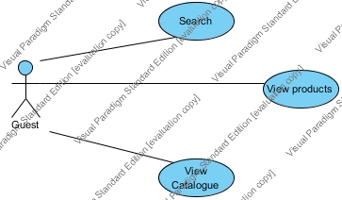

**Use Case: View Single Product**

**1.Description:**

A user views the description page of a single item

**2.Precondition:**

None

**3.Trigger:**

Simple url gives access to this page from anywhere

**4.Steps of Execution:**

4.1 Database checks if this item still exists in database. If failed user taken to 404 page

4.2 Item description, reviews, rating, seller info, item specifications, etc are loaded and displayed

4.3 Item image loaded.

4.4 (Optional) Multiple views of same object are loaded and can be accessed. Zoom functionality given

**Use case: Viewing Catalogue:**

**1. Description:**

The buyer can view the entire catalogue of products being displayed by categories.

2. Precondition:

The user loads the Landing Page of the website.

3.Trigger:

User Selects view product option.

**4.Steps of Execution:**

4.1 The entire catalogue of items arranged according to departments (like electronics, home, clothes etc.)

4.2 The user can browse the department-wise catalogues by scrolling.

4.3 The user can click on individual products.

4.4 Upon click redirect to the product page.

4.5 Move to view product use case.

4.5 The user can click on the search bar.

4.6 Take the entered string as the query variable.

4.7 Move to Search use case.

4.8 The user clicks on the Log in button.

4.9 Upon click redirect to the Login form.

4.10 Move to Login use case.

**Postcondition:**

Navigate to subsequent page.

**Failure:**

Non response on clicking or scrolling or any other kind of User interaction.

**Use Case: Search**

**1.Description:**

Allows search query based on user entered string.

**2.Trigger:**

The search button is clicked.

**3.Preconditions:**

A valid Search String is entered.

**4. Steps of Execution:**

4.1: A valid search string is passed into the database query system.

4.2a: If nothing is found, then display an appropriate message.

4.2b: Redirect to a new page which displays all appropriate results.

**5. Success:**

Results are shown.

**6. Failure:**

6.1: No response.

6.2: Network resets between search.

1. **Seller**

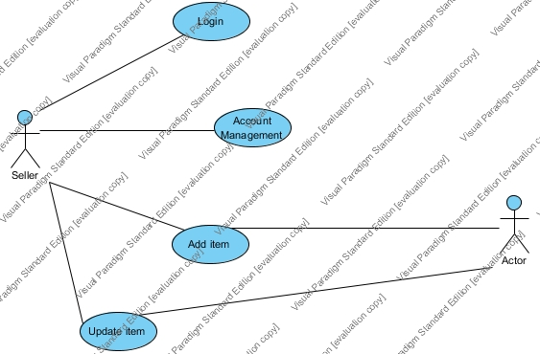

**Use Case : Login**

**1.Description:**

User will provide credentials to login into system.

**2.Trigger:**

User invokes login protocol.

**3.Preconditions:**

User has a registered account.

**4.Steps of Execution:**

4.1 User invokes a login protocol.

4.2 User provides credentials.

4.3 System checks for the user.

4.4 User logs into his account.

**5.Success:**

User logs into his account.

**6.Faliure:**

6.1 User does not have an account.

6.2 Credentials does not match to the registered account.

**Use Case: Account Management**

**1.Description:**

User updates his account information such as login credentials, address and contact information.

**2.Trigger:**

User invokes account management protocol.

**3.Preconditions:**

3.1 User has a registered account.

3.2 User is logged into his account.

**4.Steps of Execution:**

4.1 User invokes account management protocol.

4.2 User updates his information.

4.3 System asks for Login credentials.

4.4 System updates the information in the database.

4.5 Information regarding user is updated in the database.

**5.Success:**

Information regarding user is updated in the database.

**6.Faliure:**

6.1 Connection resets midway between update.

6.2 Credentials does not match to the registered account.

**Use Case: Add item**

**Description:**

A seller adds an item

**Precondition:**

Seller is logged in

**Trigger:**

Seller clicks on "Add item" on the dashboard

**Steps of Execution:**

Step 1: System checks if seller is allowed to add items. If failed, suitable error is thrown and use case ends

Step 2: User selects category, item name, price, description, item specifications and external URL links

Step 3: Item image(s) are uploaded

Step 4: Any limited time offers/combos etc are specified alongwith stock(which may or may not be hidden to users)

Step 5: Item added to Seller's Product Catalogue and also History

**Use Case: Update item**

**Description:**

A seller updates details pertaining to the item

**Precondition:**

Seller is logged in

This seller is authorised to make changes to the item

**Trigger:**

Seller clicks on "Change info" on the Product page

**Steps of Execution:**

Step 1: System once again checks credentials of the seller. If not in appropriate account user is logged out and taken to log in page

Step 2: All item details displayed in an editable format. Image can be changed as well.

Step 3: Preview of new Product page is given. User can go back one page

Step 4: Database updated with new info. Seller given "Update Succesful" notification.