ASP.NET A Web Development Tool

Web Programming Architecture:

The typical web programming architecture is shown in figure 1. Request and Response are the key components of the architecture. The Client sends the request to the server. The server in turn sends the response back to the client. ASP.NET uses Request and Response object corresponding to the client request and server response

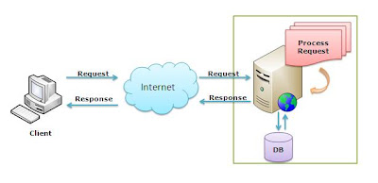
Figure 1 -Web programming architecture.

A common approach to develop an ASP.NET web program is with the following two steps. The first step is to make a provision to receive the request and the second step is to process the request.
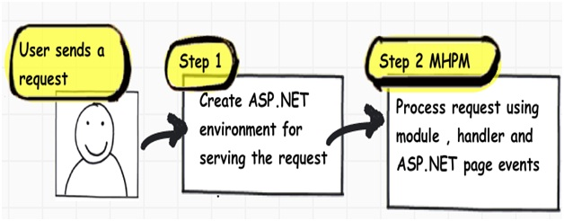

The client can send a request to the server in the form of URL using a browser. The Request object is used by the server to handle the request from the client.

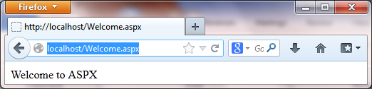

To send the output to the client, the server uses Response object. The following Welcome.aspx program sends "Welcome to ASPX" message to be displayed in the client’s browser window.

Welcome.aspx

<% Response.Write("Welcome to ASPX")%>

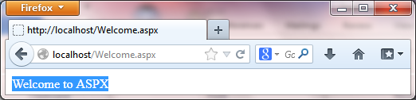

A query string is the part of a uniform resource locator (URL) that contains data to be passed to web server.
A sample URL containing a query string is as follows:
http://localhost/WelcomeIt.aspx?Jacob

The WelcomeIt.aspx program sends back the query string to client after the "Welcome to ASPX " message.

WelcomeIt.aspx

<% Response.Write("Welcome to ASPX ")
Response.Write(Request.QueryString)
%>
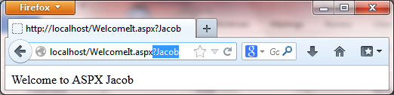

The independent components of query string can be accessed by using query string index or parameter name as given in display.aspx file.

Display.aspx

<%
Response.Write("<br>QueryString = ")
Response.Write(Request.QueryString)
Response.Write("<br>QueryString(0) = ")
Response.Write(Request.QueryString(0))
Response.Write("<br>QueryString(""User"")=")
Response.Write(Request.QueryString("User"))
Response.Write("<br>QueryString(1) = ")
Response.Write(Request.QueryString(1))
Response.Write("<br>QueryString(""pwd"")=")
Response.Write(Request.QueryString("pwd"))
%>

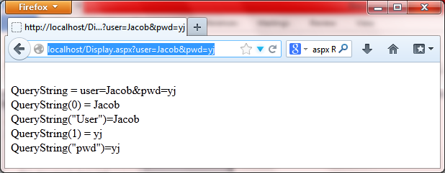

Here is a simple program that takes radius as the input through query string. Then computes the area of the circle and send as the response.

AreaCircle.aspx

<%
Dim rad As Integer
Dim area As Single
rad = CInt(Request.QueryString("Radius"))
area = Math.PI * rad ^ 2
Response.Write("Area = " & area)
%>
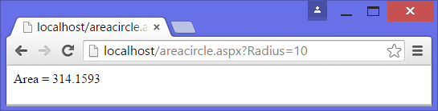
WebForms
Web Forms is one of the programming models for creating ASP.NET web sites and web applications.
Web Forms is the oldest ASP.NET programming model, with event driven web pages written as a combination of HTML, server controls, and server code.
Web Forms are compiled and executed on the server, which generates the HTML that displays the web pages. A sample web form is given in LoginFrm.aspx file.

LoginFrm.aspx

<html>
<head runat="server"></head>
<body>
<form id="form1" runat="server">
<div>
User <asp:TextBox ID="TextBoxUser" runat="server"></asp:TextBox>
<br />
Pwd <asp:TextBox ID="TextBoxPwd" runat="server" TextMode="Password"></asp:TextBox>
<br />
<asp:Button ID="ButtonLogin" runat="server" Text="Login" />
</div>
</form>
</body>
</html>

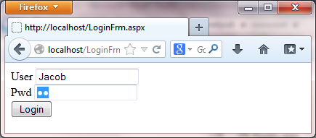
Graphics
Using aspx, graphical output can be generated and send back to the client according the request. A sample Circle.aspx prgram demonstrate how a graphical output is generated .
Circle.aspx
<%@ Page ContentType = "image/gif"%>
<%@ Import Namespace = "System.Drawing" %>
<%@ Import Namespace = "System.Drawing.Imaging" %>
<Script Runat = "Server">

Sub Page_Load

Dim objBitmap As Bitmap
Dim objGraphics As Graphics

objBitmap = New Bitmap(100, 100)
objGraphics = Graphics.FromImage(objBitmap)

objGraphics.DrawEllipse(New Pen(Color.Yellow, 3), 0, 0, 100, 100)

objBitmap.Save(Response.OutputStream, ImageFormat.Gif)

objBitmap.Dispose()
objGraphics.Dispose()

End Sub

</Script>

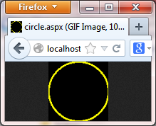
A combination of both text and graphical output can also be generated. A sample of this kind is given in the CircleFrm.aspx program.
CircleFrm.aspx
<html>
<body>
<form id="formCir" runat="server">

Circle created by Circle.aspx
<asp:Image ID="Image1" runat="server" AlternateText="Circle" ImageUrl="Circle.aspx" />

</form>
</body>
</html>

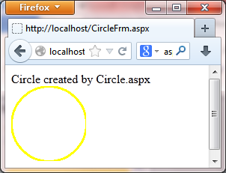
‘Capha Testing
‘WebForm1.aspx.vb file
Public Class WebForm1
Inherits System.Web.UI.Page

Public Sub CreateCaptcha()
Dim dynaText = ""
For i = 1 To 5
dynaText = dynaText & Chr(CInt(Rnd() * 100 + 9) Mod 26 + 65)
Next
Session("DynaText") = dynaText
Image1.ImageUrl = "http://localhost/GraphicText.aspx?dynaText=" & dynaText
End Sub

Protected Sub Page_Load(ByVal sender As Object, ByVal e As System.EventArgs) Handles Me.Load
If IsPostBack = False Then
CreateCaptcha()
End If
End Sub

Protected Sub Button1_Click(sender As Object, e As EventArgs) Handles Button1.Click
If (Session("DynaText") = TextBox1.Text) Then
TextBox1.Text = "Success"
End If
End Sub
Protected Sub Button2_Click(sender As Object, e As EventArgs) Handles Button2.Click
CreateCaptcha()
TextBox1.Text = ""
End Sub
End Class
<%@ Page Language="vb" AutoEventWireup="false" CodeBehind="WebForm1.aspx.vb" Inherits="WebApplication2.WebForm1" %>
<!DOCTYPE html>

<html xmlns="http://www.w3.org/1999/xhtml">
<head runat="server">
<title></title>
</head>
<body>
<form id="form1" runat="server">
<div>
<asp:Image ID="Img1" runat="server" AlternateText="Capcha" />
Capcha
<asp:TextBox ID="TextBox1" runat="server"></asp:TextBox>
</div>
<asp:Button ID="Button2" runat="server" Text="Change" />
<asp:Button ID="Button1" runat="server" Text="Test" />
</form>
</body>
</html>

Login.aspx

<%@ Page Language="Vb" AspCompat="true" %>

<script runat="server">

Sub Page_Load(sender As Object, e As EventArgs)
If (IsPostBack() = False) Then
Session("captcha") = GenerateDynaText()
Image1.ImageUrl = "CircleMsg.aspx?msg=" & Session("captcha")
End If
End Sub

Sub SendSMS(mobile As String, otp As String)
Dim httpUrl, Token, Credit, Senderid, TemplateID, strResp, Message As String
httpUrl = "http://pay4sms.in/sendsms/index.php"
Token = "0514a87879eeb2fe841924da6282365a"
Credit = "2"
Senderid = "YJACOB"
TemplateID = 1707166852607742941
Message = "The OTP for login is " & otp & ". Pls do not share with others.-YJACOB"
Message = Server.UrlEncode(Message)
httpUrl = httpUrl & "?token=" & Token & "&credit=" & Credit & "&sender=" & Senderid & "&templateid=" & TemplateID & "&message=" & Message & "&number=" & mobile
If mobile <> "" Then
Dim xmlhttp
Try
xmlhttp = Server.CreateObject("Microsoft.XMLHTTP")
xmlhttp.Open("GET", httpUrl, True)
xmlhttp.Send()
GreetingLabel.Text = "OTP Send to " & mobile
Catch
GreetingLabel.Text = "Failed " & httpUrl

' strResp = Trim(xmlhttp.responseText)
'xmlhttp = Nothing
' GreetingLabel.Text = strResp
End Try
End If
End Sub
Sub Login_Click(sender As Object,
e As EventArgs)

Dim clickedButton As Button = sender
If (Session("captcha") = txtCaptcha.Text.Trim) Then
Dim otp = CInt(Rnd() * 100000 + 10000)
Session("otp") = otp
SendSMS(txtUID.Text, otp)
clickedButton.Enabled = False

Image1.ImageUrl = "CircleMsg.aspx?msg=" & Session("captcha")
otpLabel.Visible = True
txtOTP.Visible = True
GreetingLabel.Visible = True
SUBMIT.Visible = True
Else
GreetingLabel.Text = "Not matching captcha " & Session("captcha") & "and " & txtCaptcha.Text
GreetingLabel.Visible = True
End If
End Sub

Sub Submit_Click(sender As Object,
e As EventArgs)

If (Session("OTP") = txtOTP.Text) Then
Session("OTPVerified") = True
GreetingLabel.Text = "Wonderful..."
Server.Transfer("Start.aspx")
'Response.Redirect("https://nmcc.ac.in")
GreetingLabel.Visible = True
Else
Session("OTPVerified") = False
End If
End Sub

Public Function GenerateDynaText() As String
Dim dynaText As String
Dim i As Integer
dynaText = ""
Randomize()
For i = 1 To 5
If (i Mod 3) = 0 Then
dynaText = dynaText & Chr(CInt(Rnd() * 100 + 9) Mod 10 + 48)
Else
dynaText = dynaText & Chr(CInt(Rnd() * 100 + 9) Mod 26 + 65)
End If
Next
GenerateDynaText = dynaText
End Function

</script>

<html xmlns="http://www.w3.org/1999/xhtml">
<head runat="server">
<title>Untitled Page</title>
</head>
<body style="background-image:url(SineWave.aspx)">
<form id="form1" runat="server" style="background-image : linear-gradient( cyan ,white ,blue )">
<table>
<tr>
<td colspan="2">

<h3 align="center">Welcome to Login </h3>
</td>
</tr>
<tr>
<td>User ID </td><td>
<asp:TextBox ID="txtUID" Text="" runat="server"></asp:TextBox>
</td>

</tr>

<tr>
<td>Captcha :</td>
<td>
<asp:Image ID="Image1" runat="server" AlternateText="Circle" ImageUrl="CircleMsg.aspx" />
</td>
</tr>
<tr>
<td>Enter Captcha </td>
<td>
<asp:TextBox ID="txtCaptcha" Text="" runat="server"></asp:TextBox></td>
</tr>

<tr>
<td colspan="2" align="center">
<asp:Button ID="Login"
Text="Login"
OnClick="Login_Click"
runat="server" /></td>
</tr>
<br />
<br />
<tr>
<td>
<asp:Label ID="otpLabel" Text="Enter OTP :" Visible="false" runat="server"></asp:Label></td>
<td>
<asp:TextBox ID="txtOTP" Text="" runat="server" Visible="false"></asp:TextBox>
</td>
</tr>
<tr>
<td colspan="2" align="center">
<asp:Button ID="SUBMIT"
Text="Submit"
OnClick="Submit_Click"
runat="server" Visible="false" />
</td>
</tr>
<tr>
<td colspan="2">
<asp:Label ID="GreetingLabel" runat="server"
Visible="false" Text="Hello World!" />
</td>
</tr>
</table>
</form>
</body>
</html>
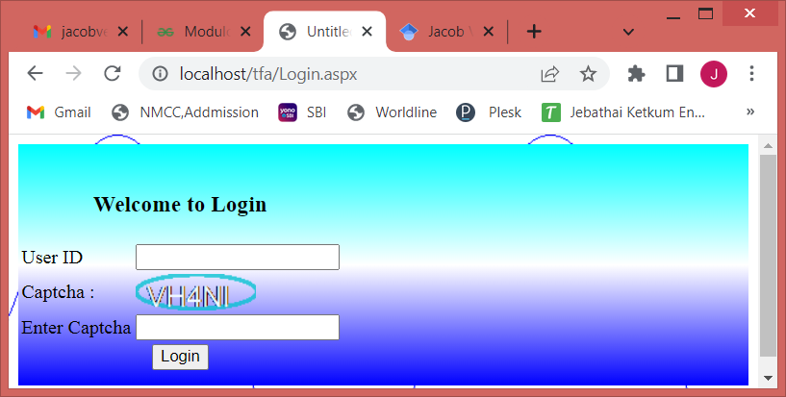
Start.aspx
<%@ Page Language="Vb" ContentType = "image/png"%>
<% If (Session("OTPVerified") = True) Then
Response.Write("Two Factor Authentication Successfull.")
Response.Redirect("https://nmcc.ac.in")
Else
Server.Transfer("Login.aspx")
End If
%>

