MemPoisonGuard: A Provenance-Aware Framework for Detecting and Mitigating Long-Term Memory Poisoning in AI Agents

Premkumar S
M.Tech Data Science
Rajalakshmi Engineering College
Chennai, Tamil Nadu, India prem021003@gmail.com
Dr. Prasannakumari V
Professor, Department of Information Technology
Rajalakshmi Engineering College
Chennai, Tamil Nadu, India
prasannakumari.v@rajalakshmi.edu.in

Abstract—AI agents can retain user preferences, information, and task context across sessions through long-term memory. Although this capability improves continuity, it also introduces a persistent security risk: harmful instructions, incorrect facts, or false authorization claims may be stored and later influence otherwise benign interactions. This paper presents MemPoisonGuard, a locally deployable framework for validating memory before persistence. The framework records provenance information, generates a SHA-256 integrity hash, screens for prompt-injection patterns and sensitive claims, checks for contradictions against verified memory, and calculates trust and risk scores. Each candidate memory is classified as verified, provisional, or quarantined. Only verified entries are considered during retrieval. A controlled evaluation of 12 memory candidates, including five benign and seven malicious cases, compares MemPoisonGuard with an unprotected baseline. The baseline made all malicious entries available to retrieval, whereas MemPoisonGuard quarantined six and marked one as provisional. Consequently, no malicious candidate entered the verified-memory collection. These results are limited to the controlled test set and do not demonstrate universal robustness.

Keywords—AI agent security, long-term memory, memory poisoning, prompt injection, provenance, natural language inference, secure retrieval.

Introduction
AI agents combine large language models with persistent memory to keep user preferences, task context, historical observations, and retrieved knowledge across multiple chats [1], [2]. Although this improves continuity and personalization, it also creates a persistent attack surface. Malicious instructions, misleading facts, and unverified authorization claims can be stored during one interaction and later retrieved during an unrelated conversation.
Memory poisoning differs from one-session prompt injection because adversarial content can persist beyond the original interaction [1], [4]. A poisoned memory may later influence retrieval, agent reasoning, or response generation. Therefore, memory-enabled agents require controls not only at the prompt boundary but also at the memory-write and memory-retrieval stages.
This paper presents MemPoisonGuard, a provenance-aware framework for validating candidate memories before they become persistent agent state. The framework captures source provenance and a SHA-256 content hash, applies rule-based prompt-injection detection, identifies sensitive authorization claims, detects contradictions against trusted verified memory using natural language inference, and computes trust and risk scores. Based on these signals, each memory is classified as verified, provisional, or quarantined. Only verified memory is eligible for guarded retrieval.
The main contributions of this work are as follows:
- A provenance-aware memory-write validation framework for local AI agents.
- A layered defense combining injection detection, sensitive-claim screening, NLI contradiction analysis, and trust-risk scoring.
- A three-state memory governance model consisting of verified, provisional, and quarantined memory.
- A verified-only retrieval mechanism with relevance, trust, and risk-aware ranking.
- A controlled baseline-versus-guarded evaluation using benign and malicious memory candidates.
The remainder of this paper is organized as follows. Section II reviews related work. Section III presents the proposed framework. Section IV describes the experimental setup. Section V discusses the controlled evaluation results. Section VI concludes the paper and identifies future work.

Related work
Persistent memory is increasingly used in AI agents to retain facts, user preferences, task context, and historical interactions across sessions. However, persistent storage also expands the attack surface because untrusted content can be retained and later presented to the language model as contextual information [1], [2]. In contrast to a conventional prompt-injection attack that is typically limited to an active interaction [1], [4], memory poisoning separates the malicious write event from its eventual effect. A single successful write can therefore influence later interactions without requiring the original payload to remain in the active prompt.

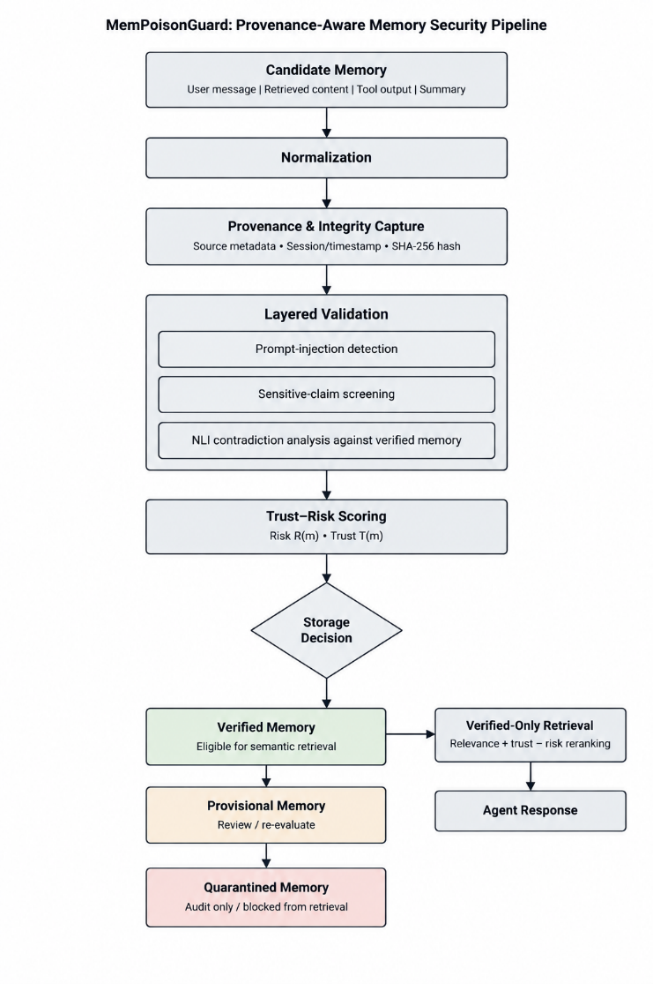
Recent studies have examined memory poisoning in long-term-memory-enabled agents. These studies show that adversarial content can enter memory through normal interaction channels and subsequently affect agent behavior during later sessions [1], [2]. The threat is particularly difficult because some malicious memories may resemble plausible user preferences, policies, facts, or prior observations rather than explicit instructions. Consequently, filtering only obvious injection phrases at the initial prompt boundary is insufficient for protecting persistent memory.
Retrieval security and prompt injection are important concerns in memory poisoning. Retrieval-augmented systems generally identify useful context through semantic similarity. An attacker can exploit this by creating malicious content that looks relevant to a later user request, increasing the chance that it will be retrieved. If the system accepts such retrieved content without checking its source, integrity, or agreement with existing trusted information, the poisoned content may affect the agent’s reasoning and output [5]. Hence, security validation should be applied both before storing memory and before using retrieved memory.
Provenance-based mechanisms are useful for managing memory safely. Information such as the origin of a memory, its creation time, session details, content hash, and validation status can help track how it entered the system and support later audits. These details allow the system to distinguish between reliable and untrusted memories. High-risk entries can then be restricted from being treated as authoritative context [7], [8].
NLI can provide another layer of validation for detecting contradictions. It evaluates whether a statement is entailed by, contradicted by, or neutral with respect to another statement [9]. In this framework, a new memory entry can be compared with relevant verified memories to find semantic inconsistencies that may not be detected through direct word matching.
Existing work establishes that persistent memory poisoning is a meaningful agent-security problem, but practical local defenses must combine several signals. MemPoisonGuard addresses this gap through a lightweight, provenance-aware pipeline that combines rule-based injection screening, sensitive-authorization-claim detection, NLI-based contradiction analysis, trust-risk scoring, quarantine, and verified-only retrieval [2], [7].

proposed mempoisonguard framework
MemPoisonGuard is a local, provenance-aware memory-security framework for AI agents that use long-term memory. Its objective is not to determine whether every candidate memory statement is universally true. Instead, it assesses whether a candidate should be trusted for persistent storage and later retrieval. The framework evaluates each candidate during the memory-write stage and assigns one of three states: verified, provisional, or quarantined. Only verified memories are eligible for ordinary semantic retrieval.
Fig. 1 presents the overall workflow. A candidate memory is received from an interaction source and is first normalized for analysis. The framework records provenance metadata and computes an integrity hash. Next, the framework performs multiple validation checks to identify prompt-injection attempts, sensitive authorization-related statements, and possible contradictions with relevant verified memories. The results of these checks are used to calculate risk and trust scores, which are then used to decide whether the memory should be verified, marked as provisional, or quarantined.

Fig. 1. Overview of the MemPoisonGuard pipeline, showing candidate-memory input, text normalization, provenance recording with SHA-256 hashing, prompt-injection and sensitive-claim detection, NLI-based contradiction checking, trust–risk evaluation, memory-state classification, and retrieval restricted to verified memories.

Threat Model and Design Goals
In the proposed threat model, an attacker tries to affect an agent’s future behavior by injecting harmful, misleading, or unauthorized information into its long-term memory. Memory candidates can come from user interactions, retrieved documents, tool responses, or summaries produced by the application. The model considers threats such as prompt-injection attempts, security-control bypasses, false permission claims, data-exfiltration requests, conflicting information, and content intended to manipulate future retrieval.
MemPoisonGuard aims to reduce the risk of these entries becoming trusted persistent memory. It is designed to retain useful benign information, preserve metadata for later auditing, separate suspicious entries from verified retrieval, and provide understandable reasons for storage decisions. However, the framework is not claimed to detect every adaptive, multilingual, obfuscated, or previously unseen attack [6], [7].

Provenance and Integrity Capture
For every candidate memory m, MemPoisonGuard records a structured provenance record containing a unique memory identifier, source type, source session or interaction identifier, creation time, normalized content, validation signals, classification state, and a SHA-256 content hash. The hash provides an integrity reference that can be recomputed later to identify unintended modifications to stored content [10].
The provenance record enables later audit of why a memory was accepted, provisionally retained, or quarantined. It also avoids treating all persisted content as equally trustworthy. A memory received directly from an authenticated and expected source can receive a higher provenance signal than an unauthenticated or externally retrieved item; however, provenance alone does not override evidence of injection or contradiction.
$$h\left(m\right)=SHA-256\left(normalize\left(m\right)\right)$$ | (1)
Here, normalize(·) denotes deterministic preprocessing applied before hashing, and h(m) is the stored integrity digest. SHA-256 is a standardized hash algorithm that produces a message digest suitable for detecting changes to a message after the digest is generated.

Injection and Sensitive-Claim Screening
The initial security check applies predefined rules to the normalized memory content. The prompt-injection module identifies suspicious patterns such as attempts to override instructions, change the agent’s role, extract system prompts, bypass security restrictions, misuse tools, or execute concealed instructions. A separate sensitive-claim module detects content involving privileged access, policy exemptions, credential exposure, unrestricted permissions, or other high-impact authorization claims.
Rule-based checks are suitable for a local implementation because they are easy to understand and computationally inexpensive [6], [7]. However, these rules are not sufficient by themselves, since malicious instructions can be rewritten or hidden through obfuscation. Therefore, detected patterns increase the memory item’s risk score and are considered together with other validation signals before making a quarantine decision.

NLI-Based Contradiction Analysis
To detect inconsistencies, MemPoisonGuard compares each new memory candidate with related entries from the verified-memory collection. The candidate and verified-memory pairs are evaluated using a natural language inference model, which determines whether the new statement is supported by, contradicts, or is unrelated to an existing verified memory [9]. The contradiction output is treated as an important risk signal rather than final proof that the candidate is false.
Let $p_{contr}\left(m , v\right)$represent the contradiction probability between candidate memory $m$and verified memory $v$. The system calculates the contradiction score by selecting the highest contradiction probability among the relevant verified memories in $V\left(m\right)$:

$$c\left(m\right)=\max_{v∈V(m)}{p_{contr}(m,v)}$$ | (2)
A larger value of $C\left(m\right)$suggests that the candidate memory conflicts with one or more verified entries. In such cases, the item may be quarantined or marked for review instead of being allowed to replace or influence trusted information. NLI is useful here because it explicitly distinguishes entailment, contradiction, and neutral relationships between statements.

Trust-Risk Scoring and Decision Policy
MemPoisonGuard combines the outputs of its validation stages to calculate understandable risk and trust values. Let $I\left(m\right)$indicate prompt-injection detection, $A\left(m\right)$represent a sensitive authorization claim, $P\left(m\right)$denote provenance confidence, and $C\left(m\right)$represent the contradiction score. All values are normalized between 0 and 1. The risk score is calculated as:

$$R\left(m\right)=0.50I\left(m\right)+0.20C\left(m\right)+0.20\left[1-P\left(m\right)\right]+0.10A(m)$$ | (3)

The trust score increases when the memory has reliable provenance, passes validation checks, and does not show injection or contradiction signals:

$$T\left(m\right)=0.45P\left(m\right)+0.25V\left(m\right)+0.20\left[1-C\left(m\right)\right]+0.10[1-I\left(m\right)]$$ | (4)
In (4), $V\left(m\right)$refers to the validation confidence generated by the local validation process. The selected weights are prototype design settings and can be adjusted using a larger evaluation dataset. The final storage state is assigned as follows:

$$state\left(m\right)= \left\{\begin{aligned}quarantined, R\left(m\right)≥{\text{τ}}_{R}∨I\left(m\right)=1 \\ verified, T\left(m\right)≥τ_{T} ∧R\left(m\right)< τ_{R} \\ provisional, otherwise \end{aligned}\right.$$ | (5)
Here, $τ_{R}$and $τ_{T}$are configurable thresholds for risk and trust. Quarantined memories are preserved for audit purposes but are not used in verified retrieval. Provisional memories are stored separately and can be reviewed or validated again when more information becomes available.

Verified-Only Retrieval
When a user query is received, MemPoisonGuard searches only within the verified-memory collection. This prevents provisional and quarantined records from being automatically provided to the language model as trustworthy context. The retrieved verified entries are then ranked using their relevance to the query, trust score, and remaining risk:

$$S_{safe}\left(m,q\right)=0.65 Rel\left(m,q\right)+0.25T\left(m\right)-0.10R\left(m\right)$$ | (6)
In (6), $Rel⁡\left(m , q\right)$measures how relevant memory $m$is to the query $q$. The ranking process gives preference to memories that are relevant and highly trusted, while reducing the score of entries with residual risk. This approach separates memory validation from retrieval: an item must first be classified as verified before it can be considered for retrieval and ranking.

experimental setup

Evaluation Objective and Scenarios
The controlled evaluation assesses whether MemPoisonGuard prevents malicious memory candidates from entering the verified-memory collection while retaining benign memories for normal retrieval. The evaluation compares an unprotected baseline system, which stores submitted candidates directly, with the guarded MemPoisonGuard workflow, which validates candidates before storage.
The evaluation set contains 12 manually defined memory candidates: five benign candidates and seven malicious candidates. Benign candidates represent ordinary preferences, factual notes, and task-related context that should remain available to the agent. Malicious candidates represent direct prompt injection, security-bypass attempts, data-exfiltration requests, authority spoofing, contradiction poisoning, false authorization claims, and retrieval-manipulation attempts. The set was designed as a controlled functional-security test rather than as a representative benchmark of real-world attack prevalence.
- CONTROLLED MEMORY-CANDIDATE SCENARIOS
Category | Count | Expected Outcome
Benign memory | 5 | Verified
Prompt injection | 1 | Quarantined
Security bypass | 1 | Quarantined
Data exfiltration | 1 | Quarantined
Authority spoofing | 1 | Provisional
Contradictory memory | 1 | Quarantined
False authorization | 1 | Quarantined
Retrieval manipulation | 1 | Quarantined

Systems Compared
Two systems were evaluated. The baseline system accepts each candidate memory and stores it without provenance-aware validation, injection screening, contradiction analysis, trust-risk scoring, or state-based retrieval restrictions. The MemPoisonGuard system processes every candidate through normalization, provenance and SHA-256 integrity capture, rule-based injection detection, sensitive-claim screening, NLI-based contradiction analysis, risk-trust scoring, and state assignment.
For the guarded system, candidates classified as verified are stored in the verified-memory collection and are eligible for semantic retrieval. Candidates classified as provisional are retained separately for later review or re-evaluation. Candidates classified as quarantined are retained only for audit and are excluded from verified-memory retrieval.

Implementation Environment
The prototype was implemented and evaluated on a local Windows system with an Intel Core i5-10310U CPU operating at 1.70 GHz and 16 GB of RAM. No dedicated GPU was used. The software environment used Python 3.12.10, FastAPI for the backend service [12], SQLite for structured local records, ChromaDB for vector-based memory storage and retrieval [13], Sentence Transformers for embeddings and NLI-related model integration, Streamlit for the dashboard, Pandas and scikit-learn for analysis, and Plotly for visualization.
A local Ollama deployment running the qwen2.5:3b model [11] was used for language-model interaction. All experiments were conducted locally. The reported results therefore reflect the described prototype, implementation settings, validation rules, and controlled candidate set; they should not be interpreted as hardware-independent or model-independent performance estimates.

Evaluation Metrics
The primary evaluation objective is to identify malicious memory candidates before they enter verified retrieval. A malicious candidate correctly blocked from verified memory is treated as a true positive, whereas a malicious candidate incorrectly accepted as verified is treated as a false negative. A benign candidate correctly accepted as verified is treated as a true negative, whereas a benign candidate incorrectly blocked or quarantined is treated as a false positive.
Precision, recall, and F1-score are calculated for malicious-candidate detection. The false-positive rate and false-negative rate are also reported to indicate the effect of the safeguards on benign content and the residual risk of allowing malicious content into verified memory. Storage outcomes, including verified, provisional, and quarantined counts, are reported alongside the classification metrics.
$$Precision= \frac{TP}{TP+FP}$$ | (7)
$$Recall=\frac{TP}{TP+FN}$$ | (8)
$$F1=2 × \frac{Precision ×Recall}{Precision+Recall}$$ | (9)
Here, TP, FP, TN, and FN denote true positives, false positives, true negatives, and false negatives, respectively. For the controlled result table, a provisional malicious candidate is counted as successfully withheld from verified memory because it is not eligible for ordinary verified retrieval.

Ethical and Security Considerations
The evaluation uses only synthetic, non-sensitive memory candidates created for controlled security testing. No personal data, credentials, private documents, or active external systems were targeted. Malicious examples are included solely to assess detection and containment behavior and are not executed as instructions.
MemPoisonGuard is intended as a defense-in-depth prototype rather than a substitute for access control, source authentication, secure tool design, model alignment, audit logging, or human review. Rule-based detection and NLI analysis can produce errors, particularly for ambiguous, multilingual, adversarially paraphrased, or domain-specific content. The system therefore retains provisional and quarantined entries for audit instead of silently deleting them.

results and discussion

Storage Outcomes
Metric | Baseline | Mempoisonguard
Total Scenarios | 12 | 12
Benign Scenarios | 5 | 5
Malicious Scenarios | 7 | 7
Precision | N/A | 1.0000
Recall | N/A | 1.0000
F1-Score | N/A | 1.0000
False-Positive Rate | N/A | 0.0000
False-Negative Rate | N/A | 0.0000
The controlled evaluation processed 12 memory candidates: five benign candidates and seven malicious candidates. The unprotected baseline stored all submitted candidates directly and made all seven malicious candidates available to its retrieval path. Because the baseline did not maintain trust states or retrieval restrictions, these malicious entries remained available for later retrieval.
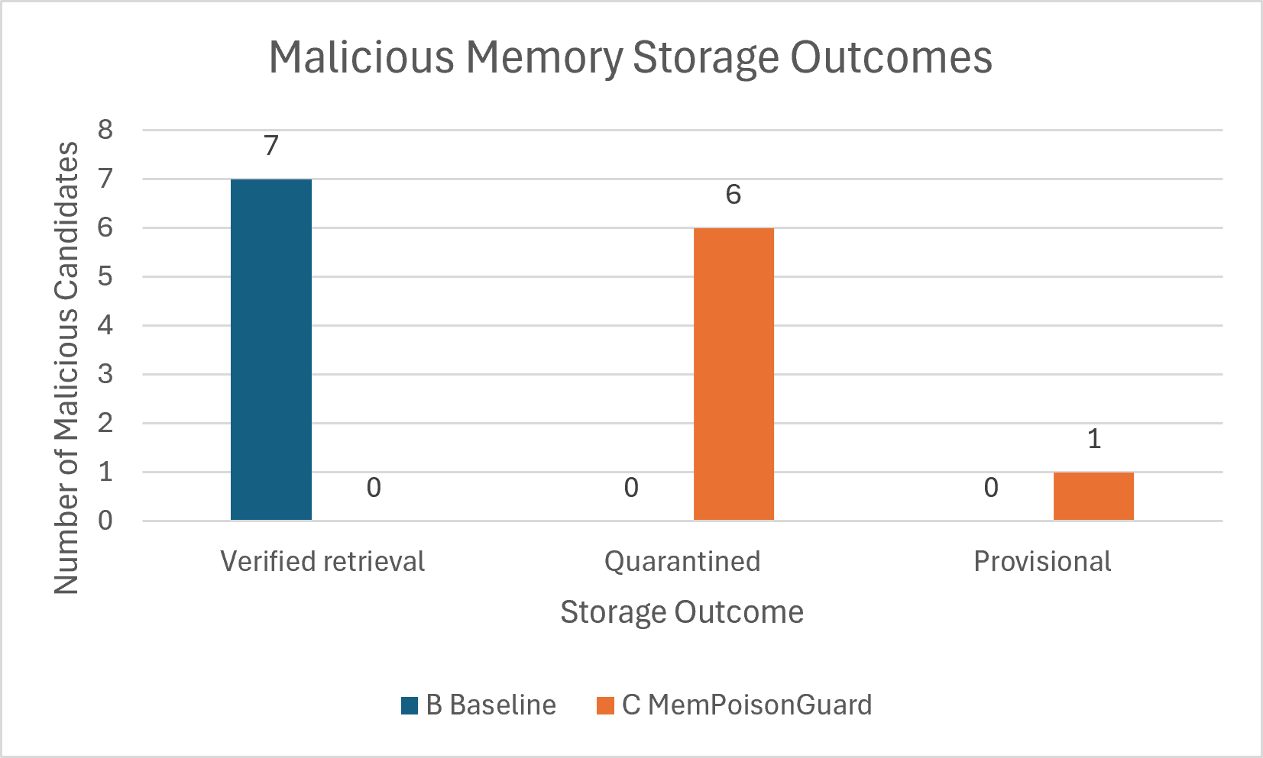
MemPoisonGuard evaluated each candidate before persistence. All five benign candidates were classified as verified. Of the seven malicious candidates, six were classified as quarantined and one authority-spoofing candidate was classified as provisional. Consequently, no malicious candidate entered the verified-memory collection. Since provisional and quarantined entries are excluded from ordinary verified retrieval, the guarded workflow withheld all seven malicious candidates from use as trusted context.
Fig. 2. Controlled storage outcomes for seven malicious memory candidates. The baseline made all seven candidates available to retrieval, whereas MemPoisonGuard quarantined six and marked one as provisional; therefore, none entered verified retrieval.
- BASELINE AND MEMPOISONGUARD STORAGE OUTCOMES
Outcome | Baseline | MemPoisonGuard
Total candidates processed | 12 | 12
Benign candidates available for retrieval | 5 | 5
Malicious candidates available to retrieval | 7 | 0
Malicious candidates quarantined | 0 | 6
Malicious candidates provisional | 0 | 1
Table II shows that the baseline and guarded systems differ primarily at the memory-write boundary. The baseline has no mechanism to distinguish trustworthy context from adversarial or unverified content. In contrast, MemPoisonGuard assigns an explicit state to each candidate and prevents non-verified entries from entering the retrieval path used for ordinary agent responses.

Detection Metrics
For malicious-candidate detection, a candidate withheld from verified memory was treated as a successful detection. The guarded prototype produced seven true positives, zero false positives, five true negatives, and zero false negatives on the controlled set. This produces a precision of 1.0000, a recall of 1.0000, an F1-score of 1.0000, a false-positive rate of 0.0000, and a false-negative rate of 0.0000.
- CONTROLLED EVALUATION METRICS

Retrieval Isolation
The storage-state design provides a second layer of protection after detection. Quarantined entries are retained for audit but excluded from verified retrieval. The provisional authority-spoofing entry was also excluded from ordinary verified retrieval, preventing an uncertain authorization claim from being supplied to the language model as trusted context.
This separation is important because identifying suspicious content is not sufficient if the system still retrieves that content during later agent operation [3], [6]. By restricting semantic retrieval to the verified-memory collection and then reranking candidates with relevance, trust, and risk signals, MemPoisonGuard reduces the likelihood that malicious or insufficiently validated context affects response.
The baseline values are shown as not applicable because the baseline does not perform malicious-memory classification or apply an explicit security decision policy. The guarded-system values summarize performance only on the defined controlled candidate set.

Interpretation and Limitations
The results demonstrate that, under the specified local implementation and controlled 12-scenario evaluation, MemPoisonGuard prevented all seven malicious candidates from entering verified retrieval while retaining all five benign candidates as verified memory. The result supports the feasibility of combining provenance capture, deterministic screening, contradiction analysis, trust-risk scoring, quarantine, and verified-only retrieval in a local AI-agent memory pipeline.
The reported precision, recall, and F1-score values of 1.0000 were obtained only on the defined controlled 12-scenario dataset. They do not establish universal robustness against real-world, multilingual, obfuscated, adaptive, or previously unseen memory-poisoning attacks. The dataset is small, manually constructed, and may not capture realistic attacker strategies, ambiguous inputs, model errors, source-authentication failures, or retrieval behavior under large memory collections.
The prototype also depends on threshold values, rule definitions, embedding behavior, and NLI-model outputs. These components can produce false positives or false negatives in broader deployment settings. Future evaluation should use larger and independently constructed datasets, multiple attack paraphrases, multilingual examples, external retrieved content, varied models, ablation studies, and human-in-the-loop review of provisional decisions [8].

conclusion and future work
Persistent memory improves the continuity and usefulness of AI agents, but it also creates a security risk when untrusted content can be retained and later retrieved as context. This paper presented MemPoisonGuard, a provenance-aware framework for reducing long-term memory poisoning in local AI agents. The framework validates candidate memories before persistence using provenance capture, SHA-256 integrity hashing, rule-based prompt-injection and sensitive-claim screening, NLI-based contradiction analysis, trust-risk scoring, and a three-state storage policy consisting of verified, provisional, and quarantined memory.
In the controlled evaluation of 12 manually defined memory candidates, the unprotected baseline stored all seven malicious candidates directly. MemPoisonGuard classified five benign candidates as verified, quarantined six malicious candidates, and marked one malicious authority-spoofing candidate as provisional. Thus, no malicious candidate entered verified retrieval in the reported experiment. These results demonstrate the feasibility of applying layered, interpretable checks at the memory-write boundary and of separating suspicious content from the retrieval path used for ordinary agent responses.
The results are limited to the local prototype and the defined controlled dataset. Future work should evaluate the framework using larger and independently constructed datasets, indirect prompt-injection sources, external documents and web retrieval, multilingual and obfuscated attacks, multiple language and NLI models, threshold calibration, ablation studies, authenticated provenance, human review workflows, and end-to-end testing of downstream tool-execution safety. Containerized deployment and systematic measurement of latency, throughput, scalability, and usability are also needed before operational use.

References
- S. Dong, S. Xu, P. He, Y. Li, J. Tang, T. Liu, H. Liu, and Z. Xiang, “Memory injection attacks on LLM agents via query-only interaction,” arXiv preprint arXiv:2503.03704, 2025.
- B. D. Sunil, I. Sinha, P. Maheshwari, S. Todmal, S. Mallik, and S. Mishra, “Memory poisoning attack and defence on memory based LLM-agents,” arXiv preprint arXiv:2601.05504, 2026.
- S. Patlan, P. Sheng, S. A. Hebbar, P. Mittal, and P. Viswanath, “Real AI agents with fake memories: Fatal context manipulation attacks on Web3 agents,” arXiv preprint arXiv:2503.16248, 2025.
- OWASP Foundation, “AI agent security cheat sheet.” Accessed: Sep. 25, 2026. [Online]. Available: https://cheatsheetseries.owasp.org/cheatsheets/AI_Agent_Security_Cheat_Sheet.html
- S. Abdelnabi and E. Bagdasarian, “AI agents may always fall for prompt injections,” arXiv preprint arXiv:2605.17634, 2026.
- OWASP Foundation, “LLM prompt injection prevention cheat sheet.” Accessed: Sep. 25, 2026. [Online]. Available: https://cheatsheetseries.owasp.org/cheatsheets/LLM_Prompt_Injection_Prevention_Cheat_Sheet.html
- A. Al Masoud, M. Arazzi, and A. Nocera, “SD-RAG: A prompt-injection-resilient framework for selective disclosure in retrieval-augmented generation,” arXiv preprint arXiv:2601.11199, 2026.
- National Institute of Standards and Technology, “Artificial intelligence risk management framework (AI RMF 1.0),” NIST AI 100-1, Jan. 2023. [Online]. Available: https://doi.org/10.6028/NIST.AI.100-1
- S. R. Bowman, G. Angeli, C. Potts, and C. D. Manning, “A large annotated corpus for learning natural language inference,” in Proc. 2015 Conf. Empirical Methods Natural Language Processing, Lisbon, Portugal, 2015, pp. 632–642.
- National Institute of Standards and Technology, “Secure hash standard (SHS),” FIPS PUB 180-4, Aug. 2015. [Online]. Available: https://doi.org/10.6028/NIST.FIPS.180-4
- Ollama, “qwen2.5:3b.” Accessed: Sep. 25, 2026. [Online]. Available: https://ollama.com/library/qwen2.5:3b
- FastAPI, “FastAPI documentation.” Accessed: Sep. 25, 2026. [Online]. Available: https://fastapi.tiangolo.com/
[13] Chroma, “Chroma documentation: Introduction.” Accessed: Sep. 25, 2026. [Online]. Available: https://docs.trychroma.com/docs/overview/introduction

