**EXPERIMENT-5**

**Study of linux editors with their command specifications**

Linux text editor is kind of a computer program that can edit text like notepad software. Text editors provide services in software development and operating system software which can be utilized to include programming languages, source code, documentation files etc.

Linux text editors can be used for editing text files, writing codes and updating user instruction files and many more.

Linux Text editors come in two forms-

**(i) Command Line Text editors** (such as Vi, nano, pico and more) and

**(ii) GUI based text editors** (such as GNOME, KDE, etc)

❖ **Introduction of Vi editor :-**

The default editor that comes with a UNIX os is Vi editor(Visual editor).

The unix editor is a full screen editor used to perform a variety of tasks. The unix architecture comes in three modes:

**(i) Command**, **(ii) insert** and **(iii) Esc mode**

Figure 12 Modes of operation and their transition in VI editor

**1. Vi/Vim Editor**

Vim is a highly configurable text editor built to enable efficient text editing. It has a steeper learning curve compared to nano but offers powerful features.

* **Command to Open File**: vi filename or vim filename
* **Modes**: Command mode (for commands) and Insert mode (for text editing)
* **Commands**:
  + **i**: Enter Insert mode
  + **:w**: Save changes
  + **:q**: Quit
  + **:wq**: Save and quit
  + **:q!**: Quit without saving



**Features:**

* Multiple modes (normal, insert, visual).
* Extensive plugins and configurations.
* Powerful search and replace capabilities.

**2. Nano Editor**

* **Command to Open File**: nano filename
* **Commands**:
  + CTRL + O: Save file
  + CTRL + X: Exit editor
  + CTRL + K: Cut current line
  + CTRL + U: Paste cut text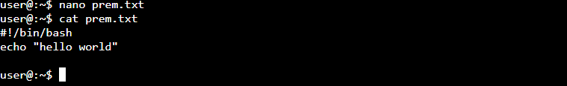

**Features:**

● Simple interface.

● On-screen command shortcuts.

● Supports syntax highlighting.

**3. Emacs Editor**

* **Command to Open File**: emacs filename
* **Commands**:
  + CTRL + X CTRL + S: Save file
  + CTRL + X CTRL + C: Exit editor
  + CTRL + _: Undo last action
  + CTRL + K: Cut text from cursor to end of line

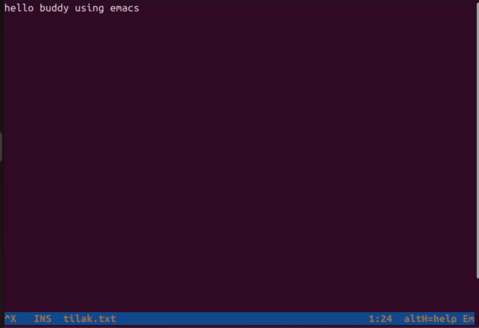

| **Command** | **Nano** | **Vim** | **Emacs** |
| --- | --- | --- | --- |
| Open a file | Nano filename | Vim filename | emacs filename |
| Save changes | ctrl+o | :w | Ctrl+x, ctrl+s |
| Exit | ctrl+x | :q | Ctrl+x, ctrl+c |
| Cut Text | ctrl+k | dd | ctrl+k |
| Paste Text | ctrl+u | p | ctrl+y |
| Search Text | ctrl+w | / | ctrl+s |
| Undo Changes | Not available | u | ctrl+_ |