**Experiment-6**

**Create a file called WLCC.txt with some lines and display how many lines, words and characters are present.**

To create a file named wlcc.txt and count lines, words, and characters:

**Step-1**: vi command opens the text editor

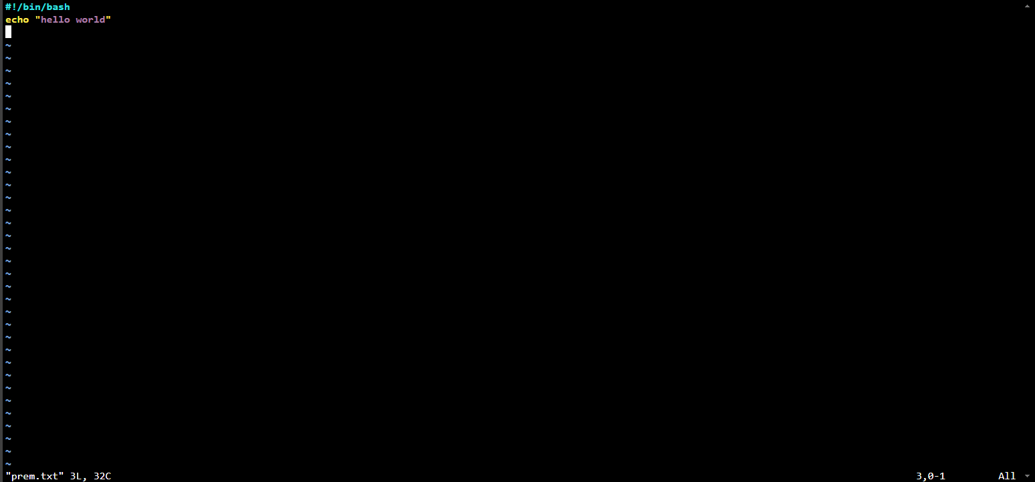

**Step-2**: wc command is used to count the number of lines, words, and characters respectively.

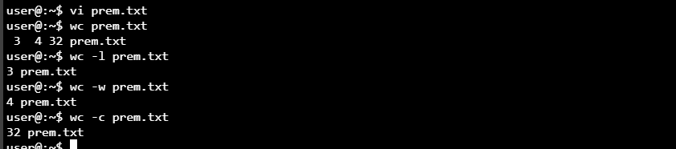

**Contents of prem.txt –**

