

**Capstone Project** **(Customer_Orders_Products Database)**

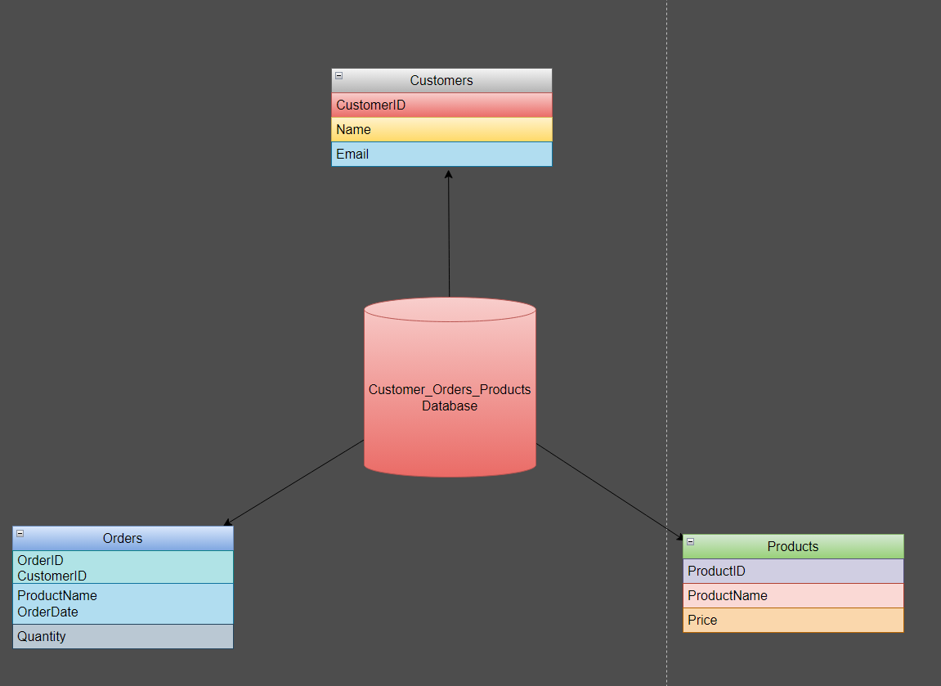

Let’s Create One Database name as Customers_Orders_Products

Create three tables called as

Customers

Orders

Products

Insert atleast 10 Records in it

Records are

CREATE TABLE Customers (

CustomerID INT PRIMARY KEY,

Name VARCHAR(50),

Email VARCHAR(100)

);

INSERT INTO Customers (CustomerID, Name, Email)

VALUES

(1, 'John Doe', 'johndoe@example.com'),

(2, 'Jane Smith', 'janesmith@example.com'),

(3, 'Robert Johnson', 'robertjohnson@example.com'),

(4, 'Emily Brown', 'emilybrown@example.com'),

(5, 'Michael Davis', 'michaeldavis@example.com'),

(6, 'Sarah Wilson', 'sarahwilson@example.com'),

(7, 'David Thompson', 'davidthompson@example.com'),

(8, 'Jessica Lee', 'jessicalee@example.com'),

(9, 'William Turner', 'williamturner@example.com'),

(10, 'Olivia Martinez', 'oliviamartinez@example.com');

CREATE TABLE Orders (

OrderID INT PRIMARY KEY,

CustomerID INT,

ProductName VARCHAR(50),

OrderDate DATE,

Quantity INT

);

INSERT INTO Orders (OrderID, CustomerID, ProductName, OrderDate, Quantity)

VALUES

(1, 1, 'Product A', '2023-07-01', 5),

(2, 2, 'Product B', '2023-07-02', 3),

(3, 3, 'Product C', '2023-07-03', 2),

(4, 4, 'Product A', '2023-07-04', 1),

(5, 5, 'Product B', '2023-07-05', 4),

(6, 6, 'Product C', '2023-07-06', 2),

(7, 7, 'Product A', '2023-07-07', 3),

(8, 8, 'Product B', '2023-07-08', 2),

(9, 9, 'Product C', '2023-07-09', 5),

(10, 10, 'Product A', '2023-07-10', 1);

CREATE TABLE Products (

ProductID INT PRIMARY KEY,

ProductName VARCHAR(50),

Price DECIMAL(10, 2)

);

INSERT INTO Products (ProductID, ProductName, Price)

VALUES

(1, 'Product A', 10.99),

(2, 'Product B', 8.99),

(3, 'Product C', 5.99),

(4, 'Product D', 12.99),

(5, 'Product E', 7.99),

(6, 'Product F', 6.99),

(7, 'Product G', 9.99),

(8, 'Product H', 11.99),

(9, 'Product I', 14.99),

(10, 'Product J', 4.99);

After Creating tables Solve Following tasks:

**Task 1 :-**

1. Write a query to retrieve all records from the Customers table..
2. Write a query to retrieve the names and email addresses of customers whose names start with 'J'.
3. Write a query to retrieve the order details (OrderID, ProductName, Quantity) for all orders..
4. Write a query to calculate the total quantity of products ordered.
5. Write a query to retrieve the names of customers who have placed an order.
6. Write a query to retrieve the products with a price greater than $10.00.
7. Write a query to retrieve the customer name and order date for all orders placed on or after '2023-07-05'.
8. Write a query to calculate the average price of all products.
9. Write a query to retrieve the customer names along with the total quantity of products they have ordered.
10. Write a query to retrieve the products that have not been ordered.

Task 2 :-

1. Write a query to retrieve the top 5 customers who have placed the highest total quantity of orders.
2. Write a query to calculate the average price of products for each product category.
3. Write a query to retrieve the customers who have not placed any orders.
4. Write a query to retrieve the order details (OrderID, ProductName, Quantity) for orders placed by customers whose names start with 'M'.
5. Write a query to calculate the total revenue generated from all orders.
6. Write a query to retrieve the customer names along with the total revenue generated from their orders.
7. Write a query to retrieve the customers who have placed at least one order for each product category.
8. Write a query to retrieve the customers who have placed orders on consecutive days.
9. Write a query to retrieve the top 3 products with the highest average quantity ordered.
10. Write a query to calculate the percentage of orders that have a quantity greater than the average quantity.

**Task 3:-**

1. Write a query to retrieve the customers who have placed orders for all products.
2. Write a query to retrieve the products that have been ordered by all customers.
3. Write a query to calculate the total revenue generated from orders placed in each month.
4. Write a query to retrieve the products that have been ordered by more than 50% of the customers.
5. Write a query to retrieve the top 5 customers who have spent the highest amount of money on orders.
6. **Write a query to calculate the running total of order quantities for each customer.**
7. Write a query to retrieve the top 3 most recent orders for each customer.
8. Write a query to calculate the total revenue generated by each customer in the last 30 days.
9. Write a query to retrieve the customers who have placed orders for at least two different product categories.
10. **Write a query to calculate the average revenue per order for each customer.**
11. Write a query to retrieve the customers who have placed orders for every month of a specific year.
12. Write a query to retrieve the customers who have placed orders for a specific product in consecutive months.
13. Write a query to retrieve the products that have been ordered by a specific customer at least twice.