

SQL Project:-



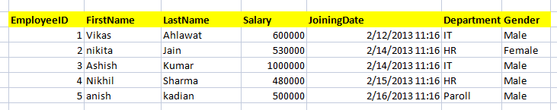

1) Write a query to get all employee detail from "EmployeeDetail" table

2) Write a query to get only "FirstName" column from "EmployeeDetail" table

3) Write a query to get FirstName in upper case as "First Name".

4) Write a query to get FirstName in upper case as "First Name".

5) Write a query for combine FirstName and LastName and display it as "Name" (also include white space between first name & last name)

1. Select employee detail whose name is "Vikas
2. Get all employee detail from EmployeeDetail table whose "FirstName" start with latter 'a'.

8) Get all employee detail from EmployeeDetail table whose "FirstName" start with latter 'a'.

1. Get all employee details from EmployeeDetail table whose "FirstName" end with 'h'
2. Get all employee detail from EmployeeDetail table whose "FirstName" start with any single character between 'a-p'
3. Get all employee detail from EmployeeDetail table whose "FirstName" not start with any single character between 'a-p'
4. Get all employee detail from EmployeeDetail table whose "Gender" end with 'le' and contain 4 letters. The Underscore(_) Wildcard Character represents any single character
5. Get all employee detail from EmployeeDetail table whose "FirstName" start with 'A' and contain 5 letters
6. Get all employee detail from EmployeeDetail table whose "FirstName" containing '%'. ex:-"Vik%as".
7. Get all unique "Department" from EmployeeDetail table
8. Get the highest "Salary" from EmployeeDetail table.
9. Get the lowest "Salary" from EmployeeDetail table
10. Show "JoiningDate" in "dd mmm yyyy" format, ex- "15 Feb 2013
11. Show "JoiningDate" in "yyyy/mm/dd" format, ex- "2013/02/15"
12. Show only time part of the "JoiningDate"
13. Get only Year part of "JoiningDate"
14. Get only Month part of "JoiningDate”
15. Get system date
16. Get UTC date.
    1. Get the first name, current date, joiningdate and diff between current date and joining date in months.
17. Get the first name, current date, joiningdate and diff between current date and joining date in days.
18. Get all employee details from EmployeeDetail table whose joining year is 2013
19. Get all employee details from EmployeeDetail table whose joining month is Jan(1)
20. Get all employee details from EmployeeDetail table whose joining month is Jan(1)
21. Get how many employee exist in "EmployeeDetail" table
22. Select only one/top 1 record from "EmployeeDetail" table
23. Select all employee detail with First name "Vikas","Ashish", and "Nikhil".
24. Select all employee detail with First name not in "Vikas","Ashish", and "Nikhil"
25. Select first name from "EmployeeDetail" table after removing white spaces from right side
26. Select first name from "EmployeeDetail" table after removing white spaces from left side
27. Display first name and Gender as M/F.(if male then M, if Female then F)
28. Select first name from "EmployeeDetail" table prifixed with "Hello
29. Get employee details from "EmployeeDetail" table whose Salary greater than 600000
30. Get employee details from "EmployeeDetail" table whose Salary less than 700000
31. Get employee details from "EmployeeDetail" table whose Salary between 500000 than 600000



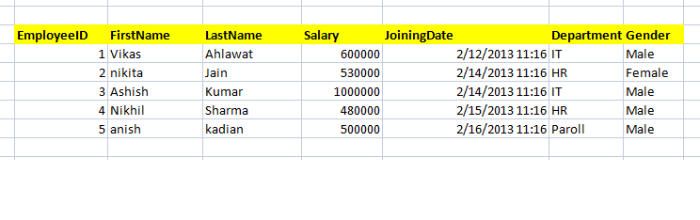

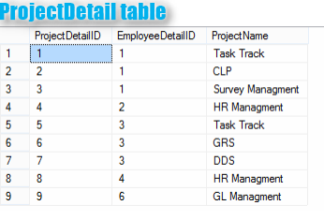

1. Give records of ProjectDetail table
2. Write the query to get the department and department wise total(sum) salary from "EmployeeDetail" table.
3. Write the query to get the department and department wise total(sum) salary, display it in ascending order according to salary.
4. Write the query to get the department and department wise total(sum) salary, display it in descending order according to salary
5. Write the query to get the department, total no. of departments, total(sum) salary with respect to department from "EmployeeDetail" table.
6. Get department wise average salary from "EmployeeDetail" table order by salary ascending

47 . Get department wise maximum salary from "EmployeeDetail" table order by salary ascending

48.Get department wise minimum salary from "EmployeeDetail" table order by salary ascending.

1. Get department wise minimum salary from "EmployeeDetail" table order by salary ascending
2. Join both the table that is Employee and ProjectDetail based on some common paramter
3. Get employee name, project name order by firstname from "EmployeeDetail" and "ProjectDetail" for those employee which have assigned project already.
4. Get employee name, project name order by firstname from "EmployeeDetail" and "ProjectDetail" for all employee even they have not assigned project.
5. Get employee name, project name order by firstname from "EmployeeDetail" and "ProjectDetail" for all employee if project is not assigned then display "-No Project Assigned"

54.Get all project name even they have not matching any employeeid, in left table, order by firstname from "EmployeeDetail" and "ProjectDetail

1. Get complete record (employeename, project name) from both tables ([EmployeeDetail],[ProjectDetail]), if no match found in any table then show NULL
2. Get complete record (employeename, project name) from both tables ([EmployeeDetail],[ProjectDetail]), if no match found in any table then show NULL

57.Get complete record (employeename, project name) from both tables ([EmployeeDetail],[ProjectDetail]), if no match found in any table then show NULL

58.Write down the query to fetch EmployeeName & Project who has assign more than one project

1. Write down the query to fetch ProjectName on which more than one employee are working along with EmployeeName
2. Apply Cross Join in Both the tables