Image Generation

Executive summary

1. Overview

leonardo AI tends to produce more realistic and detailed images compared to DALL·E, especially when it comes to people and natural lighting. While DALL·E often creates more artistic or stylized visuals, Leonardo focuses on lifelike textures and cinematic vibes. For scenes like a girl holding coffee in Italy, Leonardo can capture the immersive, grand background with natural sunlight and fine details better. If you want, prompts can be customized to highlight these strengths and get exactly the look you want.



# Dall E

### ***Dall E have some cool features***

1. Creative and imaginative outputs
2. Strong at abstract and artistic styles
3. User-friendly with versatile prompt handling

# https://lh7-rt.googleusercontent.com/docsz/AD_4nXcz9XsQr7umJNc17zRX0z3cATfkk74LYD4JbZaLnlrOByOxrvMBRH2_QTxr4_Eo-nsfhL6zVORD7odbYMCJmsjbmh2POGzQV3O-q3oDalnCmgH5z4g0Kv0Q0JGuZsrOZegbx195?key=mRzhfo5Ju35n0euttmOxIg

# Leonardo AI

### ***Leonardo is more realistic than Dall E***

1. Highly realistic and detailed images
2. Excellent at natural lighting and textures
3. Great for lifelike human figures and environments

## **Task 1: Comparative Research — DALL·E vs Leonardo AI**

### **1. Image Quality**

* DALL·E: Produces high-quality images with vibrant colors and good detail. It can sometimes be more artistic or stylized depending on the prompt.
* Leonardo AI: Known for extremely realistic and detailed images, especially with human figures, textures, and natural lighting.

### **2. Prompt Accuracy**

* DALL·E: Generally interprets prompts very well, especially descriptive ones, creating images that closely match the text.
* Leonardo AI: Also very good at prompt accuracy, with an emphasis on realism. It interprets complex prompts and renders lifelike visuals.

### **3. Style Flexibility**

* DALL·E: Versatile in style, ranging from photorealistic to surreal or artistic. Good for abstract, imaginative outputs.
* Leonardo AI: Focuses more on photorealism and cinematic styles but can handle a variety of naturalistic artistic styles well.

### **4. Usability**

* DALL·E: Easy to use, available via ChatGPT and OpenAI platforms, with simple prompt input and user-friendly interface.
* Leonardo AI: Also user-friendly but sometimes requires specific prompt engineering to get the best realism; available through its own platform.

### **5. Licensing & Terms**

* DALL·E: Allows commercial use of generated images under OpenAI’s policies, with some restrictions on sensitive content.
* Leonardo AI: Offers commercial rights for images generated, with user ownership depending on subscription plans and terms.

Sunset Jazz Festival in Venice  
Experience an unforgettable evening of soulful jazz music by the enchanting Venetian canals. As the sun sets, warm hues of orange and pink fill the sky, reflecting off the shimmering waters where gondolas gently glide by. The festival blends vibrant live performances with a romantic, magical atmosphere, illuminated by glowing fairy lights and floating lanterns. Join us for a night of music, culture, and beauty in one of the world’s most picturesque cities.

DALL E

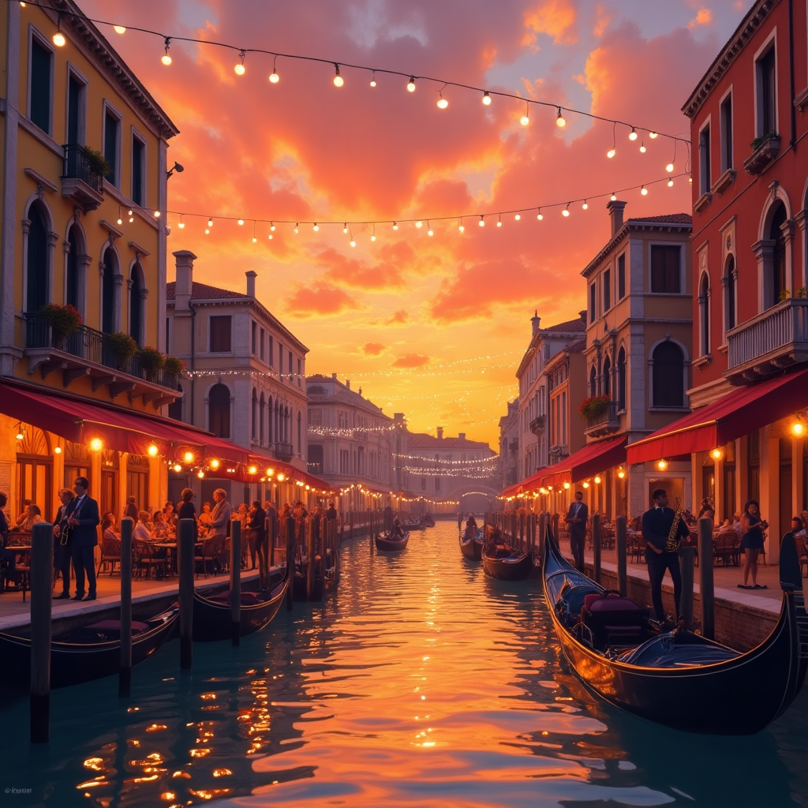

LEONARDO AI

