SOFTWARE TEST PLAN
OrangeHRM Manual Testing using Jira & Zephyr Scale
OrangeHRM Demo Application | Agile Scrum QA Engagement
Document Type: Test Plan
Version: 1.1
Prepared By: QA Engineering Team
Date: July 09, 2026
Classification: Internal / Portfolio Reference

Table of Contents
Document Control & Version History 3
1. Project Overview 4
2. Project Objectives 4
3. Scope 4
3.1 In Scope 4
3.2 Out of Scope 5
4. Testing Methodology 5
5. Test Strategy 6
6. Test Environment 7
7. Tools Used 7
8. Entry Criteria 7
9. Exit Criteria 7
10. Roles and Responsibilities 7
11. Deliverables 8
12. Risks 8
13. Assumptions 8
14. Dependencies 8
15. Test Schedule 9
16. Conclusion 9

Document Control
Field | Details
Document Title | Software Test Plan - OrangeHRM Manual Testing
Project Name | OrangeHRM Manual Testing using Jira & Zephyr Scale
Application Under Test | OrangeHRM Demo Application
Document Version | 1.1
Document Status | Final
Prepared By | QA Engineering Team
Reviewed By | QA Lead
Approved By | Project Stakeholder
Date Prepared | July 09, 2026
Test Management Tool | Jira with Zephyr Scale

Version History
Version | Date | Author | Description
0.1 | 23-Jun-2026 | QA Engineering Team | Initial draft created for internal review
0.2 | 27-Jun-2026 | QA Lead | Incorporated Sprint 1 scope and test strategy feedback
1.0 | 09-Jul-2026 | QA Engineering Team | Finalized after Sprint 1 and Sprint 2 planning sign-off
1.1 | 09-Jul-2026 | QA Engineering Team | Added Table of Contents, STLC and module distribution charts, and expanded section detail

1. Project Overview
The OrangeHRM Manual Testing project was undertaken to validate the core functional modules of the OrangeHRM Demo Application, a widely used open-source Human Resource Management System. The engagement was executed by the QA Engineering Team following the Agile Scrum methodology, with all planning, execution, and defect tracking activities managed through Jira and Zephyr Scale. The scope of testing covered four primary modules of the application: Login, Dashboard, Employee, and Leave, which together represent the core workflows a typical HR user interacts with on a daily basis.
This document defines the overall approach, strategy, resources, schedule, and deliverables associated with the manual testing effort. It serves as the controlling reference for all test activities performed across Sprint 1 and Sprint 2 of the project and is intended for use by the QA team, development team, Scrum Master, and Product Owner. The project was tracked end-to-end in Jira, with 80 test cases authored in Zephyr Scale and 10 defects logged against the two sprints, giving full visibility into planning, execution, and quality outcomes at every stage.

2. Project Objectives
The primary objective of this testing engagement is to verify that the Login, Dashboard, Employee, and Leave modules of the OrangeHRM Demo Application function according to their intended business requirements and deliver a consistent, error-free user experience. The testing effort is designed to validate both positive and negative user workflows, confirm that field-level validations behave correctly, and ensure that data entered through the application is processed and persisted accurately.
A secondary objective is to establish a traceable and auditable quality record for the project. This is achieved by mapping every requirement to one or more test cases in Zephyr Scale, logging all defects discovered during execution in Jira, and producing summary metrics that allow stakeholders to make an informed release decision. The engagement also aims to demonstrate a repeatable Agile Scrum testing process that can be reused in subsequent sprints as additional OrangeHRM modules are brought into scope, and to leave behind documentation of sufficient quality to serve as a reference standard for future QA engagements on this application.

3. Scope

3.1 In Scope
Testing covers the following four modules of the OrangeHRM Demo Application: the Login module, including authentication, credential validation, and account lockout behavior; the Dashboard module, including widget rendering, navigation, and page load behavior; the Employee module, including creation, search, update, and deletion of employee records; and the Leave module, including leave application submission, balance validation, date range validation, and leave status updates. Functional testing, UI testing, validation testing, negative testing, smoke testing, and regression testing were performed against these four modules as detailed in the Test Strategy section of this document.
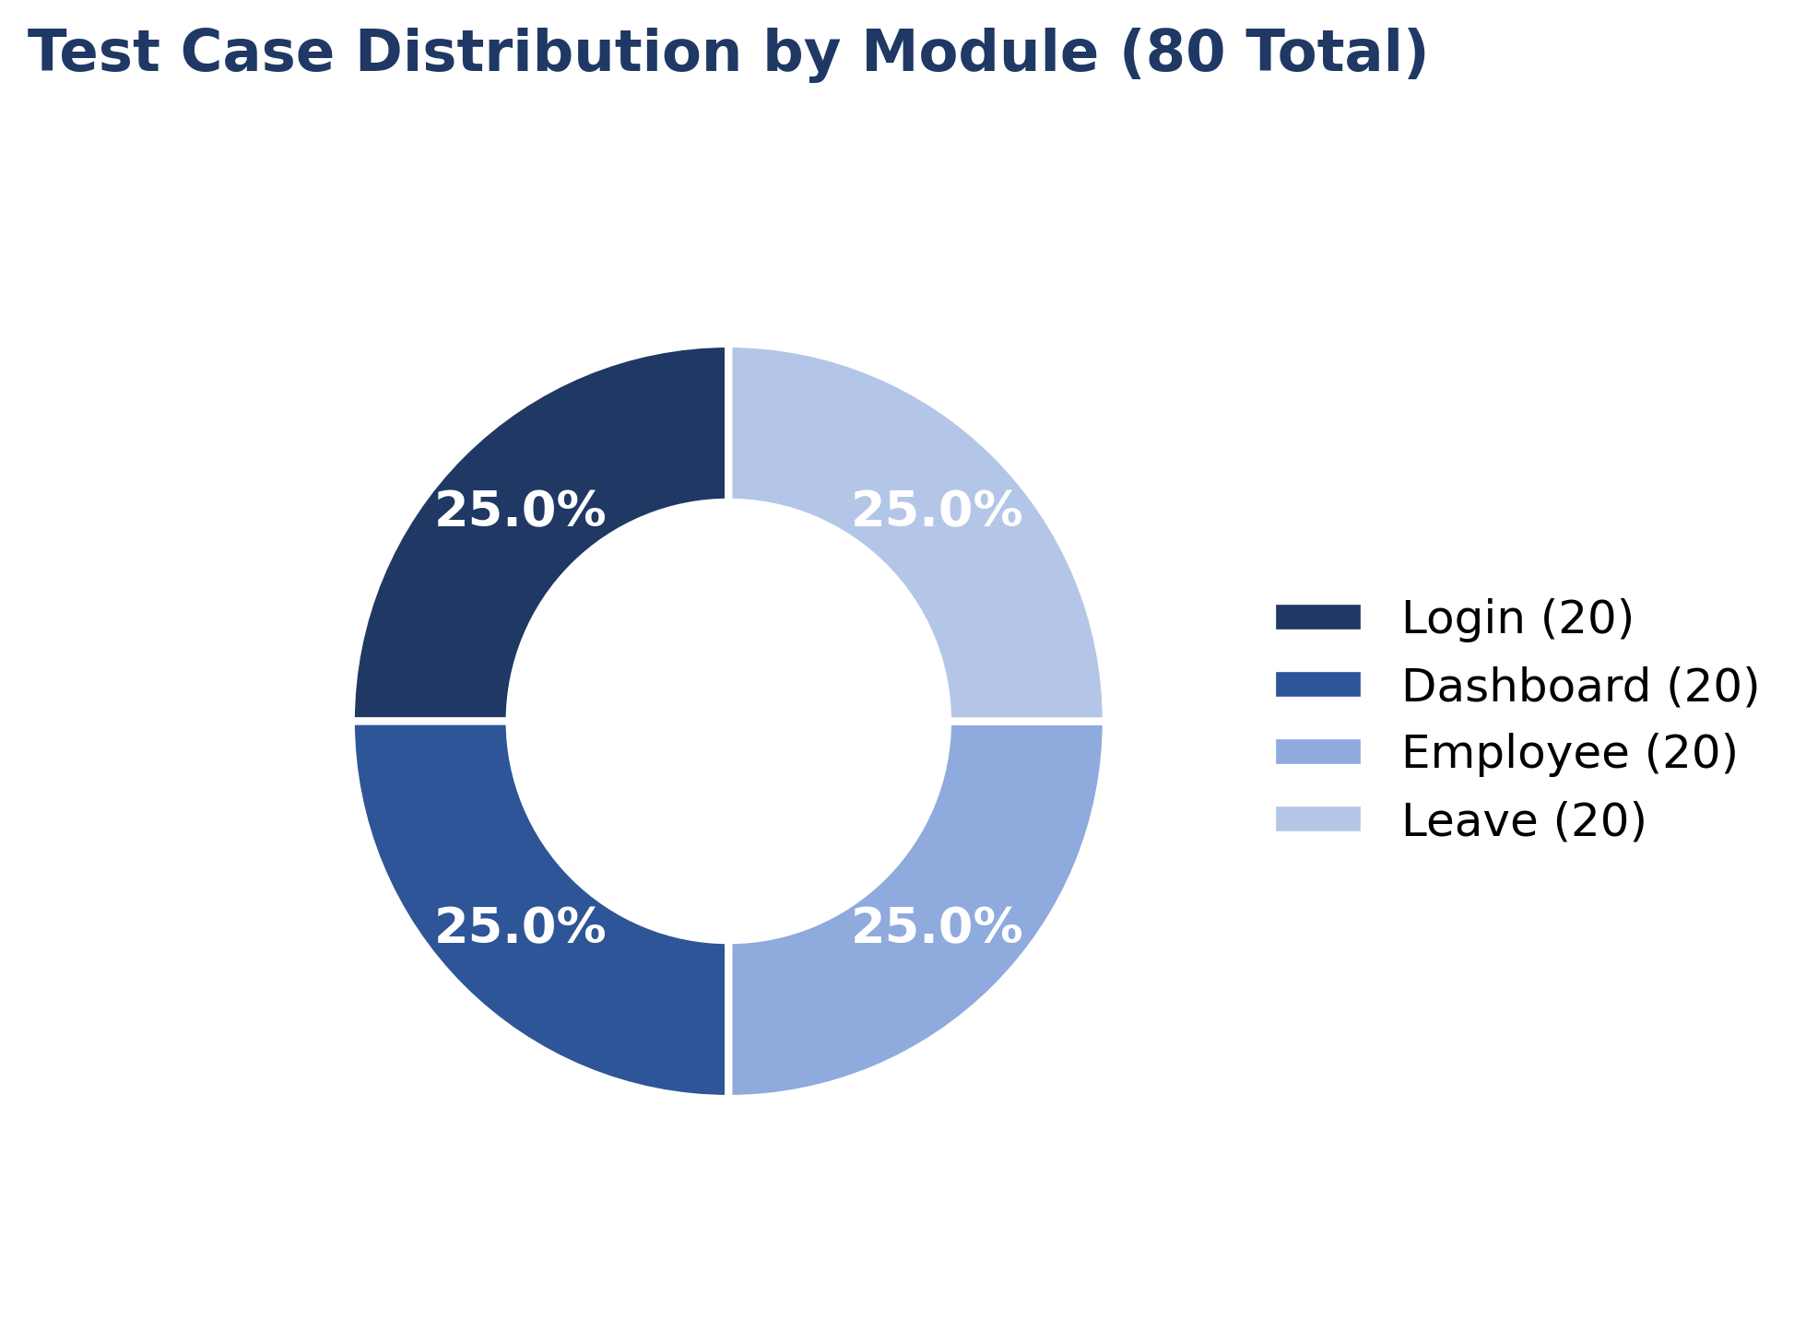
Figure 1: Test Case Distribution by Module (20 test cases per module, 80 total)

3.2 Out of Scope
The following items are explicitly excluded from this testing engagement: performance and load testing, formal security penetration testing, test automation, and testing of OrangeHRM modules outside the four identified in scope, including Recruitment, PIM Reports, Time, Performance, Admin, and Payroll. Cross-browser compatibility testing was limited to Google Chrome on Windows 11 and did not extend to other browsers or operating systems. API-level testing and database-level validation were also not performed as part of this cycle, as the engagement was scoped strictly to UI-driven manual testing.

4. Testing Methodology
The project followed the Agile Scrum methodology across two testing sprints, with the full Software Test Life Cycle (STLC) applied within each sprint rather than once across the whole project. Sprint 1 focused on the Login and Dashboard modules, while Sprint 2 focused on the Employee and Leave modules. Each sprint began with backlog grooming, during which test scenarios were derived from application requirements and logged as test cases in Zephyr Scale, followed by sprint planning to assign test design and execution tasks. Daily progress was tracked informally against the Jira board, with test case status, defect status, and blockers reviewed regularly by the QA Lead.
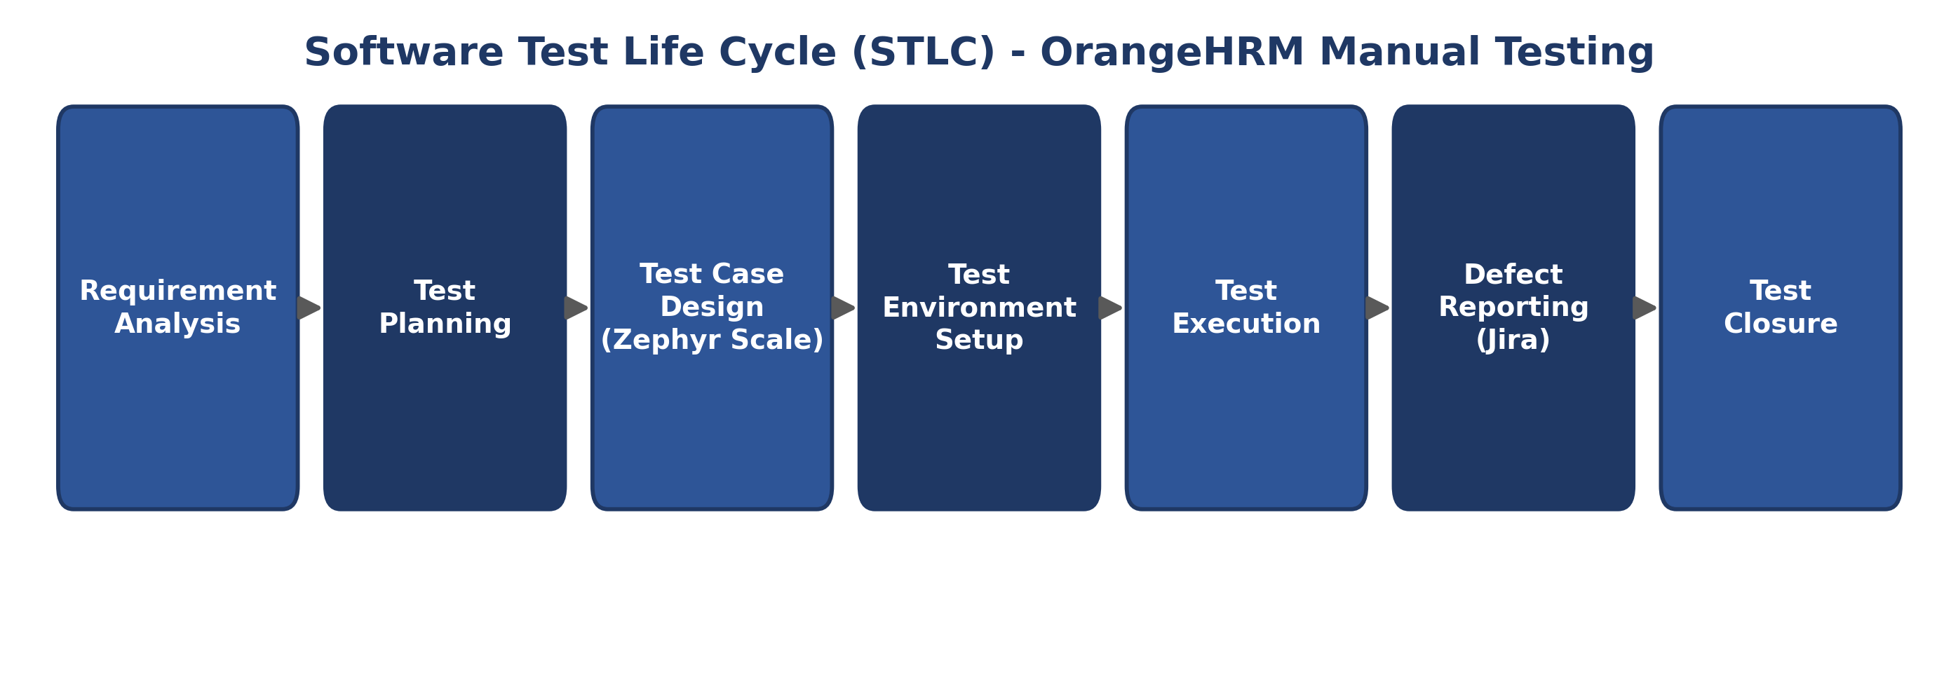
Figure 2: Software Test Life Cycle (STLC) applied within each sprint of the OrangeHRM engagement
At the close of each sprint, a sprint review was conducted to walk through execution results and outstanding defects, followed by a retrospective to capture process improvements to be carried into the next sprint. This iterative structure allowed testing to begin as soon as a module was development-complete, rather than waiting for the entire application to be finalized, and ensured that defects were surfaced and communicated to stakeholders early in the project timeline.

5. Test Strategy

5.1 Functional Testing
Functional testing validated that core business workflows behaved as expected, including user authentication on the Login module, widget and menu behavior on the Dashboard, employee record creation and maintenance on the Employee module, and end-to-end leave application submission and approval on the Leave module.

5.2 UI Testing
UI testing verified that page layouts, widgets, form fields, buttons, and navigation elements rendered correctly and consistently across the four in-scope modules, with particular attention paid to dashboard widget alignment and overall page presentation.

5.3 Validation Testing
Validation testing confirmed that mandatory fields, format restrictions, and business rules were correctly enforced, including username and password requirements on Login, Employee ID and Employee Name constraints on the Employee module, and leave balance and date range rules on the Leave module.

5.4 Negative Testing
Negative testing exercised the application with invalid, boundary, and unexpected inputs, such as incorrect login credentials, duplicate Employee IDs, invalid special characters in name fields, and leave requests that exceeded available balance, to confirm the system responded with appropriate error handling.

5.5 Security Testing
Limited security-focused checks were performed at the UI level, including verification of login attempt restrictions and confirmation that the application did not accept clearly malformed or boundary-violating input on sensitive fields. This did not extend to formal penetration testing or vulnerability scanning.

5.6 Smoke Testing
A smoke test pass was executed at the start of each sprint immediately after build deployment to confirm that the Login module was accessible and that the Dashboard, Employee, and Leave modules loaded without critical blocking issues before detailed test execution began.

5.7 Regression Testing
Regression testing was performed after defect fixes were applied, re-executing the affected test cases in Zephyr Scale along with a targeted subset of related test cases to confirm that the fix did not introduce new issues in previously validated functionality.

6. Test Environment
All testing was performed against the publicly hosted OrangeHRM Demo Application using the standard demo credentials provided by OrangeHRM. Test execution was carried out on machines running Windows 11 using Google Chrome as the primary browser. No dedicated staging or internal environment was required, as the OrangeHRM demo instance was reset independently and provided a consistent, stable environment for repeated test execution across both sprints.

7. Tools Used
Tool | Purpose
Jira | Sprint planning, task tracking, and defect (bug) management
Zephyr Scale | Test case design, organization, and execution tracking within Jira
Microsoft Excel | Test metrics analysis and Requirement Traceability Matrix preparation
Google Chrome | Primary browser used for executing all test cases
Windows 11 | Operating system used for the test execution environment
GitHub | Version control and portfolio hosting of QA documentation and artifacts

8. Entry Criteria
Test execution for a given module was permitted to begin once the following conditions were satisfied: the module had been deployed to the OrangeHRM demo environment and confirmed accessible; test cases for the module had been authored and reviewed in Zephyr Scale; the Jira sprint backlog had been finalized and test tasks assigned; and a successful smoke test had been completed confirming that the application was stable enough for detailed functional execution.

9. Exit Criteria
Testing for the project was considered complete once all 80 planned test cases across the four in-scope modules had been executed in Zephyr Scale, achieving 100 percent execution coverage. All defects identified during execution were required to be logged in Jira with appropriate severity and priority classification, and no untriaged defects were permitted to remain at sprint close. While 10 defects remained in Open status at the time of reporting, exit was approved on the basis that none were classified as blocking release, subject to the recommendations captured in the Test Summary Report.

10. Roles and Responsibilities
Role | Responsibility
QA Lead | Owns the test strategy, reviews test cases, approves the test plan, and signs off on sprint exit criteria
QA Engineer / Tester | Designs test cases in Zephyr Scale, executes tests, logs defects in Jira, and reports execution status
Scrum Master | Facilitates sprint ceremonies and removes process blockers impacting the testing team
Product Owner | Clarifies acceptance criteria and prioritizes defect resolution within the sprint backlog
Development Team | Fixes defects logged in Jira and supports root-cause analysis for reported issues

11. Deliverables
The following artifacts were produced and delivered as part of this testing engagement: this Software Test Plan; 80 documented test cases maintained in Zephyr Scale covering the Login, Dashboard, Employee, and Leave modules; a Requirement Traceability Matrix mapping requirements to test cases and execution status; 10 defect reports logged and tracked in Jira; and a comprehensive Test Summary Report presenting execution metrics, defect analysis, and release recommendations. All deliverables are version-controlled and hosted in the project's GitHub repository for portfolio and audit purposes.

12. Risks
Risk | Impact | Mitigation
Shared public demo environment may be reset or modified by other users | Medium | Execute critical test cases early in each sprint and re-verify before final sign-off
Limited sprint duration may constrain full regression coverage | Medium | Prioritize high-priority test cases and apply risk-based regression scoping
Defects identified late in a sprint may delay retesting | High | Track defect aging in Jira and escalate high-priority defects immediately upon discovery
Manual execution is susceptible to human error and inconsistent coverage | Low | Use standardized Zephyr Scale test case templates and peer review of test cases

13. Assumptions
It is assumed that the OrangeHRM Demo Application remains accessible and stable throughout the testing period, that test data created during execution does not need to persist beyond the current sprint, that all four in-scope modules are functionally complete prior to the start of their respective sprint, and that the QA team has uninterrupted access to Jira and Zephyr Scale for the full duration of the engagement.

14. Dependencies
Testing progress is dependent on the timely availability of the OrangeHRM Demo Application, continued access to Jira and Zephyr Scale licensing, and prompt triage of defects by the Product Owner so that priority and severity can be confirmed. Any extended outage of the demo environment or the Jira/Zephyr Scale platform would directly impact the ability to meet sprint execution targets.

15. Test Schedule
Sprint | Modules Covered | Start Date | End Date | Key Activities
Sprint 1 | Login, Dashboard | 15-Jun-2026 | 26-Jun-2026 | Test design, smoke testing, functional/validation execution, BUG-001 to BUG-005 logged
Sprint 2 | Employee, Leave | 29-Jun-2026 | 10-Jul-2026 | Test design, functional/negative execution, BUG-006 to BUG-010 logged, final reporting

16. Conclusion
This Test Plan establishes the scope, strategy, schedule, and governance for the manual testing of the OrangeHRM Demo Application across its Login, Dashboard, Employee, and Leave modules. By combining Agile Scrum ceremonies with structured test management in Jira and Zephyr Scale, the plan is designed to deliver complete requirement traceability, full execution coverage, and a well-documented defect record. Execution of this plan across Sprint 1 and Sprint 2 is expected to provide stakeholders with a clear, evidence-based view of application quality sufficient to support a release readiness decision, with detailed results presented in the accompanying Test Summary Report.

