TEST SUMMARY REPORT
OrangeHRM Manual Testing using Jira & Zephyr Scale
OrangeHRM Demo Application | Sprint 1 & Sprint 2 Consolidated Report
Document Type: Test Summary Report
Version: 1.1
Prepared By: QA Engineering Team
Date: July 09, 2026
Classification: Internal / Portfolio Reference

Table of Contents
Document Control & Version History 3
1. Executive Summary 4
2. Project Scope 4
3. Modules Tested 4
4. Testing Approach 5
5. Execution Summary 5
6. Requirement Coverage 6
7. Defect Summary 6
8. Bug Analysis 7
8.1 Bug Severity Distribution 7
8.2 Module-wise Bug Distribution 8
9. Risk Analysis 9
10. Recommendations 9
11. Lessons Learned 9
12. Conclusion 9

Document Control
Field | Details
Document Title | Test Summary Report - OrangeHRM Manual Testing
Project Name | OrangeHRM Manual Testing using Jira & Zephyr Scale
Application Under Test | OrangeHRM Demo Application
Document Version | 1.1
Document Status | Final
Prepared By | QA Engineering Team
Reviewed By | QA Lead
Approved By | Project Stakeholder
Date Prepared | July 09, 2026
Test Management Tool | Jira with Zephyr Scale

Version History
Version | Date | Author | Description
0.1 | 03-Jul-2026 | QA Engineering Team | Initial draft with execution results from Sprint 1 and Sprint 2
1.0 | 09-Jul-2026 | QA Engineering Team | Finalized with complete defect analysis and recommendations
1.1 | 09-Jul-2026 | QA Engineering Team | Added Table of Contents, embedded charts, and expanded bug and risk analysis

1. Executive Summary
This report summarizes the results of the manual testing engagement performed against the OrangeHRM Demo Application. The QA Engineering Team executed 80 test cases across four functional modules, Login, Dashboard, Employee, and Leave, using Jira for sprint and defect management and Zephyr Scale for test case design and execution tracking. Testing was completed across two Agile Scrum sprints, achieving 100 percent execution coverage against the planned test scope.
Of the 80 test cases executed, 70 passed and 10 failed, resulting in an overall pass rate of 87.5 percent. Ten defects were logged in Jira as a result of the failed test cases: 3 High severity, 6 Medium severity, and 1 Low severity, all of which remained in Open status at the time of this report. The findings, metrics, and recommendations contained in this report are intended to support a release readiness decision by the Product Owner and project stakeholders.

2. Project Scope
The scope of this testing engagement covered functional, UI, validation, and negative testing of four OrangeHRM modules: Login, Dashboard, Employee, and Leave. Smoke and regression testing were performed alongside the primary test cycles to confirm build stability and to verify that defect fixes did not introduce regressions. Performance testing, security penetration testing, and automation were outside the scope of this engagement, as documented in the associated Test Plan.

3. Modules Tested
Module | Description | Sprint | Test Cases
Login | User authentication, credential validation, and login attempt handling | Sprint 1 | 20
Dashboard | Post-login landing page, widgets, navigation, and page performance | Sprint 1 | 20
Employee | Employee record creation, search, update, deletion, and field validation | Sprint 2 | 20
Leave | Leave application submission, balance validation, and status updates | Sprint 2 | 20
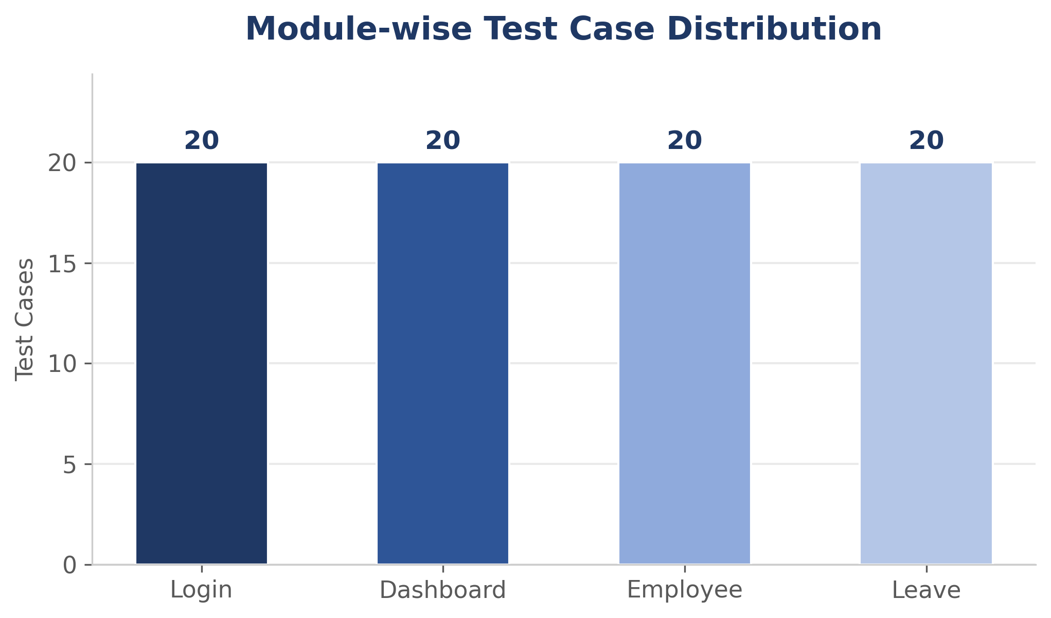
Figure 1: Module-wise Test Case Distribution (20 test cases per module, 80 total)

4. Testing Approach
Testing was organized into two sprints under the Agile Scrum methodology. Sprint 1, running from June 15 to June 26, 2026, covered the Login and Dashboard modules. Sprint 2, running from June 29 to July 10, 2026, covered the Employee and Leave modules. All 80 test cases were authored, organized, and executed in Zephyr Scale, with execution status synchronized to Jira for real-time visibility. A combination of functional, UI, validation, negative, smoke, and regression testing techniques was applied to each module, with negative and validation testing given particular emphasis given the data-entry-heavy nature of the Employee and Leave modules.
Defects identified during execution were logged directly in Jira and linked to their originating test case in Zephyr Scale for full traceability. Each defect was triaged for severity and priority at the time of logging, and re-verified against the relevant test case once a fix was made available, forming the basis of the regression testing carried out toward the end of each sprint.

5. Execution Summary
The table below presents the overall test execution summary across the full engagement. All planned test cases were executed within the scheduled sprint timelines, with no test cases left in a not-executed or blocked state at project close.
Metric | Value
Total Test Cases Planned | 80
Total Test Cases Executed | 80
Test Cases Passed | 70
Test Cases Failed | 10
Execution Coverage | 100%
Overall Pass Rate | 87.5%
Total Defects Raised | 10
Defects Currently Open | 10
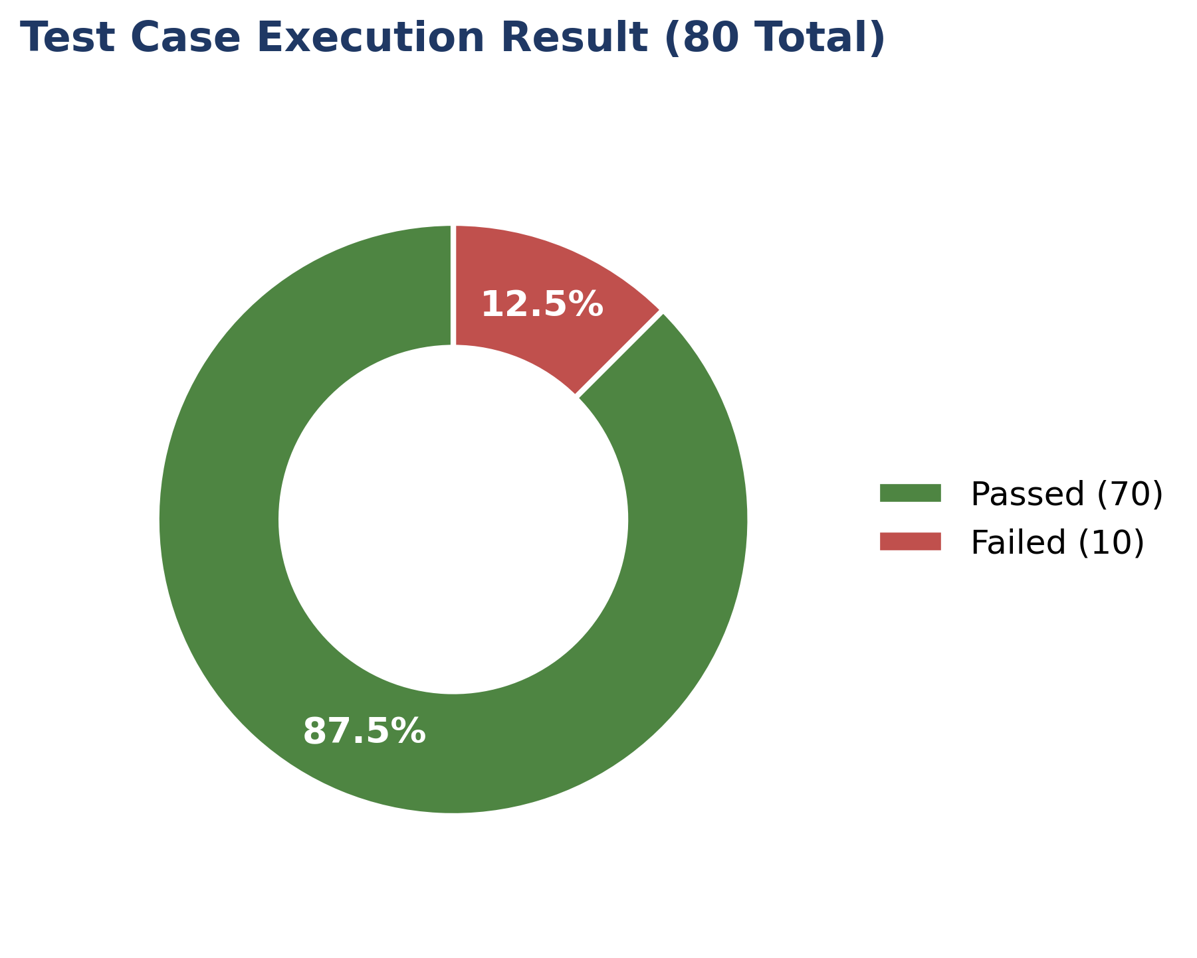
Figure 2: Test Case Execution Result - Passed 70 / Failed 10 (80 Total)

6. Requirement Coverage
A total of 16 functional requirements were identified across the four in-scope modules and mapped to test cases in the Requirement Traceability Matrix (RTM). All 16 requirements achieved full test coverage. Of these, 8 requirements passed all associated test cases without issue, while the remaining 8 requirements recorded at least one failed test case linked to an open defect, as detailed in the RTM.
Metric | Value
Total Requirements Identified | 16
Requirements with Full Test Coverage | 16 (100%)
Requirements Fully Passed | 8
Requirements with Failures | 8

7. Defect Summary
Ten defects were identified during test execution and logged in Jira. The table below lists each defect along with its associated module, severity, priority, and current status.
Bug ID | Description | Module | Severity | Priority | Status
BUG-001 | Leading spaces accepted during Login | Login | Medium | Medium | Open
BUG-002 | Trailing spaces accepted during Login | Login | Medium | Medium | Open
BUG-003 | Unlimited invalid login attempts allowed | Login | High | High | Open
BUG-004 | Dashboard widgets overlap on page load | Dashboard | Low | Medium | Open
BUG-005 | Dashboard loading time is slow | Dashboard | Medium | Medium | Open
BUG-006 | Duplicate Employee ID accepted | Employee | High | High | Open
BUG-007 | Invalid special characters accepted in Employee Name | Employee | Medium | Medium | Open
BUG-008 | Leave request submitted despite insufficient balance | Leave | High | High | Open
BUG-009 | Invalid leave date accepted | Leave | Medium | High | Open
BUG-010 | Leave status not updated properly | Leave | Medium | High | Open

8. Bug Analysis

8.1 Bug Severity Distribution
Of the 10 defects raised, 3 were classified as High severity, 6 as Medium severity, and 1 as Low severity. The High-severity defects are concentrated around login attempt control and data integrity on the Employee and Leave modules, all of which affect core business rules rather than cosmetic presentation.
Severity | Count | Percentage
High | 3 | 30%
Medium | 6 | 60%
Low | 1 | 10%
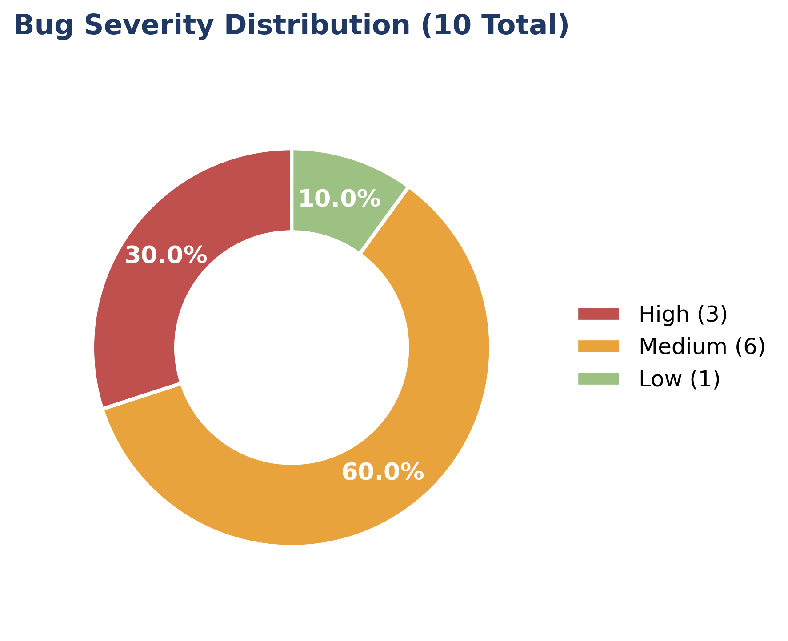
Figure 3: Bug Severity Distribution - High 3 / Medium 6 / Low 1 (10 Total)

8.2 Module-wise Bug Distribution
By module, the Login and Leave modules each recorded 3 defects, while the Dashboard and Employee modules each recorded 2 defects. This distribution aligns with the module-wise execution results, where Login and Leave also recorded the lowest pass rates during test execution.
Module | Defects Raised
Login | 3
Dashboard | 2
Employee | 2
Leave | 3
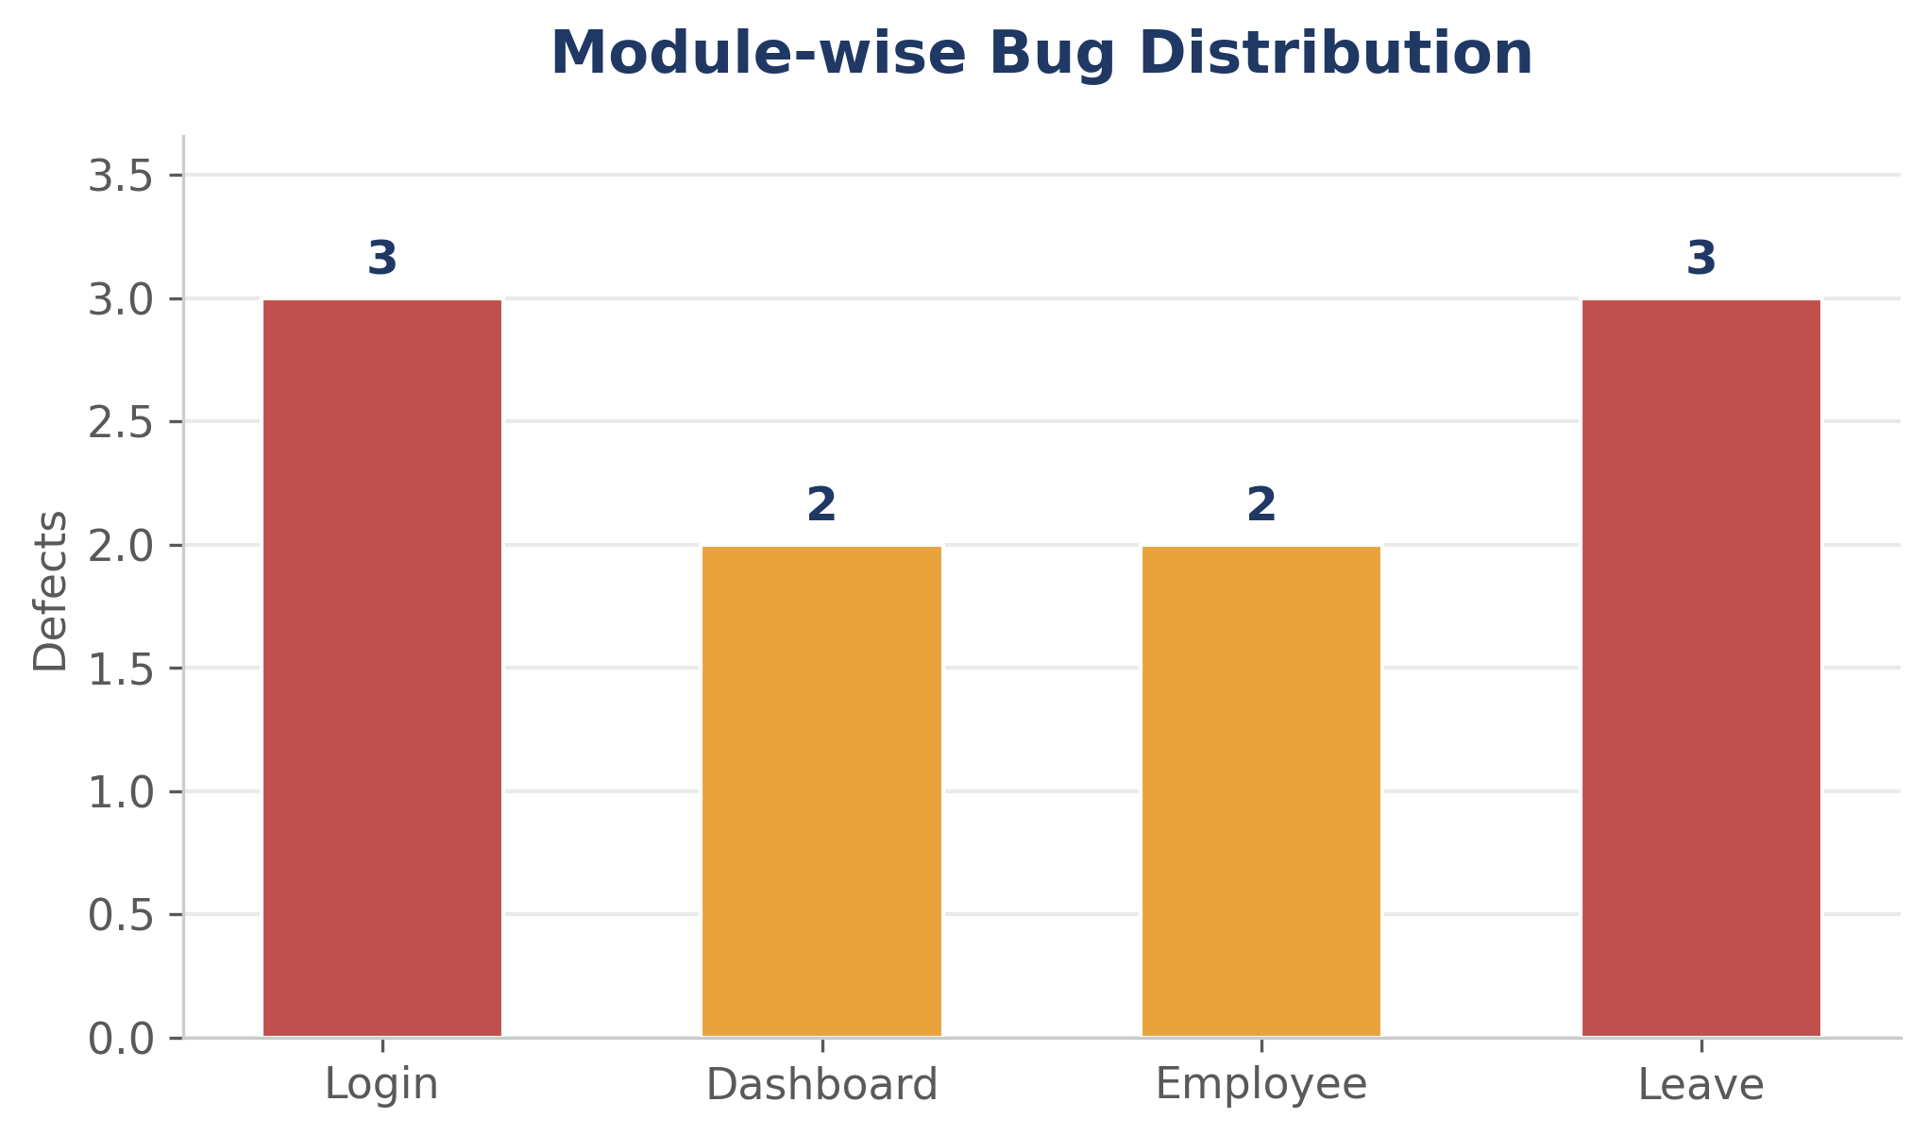
Figure 4: Module-wise Bug Distribution (10 defects total)

9. Risk Analysis
The unlimited invalid login attempts defect (BUG-003) represents a risk beyond functional correctness, as it could allow brute-force credential guessing if the application were deployed in a production context. The duplicate Employee ID defect (BUG-006) poses a data integrity risk, as downstream reports and payroll-adjacent modules may rely on Employee ID uniqueness. The leave balance and status defects (BUG-008 and BUG-010) carry a business risk, as they could result in employees being granted leave they are not entitled to, or in inaccurate leave records being relied upon by managers and HR staff.
Taken together, the three High-severity defects account for 30 percent of all open issues but are concentrated in areas with outsized business impact, security exposure for the login module and data integrity for the Employee and Leave modules, and should therefore be weighted more heavily than their count alone would suggest when planning remediation.

10. Recommendations
It is recommended that the three High-severity defects (BUG-003, BUG-006, BUG-008) be prioritized for a fix in the next development cycle prior to any production release, given their impact on security posture and data integrity. A consistent, centrally enforced input validation and trimming strategy should be adopted across the Login and Employee modules to prevent the recurrence of similar defects in other areas of the application. It is further recommended that a focused round of regression testing be performed on the Leave module once fixes are applied, given that it recorded the joint-highest number of defects during this cycle.

11. Lessons Learned
Organizing test execution around Zephyr Scale test cycles aligned closely to Jira sprints made it straightforward to track daily progress and kept defect logging tightly linked to the originating test case, which simplified root-cause discussions with the development team. Running a smoke test at the start of each sprint before full execution proved valuable in catching environment-level issues early, avoiding wasted effort on modules that were not yet stable enough for detailed testing. For future sprints, allocating dedicated time for input-validation-focused negative testing earlier in the cycle would likely surface defects like the ones seen in this engagement sooner, allowing more time for fixes and retesting within the same sprint.

12. Conclusion
The OrangeHRM manual testing engagement achieved its planned objective of validating the Login, Dashboard, Employee, and Leave modules with full execution coverage across 80 test cases. An overall pass rate of 87.5 percent, combined with complete requirement traceability and a well-documented set of 10 defects, provides the Product Owner and stakeholders with a clear, evidence-based basis for a release readiness decision. Provided that the three High-severity defects identified in this report are resolved and verified through regression testing, the application is considered to be in a reasonable state of quality for its current scope of functionality.

