**Praneeth M V L S S S**

**1NT19IS112**

**C1 -BATCH**

**BIG DATA**

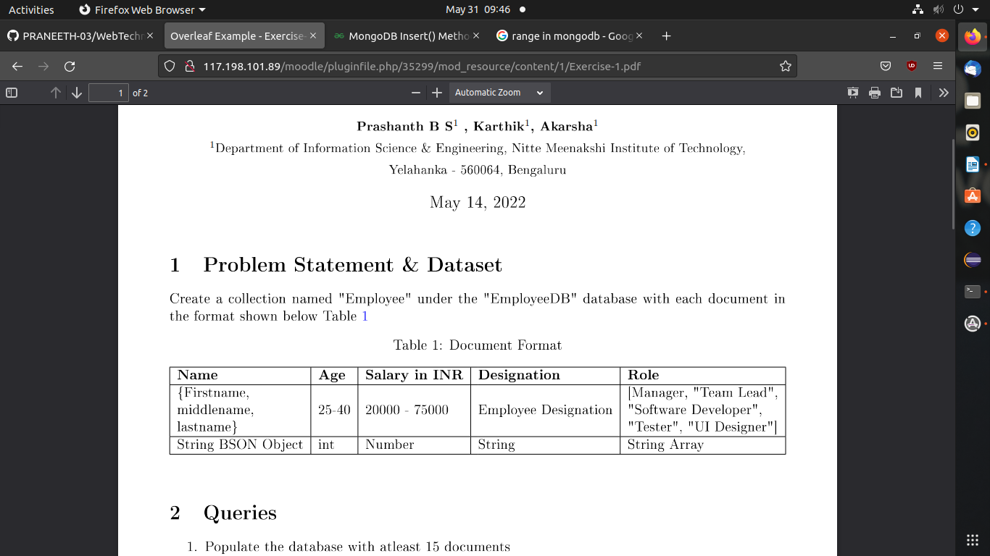

**1)**Populate the database with at least 15 documents

> db.Employee.find()

{ "_id" : ObjectId("62959089c31676ff46729289"), "Firstname" : "Praneeth", "Lastname" : " M V", "Salary" : 35000, "Designation" : "Team leader", "Age" : 23, "Role" : [ "Team Lead", "Software Developer" ] }

{ "_id" : ObjectId("62959089c31676ff4672928a"), "Firstname" : "Rajesh", "Middlename" : "C", "Lastname" : "Rajesh", "Age" : 26, "Salary" : 50000, "Designation" : "Tester", "Role" : [ "Manager", "Tester", "UI designer" ] }

{ "_id" : ObjectId("62959166c31676ff4672928b"), "Firstname" : "Sohan", "Middlename" : "Raj", "Lastname" : " M", "Age" : 30, "Salary" : 65000, "Designation" : "UI designer", "Role" : [ "Team Lead", "Ui designer" ] }

{ "_id" : ObjectId("62959166c31676ff4672928c"), "Firstname" : "Prateek", "Middlename" : "P", "Lastname" : "Nayak", "Age" : 24, "Salary" : 70000, "Designation" : "Manager", "Role" : [ "Manager", "Tester", "Team Lead" ] }

{ "_id" : ObjectId("6295924bc31676ff4672928d"), "Firstname" : "Sriman", "Middlename" : "S", "Lastname" : " Kumar", "Age" : 26, "Salary" : 75000, "Designation" : "UI designer", "Role" : [ "Manager", "Ui designer" ] }

{ "_id" : ObjectId("6295924bc31676ff4672928e"), "Firstname" : "Vishal", "Middlename" : "Kumar", "Lastname" : "H k", "Age" : 24, "Salary" : 72000, "Designation" : "Team Lead", "Role" : [ "Manager", "Tester", "Team Lead" ] }

{ "_id" : ObjectId("629592ecc31676ff4672928f"), "Firstname" : "Ullaas", "Middlename" : "M", "Lastname" : " Kumar", "Age" : 26, "Salary" : 20000, "Designation" : "UI designer", "Role" : [ "Tester", "UI designer" ] }

{ "_id" : ObjectId("629592ecc31676ff46729290"), "Firstname" : "Sanjeev", "Middlename" : "Sai", "Lastname" : "V V S", "Age" : 25, "Salary" : 32000, "Designation" : "Team Lead", "Role" : [ "Manager", "Tester", "Team Lead" ] }

{ "_id" : ObjectId("62959353c31676ff46729291"), "Firstname" : "Baba", "Middlename" : "M", "Lastname" : "Vinayak", "Age" : 35, "Salary" : 65000, "Designation" : "UI designer", "Role" : [ "Tester", "UI designer" ] }

{ "_id" : ObjectId("62959353c31676ff46729292"), "Firstname" : "Mohan", "Middlename" : "Kumar", "Lastname" : "T G", "Age" : 25, "Salary" : 30920, "Designation" : "Team Lead", "Role" : [ "Manager", "Tester", "Team Lead" ] }

{ "_id" : ObjectId("62959441c31676ff46729293"), "Firstname" : "Rajesh", "Middlename" : "Kumar", "Lastname" : "Rai", "Age" : 37, "Salary" : 75000, "Designation" : "Scientist", "Role" : [ "Tester", "UI designer", "Manager" ] }

{ "_id" : ObjectId("62959441c31676ff46729294"), "Firstname" : "Madhu", "Middlename" : "Rai", "Lastname" : "S G", "Age" : 25, "Salary" : 67920, "Designation" : "Team Lead", "Role" : [ "Manager", "Team Lead" ] }

{ "_id" : ObjectId("62959515c31676ff46729295"), "Firstname" : "Sachin", "Middlename" : "Ramesh", "Lastname" : "Tendulkar", "Age" : 45, "Salary" : 75000, "Designation" : "Scientist", "Role" : [ "Tester", "UI designer", "Manager", "Team Lead" ] }

{ "_id" : ObjectId("62959515c31676ff46729296"), "Firstname" : "Sunil", "Middlename" : "Kumar", "Lastname" : "Narine", "Age" : 30, "Salary" : 67920, "Designation" : "Team Lead", "Role" : [ "Manager", "Team Lead", "Software developer" ] }

{ "_id" : ObjectId("629595a5c31676ff46729297"), "Firstname" : "Laisha", "Middlename" : "sheik", "Lastname" : "abdul", "Age" : 23, "Salary" : 40000, "Designation" : "Tester", "Role" : [ "Tester", "UI designer" ] }

{ "_id" : ObjectId("629595a5c31676ff46729298"), "Firstname" : "Priya", "Middlename" : "Arul", "Lastname" : "Mohan", "Age" : 26, "Salary" : 67220, "Designation" : "Team Lead", "Role" : [ "Manager", "Team Lead", "Software developer" ] }

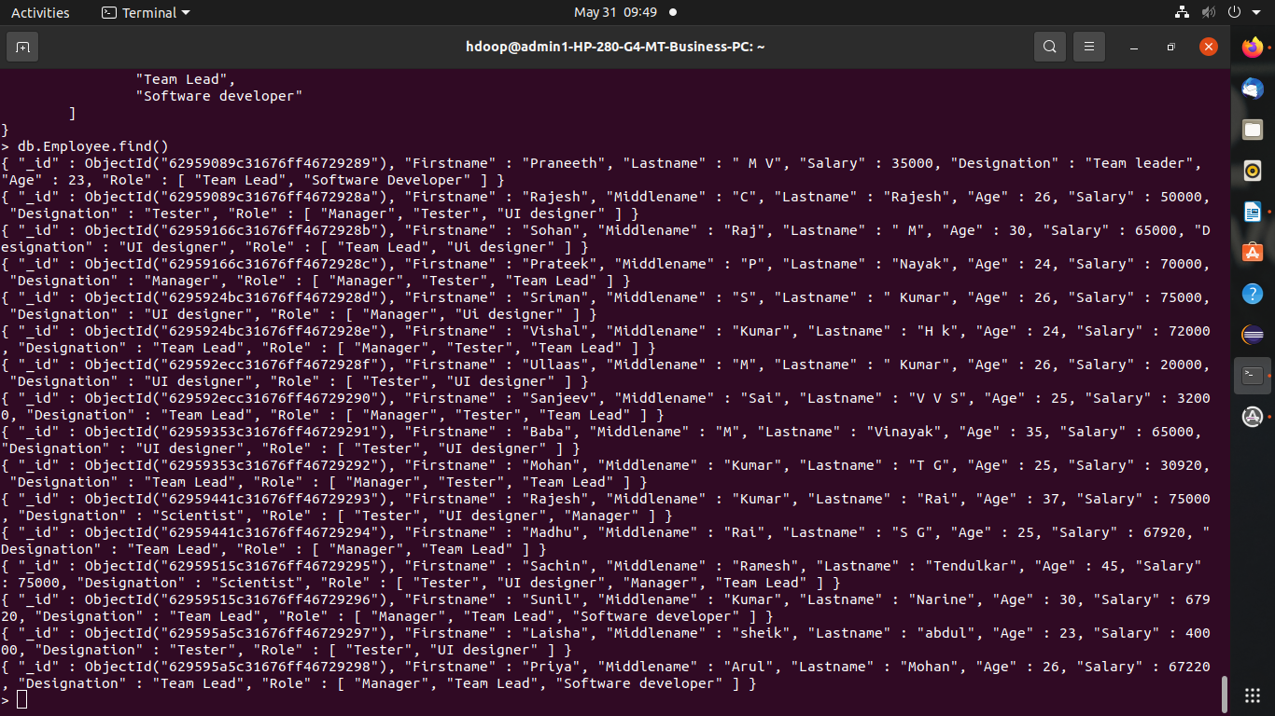

2)List all the records having salary in the range of 20000 – 35000

db.Employee.find({$and:[{Salary:{$gt:20000}},{Salary:{$lt:35000}}]}).pretty()

(or)

db.Employee.find({$and:[{Salary:{$gt:20000}},{Salary:{$lt:35000}}]})

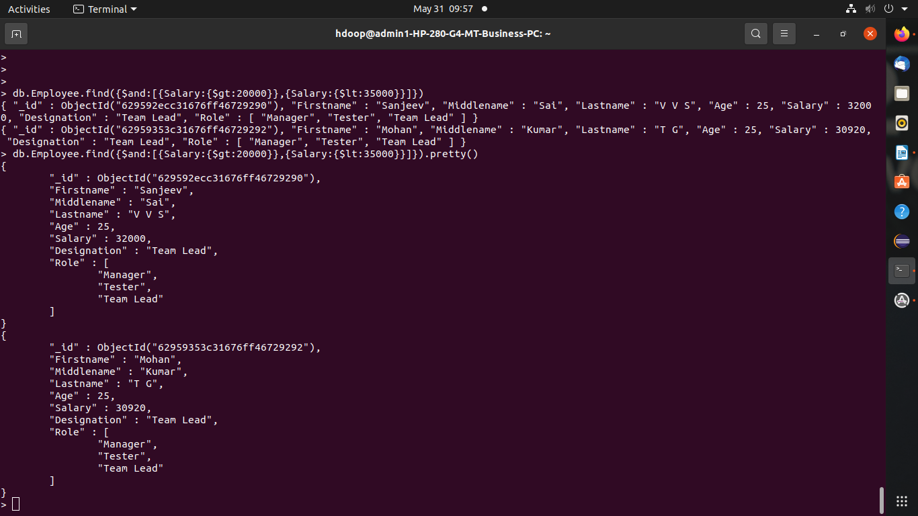

3)List all the Employee whose Middle name is "Kumar"

db.Employee.find({Middlename:"Kumar"})

(or)

db.Employee.find({Middlename:"Kumar"}).pretty()

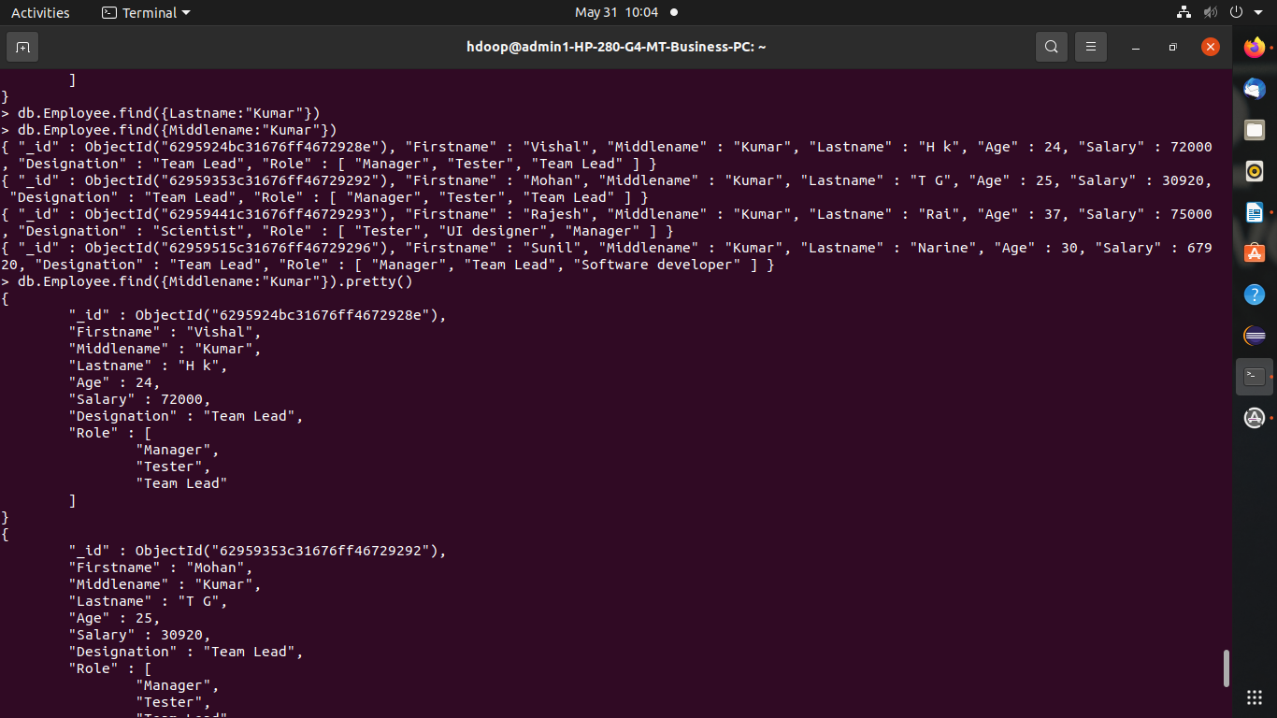

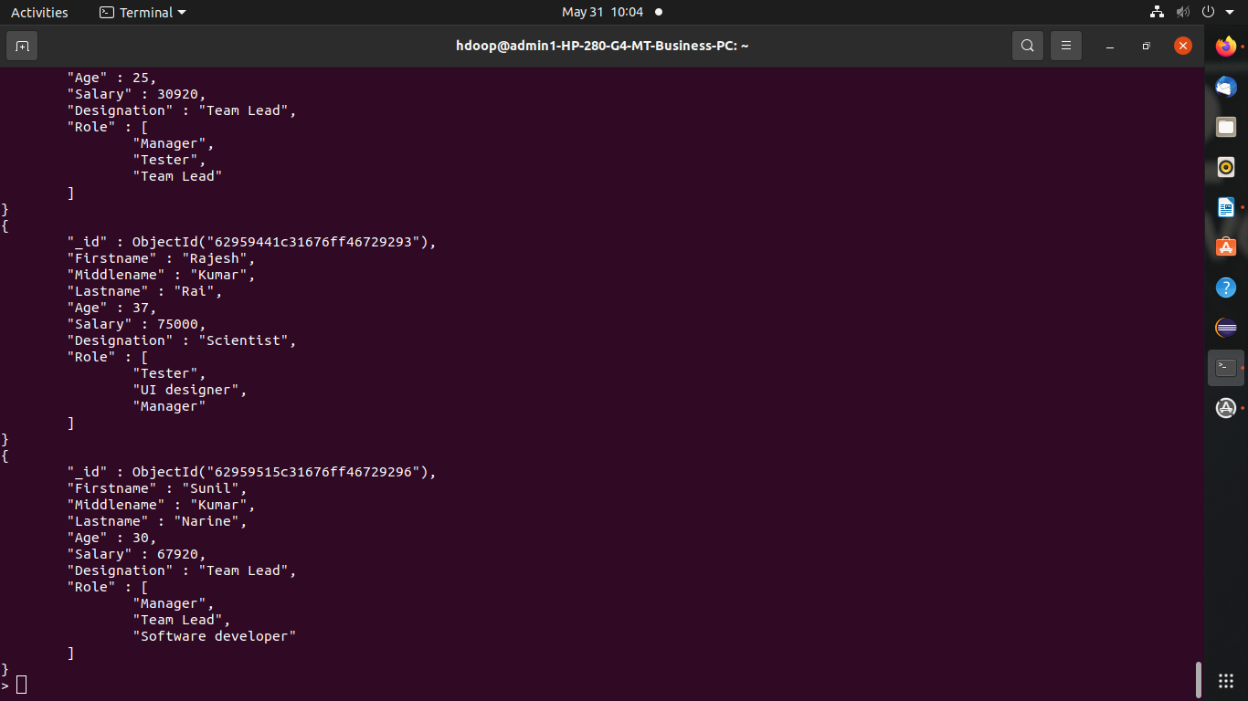

4)Count the number of Employees who has a role "Manager" in the Role field

db.Employee.count({Role:"Manager"})



5)Find out all the documents who have age < 35 and salary in the range of 30000-35000

db.Employee.find({$and:[{Salary:{$gt:30000}},{Salary:{$lt:35000}},{Age:{$lt:35}}]})



6)Delete an Employee whose "Firstname" is "Rajesh" and having the designation as "Scientist"

db.Employee.remove({$and:[{Firstname:"Rajesh"},{Designation:"Scientist"}]})

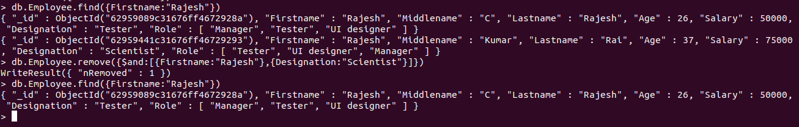

7)update all the Employees whose role is "Team Lead" with a salary of 55650 INR

db.Employee.updateMany({Role:"Team Lead"},{$set:{Salary:55650}})

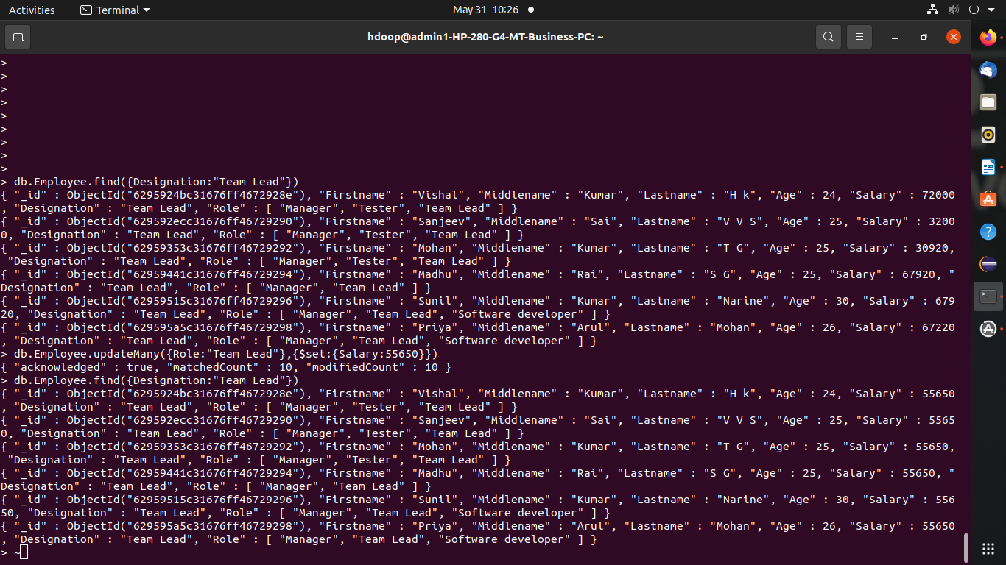

8)Group all the Employees by their age(common age should be there) and calculate the average  
salary obtained in the each group

db.Employee.aggregate([{$group:{_id:"$Age",Average:{$avg:"$Salary"}}}])



9)Apply the map-reduce to perform the above operation and obtain the results

> var mapfunction=function(){emit (this.Age,this.Salary)}

> var reducefunction=function(key,values){return Array.avg(values)}

> db.Employee.mapReduce(mapfunction,reducefunction,{'out':'result'})

> db.result.find()

