Praneeth M V L S S S
1NT19IS112

HIVE INSTALLIATION:
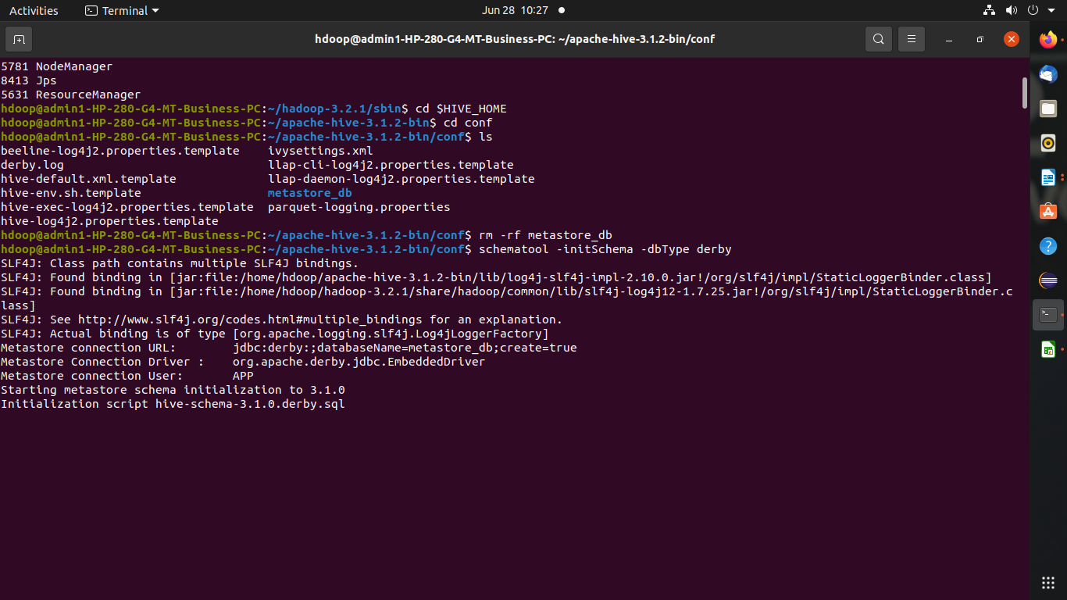
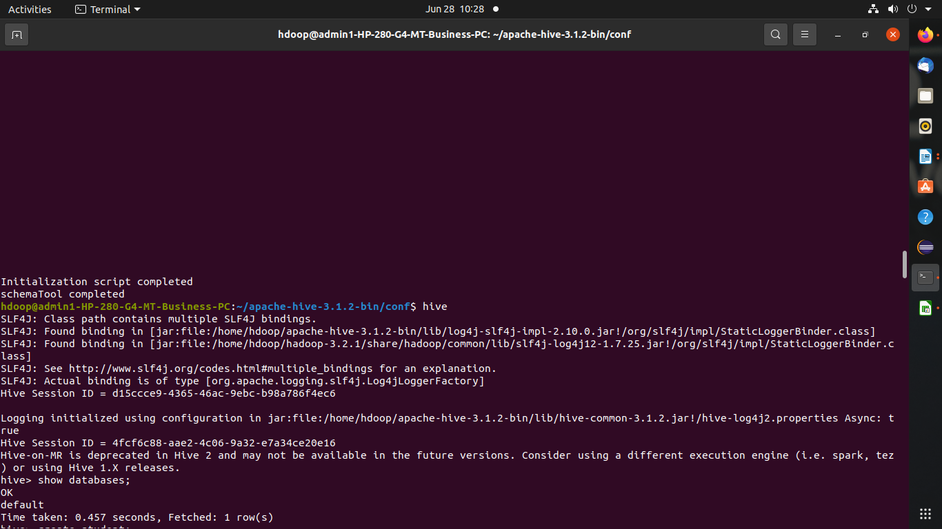

1) Create and Drop databases

hive> create database data;
OK
Time taken: 0.035 seconds
hive> use data;
OK
Time taken: 0.014 seconds
hive> drop database data;
OK
Time taken: 0.122 seconds



2)Create ,Alter ,Drop table

Create :
hive> create table std(usn int,name string,age int);
OK
Time taken: 0.442 seconds
hive> desc std;
OK
usn int
name string
age int
Time taken: 0.113 seconds, Fetched: 3 row(s)
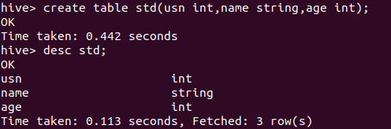

drop table s;
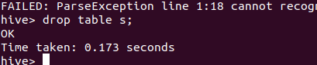

operations:
created new table bank:
create table bank(slno int, cname string, custname string, amount int)
> row format delimited
> fields terminated by "," ;
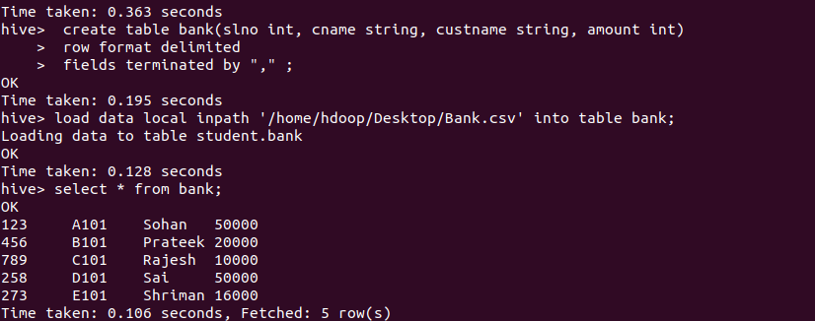
load csv file into table:

load data local inpath '/home/hdoop/Desktop/Bank.csv' into table bank;

and display the data
select * from bank;
MIN , MAX AVG Operations:

select max(amount) from bank;

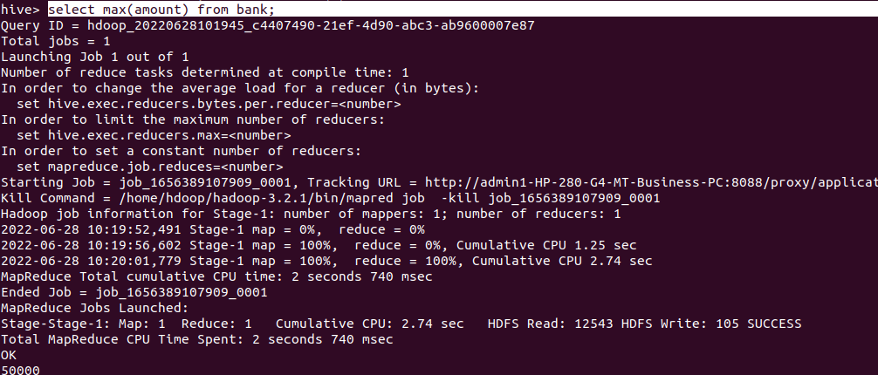
select min(amount) from bank;

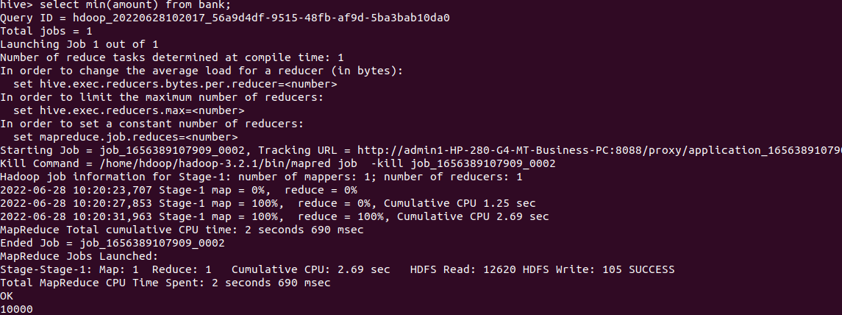

select avg(amount) from bank;
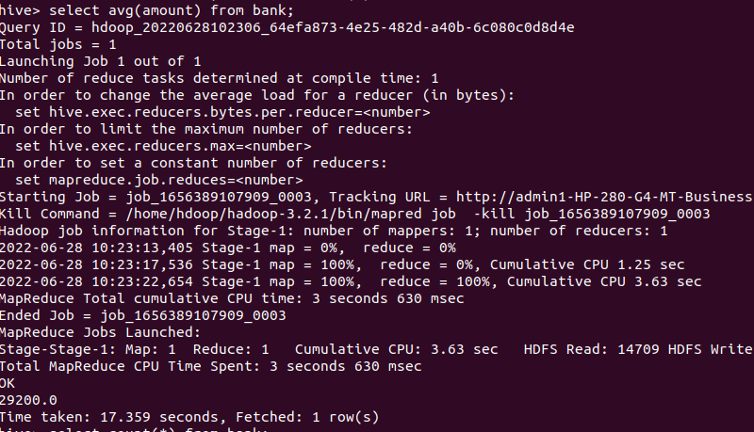

select count(*) from bank;

