Name:-Vinayak P Bhupal USN:-1NT19IS187

**HYBRID APPLICATION DEVELOPMENT LAB**

(FLUTTER )

SafeArea:

Without SafeArea:-

import 'package:flutter/material.dart'; void main() {

runApp(MaterialApp( home: Text(

'WITHOUT-SAFEAREA', // Text to display textAlign: TextAlign.center, //align the text to center style: TextStyle(

fontSize: 40,

fontStyle: FontStyle.normal,// fontSize in px fontWeight: FontWeight.w800, // font weight

color: Colors.blueAccent, // Setting up the color font

),

),

));

}

**OUTPUT:-**

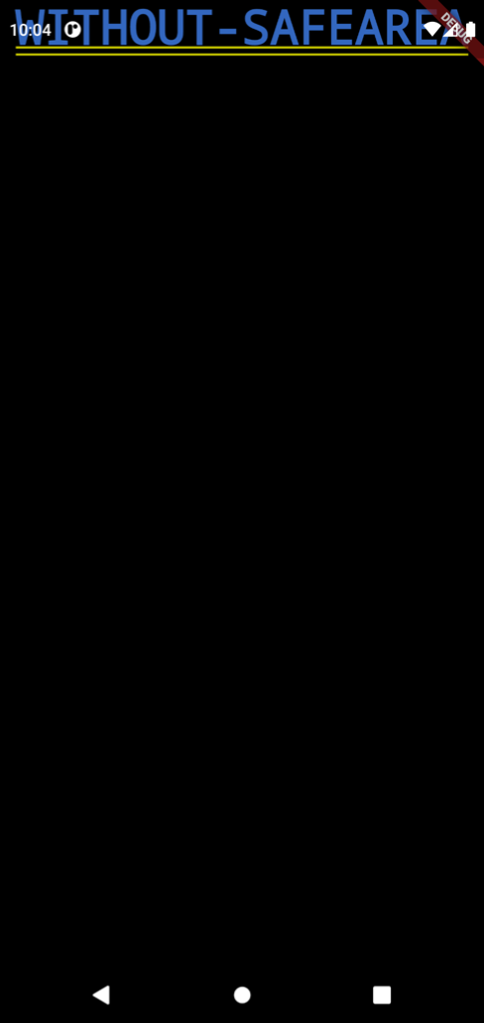

**Usage Of SafeArea:-**

**import 'package:flutter/material.dart'**; **void** main() { runApp(MaterialApp( home: SafeArea(

## child: Text(

**'WITHOUT SAFEAREA'**, textAlign: TextAlign.**center**, style: TextStyle( fontSize: 40,

fontWeight: FontWeight.*w800*, color: Colors.*blueAccent*, ),

## ), ),

)); }

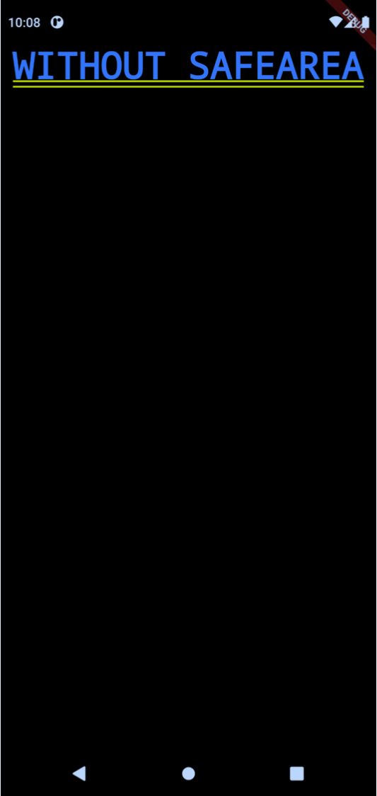

# Create a Flutter App to demonstrate the usage of Scaffold.

**import 'package:flutter/material.dart'**; **void** main() { runApp( MaterialApp(

home:Scaffold( appBar: AppBar(

title: Text(**"FIRST FLUTTER APP"**), ),

body: Center( child: Text(

**'THIS IS THE FIRST APP'** , style: TextStyle( fontSize: 35,

fontStyle: FontStyle.**normal**, fontWeight: FontWeight.*bold*, ),

), ),

), ), );}

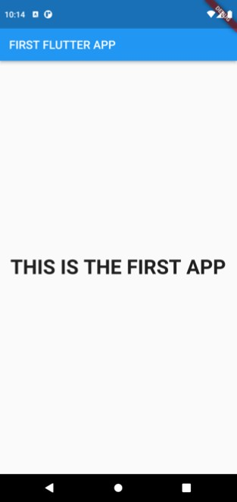

Combining Scaffold and SafeArea

**import 'package:flutter/material.dart'**; **void** main() { runApp(MaterialApp(

home: Scaffold( *// Scaffold houses appBar and body property* appBar:AppBar( title: Text( **'Scaffold-SafeArea'**

), ),

body:Container(

child: SafeArea( *// Defining SafeArea as Child of Container*

child: Center( child: Text(

**'THIS IS SAMPLE TEXT'**, style: TextStyle( fontSize: 40, ),

), ),

), ),

), ));

}

