Name:-Vinayak P Bhupal USN:-1NT19IS187

**HYBRID APPLICATION DEVELOPMENT LAB**

(FLUTTER )

# WIDGETS:

column:

import 'package:flutter/material.dart'; void main() { runApp(MaterialApp( home: Scaffold( body: RowApp(),

), ));

}

class RowApp extends StatefulWidget {

const RowApp({Key? key}) : super(key: key); @override

_RowAppState createState() => _RowAppState(); }

class _RowAppState extends State<RowApp> { @override Widget build(BuildContext context) {

return Container( child: SafeArea( child: Row(

mainAxisAlignment: MainAxisAlignment.spaceEvenly, crossAxisAlignment: CrossAxisAlignment.start, children: [

Container( height: 100,

width: 100,

color: Colors.green, child: Center( child: Text('First Child'), ),

),

Container(

height: 100,

width: 100, color: Colors.red, child: Center(

child:Text( 'Second Child'

)

),

),

Container( height: 100,

width: 100,

color: Colors.blueGrey, child: Center(

child:Text( 'Third Child'

)

),

),

],

),

),

); }

}

), ));

}

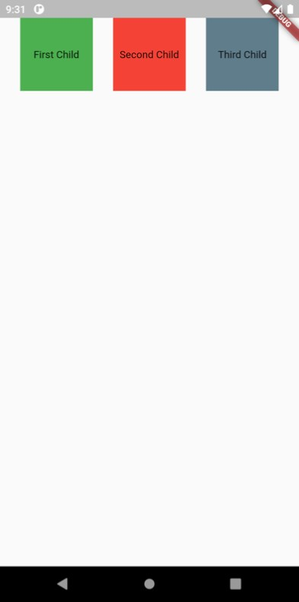

# row:

import 'package:flutter/material.dart';

void main() { runApp(MaterialApp(

home: Scaffold( body: RowApp(),

const RowApp({Key? key}) : super(key: key);

@override

_RowAppState createState() => _RowAppState();

}

class _RowAppState extends State<RowApp> {

@override

Widget build(BuildContext context) { return Container(

child:SafeArea( child: Column(

mainAxisAlignment: MainAxisAlignment.spaceEvenly, crossAxisAlignment: CrossAxisAlignment.start,

children:[ Container( height: 100,

width: 100,

color: Colors.green, // change the color to red and green for other two child: Center(

child: Text( 'First Child'

), ), ),

), ), ),

), ), ), ], ),

)); }

}

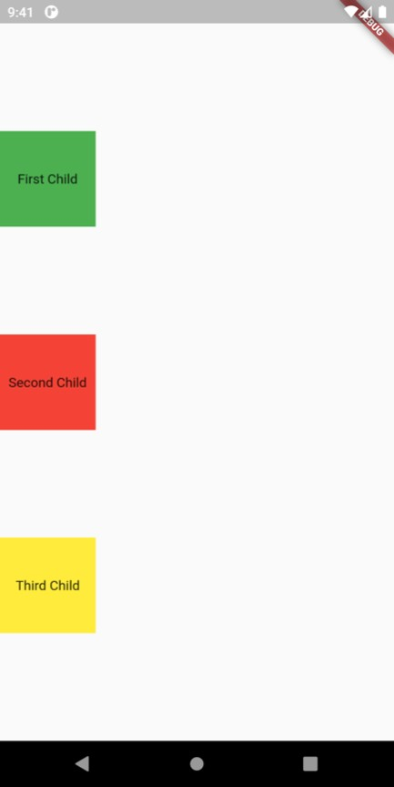

# DIAGONAL:

import 'package:flutter/material.dart';

void main() { runApp(MaterialApp(

),

)); }

}

debugShowCheckedModeBanner: false, home:SafeArea(

child:ColumnApp(),

class ColumnApp extends StatefulWidget {

const ColumnApp({Key? key}) : super(key: key); @override

_ColumnAppState createState() => _ColumnAppState(); class _ColumnAppState extends State<ColumnApp> {

@override

Widget build(BuildContext context) { return Scaffold(

body:Row(

mainAxisAlignment: MainAxisAlignment.spaceBetween,

children:[ Column(

mainAxisAlignment: MainAxisAlignment.start, children:[Container(

height: 100,

width: 100, color: Colors.red, child: Center(

child: Text( "First Child"

),

), ), ], ),

), ), ),

], ),

),

),

),

],

),

],

),

);

}

}

