PASSWORD STRENGTH ANALYZER
Project Report
Submitted in Partial Fulfillment of the Requirements for the
Ethical Hacking & Cybersecurity Internship
Conducted by
VaultofCodes

Submitted By
Name: Thonduru Premsai
College: Akshaya College Of Engineering and Technology
Department: Computer Science and Engineering
Academic Year: 2026

Submission Date: ___________

ACKNOWLEDGEMENT
I would like to express my sincere gratitude to VaultofCodes for providing me with the opportunity to participate in the Ethical Hacking & Cybersecurity Internship. This internship has given me practical exposure to cybersecurity concepts and has enhanced my understanding of secure software development.
I extend my heartfelt thanks to my mentors and instructors for their valuable guidance, continuous encouragement, and constructive feedback throughout the project. Their support motivated me to successfully complete the Password Strength Analyzer project.
I also express my gratitude to my college for providing the necessary learning environment and technical resources that helped me complete this project efficiently.
Finally, I would like to thank my parents, family members, and friends for their constant encouragement, motivation, and support throughout the internship. Their confidence in me played an important role in the successful completion of this project.

ABSTRACT
Passwords remain one of the most widely used methods for protecting digital accounts and sensitive information. Despite advancements in authentication technologies, weak passwords continue to be one of the leading causes of unauthorized access and cyberattacks. Many users still create passwords that are short, predictable, or based on common words and number sequences, making them vulnerable to brute-force and dictionary attacks.
The Password Strength Analyzer is a Python-based cybersecurity tool developed to evaluate the security level of user passwords. The application examines multiple password characteristics, including length, uppercase letters, lowercase letters, numeric digits, special characters, common weak passwords, sequential patterns, and repeated characters. Based on these security checks, the application calculates a score and classifies the password as Weak, Medium, or Strong.
In addition to evaluating password strength, the application provides meaningful recommendations that help users improve password security by following best practices. This project demonstrates the practical application of Python programming in cybersecurity and highlights the importance of strong password policies in protecting personal and organizational data.
The project aims to increase cybersecurity awareness while providing users with a simple and effective tool for evaluating password quality before using it in online applications.

S.No | Contents | Page No.
1 | Introduction | 5
2 | Problem Statement | 7
3 | Objectives | 8
4 | Technologies Used | 10
5 | System Requirements | 13
6 | Project Methodology | 15
7 | Algorithm | 20
8 | Project Features | 22
9 | Results and Screenshots | 26
10 | Advantages | 30
11 | Limitations | 32
12 | Future Scope | 34
13 | Conclusion | 36
14 | References | 37

CHAPTER 1
INTRODUCTION
In today's digital world, cybersecurity has become one of the most important aspects of protecting personal, organizational, and financial information. Almost every online service, including banking applications, email accounts, social media platforms, cloud storage services, educational portals, and e-commerce websites, requires users to create passwords to protect their accounts. A password acts as the first layer of security between a user and unauthorized access.
Despite increasing awareness about cybersecurity, many users continue to create passwords that are simple, predictable, or easy to remember. Passwords such as 123456, password, qwerty, and combinations of personal information remain among the most commonly used passwords worldwide. Such passwords can be cracked easily using brute-force attacks, dictionary attacks, credential stuffing, or automated password-cracking tools. As a result, weak passwords remain one of the major causes of cyber incidents and data breaches.
A strong password significantly reduces the risk of unauthorized access. Security experts recommend creating passwords that are long, unique, and contain a combination of uppercase letters, lowercase letters, numbers, and special characters. Users should also avoid common words, predictable sequences, and repeated characters while creating passwords. Following these best practices makes passwords much more resistant to cyberattacks.
The Password Strength Analyzer was developed as a simple cybersecurity tool to help users evaluate the strength of their passwords before using them. The application analyzes several important security factors, including password length, uppercase letters, lowercase letters, numbers, special characters, commonly used weak passwords, repeated characters, and sequential patterns. Based on these checks, it assigns a security score and classifies the password as Weak, Medium, or Strong.
One of the important features of this application is that it not only evaluates the password but also provides meaningful suggestions to improve password quality. These suggestions guide users in creating stronger passwords that follow widely accepted cybersecurity best practices. As a result, users become more aware of secure password creation and can better protect their online accounts.
This project was developed using Python, a powerful and beginner-friendly programming language widely used in cybersecurity, automation, scripting, and data analysis. Python provides simple syntax, built-in functions, and excellent libraries, making it an ideal choice for developing security-related applications.
The Password Strength Analyzer demonstrates how basic cybersecurity concepts can be implemented through programming to solve real-world security problems. Although the application is simple, it effectively highlights the importance of password security and user awareness in protecting digital systems.
The primary objective of this project is to educate users about password security, encourage the creation of stronger passwords, and reduce the possibility of unauthorized access caused by weak authentication practices. The project also provides practical experience in Python programming while demonstrating the application of cybersecurity principles in software development.
Importance of Password Security
Passwords are one of the most commonly used authentication methods across digital platforms. Strong passwords help protect confidential information, prevent unauthorized access, and reduce the chances of cyberattacks. Poor password practices can lead to identity theft, financial losses, data breaches, and compromised user accounts.
The increasing number of cyberattacks around the world highlights the importance of educating users about password security. Even advanced security systems cannot provide complete protection if users continue to choose weak passwords. Therefore, password strength evaluation tools play an important role in improving cybersecurity awareness and encouraging secure password practices.

CHAPTER 2
PROBLEM STATEMENT
2.1 Problem Statement
In the modern digital era, passwords are the primary method of authentication for accessing online services such as banking applications, email accounts, educational portals, social networking platforms, and cloud storage systems. Although passwords are designed to protect sensitive information, many users continue to create weak and predictable passwords that can be easily guessed or cracked by attackers.
Common passwords such as 123456, password, qwerty, and passwords based on personal information are frequently used because they are easy to remember. Unfortunately, these passwords provide very little security and are highly vulnerable to cyberattacks. Attackers often use automated tools and techniques such as brute-force attacks, dictionary attacks, credential stuffing, and password spraying to gain unauthorized access to user accounts.
Many users are unaware of what makes a password secure. They often believe that adding a few numbers or symbols is sufficient, while ignoring other important factors such as password length, randomness, uniqueness, and the avoidance of common patterns. This lack of awareness significantly increases the risk of identity theft, financial fraud, data breaches, and unauthorized access.
Another major challenge is that users usually receive no immediate feedback regarding the strength of the passwords they create. Without proper guidance, they may continue using insecure passwords across multiple websites, making them vulnerable if one account is compromised.
To address this issue, a simple and effective password evaluation tool is required. Such a tool should analyze passwords based on established security standards, identify weaknesses, classify password strength, and provide practical recommendations for improvement. This approach helps users understand password security principles while encouraging them to create stronger and more secure passwords.
The Password Strength Analyzer was developed to solve this problem by automatically evaluating passwords using multiple security criteria and providing users with clear feedback and suggestions to improve password quality.
CHAPTER 3
OBJECTIVES
3.1 Objectives of the Project
The main objective of this project is to develop a simple and efficient application that evaluates the strength of user passwords using multiple security parameters and provides recommendations to improve password security.
The specific objectives of this project are:
- To analyze passwords based on length, uppercase letters, lowercase letters, numbers, and special characters.
- To identify commonly used weak passwords that are easily vulnerable to cyberattacks.
- To detect predictable sequential patterns such as 12345, abcd, and qwerty.
- To identify repeated characters that may reduce password strength.
- To classify passwords into Weak, Medium, or Strong categories based on the evaluation score.
- To provide clear and user-friendly suggestions for creating stronger passwords.
- To promote cybersecurity awareness by educating users about secure password creation practices.
- To demonstrate the practical application of Python programming in solving cybersecurity-related problems.
- To encourage users to adopt better password management habits and improve the security of their online accounts.

3.2 Scope of the Project
The Password Strength Analyzer is designed as a lightweight educational cybersecurity tool that evaluates password strength based on predefined security rules. The project focuses on local password analysis without storing or transmitting user passwords, thereby maintaining user privacy.
The application is suitable for students, beginners in cybersecurity, and individuals who wish to verify the strength of their passwords before using them in real-world applications. Although the project does not replace enterprise-level password management systems, it provides a practical demonstration of password evaluation techniques and cybersecurity best practices.
project can also serve as a foundation for future enhancements, including graphical user interfaces, password generation features, integration with breached password databases, and advanced password entropy analysis.

CHAPTER 4
TECHNOLOGIES USED
4.1 Python Programming Language
Python is a high-level, interpreted, and object-oriented programming language that is widely used in software development, cybersecurity, artificial intelligence, automation, and data science. It is known for its simple syntax, readability, and extensive library support, making it one of the most popular programming languages among beginners and professionals.
In this project, Python was used to implement all password validation logic. The application checks password length, uppercase letters, lowercase letters, numbers, special characters, repeated characters, and common weak password patterns. Python's built-in functions made it possible to implement these security checks efficiently without requiring external libraries.
Advantages of Python
- Simple and easy-to-understand syntax
- Fast application development
- Cross-platform compatibility
- Large community support
- Rich collection of built-in functions
- Suitable for cybersecurity and automation projects
4.2 Visual Studio Code (VS Code)
Visual Studio Code is a lightweight and powerful source-code editor developed by Microsoft. It supports multiple programming languages and provides various features that improve coding productivity.
For this project, VS Code was used to write, edit, debug, and execute the Python program. Its integrated terminal and syntax highlighting features simplified project development.

Features of VS Code
- Intelligent code completion
- Integrated terminal
- Syntax highlighting
- Error detection
- Extension support
- Git integration
4.3 GitHub
GitHub is a cloud-based platform used for version control and project hosting. It allows developers to store, manage, and share their source code.
In this project, GitHub is used to upload the source code, README file, screenshots, and project documentation. It also helps maintain version history and makes the project accessible online.
Benefits of GitHub
- Version control
- Project backup
- Easy collaboration
- Professional project portfolio
- Public code sharing
4.4 Markdown
Markdown is a lightweight markup language used to create formatted documentation.
The README.md file of this project is written using Markdown. GitHub automatically converts Markdown into a well-structured project documentation page.

Uses of Markdown
- Project documentation
- Headings and formatting
- Bullet points
- Tables
- Hyperlinks
- Images

CHAPTER 5
SYSTEM REQUIREMENTS
5.1 Hardware Requirements
Component | Requirement
Processor | Intel Core i3 or above
RAM | Minimum 4 GB
Storage | 200 MB Free Space
Display | 1366 × 768 Resolution
Keyboard | Standard Keyboard

5.2 Software Requirements
Software | Version
Operating System | Windows 10 / Windows 11
Python | Python 3.10 or Above
Visual Studio Code | Latest Version
Git | Latest Version
GitHub | Web Platform

5.3 Functional Requirements
The application should be able to:
- Accept password input from the user.
- Verify password length.
- Check uppercase letters.
- Check lowercase letters.
- Detect numeric digits.
- Detect special characters.
- Identify common weak passwords.
- Detect sequential character patterns.
- Detect repeated characters.
- Calculate password strength score.
- Classify password strength.
- Display suggestions for improvement.

5.4 Non-Functional Requirements
The application should satisfy the following quality requirements:
- Fast execution
- Easy to use
- User-friendly interface
- Reliable password analysis
- Secure local execution
- Lightweight implementation
- Easy maintenance
- High readability of source code

CHAPTER 6
PROJECT METHODOLOGY
6.1 Overview
The Password Strength Analyzer was developed using a systematic methodology to ensure that the application performs password analysis accurately and efficiently. The development process involved identifying the problem, designing the solution, implementing the program in Python, testing the application with different passwords, and verifying the results.
The methodology focuses on analyzing the password using predefined security rules rather than storing or transmitting user data. This ensures that the application is lightweight, secure, and suitable for educational purposes.
The project follows a sequential process where each password is evaluated against multiple security criteria. Based on the evaluation, the program calculates a score, determines the password strength, and provides appropriate recommendations for improvement.

6.2 Development Methodology
The development of this project follows the following phases:
Phase 1 – Requirement Analysis
In this phase, the security requirements of a strong password were studied. Different password policies followed by organizations and cybersecurity standards were analyzed to identify important password characteristics.
The following security parameters were selected:
- Password Length
- Uppercase Letters
- Lowercase Letters
- Numeric Digits
- Special Characters
- Common Weak Password Detection
- Sequential Pattern Detection
- Repeated Character Detection
These parameters formed the basis for password evaluation.

Phase 2 – System Design
During the design phase, the overall structure of the application was planned.
The application was designed to:
- Accept password input from the user.
- Perform individual security checks.
- Calculate a password score.
- Determine password strength.
- Display suggestions for improvement.
The design was kept simple so that the application remains easy to understand and maintain.

Phase 3 – Implementation
The implementation phase involved writing the Python program.
Python built-in functions such as:
- len()
- any()
- isdigit()
- isupper()
- islower()
were used to evaluate password characteristics efficiently.
Conditional statements and loops were used to implement the password validation logic.

Phase 4 – Testing
The application was tested using different categories of passwords.
Examples include:
Password | Expected Result
12345 | Weak
password | Weak
Prem123 | Medium
Prem@12345 | Strong
Admin123 | Medium
Welcome@2026 | Strong
The testing process confirmed that the application correctly classified passwords based on the implemented security rules.

Phase 5 – Result Analysis
After testing, the output generated by the application was analyzed.
The application successfully:
- Evaluated password strength.
- Detected weak passwords.
- Identified common patterns.
- Generated improvement suggestions.
- Displayed password strength clearly.
The results demonstrated that the application works as expected for different password combinations.

6.3 Workflow of the Project
The working process of the application can be summarized as follows:
- Start the application.
- Accept password input.
- Check password length.
- Verify uppercase letters.
- Verify lowercase letters.
- Verify numeric digits.
- Verify special characters.
- Detect weak passwords.
- Detect sequential patterns.
- Detect repeated characters.
- Calculate the password score.
- Determine password strength.
- Display suggestions.
- End the program.

6.4 Workflow Diagram

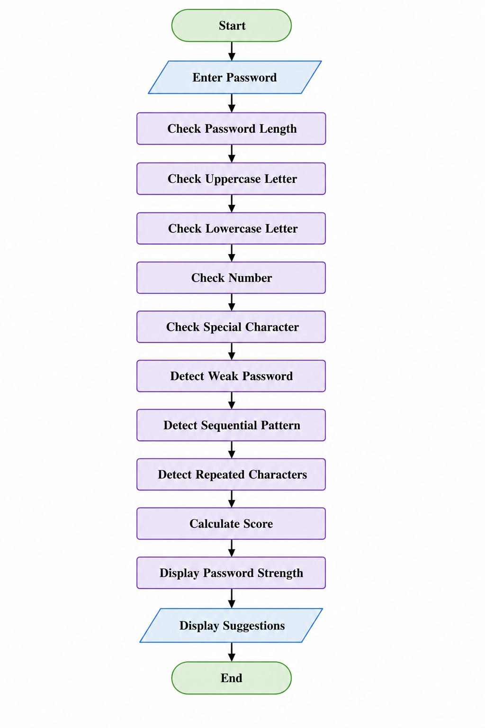

CHAPTER 7
ALGORITHM
7.1 Overview
An algorithm is a step-by-step procedure used to solve a problem or perform a specific task. The Password Strength Analyzer follows a simple and systematic algorithm to evaluate the strength of a password. It checks multiple security parameters and assigns a score based on the results. Finally, it classifies the password as Weak, Medium, or Strong and provides suggestions to improve password security.
The algorithm is designed to be efficient, easy to understand, and suitable for educational as well as practical cybersecurity applications.
7.2 Algorithm Steps
Step 1: Start the program.
Step 2: Display the title of the Password Strength Analyzer.
Step 3: Accept a password from the user.
Step 4: Initialize the password score to zero.
Step 5: Check whether the password length is at least 8 characters.
- If the condition is satisfied, increment the score by one.
Step 6: Check whether the password contains at least one uppercase letter.
- If present, increment the score by one.
Step 7: Check whether the password contains at least one lowercase letter.
- If present, increment the score by one.
Step 8: Check whether the password contains at least one numeric digit.
- If present, increment the score by one.
Step 9: Check whether the password contains at least one special character.
- If present, increment the score by one.
Step 10: Compare the password with the predefined list of common weak passwords.
- If a match is found, reduce or reset the score.
Step 11: Detect sequential patterns such as 12345, abcd, and qwerty.
- If detected, reduce the score.
Step 12: Detect repeated consecutive characters.
- If detected, reduce the score.
Step 13: Calculate the final password score.
Step 14: Classify the password into one of the following categories:
- Weak
- Medium
- Strong
Step 15: Display the password analysis summary and suggestions.
Step 16: End the program.

7.3 Algorithm Flow
The algorithm performs password evaluation sequentially by validating each security rule. Every successful validation increases the password score, while insecure patterns reduce the score. After evaluating all conditions, the application determines the final password strength and generates appropriate recommendations for the user.
This approach ensures that password analysis is accurate, consistent, and easy to understand.

CHAPTER 8
PROJECT FEATURES
8.1 Overview
The Password Strength Analyzer is designed to evaluate the security level of user passwords by performing multiple validation checks. The application analyzes different characteristics of a password and provides an overall strength rating along with suggestions to help users create stronger and more secure passwords. The implemented features improve password security awareness and encourage users to follow best practices while creating passwords.
8.2 Password Length Validation
The application verifies whether the entered password contains at least eight characters. Password length is one of the most important factors in determining password strength because longer passwords are generally more resistant to brute-force attacks.
8.3 Uppercase Letter Detection
The analyzer checks whether the password contains at least one uppercase letter (A–Z). Including uppercase letters increases password complexity and makes passwords more difficult to guess.
8.4 Lowercase Letter Detection
The application verifies the presence of lowercase letters (a–z). Combining uppercase and lowercase letters improves password diversity and enhances security.
8.5 Numeric Character Detection
The Password Strength Analyzer checks whether the password contains one or more numeric digits (0–9). Numbers increase password complexity and reduce the chances of successful password guessing.

8.6 Special Character Detection
The application verifies whether the password contains special characters such as:
! @ # $ % ^ & * ( ) _ + - = { } [ ] | : ; < > , . ? /
The inclusion of special characters significantly improves password strength and increases resistance against password-cracking attacks.
8.7 Weak Password Detection
The analyzer compares the entered password with a predefined list of commonly used weak passwords such as:
- password
- password123
- 123456
- admin
- qwerty
- abc123
If a match is found, the application immediately warns the user and decreases the password score.
8.8 Sequential Pattern Detection
The application detects predictable sequences that are commonly used in weak passwords.
Examples include:
- 12345
- 123456
- abc
- abcd
- qwerty
These predictable patterns make passwords vulnerable to dictionary and brute-force attacks. Therefore, the application reduces the password score whenever such patterns are detected.
8.9 Repeated Character Detection
The application checks whether the password contains repeated consecutive characters such as:
- aaa
- 111
- @@@
Repeated characters reduce password randomness and make passwords easier to predict. The analyzer generates a warning if repeated characters are found.
8.10 Password Strength Classification
After completing all validation checks, the application calculates the final score and classifies the password into one of the following categories:
Score | Password Strength
0 – 2 | Weak
3 – 4 | Medium
5 | Strong
This classification enables users to quickly understand the quality of their passwords.
8.11 Password Analysis Summary
Once the evaluation is complete, the application displays a detailed summary containing:
- Password Length
- Uppercase Letter Status
- Lowercase Letter Status
- Number Availability
- Special Character Availability
- Final Password Score
- Password Strength Level
This summary provides users with a clear understanding of how their password was evaluated.
8.12 Password Improvement Suggestions
Based on the evaluation results, the application provides personalized suggestions to improve password quality.
Examples include:
- Use a password with at least eight characters.
- Include uppercase and lowercase letters.
- Add numeric digits.
- Use special characters.
- Avoid common passwords.
- Avoid sequential patterns.
- Avoid repeated characters.
These recommendations help users create stronger passwords and improve their cybersecurity practices.
8.13 User-Friendly Interface
The Password Strength Analyzer uses a simple command-line interface that is easy to understand and operate. Users only need to enter a password, and the application automatically performs all security checks before displaying the results in a structured format.
The simple interface makes the application suitable for students, beginners, and anyone interested in learning about password security.

CHAPTER 9
RESULTS AND SCREENSHOTS
9.1 Overview
The Password Strength Analyzer was successfully developed and tested using Python. The application evaluated passwords based on multiple security parameters, including password length, uppercase letters, lowercase letters, numbers, special characters, common weak passwords, sequential patterns, and repeated characters.
The testing results confirmed that the application correctly classified passwords into Weak, Medium, and Strong categories while providing appropriate suggestions to improve password security.
The following screenshots demonstrate the successful execution of the project under different test cases.
9.2 Output Screenshots
Figure 9.1 – Weak Password Analysis
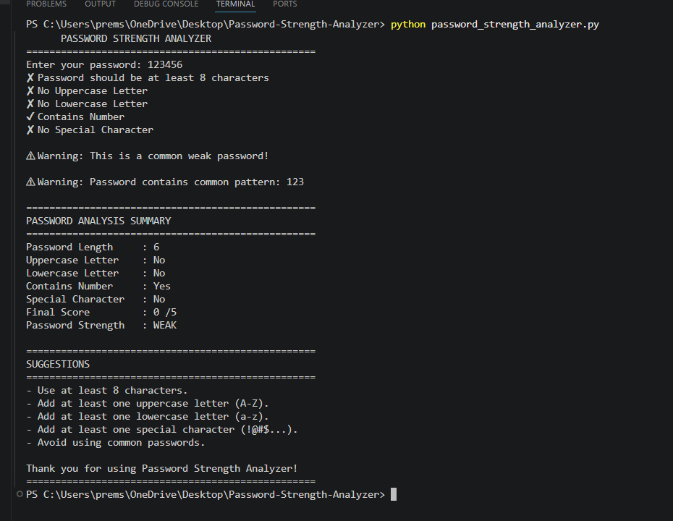
Description:
This output demonstrates the analysis of a weak password. The application identifies missing security requirements such as insufficient length, absence of uppercase and lowercase letters, lack of special characters, and provides suggestions to improve the password.

Figure 9.2 – Medium Password Analysis
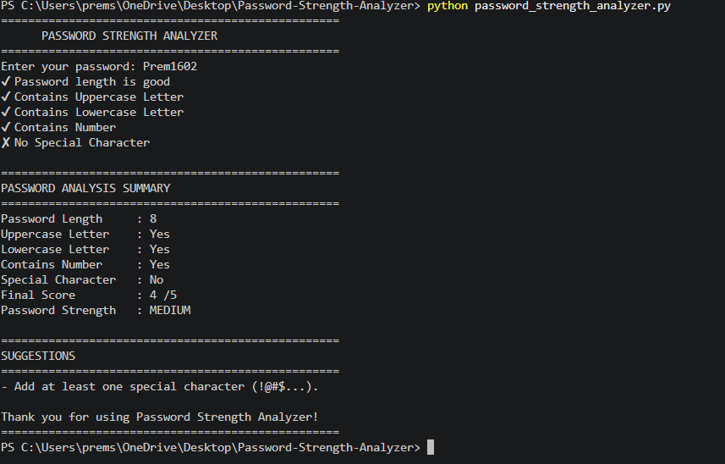
Description:
The application identifies that the password satisfies some security requirements but still lacks one or more important characteristics. The password is classified as Medium, and appropriate recommendations are displayed.
Figure 9.3 – Strong Password Analysis
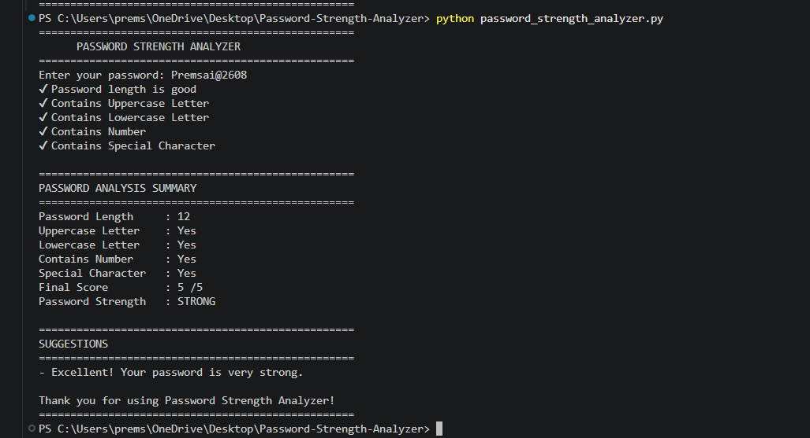
Description:
The password satisfies all required security conditions, including length, uppercase letters, lowercase letters, numbers, and special characters. The application classifies it as Strong and confirms that it is a secure password.

Figure 9.4 – Sequential Pattern Detection
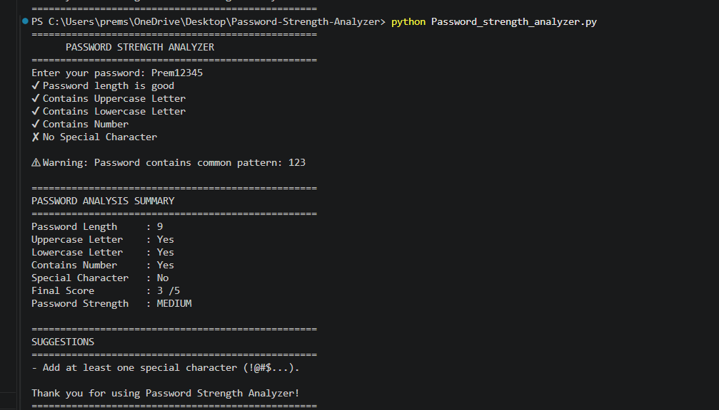

Description:
The application successfully detects predictable sequential patterns within the password and warns the user because such patterns are vulnerable to password-cracking attacks.
Figure 9.5 – Repeated Character Detection
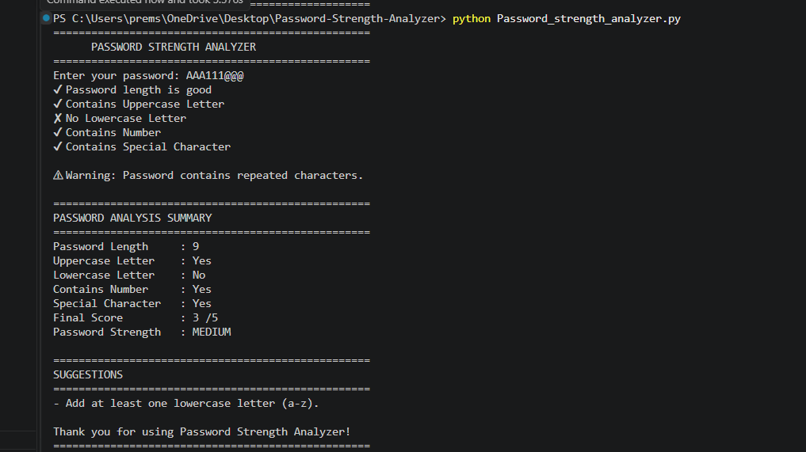
Description:
The analyzer detects repeated consecutive characters and informs the user that repeated patterns reduce password strength and should be avoided.
9.3 Testing Summary
The application was tested using different categories of passwords to verify its functionality. The results are summarized below.
Test Case | Example Password | Result
Weak Password | 1234 | Weak
Medium Password | Prem123 | Medium
Strong Password | Premsai@2608 | Strong
Common Password | password123 | Weak
Sequential Pattern | Prem12345 | Medium
Repeated Characters | AAA111@@@ | Medium

9.4 Result Analysis
The testing results demonstrate that the Password Strength Analyzer performs accurately by evaluating passwords based on multiple security parameters. The application successfully identifies weak passwords, detects common attack patterns, calculates the appropriate score, and provides meaningful recommendations for improving password security.
Overall, the project achieved its objective of helping users understand password security and encouraging the use of stronger passwords to protect digital accounts.

CHAPTER 10
ADVANTAGES
10.1 Overview
The Password Strength Analyzer provides several advantages by helping users evaluate and improve the security of their passwords. It is designed to be simple, efficient, and educational, making it suitable for students, beginners, and anyone interested in cybersecurity. The application encourages users to follow password security best practices and reduces the risk of using weak passwords.
10.2 Advantages of the Project
1. Enhances Password Security
The application helps users create stronger passwords by checking essential security parameters such as length, uppercase letters, lowercase letters, numbers, and special characters. This reduces the possibility of unauthorized access.
2. Detects Weak Passwords
The analyzer identifies commonly used weak passwords such as password, 123456, admin, and qwerty. Users receive immediate warnings, preventing the use of easily guessable passwords.
3. Detects Predictable Patterns
The application identifies sequential patterns such as 12345, abcd, and qwerty, as well as repeated consecutive characters. Detecting these patterns helps users avoid passwords that are vulnerable to password-cracking techniques.
4. Provides Instant Feedback
Users receive immediate analysis after entering a password. The application displays the password score, strength level, and detailed suggestions for improvement without any delay.
5. Easy to Use
The Password Strength Analyzer has a simple command-line interface that requires minimal technical knowledge. Users only need to enter a password, and the application automatically performs all security checks.
6. Improves Cybersecurity Awareness
The project educates users about the importance of creating secure passwords and explains the characteristics of strong passwords. It promotes good cybersecurity practices among students and general users.
7. Lightweight and Fast
The application is lightweight and requires very few system resources. Since it is developed using Python and performs local processing, password analysis is completed within a fraction of a second.
8. Privacy Protection
The application does not store, transmit, or share user passwords. All password analysis is performed locally on the user's computer, ensuring privacy and security.
9. Easy to Maintain
The source code is simple, well-organized, and easy to understand. Future developers can easily modify or extend the application by adding new password validation techniques.
10. Suitable for Educational Purposes
The project serves as an excellent learning tool for students studying Python programming, cybersecurity, and secure software development. It demonstrates how programming concepts can be applied to solve real-world security problems.

10.3 Summary
The Password Strength Analyzer successfully improves password security awareness by helping users identify weak passwords and encouraging them to create stronger and more secure passwords. Its simplicity, accuracy, and ease of use make it a valuable educational cybersecurity application.

CHAPTER 11
LIMITATIONS
11.1 Overview
Although the Password Strength Analyzer successfully evaluates password strength based on predefined security rules, it has certain limitations. The application is developed for educational purposes and demonstrates the basic concepts of password security. It does not include advanced security features available in enterprise-level password management systems.
11.2 Limitations of the Project
1. Rule-Based Evaluation
The application evaluates passwords using predefined rules such as length, uppercase letters, lowercase letters, numbers, and special characters. It does not calculate advanced password entropy or use artificial intelligence to assess password strength.
2. Limited Weak Password Database
The analyzer compares passwords with a small predefined list of common weak passwords. It does not use large online databases containing millions of leaked or compromised passwords.
3. Command-Line Interface
The project uses a command-line interface (CLI), which is simple but less user-friendly compared to modern graphical user interfaces (GUI) or web-based applications.
4. Offline Operation Only
The application runs locally on the user's computer and does not connect to the internet. As a result, it cannot verify whether a password has appeared in previous public data breaches.
5. English Character Support
The current version is designed to evaluate passwords containing English letters, numbers, and common special characters. It does not specifically support passwords created using multiple languages or Unicode characters.
6. No Password Generator
The application analyzes passwords entered by the user but does not automatically generate strong and secure passwords.
7. No Password Storage or Management
The project does not provide features such as secure password storage, password encryption, password synchronization, or password management. Its primary purpose is password strength evaluation.
8. Limited Security Checks
Although the analyzer performs several important validations, it does not evaluate advanced security factors such as password entropy, keyboard patterns, similarity with usernames, or contextual information.
11.3 Summary
Despite these limitations, the Password Strength Analyzer effectively demonstrates the fundamental concepts of password security and provides meaningful guidance for creating stronger passwords. It serves as a solid foundation for learning cybersecurity concepts and can be enhanced with more advanced features in future versions.

CHAPTER 12
FUTURE SCOPE
12.1 Overview
The current version of the Password Strength Analyzer successfully evaluates password strength using predefined security rules and provides useful suggestions to improve password quality. Although the application fulfills its intended objectives, there is significant scope for future enhancements. By integrating advanced cybersecurity techniques and modern technologies, the application can become more intelligent, user-friendly, and suitable for real-world security applications.
12.2 Future Enhancements
1. Graphical User Interface (GUI)
The current application uses a command-line interface. In the future, it can be upgraded with a graphical user interface using Python libraries such as Tkinter or PyQt, making the application more attractive and easier for users to interact with.
2. Strong Password Generator
A password generator can be integrated into the application to automatically create strong, random, and secure passwords. This feature will help users generate passwords that follow recommended cybersecurity standards.
3. Password Breach Detection
The application can be enhanced by checking whether a password has appeared in publicly available data breaches. This would help users avoid passwords that have already been exposed and improve overall account security.
4. Password Strength Meter
A visual password strength meter can be added to display the strength of the password in real time using color indicators such as Red (Weak), Yellow (Medium), and Green (Strong). This will improve the overall user experience.

5. Advanced Security Analysis
Future versions can include additional security checks such as password entropy calculation, keyboard pattern detection, dictionary word detection, and similarity analysis with usernames or personal information. These features will provide a more accurate evaluation of password strength.
6. Multi-Language Support
The application can be extended to support passwords containing Unicode and multilingual characters. This enhancement will make the tool more accessible to users from different regions and language backgrounds.
7. Web-Based Application
The Password Strength Analyzer can be converted into a web application using frameworks such as Flask or Django. This will allow users to access the application through a web browser without installing Python on their systems.
8. Mobile Application
A mobile version of the application can be developed for Android and iOS devices, enabling users to check password strength conveniently from their smartphones.
9. Integration with Authentication Systems
The application can be integrated into user registration and login systems to enforce strong password policies automatically. This enhancement will help organizations improve account security by preventing weak passwords during account creation.

12.3 Summary
The Password Strength Analyzer has the potential to evolve into a comprehensive password security solution by incorporating advanced features and modern technologies. Future enhancements such as graphical interfaces, password generation, breach detection, and web or mobile deployment will significantly improve its usability and effectiveness. These improvements will make the application more practical for real-world cybersecurity environments while continuing to promote secure password practices.
CHAPTER 13
CONCLUSION
13.1 Conclusion
The Password Strength Analyzer project was successfully designed, developed, and tested using Python. The primary objective of this project was to analyze the strength of user passwords based on essential cybersecurity principles and encourage users to create stronger and more secure passwords.
The application evaluates passwords using multiple security parameters, including password length, uppercase letters, lowercase letters, numeric digits, special characters, common weak passwords, sequential patterns, and repeated characters. Based on these evaluations, the program calculates a password score, classifies the password as Weak, Medium, or Strong, and provides meaningful suggestions to improve password quality.
Throughout the development process, the project demonstrated the practical application of Python programming in solving a real-world cybersecurity problem. The implementation helped in understanding important concepts such as password validation, secure authentication practices, user awareness, and basic software development methodologies.
The testing results confirmed that the application performs accurately and consistently across different password combinations. It successfully identifies weak passwords, detects insecure patterns, and encourages users to follow recommended password creation guidelines. Since all password analysis is performed locally, user privacy is also maintained.
This project has significantly improved my understanding of cybersecurity concepts, secure password policies, and Python programming. It has also strengthened my problem-solving skills and provided valuable practical experience in developing a security-focused application.
In conclusion, the Password Strength Analyzer is a simple, reliable, and effective educational tool that promotes good password practices and contributes to improving cybersecurity awareness. With additional enhancements such as graphical interfaces, password generation, and advanced security analysis, the application can be further developed into a more comprehensive password security solution.
CHAPTER 14
REFERENCES
- Python Software Foundation. Python Documentation. Available at: https://docs.python.org/3/
- Microsoft. Visual Studio Code Documentation. Available at: https://code.visualstudio.com/docs
- GitHub. GitHub Documentation. Available at: https://docs.github.com/
- National Institute of Standards and Technology (NIST). Digital Identity Guidelines (Special Publication 800-63B). Available at: https://pages.nist.gov/800-63-3/
- OWASP Foundation. Authentication Cheat Sheet. Available at: https://cheatsheetseries.owasp.org/cheatsheets/Authentication_Cheat_Sheet.html
- OWASP Foundation. Password Storage Cheat Sheet. Available at: https://cheatsheetseries.owasp.org/cheatsheets/Password_Storage_Cheat_Sheet.html
- Cybersecurity and Infrastructure Security Agency (CISA). Cybersecurity Best Practices. Available at: https://www.cisa.gov/
- Python Standard Library Documentation. Available at: https://docs.python.org/3/library/
- Course materials, programming practice, and cybersecurity concepts learned during the VaultofCodes Ethical Hacking & Cybersecurity Internship.

