**Graded Assignment on Monitoring, Scaling and Automation**

Using boto3 to create an S3 bucket to store your web application's static files.

import boto3

import os

# Initialize the S3 client

s3_client = boto3.client('s3')

# Define the bucket nameclear

bucket_name = 'prem-s3-static-bucket'

# Specify the region for the bucket

region = 'us-west-2' # Replace with your desired region

# Create the S3 bucket with region specified

s3_client.create_bucket(Bucket=bucket_name, CreateBucketConfiguration={'LocationConstraint': region})

print(f'S3 bucket "{bucket_name}" created successfully in region "{region}"!')

# Specify the directory containing static files

static_files_directory = '/Users/pkumar23/prem4eru/Monitorning_Scaling_Automation/staticwebpage'

# Initialize the S3 resource

s3_resource = boto3.resource('s3')

# Upload static files to S3 bucket

for file_name in os.listdir(static_files_directory):

file_path = os.path.join(static_files_directory, file_name)

with open(file_path, 'rb') as file:

s3_client.upload_fileobj(file, bucket_name, file_name)

print(f"Uploaded '{file_name}' to S3 bucket '{bucket_name}'.")

print("Static files uploaded successfully.")

Output shows bucket created successfully and files uploaded to buckets.

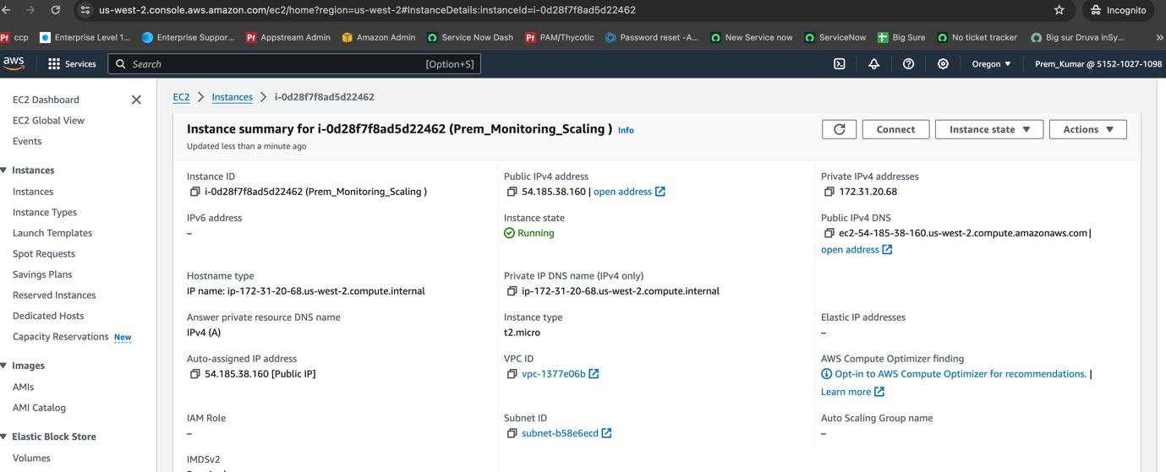

We have created the Ec2 instance and installed the Nginx on Ec2 instance , Nginx server is on running state and able to deploy the static websites. It shows the output below Nginx server is running and able to access the static websites using the public IP of Ec2 server.

Using boto3 creating the Application Load balancer and registering the Ec2 instance with ALB.

import boto3

# Initialize the EC2 client

ec2_client = boto3.client('ec2')

# Create VPC

vpc_response = ec2_client.create_vpc(CidrBlock='172.31.0.0/16')

vpc_id = vpc_response['Vpc']['VpcId']

# Initialize the ELBv2 client

elbv2_client = boto3.client('elbv2')

# Create Subnets

subnet_response = ec2_client.create_subnet(VpcId=vpc_id, CidrBlock='172.31.16.0/20', AvailabilityZone='us-west-2b')

subnet_id = subnet_response['Subnet']['SubnetId']

subnet_response = ec2_client.create_subnet(VpcId=vpc_id, CidrBlock='172.31.48.0/20', AvailabilityZone='us-west-2a')

subnet_id = subnet_response['Subnet']['SubnetId']

# Create Security Group

security_group_response = ec2_client.create_security_group(GroupName='ALBSecurityGroup', Description='ALB Security Group', VpcId=vpc_id)

security_group_id = security_group_response['GroupId']

# Authorize Security Group Ingress (e.g., allow HTTP traffic)

ec2_client.authorize_security_group_ingress(

GroupId=security_group_id,

IpPermissions=[

{'IpProtocol': 'tcp',

'FromPort': 80,

'ToPort': 80,

'IpRanges': [{'CidrIp': '0.0.0.0/0'}]}

]

)

# Create Target Group

target_group_response = elbv2_client.create_target_group(

Name='MyTargetGroup',

Protocol='HTTP',

Port=80,

VpcId=vpc_id

)

target_group_arn = target_group_response['TargetGroups'][0]['TargetGroupArn']

# Create Application Load Balancer

load_balancer_response = elbv2_client.create_load_balancer(

Name='PremLoadBalancer',

Subnets=[subnet_id],

SecurityGroups=[security_group_id],

Scheme='internet-facing',

Tags=[{'Key': 'Name', 'Value': 'PremLoadBalancer'}],

Type='application'

)

load_balancer_arn = load_balancer_response['LoadBalancers'][0]['LoadBalancerArn']

print('Application Load Balancer deployed successfully!')

It shows that Able to deploy the Application Load balancer name : PremLoadBalancer.

Using the boto3 created an AGS and deployed Ec2 instance as template.

import boto3

# Initialize the Auto Scaling client

autoscaling_client = boto3.client('autoscaling')

# Define the EC2 instance ID

instance_id = 'i-0d28f7f8ad5d22462' # Replace with your EC2 instance ID

# Create a launch configuration

launch_config_response = autoscaling_client.create_launch_configuration(

LaunchConfigurationName='MyLaunchConfig',

ImageId='ami-0cf2b4e024cdb6960', # Replace with your AMI ID

InstanceType='t2.micro', # Replace with your desired instance type

KeyName='tm.pem', # Replace with your key pair name

SecurityGroups=['launch-wizard-57'], # Replace with your security group(s)

#UserData='your-user-data', # Replace with your user data script

InstanceMonitoring={'Enabled': True} # Enable detailed monitoring if needed

)

# Define the Auto Scaling Group parameters

desired_capacity = 1 # Set the desired capacity

min_size = 1 # Set the minimum size

max_size = 2 # Set the maximum size

# Create the Auto Scaling Group

asg_response = autoscaling_client.create_auto_scaling_group(

AutoScalingGroupName='PremMyAutoScalingGroup',

LaunchConfigurationName='MyLaunchConfig',

MinSize=min_size,

MaxSize=max_size,

DesiredCapacity=desired capacity,

AvailabilityZones=['us-west-2b'], # Replace with your desired AZ(s)

VPCZoneIdentifier='subnet-b58e6ecd', # Replace with your subnet ID(s)

Tags=[

{

'Key': 'Name',

'Value': 'MyASGInstance'

},

# Add more tags as needed

]

)

print('Auto Scaling Group created successfully!')

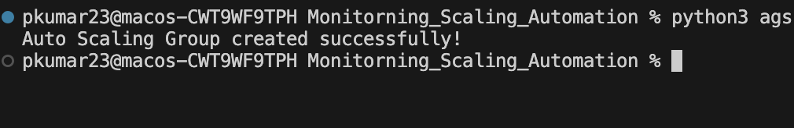

It shows that Autoscaling group has been deployed successfully and configured scaling policies to scale in/out based on metrics like CPU utilization or network traffic.

Setup different SNS topics for different alerts (e.g., health issues, scaling events, high traffic)

Infrastructure automation : using boto3 deployed the entire infrastructure and updated any component as required tear down the everything when application is no longer needed.

import boto3

import time

ec2_client = boto3.client('ec2')

s3_client = boto3.client('s3')

def create_infrastructure():

# Create VPC

vpc_response = ec2_client.create_vpc(

CidrBlock='172.31.0.0/16',

TagSpecifications=[

{

'ResourceType': 'vpc',

'Tags': [

{

'Key': 'Name',

'Value': 'MyVPC'

},

]

},

]

)

vpc_id = vpc_response['Vpc']['VpcId']

# Create Subnet

subnet_response = ec2_client.create_subnet(

AvailabilityZone='us-west-2b',

CidrBlock='172.31.16.0/20',

VpcId=vpc_id,

TagSpecifications=[

{

'ResourceType': 'subnet',

'Tags': [

{

'Key': 'Name',

'Value': 'MySubnet'

},

]

},

]

)

subnet_id = subnet_response['Subnet']['SubnetId']

# Create Security Group

security_group_response = ec2_client.create_security_group(

Description='MySecurityGroup',

GroupName='MySecurityGroup',

VpcId=vpc_id

)

security_group_id = security_group_response['GroupId']

# Add Inbound Rule to Security Group

ec2_client.authorize_security_group_ingress(

GroupId=security_group_id,

IpPermissions=[

{

'IpProtocol': 'tcp',

'FromPort': 22,

'ToPort': 22,

'IpRanges': [{'CidrIp': '0.0.0.0/0'}]

}

]

)

# Create EC2 Instance

instance_response = ec2_client.run_instances(

ImageId='ami-0cf2b4e024cdb6960', # Change to your desired AMI ID

InstanceType='t2.micro',

MinCount=1,

MaxCount=1,

KeyName='tm.pem', # Change to your key pair name

SecurityGroupIds=[security_group_id],

SubnetId=subnet_id

)

instance_id = instance_response['Instances'][0]['InstanceId']

# Create S3 Bucket

s3_client.create_bucket(

Bucket='my-unique-bucket-name',

CreateBucketConfiguration={

'LocationConstraint': 'us-east-1'

}

)

print("Infrastructure deployed successfully!")

return vpc_id, subnet_id, security_group_id, instance_id

def update_infrastructure(security_group_id):

# Update Inbound Rule to Security Group

ec2_client.authorize_security_group_ingress(

GroupId=security_group_id,

IpPermissions=[

{

'IpProtocol': 'tcp',

'FromPort': 80,

'ToPort': 80,

'IpRanges': [{'CidrIp': '0.0.0.0/0'}]

}

]

)

print("Security group updated successfully!")

def teardown_infrastructure(vpc_id, subnet_id, security_group_id, instance_id):

# Terminate EC2 Instance

ec2_client.terminate_instances(InstanceIds=[instance_id])

print("EC2 instance terminated successfully!")

# Delete Security Group

ec2_client.delete_security_group(GroupId=security_group_id)

print("Security group deleted successfully!")

# Delete Subnet

ec2_client.delete_subnet(SubnetId=subnet_id)

print("Subnet deleted successfully!")

# Delete VPC

ec2_client.delete_vpc(VpcId=vpc_id)

print("VPC deleted successfully!")

# Delete S3 Bucket

s3_client.delete_bucket(Bucket='my-unique-bucket-name')

print("S3 bucket deleted successfully!")

print("Infrastructure teardown completed!")

# Deploy infrastructure

vpc_id, subnet_id, security_group_id, instance_id = create_infrastructure()

# Wait for a few seconds for the resources to be ready

time.sleep(10)

# Update infrastructure

update_infrastructure(security_group_id)

# Wait for a few seconds for the update to take effect

time.sleep(10)

# Tear down infrastructure

teardown_infrastructure(vpc_id, subnet_id, security_group_id, instance_id)

it shows the below Output :

Infrastructure deployed successfully with all the component and teared down when application is no longer needed.

