**1.  
Read the file chal0**

**Server Details: ssh chal0@65.2.142.23  
Password: chal0**

cat chal0

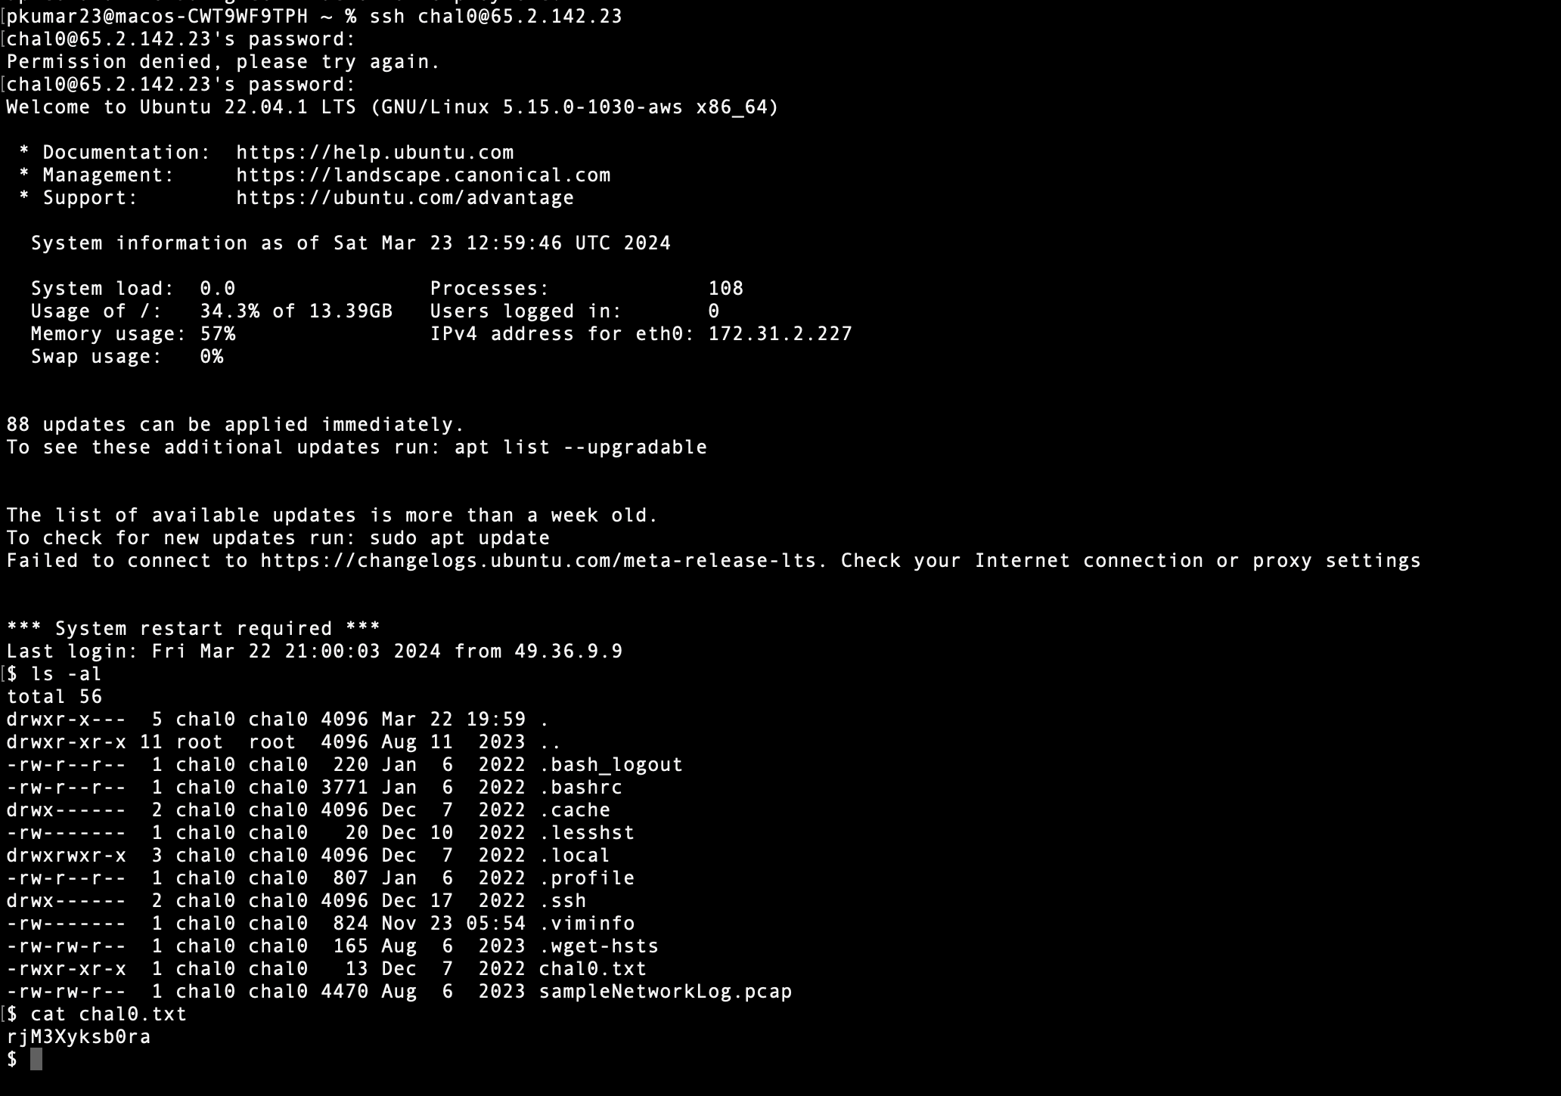

**2.**

**Joe likes to hide files, readme file is somewhere hidden**

**Login using: chal1@65.2.142.23  
Password: chal1**

mv readme.txt .readme.txt

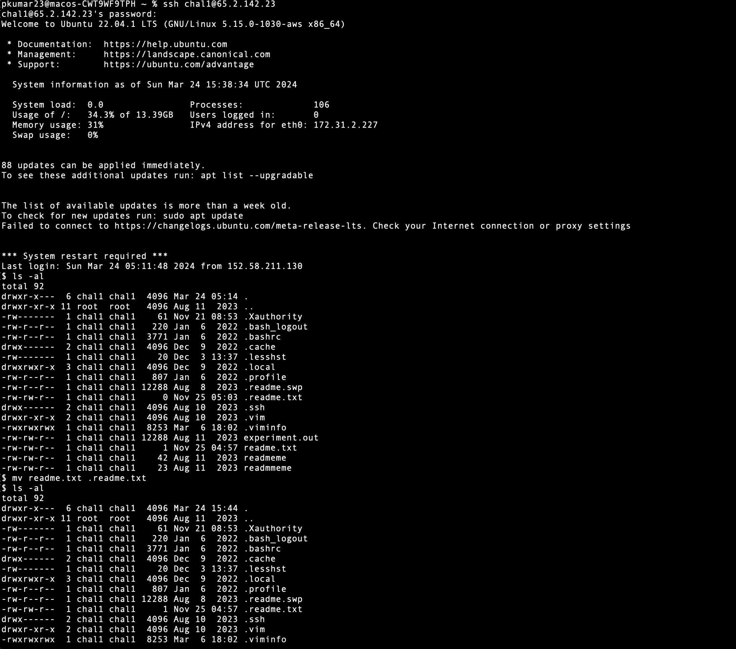

3.

**The file dump.txt contains a lot of lines which are repeated. You need to find out that line which is unique. This line will be your flag. In case you have multiple lines which have occurred just once, then try your luck!**

**Server Details: ssh chal2@65.2.142.23  
Password: chal2**

sort dump.txt | uniq -u

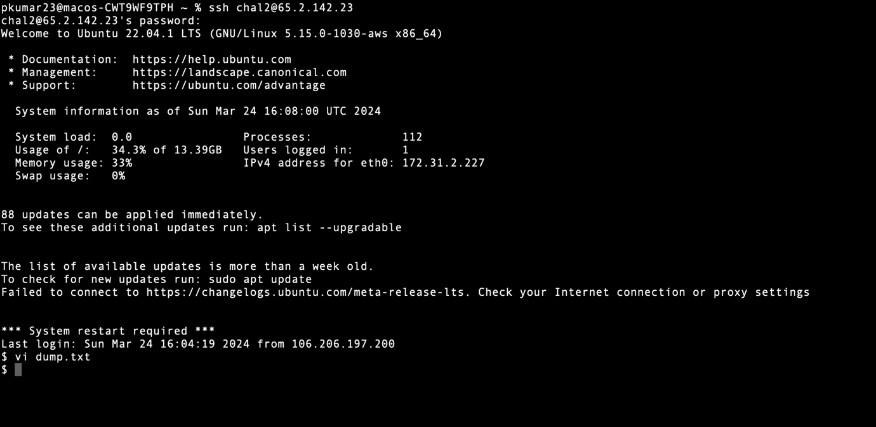

**4.**

**Read the content of the file -**

**Server Details: ssh chal4@65.2.142.23  
Password: chal4**

We can use the cat vi or nano commands to read the content of the file.

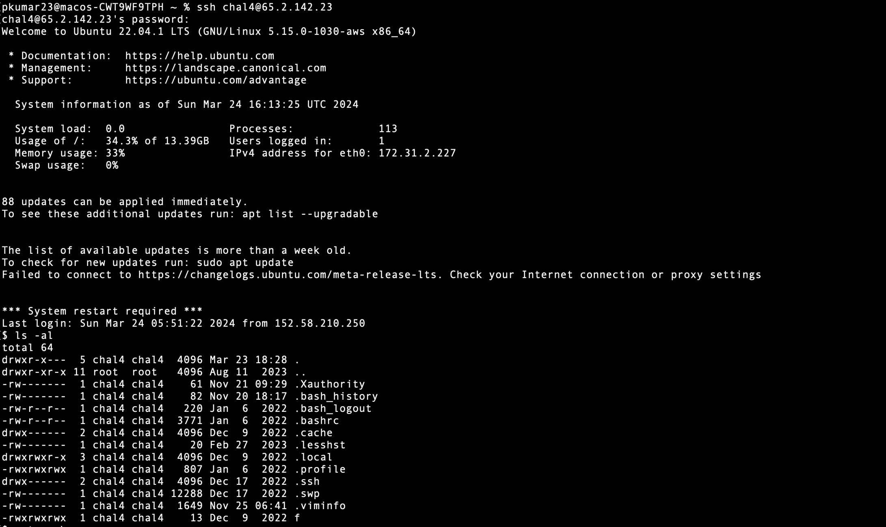

**5.**

**Find the lines that occurred exactly 11 times in the file masterdump.txt**

**Server Details: ssh chal3@65.2.142.23  
Password: chal3**

sort masterdump.txt | uniq -c | awk '$1 == 11 {print $0}'

