Name: Prem Kumar Yadav
Jaguar ID: J01280187
To run the program:
# Create virtual environment
python -m venv venv
# Activate virtual environment (on mac)
source venv/bin/activate
#Install the requirements
pip install -r requirements.txt
# Start Neo4j using Docker Compose
docker-compose up -d
# After 30s, Check if it's running
docker-compose ps
Then, Open browser and
http://localhost:7474
Login ID: neo4j
Password: password
Then run the command to get thw results:
python3 deadcode.py ./sample_code –output sample_code_results.txt

Cypher Queries
If output (Graph DB) does not appears color coded then run the below queries:
// Set GREEN for used functions
MATCH (n:CodeElement)
WHERE n.type = 'function' AND n.is_used = true
SET n:UsedFunction
REMOVE n:CodeElement;

// Set RED for dead functions
MATCH (n:CodeElement)
WHERE n.type = 'function' AND n.is_used = false
SET n:DeadFunction
REMOVE n:CodeElement;

// Set BLUE for used classes
MATCH (n:CodeElement)
WHERE n.type = 'class' AND n.is_used = true
SET n:UsedClass
REMOVE n:CodeElement;

// Set RED for dead classes
MATCH (n:CodeElement)
WHERE n.type = 'class' AND n.is_used = false
SET n:DeadClass
REMOVE n:CodeElement;

Then Use these Cypher Queries to view the results:
1. To view graph database of the sample code
MATCH (n) RETURN n LIMIT 100
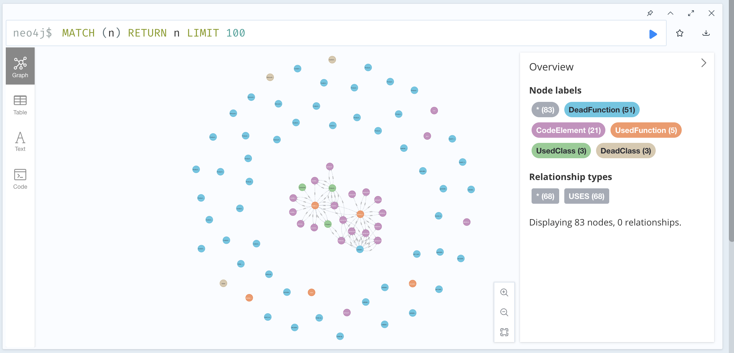
2. Get overall statistics of the codebase
MATCH (e:CodeElement)
RETURN
COUNT(e) as total_elements,
SUM(CASE WHEN e.is_used THEN 1 ELSE 0 END) as used_elements,
SUM(CASE WHEN e.is_used THEN 0 ELSE 1 END) as unused_elements,
ROUND(100.0 * SUM(CASE WHEN e.is_used THEN 0 ELSE 1 END) / COUNT(e), 2) as dead_code_percentage;
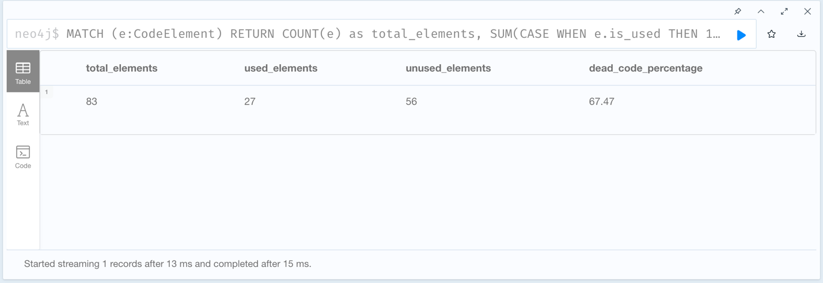

3. Break down statistics by functions, classes, imports
MATCH (e:CodeElement)
RETURN
e.type as element_type,
COUNT(e) as total,
SUM(CASE WHEN e.is_used THEN 1 ELSE 0 END) as used,
SUM(CASE WHEN e.is_used THEN 0 ELSE 1 END) as unused,
ROUND(100.0 * SUM(CASE WHEN e.is_used THEN 0 ELSE 1 END) / COUNT(e), 2) as unused_percentage
ORDER BY total DESC;
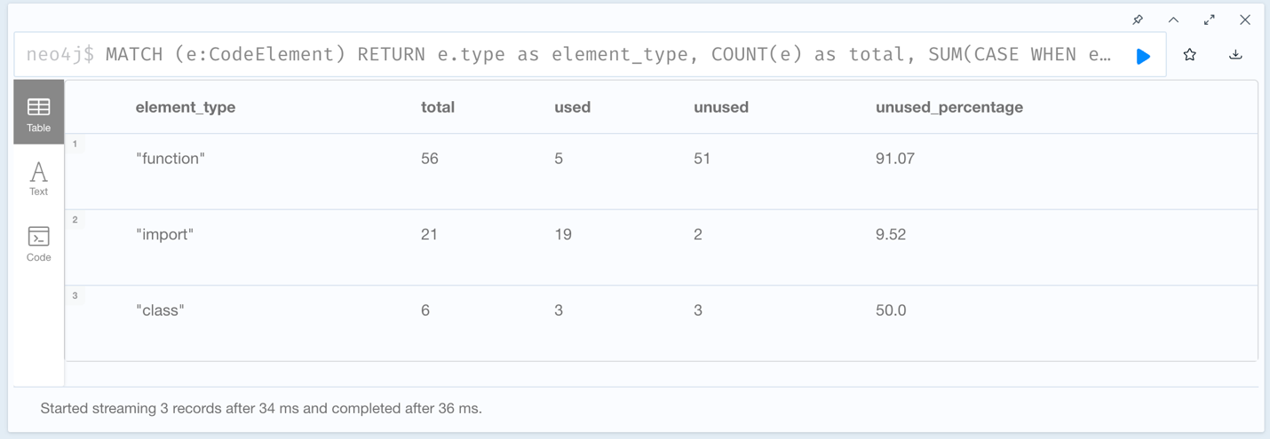

4. List all unused functions with their locations
MATCH (e:CodeElement)
WHERE e.is_used = false
AND e.type = 'function'
AND NOT e.name STARTS WITH '_'
AND NOT e.name IN ['main', '__init__']
RETURN
e.name as function_name,
e.file_path as file,
e.line_number as line
ORDER BY e.file_path, e.line_number;
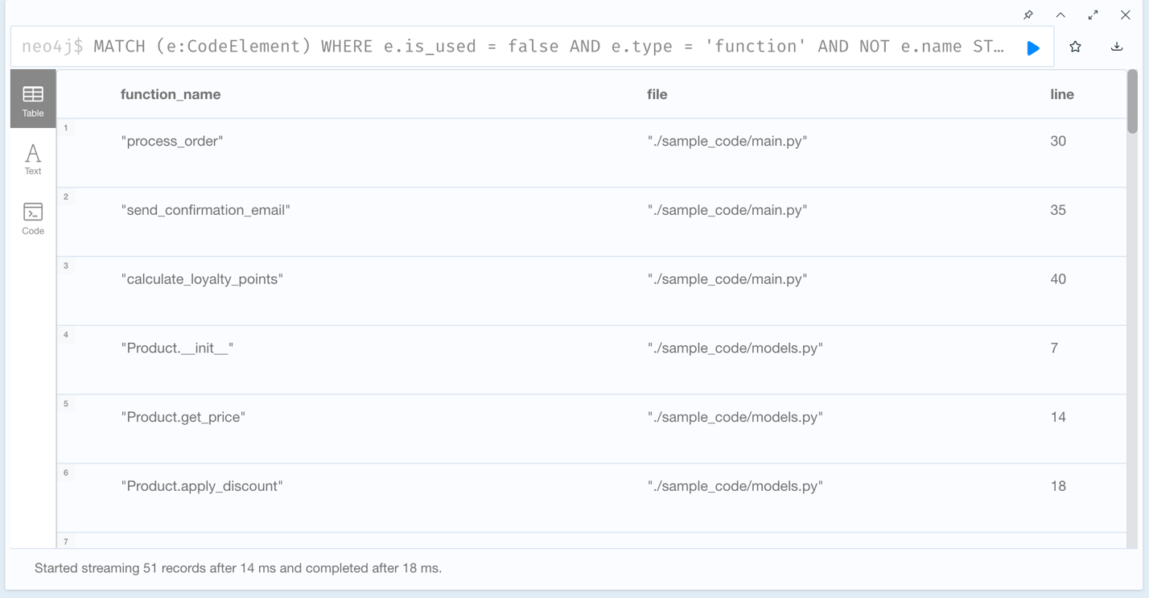
5. Show who uses what (for graph visualization)
MATCH (user:CodeElement)-[r:USES]->(used:CodeElement)
WHERE user.type IN ['function', 'class']
AND used.type IN ['function', 'class']
RETURN
user.name as caller,
user.file_path as caller_file,
used.name as callee,
used.file_path as callee_file, r.line_number as usage_line
LIMIT 50;
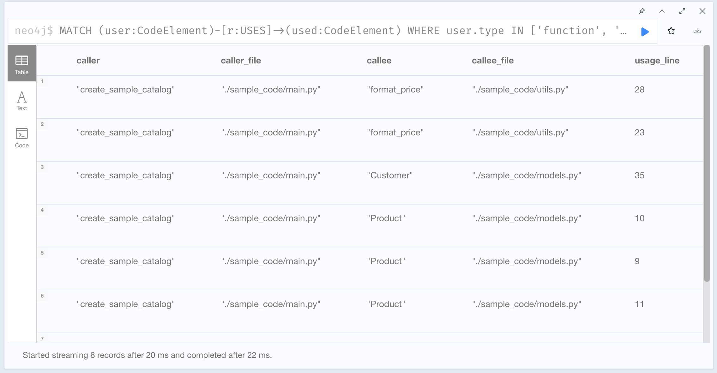

6. Find code with no relationships (neither using nor being used)
MATCH (e:CodeElement)
WHERE NOT (e)-[:USES]-()
AND NOT ()-[:USES]->(e)
AND e.type IN ['function', 'class']
AND e.is_used = false
RETURN
e.type as type,
e.name as name,
e.file_path as file,
e.line_number as line
ORDER BY e.file_path;
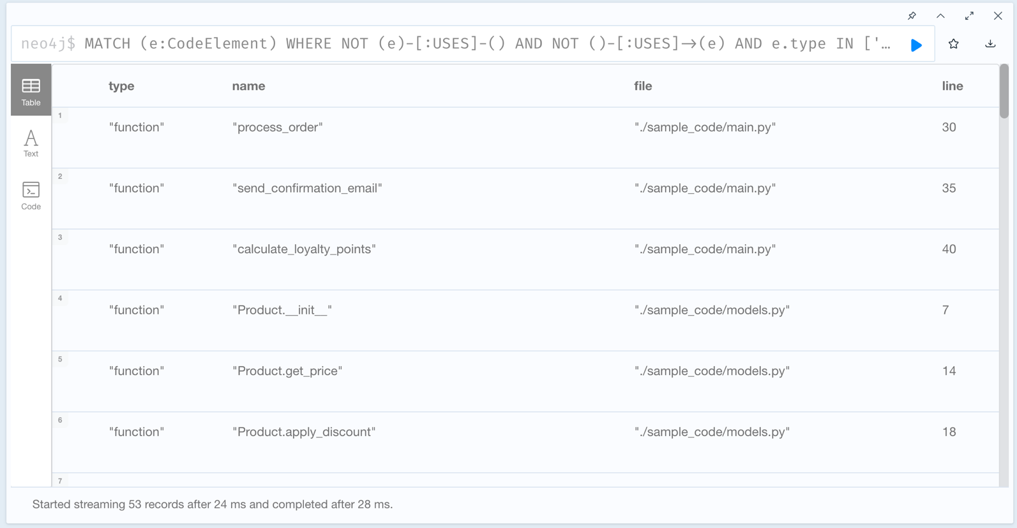

7. Find all unused functions and classes
MATCH (e:CodeElement)
WHERE e.is_used = false
AND e.type IN ['function', 'class']
AND NOT e.name STARTS WITH '_'
AND NOT e.name IN ['main', '__init__']
RETURN e.name, e.type, e.file_path, e.line_number
ORDER BY e.file_path, e.line_number;
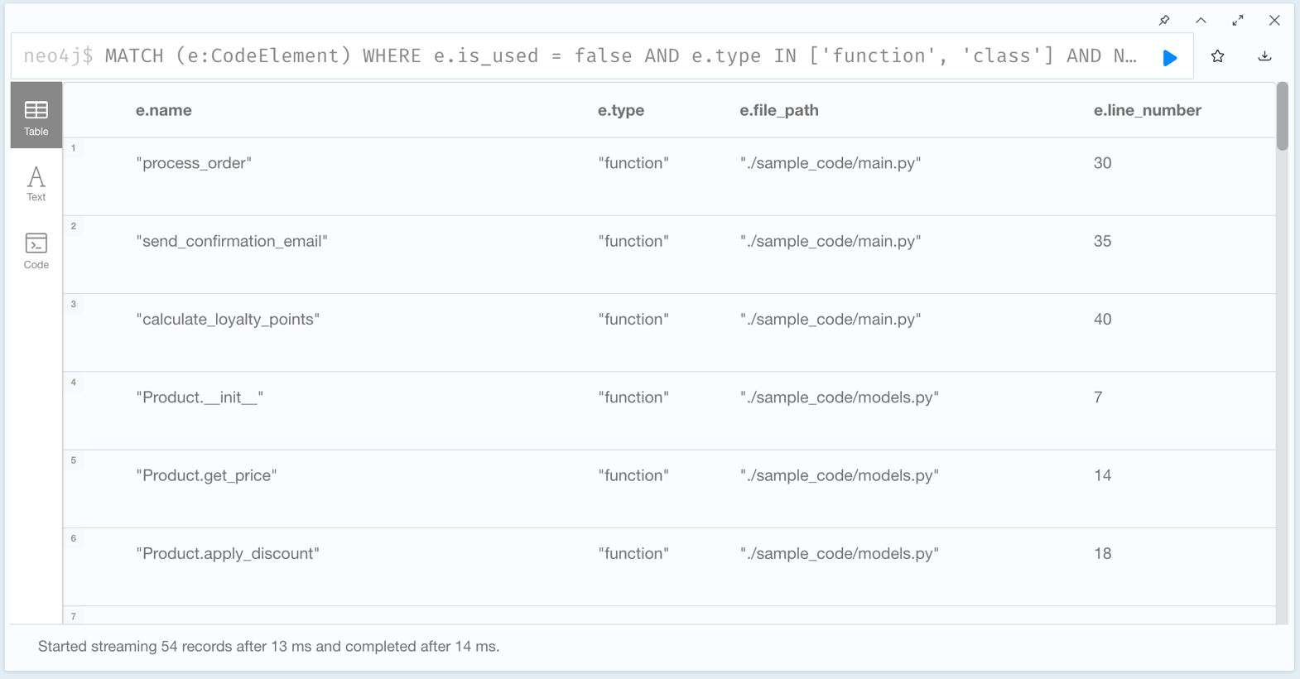
8. Find orphaned code elements (no incoming or outgoing relationships)
MATCH (e:CodeElement)
WHERE NOT (e)-[:USES]-() AND NOT ()-[:USES]->(e)
AND e.type IN ['function', 'class']
RETURN e.name, e.type, e.file_path, e.line_number
ORDER BY e.file_path;
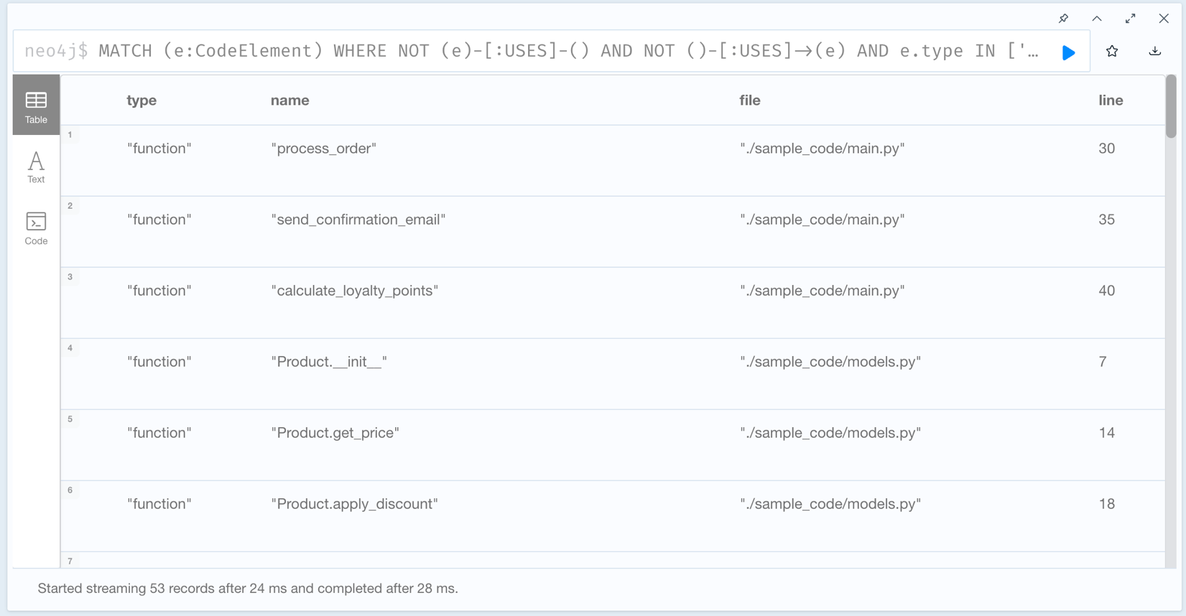
9. Find unused imports
MATCH (e:CodeElement {type: 'import'})
WHERE e.is_used = false
RETURN e.name, e.file_path, e.line_number
ORDER BY e.file_path, e.line_number;
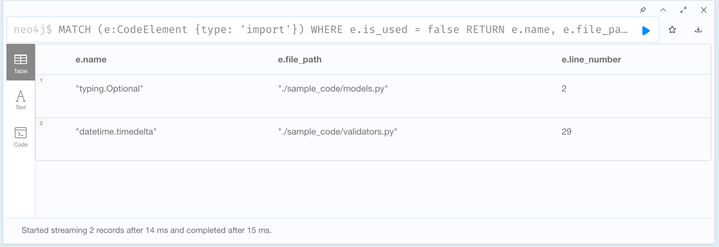

10. Get usage statistics by file
MATCH (e:CodeElement)
RETURN e.file_path,
e.type,
COUNT(e) as total,
SUM(CASE WHEN e.is_used THEN 1 ELSE 0 END) as used,
SUM(CASE WHEN e.is_used THEN 0 ELSE 1 END) as unused
ORDER BY e.file_path, e.type;
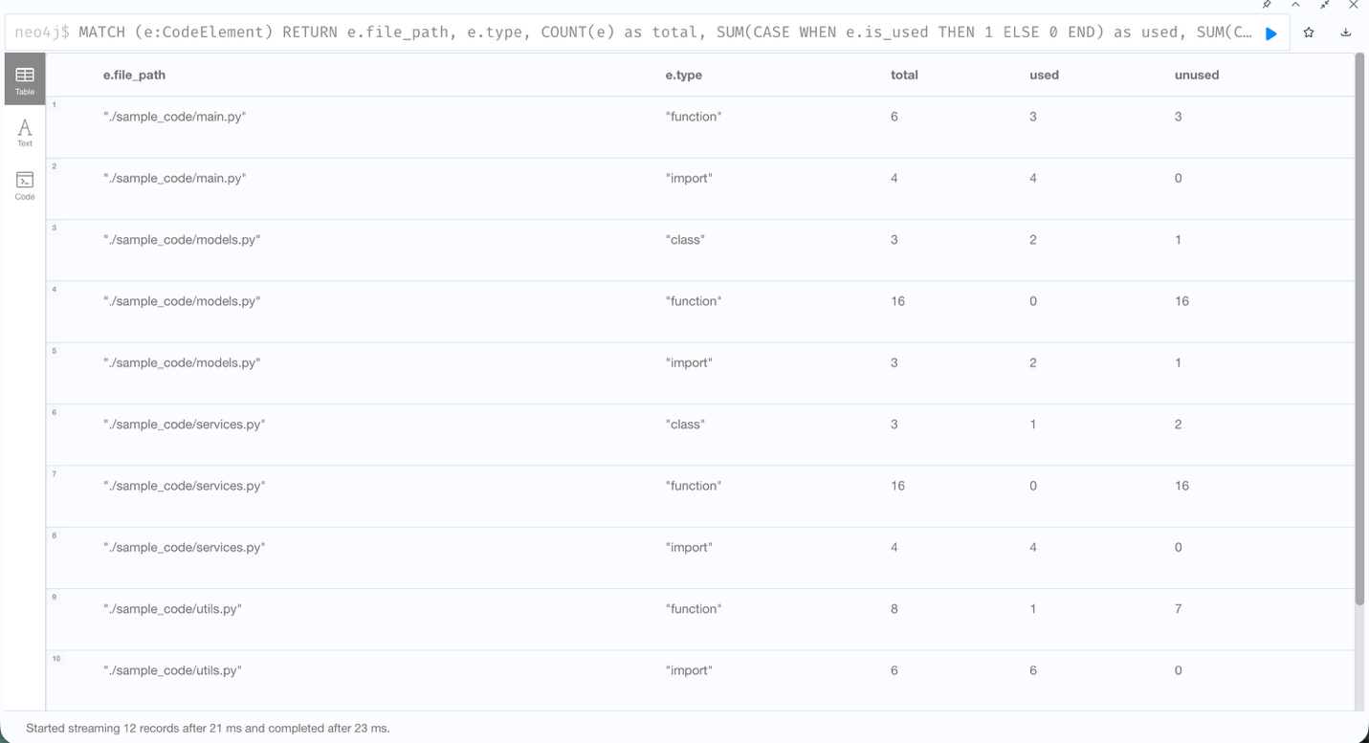

11. View Nodes WITH Relationships
MATCH (n:CodeElement)-[r:USES]->(m:CodeElement)
RETURN n, r, m
LIMIT 50
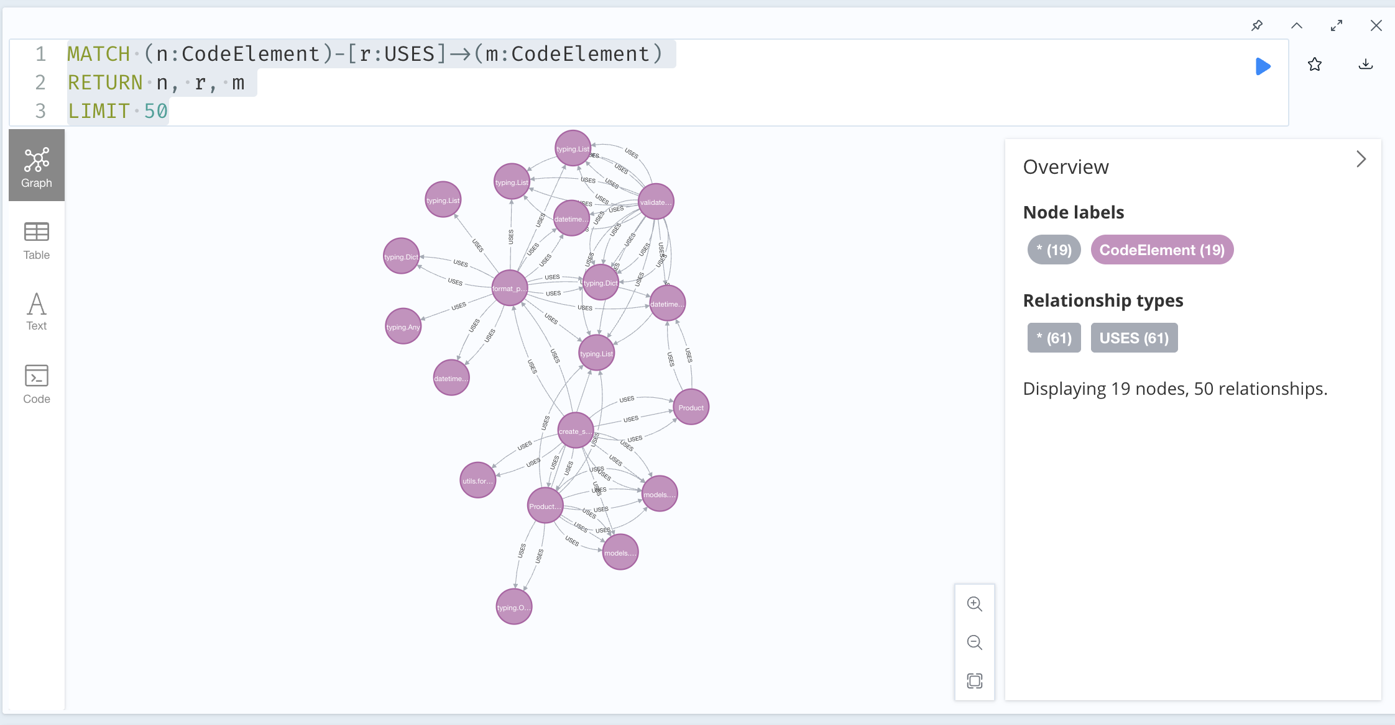

12. Find classes with no methods being used
MATCH (class:CodeElement {type: 'class'})
OPTIONAL MATCH (method:CodeElement {type: 'function'})
WHERE method.name STARTS WITH class.name + '.'
AND method.is_used = true
WITH class, COUNT(method) as used_methods
WHERE used_methods = 0
RETURN class.name, class.file_path, class.line_number;
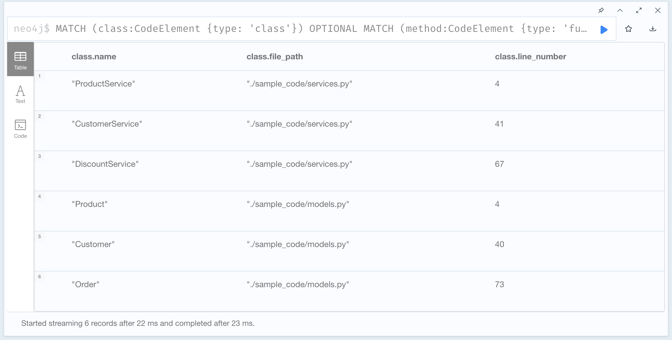

13.

