**SCREENSHOTS**

**Course-end Project 1: Set Up and Monitor a WordPress Instance**

**Step 1: Set up a live WordPress instance to publish blogs using CloudFormation**

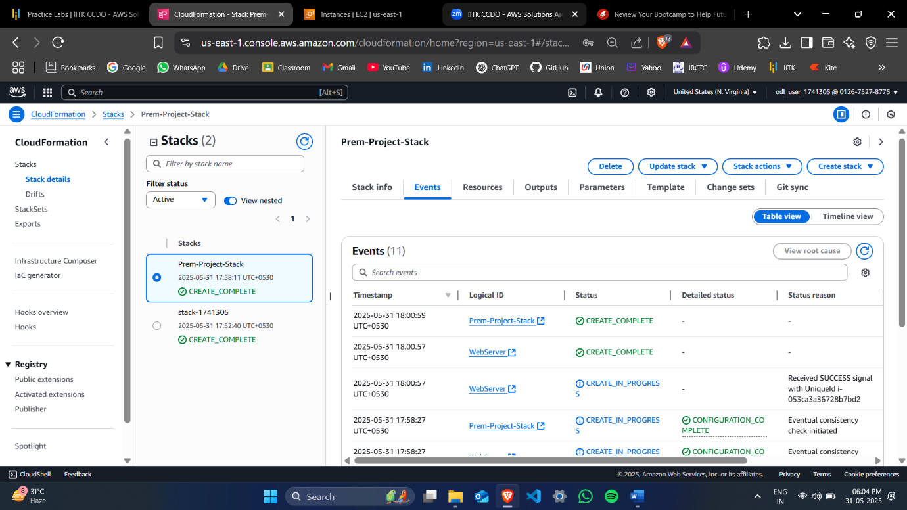

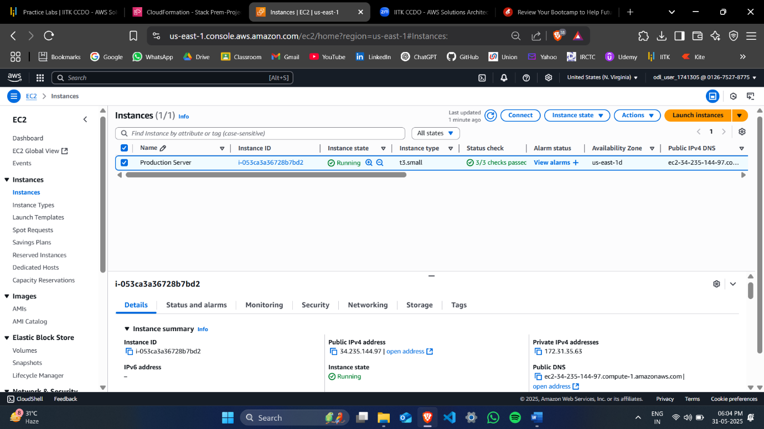

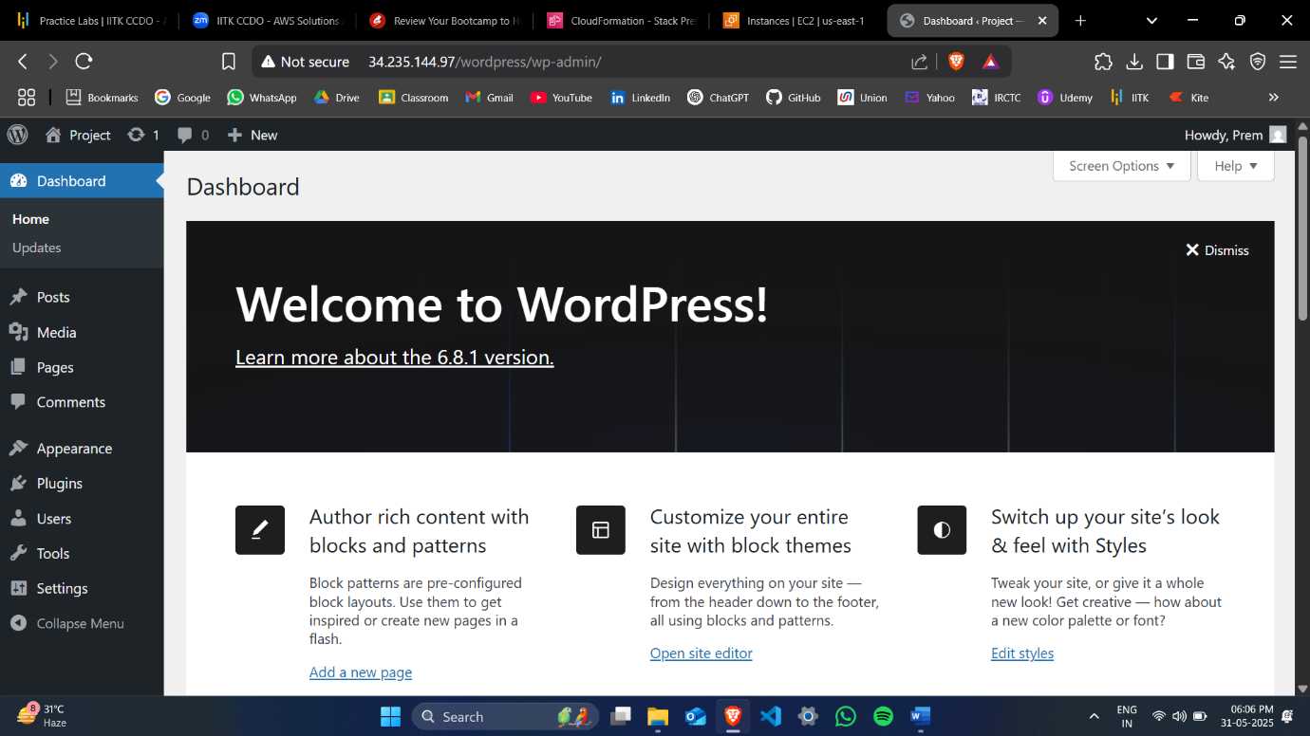

**Step 2: Launch an AMI from first instance.**

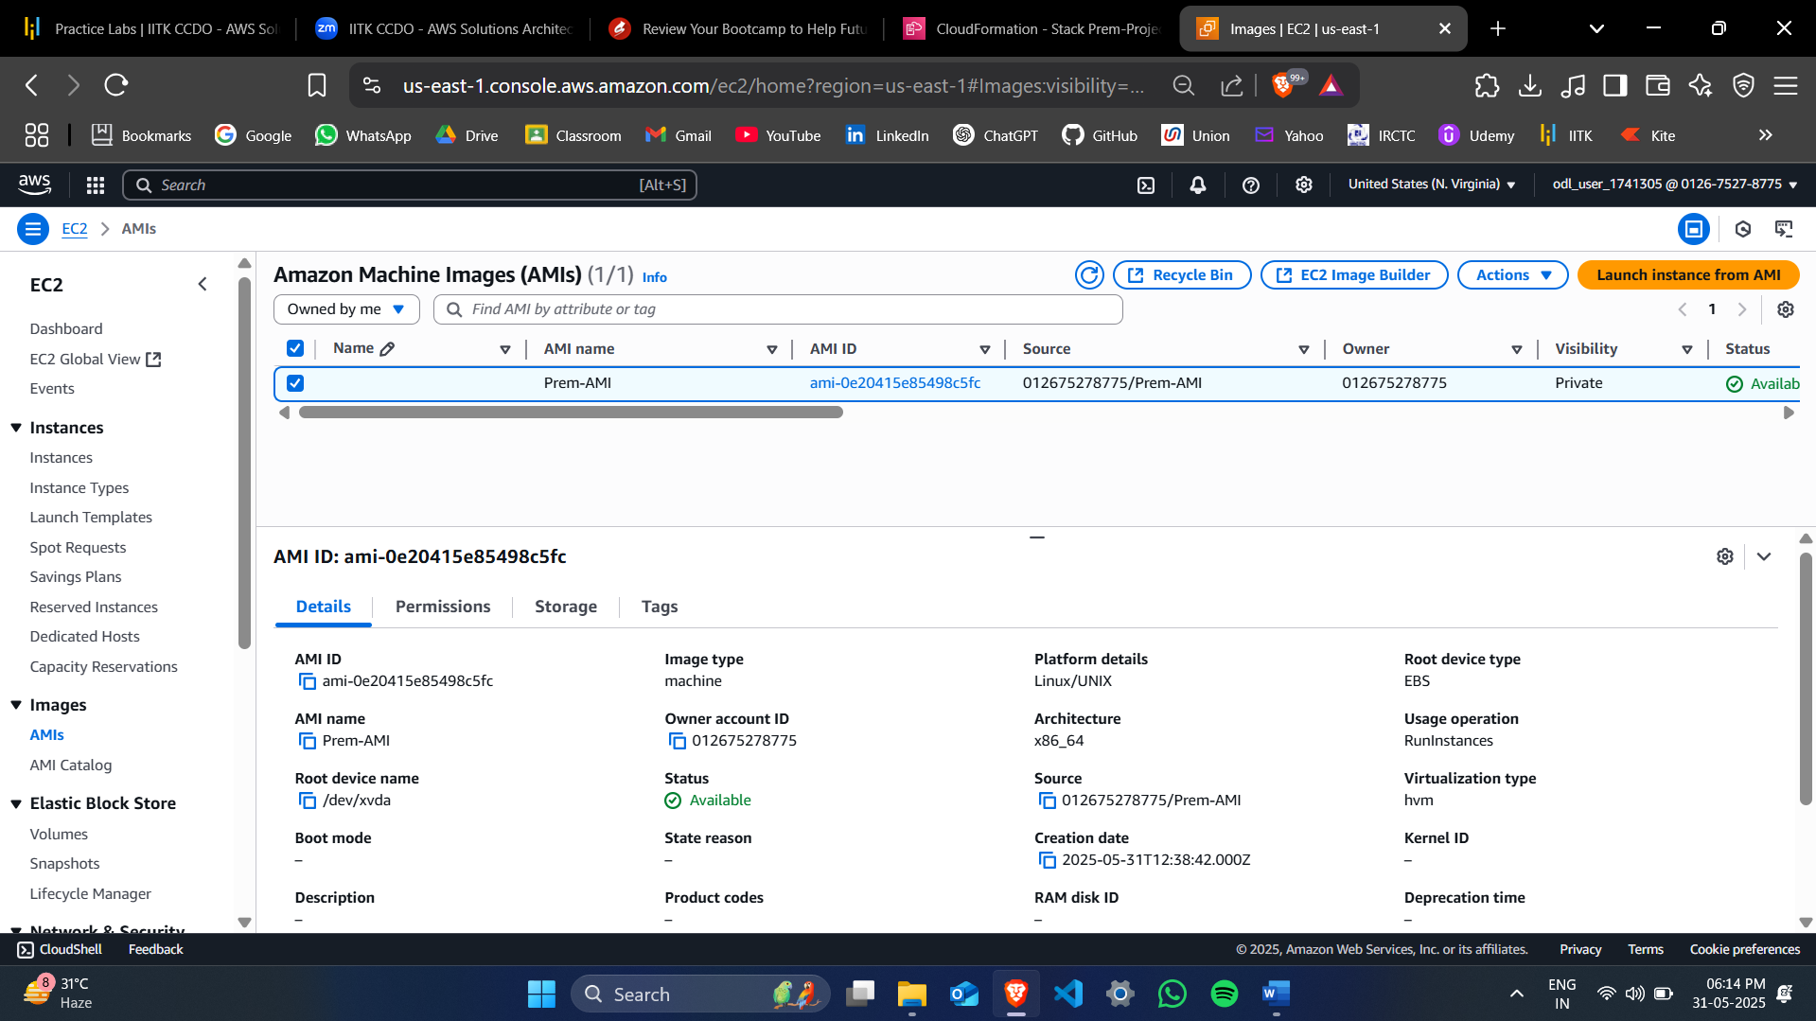

**Step 3: Set up another WordPress instance for development and testing purposes using Auto Scaling Group (ASG). Use the AMI created in step 2 for ASG.**

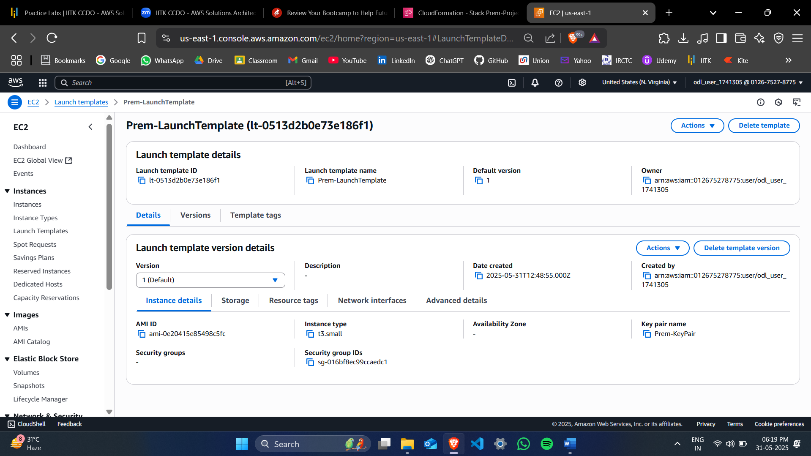

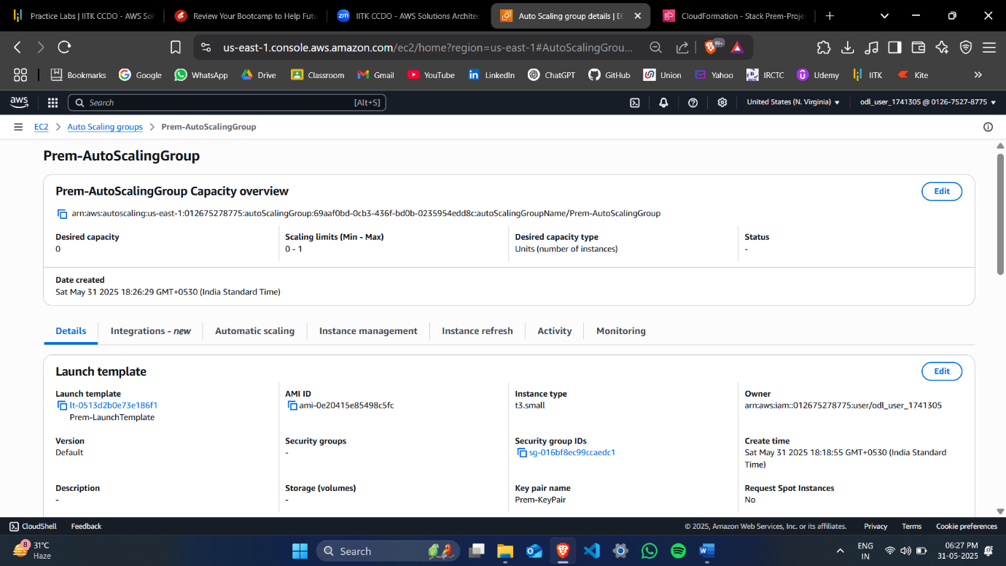

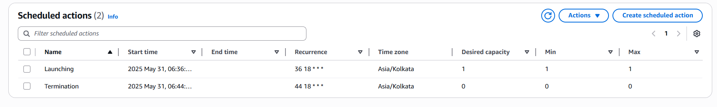**Step 4: Configure the WordPress instance for development and testing purposes using ASG Scheduled Actions so that the server will be available only during the business hours (9 AM–6 PM)**

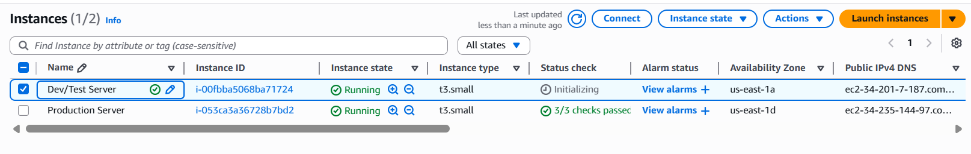

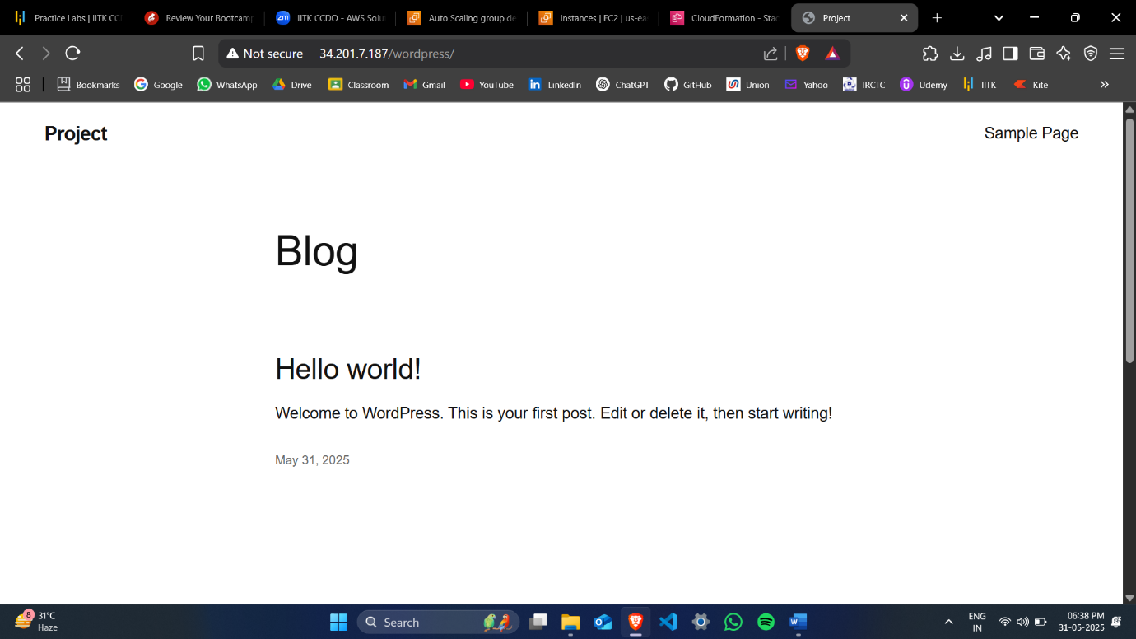

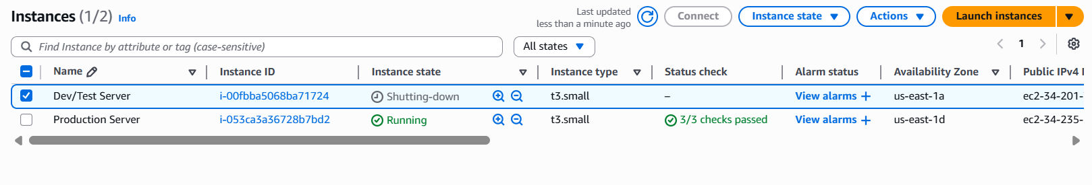

**Step 5: Monitor the servers using Route53 Health Checks**

